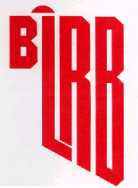
BLACK LIQUOR RECOVERY BOILER
ADVISORY COMMITTEE

MINUTES OF MEETING

April 8, 2024
OBJECTIVE
BLRBAC’s objective is to promote improved safety of chemical recovery boilers and their auxiliaries through the interchange of technical knowledge, experience, and data on past and any future recovery boiler incidents. Bylaws - 2.1

OFFICERS
David von Oepen Tel: 334-341-7900
Chairman: WestRock
Demopolis, AL david.vonoepen@westrock.com

Vice-Chair: Frank Navojosky Cell: (513) 334-9999
International Paper frank.navojosky@ipaper.com
Loveland, OH

Secretary: Everett Hume Tel: 401-415-2272
FM Global Cell: 413-265-9562
Johnston, RI everett.hume@fmglobal.com

Treasurer: Brad Osbourne Cell: 352-267-0118
Electron Machine brad@electronmachine.com
Umatilla, FL 32784

REGULAR MEMBERSHIP
Organizations operating, manufacturing, or insuring chemical recovery boilers are eligible.

ASSOCIATE MEMBERSHIP
Organizations having a direct interest or role in the safety of chemical recovery boilers are eligible.

CORRESPONDING MEMBERSHIP
Companies residing outside of the United States which finds it impractical to attend meetings on a regular basis because of distance and expenses, but desires to be involved and informed of BLRBAC activities.
Bylaws - 3.1

BLRBAC INTERNET ADDRESS: ---- www.blrbac.net
IRS Employer ID/Tax ID (IRS E.I.N.T./T.I.N.) ---- #13-366-5137

EXECUTIVE COMMITTEE

David von Oepen
BLRBAC Chairman
WestRock
Demopolis, AL
Tel: 334-341-7900
david.vonoepen@westrock.com

Frank Navojosky
BLRBAC Vice Chairman
International Paper
Memphis, TN
Cell: (513) 334-9999
frank.navojosky@ipaper.com

Everett Hume Brad Osborne

BLRBAC Secretary BLRBAC Treasurer
FM Global Electron Machine
Johnston, RI Umatilla, FL
Tel: 401-415-2272 Cell: 352-267-0118
Cell: 413-265-9562 brad@electronmanchine.com
everett.hume@fmglobal.com

John Phillips Jimmy Onstead

Manufacturing Representative Insurance Representative
Andritz FM Global
Alpharetta, GA Frisco, TX
Tel: 770-640-2434 Tel: 972-731-1656
Cell: 678-427-6899 Cell: 903-744-2734
john.phillips@andritz.com jimmy.onstead@fmglobal.com
y j
Operator Representative
Greg Burns
Domtar
Fort Mill, SC 29715
Cell: 843-991-7192
Gregory.burns@domtar.com

BLRBAC SUBCOMMITTEES

AUXILIARY FUEL  Bruce Knowlen, Chairman  International Paper  Federal Way, WA  Tel: (253) 924-4637  bruce.knowlen@ipaper.com | BLACK LIQUOR, SAFE FIRING OF  Vernon Blackard, Chairman  International Paper  Roy, MT 59471  Cell: 251-284-3471  vernon.blackard@ipaper.com
EMERGENCY SHUTDOWN PROCEDURES  Frank Navojosky, Chairman  International Paper  Loveland, OH  Cell: (513) 334-9999  frank.navojosky@ipaper.com | FIRE PROTECTION IN DIRECT  CONTACT EVAPORATORS  Stephen Cox - Chairman  International Paper  Maumelle, AR  Tel: 409-779-7104  stephen.cox@ipaper.com
INSTRUMENTATION  John Browning, Chairman  Georgia Pacific  Atlanta, GA  Tel: 251-593-6096  john.browning@GAPAC.com | MATERIALS & WELDING  Jesse Worsham - Chairman  Domtar Paper  Marlboro Mill  P. O. Box 678  Bennettsville, SC 29512  Tel: (843) 479-0200 Ext 8879  Jesse.Worsham@Domtar.com
PERSONNEL SAFETY  John Fredrickson - Chairman  Sappi North America  Cloquet, MN  Tel: 218-878-4378  john.fredrickson@sappi.com | PUBLICITY & NEWS RELEASE  Matt Paine, Chairman  FM Global  Norwood, MA  Tel: 781-255-4733  matthew.paine@fmglobal.com
WASTE STREAMS  Paul Seefeld, Chairman  A.H. Lundberg Associates, Inc.  Jacksonville, FL  Tel: 904-614-6492  paul.seefeld@lundberg-us.com | WATER TREATMENT  Tom Przybylski, Chairman  Power Specialists Associates  Somers, CT  Tel: 860-763-3241  tom.@psaengineering.com

FUTURE BLRBAC MEETINGS

Fall | October | 7, 8, 9 | 2024
Spring | April | 7, 8, 9 | 2025
"Bring Operator(s). Give them a chance to hear firsthand!"
Past Chairman Lon Schroeder

*****************************
* NOTE: For varying reasons, the previously published meeting dates have been changed at the
discretion of the Executive Committee.

BLRBAC has established its own website at: www.blrbac.net

At this website you will find a copy of past Meeting Minutes and the next Meeting Notice. Therefore, each Representative and Associate Representative is asked to inform their people of this WEB site. This is where they can obtain the following BLRBAC documents:

BLRBAC MEETING NOTICE
COVER LETTER General Information

REGISTRATION FORM Will be available on the website with a link to register and pay on line.

HILTON Airport Blocked room dates, pricing, address, hotel phone numbers

SCHEDULE List of subcommittee activities on Monday and Tuesday

AGENDA Reports given to Joint BLRBAC Meeting on Wednesday

OPERATING PROBLEMS Mail/e-mail completed questionnaires to Frank Navojosky

QUESTIONNAIRE The Vice Chairman and he will see that your concerns are brought up and discussed during the Operating Problems session at the next meeting.

These are available at the BLRBAC INTERNET ADDRESS: www.blrbac.net
BLRBAC Guidelines & Recommended Practices
LEGAL NOTICE

Recommended Good Practice For Design, Operation, and Testing of the Emergency Shutdown System for Black Liquor Recovery Boilers
(Dated: October 2023)

Safe Firing of Black Liquor in Black Liquor Recovery Boilers
(Dated: April 2016)

Materials & Welding Guidelines
(Dated: April 2013)

Safe Firing of Auxiliary Fuel in Black Liquor Recovery Boilers
(Dated: February 2012)

Fire Protection in Direct Contact Evaporators and Associated Equipment
(Dated: February 2023)

Personnel Safety & Training
(Dated: April 2018)

Application of Rotork Actuators on Black Liquor Recovery Boilers
(Dated: October 2005)

Boiler Water Management Guidelines for Black Liquor Recovery Boiler
(Dated: April 2023)

Instrumentation Checklist and Classification Guide for Instruments and Control Systems Used in the Operation of Black 9Liquor Recovery Boilers (Dated: April 2023)

Thermal Oxidation of Waste Streams in Black Liquor Recovery Boilers
(Dated: April 2017)

If you have any questions, contact:

Secretary: Everett Hume Tel: 401-415-2272
FM Global Cell: 413-265-9562
270 Central Ave
Johnston, RI 02919
everett.hume@fmglobal.com

AUXILIARY FUEL SUBCOMMITTEE
Bruce Knowlen – Chairman‡
International Paper
32901 Weyerhaeuser Way S., Ste101
Federal Way, WA 98001
Tel: (253) 924-4637
bruce.knowlen@ipaper.com

Tom DeBeer – Vice Chairman‡  AIG  5001 Willow Creek Drive  Woodstock, GA 30188  Tel:(678) 494-6026  Cell:(404) 218-8613  Thomas.DeBeer@aig.com | John C. Lewis – new  General Electric Vernova  200 Great Pond Drive G3W4  Windsor, CT 06095  Tel:(860) 285-2918  - replacing Ivan Semyanko  john.c.lewis@ge.com | Michael Bekech  CECO - CCA Combustion Systems  884 Main St.  Monroe, CT 06468  Tel: (203) 268-3139 x 137  Cell: (203) 895-4822  mbekech@onececo.com
Mike Bruce‡  Sylvamo  104 Putnam Center Road  Putnam Station, N.Y. 12861  Tel: (518) 586-6954  mike.bruce@sylvamo.com | Rick Dooks‡  Fossil Power Systems Inc  10 Mosher Drive  Dartmouth, Nova Scotia B3B 1N5  Canada  Cell: 1-902-499-0546  dooksr@fossil.ca | Chris Finnemore  Georgia Pacific  Fernandina Beach, FL 32034  Cell: (904) 321-6861  Chris.finnemore@GAPAC.com
Travis Flower  Babcock & Wilcox Company  P. O. Box 351  Barberton, OH 44203-0315  Tel: (330) 860-6042  taflower@babcock.com | Derrick Gossen‡  FM Global  301 Freedom Ct.  Mishicot, WI 54228  Cell: (920) 619-1750  derrick.gossen@fmglobal.com | Brook M. Holland  Bodman Services LLC  Cell: (828) 421-0487  brookmholland@gmail.com
Greg Imig‡  Andritz  5405 Windward Pkwy, Suite 100W  Alpharetta, GA 30004  Tel: (770) 640-2633  Cell: (404) 545-9076  greg.imig@andritz.com | Carlos Rojas  Smurfit Kappa (Colombia)  (TBD)  Columbia, S. America  Phone: (TBD)  carlos.rojas@smurfitkappa.com.co | Ivan Semyanko‡  General Electric -- RETIRING  200 Great Pond Dr.  Windsor, CT 06095  Tel: (860) 285-3953

‡ = | Denotes attendance at last meeting, Apr 8, 2024
* = | Denotes a new/replacing member

EMERGENCY SHUTDOWN PROCEDURES SUBCOMMITTEE

Frank Navojosky– Chairman
International Paper
Cell: (513) 334-9999
frank.navojosky@ipaper.com
David Frazier, IP, alternate‡
John Andrews, substitute Chairman for Spring 2024 Meeting‡

Dean Clay, Secretary‡  Boiler Services & Inspection, LLC  BSI  Cell: (513) 497-9070  dclay@bsimail.com  dclayesp@gmail.com | Scott Crysel‡  FM Global  One Cowboys Way, Suite 600  Frisco, TX 75034  Tel: (972) 731-1658  Fax: (972) 731-1820  scott.crysel@fmglobal.com | James Franks‡  AXA XL Risk Consulting  855 Dogwood Road  Somerville, TN 38068  Tel: (901) 465-0771  Fax: (888) 964-7348  james.franks@axaxl.com
Chris Jackson, previous member, resigned | Dino Aracki  Kruger Inc., Kamloops Mill  2505 Mission Flats Road  Kamloops, BC V2C 1A9  Canada  Office (250) 434-8841  Cell (250) 255-6840  Dino.aracki@kruger.com | John DeFusco‡  Babcock & Wilcox Company  4 Essex Drive  Yarmouth, ME 04096  Cell: (207) 776-0954  jpdefusco@babcock.com
Gregory Burns‡  Domtar  Cell: (843) 991-7192  Office: 803-802-8077  Fort Mill, SC  gregory.burns@domtar.com | Scott Moyer‡  WestRock  1660 Prudential Drive, Ste. 202 Jacksonville, FL 32207  Cell: 904-437-7149  scott.moyer@westrock.com | Greg Zavadoski‡  Georgia Pacific  Office: 404.487.4384  Cell: 715.432.2470  greg.zavadoski@gapac.com
John Phillips‡  Andritz Pulp & Paper  5405 Windward Parkway, Suite 100W  Alpharetta, GA 30004  Tel: (770) 640-2434  Fax: (770) 640-2521  john.phillips@andritz.com | Dan Cudmore‡  GE Vernova  1420 Blair Towers Place  Suite 500  Ottawa, ON K1J 9L8  Tel: (613) 298-5021  dan.cudmore@ge.com | Dave Gadai  Valmet Inc  3440 Torington Way  Suite 300, Bldg 3  Charlotte, NC 28277  Tel: (704) 414-3501  Cell: (704) 560-3575  dave.gadai@valmet.com  Jeremiah Yoder, Valmet, alternate‡
‡ Denotes attendance in Spring 2024 meeting

PUBLICITY & NEWS RELEASE SUBCOMMITTEE
‡Matt Paine - Chairman
FM Global
Johnston, RI
Cell: 781-255-4733
matthew.paine@fmglobal.com

‡Denotes attendance at the meeting in April of 2024.

FIRE PROTECTION IN DIRECT CONTACT EVAPORATORS
AND ASSOCIATED EQUIPMENT SUBCOMMITTEE

‡Stephen Cox - Chairman
International Paper
6318 Highway 139
Bastrop, La 71220
Tel: 409-779-7104
Stephen.cox@ipaper.com

Kevin Huelsbeck - Vice Chair  FM Global Property Insurance  Midwest-Chicago Ops  N8955 Willow Lane  Menasha, WI 54952  Tel: 920-205-5529  kevin.huelsbeck@fmglobal.com |  | Robert Goddard  XL Group  129 Drive 1143  Tupelo, MS 38804  Tel: 662 844-5897  robert.goddard@axaxl.com
Christopher Skorton  Australian Paper  Tel: 61 0408-722-672  Chris.Skorton@AustralianPaper.com.au | Rachakrit Withayaphan  Siam Cellulose Co.  19 Moo 19Saeng-Xuto Road  Tambol Thapa  Ban Pong, Ratchaburi 70110 Thailand  Tel: +66 3221 1388-90  rachakrw@scg.co.th | Joseph Lynch  Swiss Re America Holding Corporation  1150 Sanctuary Parkway, Suite 425  Alpharetta, GA 30009  Tel: 1770-569-8706  Joe_Lynch@swissre.com
James Ham  FM Global  3460 Preston Ridge Road - Suite 400 |  Alpharetta, GA 30005  T: (770) 777-3798 |  james.ham@fmglobal.com | Daniel Nesmith  WestRock  P.O. Box 118005  Charleston, SC 29423-8003  Tel:  daniel.nesmith@westrock.com

‡Denotes attendance at the meeting in April 2022. Will be updated at future meeting

INSTRUMENTATION SUBCOMMITTEE
Spring 2024 members and attendance
‡JC Browning, Jr– Chairman
Georgia Pacific
133 Peachtree St. NE (30303)
Atlanta, GA 30348-5605
Tel: 251-593-6096
john.browning@gapac.com

‡ Attended New Member Leaving Member
David Avery - Vice-Chairman  Domtar Paper Company  PO Box 678; Bennettsville, SC 29512  Tel: 843-454-8937  david.avery@domtar.com | ‡Ben Bunner - Secretary Andritz  5404 Windward Parkway  Suit 100W  Alpharetta, GA 30004  Cell: 678-907-7617  ben.bunner@andritz.com | ‡David T. Boudreau  SAPPI (S.D. Warren Company)  1329 Waterville Road  Skowhegan, ME 04976  Tel: 207-314-8024  dave.boudreau@sappi.com
Joel Byrd  International Paper Company  12515 Choctaw Rd  Bogalusa, La 70427  Tel:985-516-1110  Joel.byrd@ipaper.com | ‡C.A. Vossberg  Electron Machine Corp.  P.O. Box 2349  Umatilla, FL 32784  Tel: 352-406-1351  ca@electronmachine.com | ‡Bruce Knowlen  International Paper Company  IPGCFIC-1G39  Federal Way, WA 98001  Cell: 253-732-2285  bruce.knowlen@ipaper.com
Kevin Huelsbeck  FM Global  W4893 Cliff View Drive  Sherwood, WI 54169  Cell: 920-205-5529  kevin.huelsbeck@fmglobal.com | David DiCorpo  Vaisala / K-Patents, 10 D Gill Street, Woburn, MA 01801  Cell: 781-281-5745  david.dicorpo@vaisala.com | Gordon L. Vandenburg  Liquid Solids Control, Inc.  P.O.Box 259, Farm St.  Upton, MA 01568  Tel: (603) 833-8536  gordie@liquidsolidscontrol.com
Andy Smith  AIG  203 Dunleith Drive  Woodstock, GA 30188  Tel: 770-671-2447  william.smith2@aig.com | ‡Andy Clement  10 Mosher Drive  Dartmouth, Nova Scotia  Canada B3B 1N5  Tel:902-468-2743 ext.245  clementa@fossil.ca | ‡Mike Bruce Sylvamo  104 Putnam Center Rd  Putnam Station, NY 12861  Mike.Bruce@Sylvamo.com (578) 586-6954
‡Daniel Albert - Rotork 675 Mile Crossing Boulevard Rochester NY 14624  (585) 247-2304  Daniel.Albert@Rotorq.com | ‡Adam Marickovich  Georgia-Pacific  133 Peachtree St. NE (30303)  Atlanta, GA 30348-5605d  Adam.Marickovich1@gapac.com | ‡Daniel Guarnieri SYLVAMO

PERSONNEL SAFETY SUBCOMMITTEE

John Fredrickson - Chairman‡
Sappi North America
2201 Avenue B.
P.O. Box 511
Cloquet, MN 55720
Tel: (218) 878-4378
john.fredrickson@sappi.com

Sam Dean  Rayonier Advanced Materials  4470 Savannah Highway  Jesup, GA 31545  Tel: (912) 427-5103  samuel.dean@rayonierAM.com | Steve Morrison‡  G-P  Cell – (404) 268-6573  TEAMs – (404) 652-7141  Steve.morrison@gapac.com | Tom Edwards‡  B&W  twedwards@babcock.com
 | David Von Oepen  WestRock  28270 U.S. Highway 80 West  Demopolis, AL 36732-5121  Tel: (334) 289-6315  dvonoepen@westrock.com | Mathew Glenn‡  Irving Pulp & Paper, Limited  Recovery Superintendent  P.O. Box 3007  408 Mill Street  Saint John, New Brunswick  Tel: (506) 634-4234  glenn.matthew@irvingpulp.com
Grey Gurkin  International Paper  International Paper Co. | Zack Payne  Andritz  5405 Windward Parkway  Suite 100W  Alpharetta, GA 30004-3894  Tel: (706) 344-9006  zack.payne@andritz.com | Francisco Britt‡  FM Global  One Cowboys Way  Suite 600  Frisco, TX 75034  Tel: (972) 731-2145  Francisco.britt@fmglobal.com
Brook Holland  G.H. Bodman  228 Wild Rose Lane  Canton, NC 28716  Tel : (828) 421-0487  brookmholland@gmail.com | Jake Dowland‡  ND Paper | Sam Miller‡  Andritz
‡Denotes attendance at the April 2024 meeting

MATERIALS & WELDING SUBCOMMITTEE

‡ Jesse Worsham - Chairman
Domtar Paper
Marlboro Mill
P. O. Box 678
Bennettsville, SC 29512
Tel: (843) 479-0200 Ext 8879
Fax: (843) 479-6603
Jesse.Worsham@Domtar.com
*Alternate - none
‡ this meeting
 | ‡*Maxime Simard  FM Global  Tel: (418) 435-1551  Fax:  maxime.simard @fmglobal.com  ‡*Alt: Mark Jackson | ‡ Scott Lowry  Andritz Pulp and Paper  5405 Windward Parkway, Suite 100W  Alpharetta, GA 30004  ‡*Alternate - Mark LeBel  Cell (678) 577-8613
‡Laura Nicol  Babcock & Wilcox  20 S. VanBuren Avenue  Barberton, OH 44203-0351  Tel: 330-860-2160  lsnicol@babcock.com | Chad Harrod  Georgia-Pacific LLC  133 Peachtree St NE  Atlanta, GA 30303  404-395-3064  Chad.Harrod@gapac.com | Jennings Bird  Valmet  Tel: 803 235 8091  Cell:  FAX: N/A  Jennings.bird@valmet.com  *Alt: Ron Reed  Tel: (704) 281-3073  Ron.reed@valmet.com
*Steve Harville  Cell: (251) 591-7850  Sharville@NationalBoiler.com  *Alt: Mike Messamore  National Boiler Services  Tel: (706) 657-1584  mmessamore@NationalBoiler.com | ‡Jed Merritt  RMR Mechanical  PO Box 170  Cumming, GA 30028  Tel: 601-508-9084  Jed.merritt@rmrmechanical.com  *Alt: Cullen Roberts | Chris Rawls  Applied Technical Services  Tel: 757-218-8465  crawls@atslab.com  Alt: Thomas Kapperman  Tel: (678)231-8025  tkapperman@atslab.com
Stacey Power  Midstate SMS  2730 Mine & Mill Rd.  Lakeland, FL 33801  Tel: 843-957-2111  spower@sms midstate.com | TBD  Acuren | Jeremiah Yoder  Valmet  Tel: 704-408-6825  Jeremiah.yoder@valmet.com

SAFE FIRING OF BLACK LIQUOR SUBCOMMITTEE
‡Vernon Blackard - Chairman
International Paper
Cell: 251-284-3471
vernon.blackard@ipaper.com

Clif Barreca  International Paper  Tel: 252-633-7696  clif.barreca@ipaper.com | ‡Tim Hicks  Billerud  Tel. 901-468-5058  Tim.hicks@Billerud.com | Joel Byrd  International Paper  Tel: 85-516-1110  Joel.byrd@ipaper.com
‡Sarah Henke – Co-Chair  Valmet  Tel: 919-454-3441  Sarah.henke@valmet.com | ‡Peter Donahue  Fossil Power Systems, Inc.  Tel: 902-468-2743, Ext. 251  Cell: 902-877-9312  donahuep@fossil.ca | Len Erickson  Power Specialist Assoc.  Tel: 208-841-4246  len.erickson@PSAengineering.com
‡Daniel Franco  Smurfit Kappa Colombia  Cel: +57 3113001079  Tel: (57-2) 6914 000 Ext. 2016  daniel.franco@smurfitkappa.com.co | ‡Wes Hill  Georgia Pacific  Tel 360-607-4189  Wes.hill@gapac.com | Majed Ja’arah  International Paper  Cell: 706-728-8085  majed.jaarah@ipaper.com
‡Guy Labonte  FM Global  Tel: 514-876-7412  Cell: 514-942-3651  guy.labonte@fmglobal.com | Doug Murch  WestRock  Tel: 804-444-5245  Cell: 804-787-0781  douglas.murch@westrock.com | Alarick Tavares  Westrock  Tel - 678 492-1107  alarick.tavares@westrock.com
Mark Sargent  Bodman Services, LLC  Tel: 514-543-0480  Mark.sargent@rmrmechanical.com | ‡Pasi Miikkulainen  Andritz  p: +1 770 640 2414  m: +1 678 230 1525  Pasi.Miikkulainen@andritz.com | ‡ Brian Rawson  International Paper  Cell: 850-266-5259  brian.rawson@ipaper.com
 | ‡Rudy Haraga –  Formax Services  Tel: 860-268-1871  Rudy.haraga@thefornax.com | ‡Olli Kujanpaa –  Georgia Pacific  Tel: 404-432-8281  Olli.kujanpaa@gapac.com
  ‡Jason Lewis
  ND Paper
  m: 207-557-0952
  Jason.lewis@us.ndpaper.com
‡Ryan P Henry - (sub Justin Helton)  Green Bay Packaging Inc.  Tel: 501-306-8330  rhenry@gbp.com | Keijo Pyorala  Vaisala  keijo.pyorala@vaisala.com | David Tjaarda  Westrock  Tel – 503 728-2550  David.tjaarda@westrock.com
 | Evangelos Townsend  B&W  Tel: 469-815-8395  emtownsend@babcock.com
  ‡Justin Helton  Andritz  Tel: 470-416-1342  Justin.helton@andritz.com | Keijo Pyorala  Vaisala  keijo.pyorala@vaisala.com | David Tjaarda  Westrock  Tel – 503 728-2550  David.tjaarda@westrock.com

‡Denotes attendance at the meeting in Spring of 2024.
WASTE STREAMS SUBCOMMITTEE

*Paul Seefeld – Chairman
LDX Solutions
9246 Audubon Park Ln S
Jacksonville, FL 32257
Cell: 904-614-6492

PSeefeld@LDXSolutions.com

*Raquel Posada  Smurfit Kappa  Columbia  Raquel.posada@smurfitkappa.com.co | *Neil Chaudhuri  FM Global  100 New Park Place, Suite 200  Vaughan ON Canada L4K OH9  Tel: 647-894-5680  Neil.chaudhuri@fmglobal.com | David Frazier  International Paper  Technology  6285 Tri-Ridge Blvd  Loveland, Ohio 45140  Cell: 706-305-5321  David.frazier@ipaper.com
*Cobb Golson  Westrock  Saint Augustine, FL  Tel: 904-826-7430  Cobb.golson@westrock.com | *John Lewis  Fluor  100 Fluor Daniel Drive  Greenville, SC 29607-2762  Tel: 864 517-1683  john.lewis@fluorgov.com | *Jarmo Kaila  Andritz  5405 Windward Parkway  Alpharetta, GA 30004  Tel:770-640-2414  Cell: 678-230-1525  jarmo.kaila@andritz.com
Steven L. Osborne  Babcock & Wilcox  20 S. Van Buren Avenue  Barberton, OH 44203  Tel: 330.860.1686  slosborne@babcock.com | Michael D. Sides  AXA XL Risk Consulting  1360 Olympia Park Circle  Ocoee, FL 34761  Tel: 203-964-5333  Mobile: 407-462-4622  Michael.sides@axaxl.com | Greg Wass  LDX Solutions  8271 154th Ave NE  Redmond, WA 98052  Office: 425-283-5070  Cell: 425-503-2747  gwass@LDXSolutions.com
*Kevin Sapp – Vice Chairman  Georgia Pacific  Atlanta, GA  Tel: 387-227-1038  Kevin.sapp@gapac.com | *Oscar Guevara  Domtar Corp.  Fort Mill, SC  Tel: 479-871-0970  Oscar.guevara@domtar.com | *Wayne Bucher  NORAM  Birmingham, AL  205-368-9396  Wayne.bucher@gmail.com
 |  | .
*Denotes attendance 2024 meeting

WATER TREATMENT SUBCOMMITTEE

‡Tom Przybylski
Power Specialists Assoc. Inc.

tom.przybylski@psaengineering.com

Kelli Bastarache  Power Specialists Assoc., Inc.  E-mail Address  kelli.bastarache@psaengineering.com | Michael Bayse  George H. Bodman, Inc.  E-mail Address  bbayse@aol.com | *‡Rick Baxter  Valmet.  E-mail Address  richard.baxter@valmet.com
Fred Call  Buckman  E-mail Address  fccall@buckman.com | Ray Cassel  Rocky Mountain Industrial Services  E-mail Address  rlcassel@rmis.biz | ‡ Susan Childress  International Paper  E-mail Address  susan.childress@ipaper.com
*‡Don Downey  Purolite  E-mail Address  don.downey@purolite.com | ‡Buck Dunton  ChemTreat  E-mail Address  BuckD@chemtreat.com | ‡Don Flach  Georgia Pacific  E-mail Address  don.flach@gpac.com
‡ Jim Gannon  Nalco  E-mail Address  jgannon@ecolab.com | ‡Ken Hansen  Consultant  E-mail Address  Kenhansen0728@gmail.com | Scott Holloway  Solenis  E-mail Address  sholloway@solenis.com
Norris Johnston  Water Wizard Consulting/Solenis  E-mail Address  h2odocnnj@gmail.com | Tom Meehan  FM Global  E-mail Address  thomas.meehan@fmglobal.com | John McGraw  Shepard T. Powell  E-mail Address  jwm@stpa.com
‡ Denotes attendance at meeting in October of 2020. (No update for April 2024)

Registration List*
First Name | Last Name | Company
Frank | DeStefano | 3D Team LLC
George | Pyszynski | 3S Team, LLC
Jake | Shelton | Acoustic Cleaning Systems
Todd | Harley | Acuren
David | Dunn | Acuren Inspection
Tom | DeBeer | AIG - V
Blake | Prescott | Airtek construction
Ben | Fredrick | Allnorth
Wayne | Grilliot | American Forest & Paper Association
Madeleine | Lake | AMETEK Land
Derek | Stuart | AMETEK Land
Ben | Bunner | Andritz
Paul | Ceravolo | Andritz
Justin | Helton | Andritz
Greg | Imig | Andritz
Scott | Lowrie | Andritz
Samuel | Miller | Andritz
Preston | Morgan | Andritz
Zachary | Payne | Andritz
Pasi | Miikkulainen | Andritz Inc.
Mark | LeBel | Andrtiz
John | Phillips | Andrtiz
Pete | Carter | Augusta Actuation
James | Franks | AXA XL Risk Consulting - V
Tom | Edwards | B&W
Nick | Folster | Babcock & Wilcox
Laura | Nicol | Babcock & Wilcox
Evangelos | Townsend | Babcock & Wilcox
John | DeFusco | Babcock & Wilcox - V
Tim | Hicks | Billerud
Gregg | Lentz | Brunswick Cellulose/Georgia Pacific
John | Andrews | BSI
Dean | Clay | BSI
Fred | Call | Buckman
Duncan | Watson | Clean Harbors
Scott | Reed | Clyde Industries
James | Biggs | Crenshaw Machine Systems
Corbin | Hill | Crenshaw Machine Systems
Simon | Youssef | Diamond Power
Gregory | Burns | Domtar
Malvin | Lansdell | Domtar
Oscar | Guevara | Domtar Corp.
Jesse | Worsham | Domtar Paper Company, LLC - V
Jaye | Locke | E and E Tech
Brad | Osborne | Electron Machine
C.A. | Vossberg | Electron Machine
Mike | Brown | Energy and Environmental Technologies
John | Lewis | Fluor
Resham | Adhikari | FM Global
Rasmus | Andersson | FM Global
Francisco | Britt | FM Global
Neil | Chaudhuri | FM Global
James | Eversole | FM Global
Pavel | Fatka | FM Global
Joshua | Fetting | FM Global
Hollie | Gibson | FM Global
Derrick | Gossen | FM Global
Everett | Hume | FM Global
Patrick | Hutto | FM Global
Mark | Jackson | FM Global
Guy | Labonte | FM Global
Andreas | Lindgren | FM Global
Thomas | Meehan | FM Global
Tim | Murphy | FM Global
Jimmy | Onstead | FM Global
Matthew | Paine | FM Global
Derek | Ranney | FM Global
Maxime | Simard | FM Global
Jason | Sirros | FM Global
Ken | Taylor | FM Global
Frank | Theurer | FM Global
Scott | Crysel | FM Global - V
Rudy | Haraga | FORNAX Services, LLC
Richard | Dooks | Fossil Power Systems
Wei | Ren | FP Innovations
Andy | Clement | FPS
Peter | Donahue | FPS
Dan | Cudmore | GE Vernova - V
Yoram | Schaker | GE Vernova Steam Power
Bentley | Sherlock | Gecko Robotics
Daryl | Philo | General Electric
Michael | Rushing | General Electric
Ivan | Semyanko | General Electric Company
JC | Browning | Georgia Pacific
Peter | Fogg | Georgia Pacific
Brent | Griffin | Georgia Pacific
Olli | Kujanpaa | Georgia Pacific
Tom | Meadows | Georgia Pacific
Steve | Morrison | Georgia Pacific
Frank | Robbins | Georgia Pacific
Timothy | Rozek | Georgia Pacific
Kevin | Sapp | Georgia Pacific
Greg | Zavadoski | Georgia Pacific
Robert | Orender | Georgia Pacific - V
Adam | Marickovich | Georgia-Pacific
Wes | Hill | Georgia-Pacific - V
James | Ellis | Gore-Tex Professional
Ryan | Henry | Green Bay Packaging - V
Andreas | Aspell | Heat Management
Clark | Conley | Hydro-Thermal Corporation
Paul | Strauss | Integrated Global Services
Vernon | Blackard | International Paper
William | Fischer | International Paper
David | Frazier | International paper
Teddy | Pickard | International Paper
Brian | Rawson | International Paper
Matt | Sharron | International Paper
Bruce | Knowlen | International Paper - V
Luis | Binotto | IQS
Eduardo | Cretier | IQS
Ricardo | Gutierrez | IQS
Matthew | Glenn | Irving Pulp & Paper
Dan | Mott | Irving Pulp & Paper
Trevor | Murray | Irving Pulp and Paper - V
James | Cantrell | Jacobs Engineering
Steve | Campbell | Jansen Combustion and Boiler Technologies, Inc.
Douglas | Giarde | Jansen Combustion and Boiler Technologies, Inc.
Mark | McCabe | Jansen Combustion and Boiler Technologies, Inc.
Paul | Seefeld | LDX Solutions
Michael | Sweeney | Liquid Solids Control, Inc.
Gordon | Vandenburg | Liquid Solids Control, Inc.
Eric | Church | Liquidmetal Coatings & Mechanical Solutions
Christopher | Skorton | Liquidmetal Coatings & Mechanical Solutions
Roger | Lawton | Milhous Company
Scott | Ray | Milhous Company - Amherst, VA
Scott | Dolezal | Nalco - Ecolab
Jim | Gannon | Nalco Water
William | Burns | ND Paper
Jacob | Dowland | ND Paper
Jason | Lewis | ND Paper
Wayne | Bucher | Noram
Tell | Hunt | Packaging Corporation of America
Travis | Jackson | Packaging Corporation of America
Christian | Cote | Paragon Risk Engineering
James | Dilworth | Pixelle Specialty Solutions
Kelly | Fritz | Pixelle Specialty Solutions
Tom | Przybylski | Power Specialists Assoc., Inc.
Vince | Barreto | PowerPlus Cleaning Systems
Carl | Wise | PowerPlus Cleaning Systems
Logan | Baker | ProcessBarron
Derek | McCallum | ProcessBarron
Jennifer | Smith | ProcessBarron
Tripp | Whatley | ProcessBarron
Don | Downey | Purolite, An Ecolab Company
Bill | Jandrlich | Purolite, An Ecolab Company
Rick | Baxter | RMR Mechanical, LLC
Jenny | Joyce | RMR Mechanical, LLC
Jed | Merritt | RMR Mechanical, LLC
Dylan | Price | RMR Mechanical, LLC
Mike | Bayse | RMR Mechinical, LLC
Daniel | Albert | Rotork
Patrick | Buyck | Sappi
Gordon | Batho | Sappi - Regional Head Office
Leon | Naidoo | Sappi - Regional Head Office
Deshan | Naidoo | Sappi - Regional Head Office
Shafiek | Sheik-Essop | Sappi - Regional Head Office
Dave | Boudreau | Sappi Fine Paper
John | Fredrickson | Sappi NA
Michael | Durrell | Sappi North America
Benjamin | Roberge | Sigma 7 / Paragon Risk Engineering
Daniel | Franco | Smurfit Kappa Central Cluster - V
Jason | English | Solenis
Jim | Meredeth | SOLENIS
Joshua | Simmons | Solenis
Mike | Bruce | Sylvamo
Andy | Mckellar | Sylvamo
Brant | Oberg | Sylvamo
Daniel | Porlan Guarnieri | Sylvamo
Kristi | Schlicksup | Sylvamo
James | Monette | The Babcock & Wilcox Company
Karen | Cretier | UKKO Steam Southern
Alvaro | Parra | UKKO Steam Southern
Ricky | Henderson | Vaisala
Keijo | Pyorala | Vaisala Oyj
Nick | Dellinger | Valmet
Abby | George | Valmet
Aaron | Heidenreich | Valmet
Sarah | Henke | Valmet
Daniel | Morrison | Valmet
Matt | Waters | Valmet
Jeremiah | Yoder | Valmet - Charlotte, NC
Ron | Reed | VALMET INC.
Cliff | Carraway | WestRock
Landon | DeBerry | WestRock
Joe | DeRoy | WestRock
Brooks | Epting | Westrock
Nori | George | WestRock
Jamie | Hunt | WestRock
Thomas | Marshall | Westrock
Ridge | Mathis | Westrock
Justin | Morris | WestRock
Jim | Stell | WestRock
David | Tjaarda | WestRock
David | von Oepen | WestRock
Sammy | Wiggins | Westrock
Scott | Moyer | Westrock - V
Zack | Chapman | Xylem

MAIN COMMITTEE MEETING

1.0 Introduction – (David von Oepen – Chairman)

Good morning! Welcome to the Spring 2024 BLRBAC Main Committee Meeting! Thank you all for being here and participating this week. We had a good week with a lot of excellent participation, especially in our Sub Committee meetings, which were mostly full. BLRBAC has thrived over the years from its face-to-face interactions at these meetings. A lot of discussions and exchange of good information, especially at the bar. We continue to build momentum on our BLRBAC meeting participation. Every meeting since the COVID pandemic we have been increasing participation. We now are right at the average meeting participation level we typically have for a Spring meeting.
With that we will carry on with our business. I know everyone is anxious to get on the road or a plane. You will hear more but we are planning the Fall Meeting at the Hilton right down the street from here.
The Main Committee Meeting is now officially open. This meeting is being held in strict compliance with BLRBAC’s Anti-Trust Policy.
PLEASE REMEMBER THAT ALL BLRBAC MAIN AND SUBCOMMITTEE MEETINGS INCLUDING THIS SESSION ARE TO BE HELD IN STRICT COMPLAINCE WITH THE BLRBAC ANTITRUST POLICY. DISCUSSIONS INVOLVING PRICE, PRICING POLICY, AND ANY RESTRAINT ON COMPETION ARE NOT ALLOWED DURING THESE MEETINGS.
Looking at the number of member companies present I am declaring that we have a quorum for today’s Main Committee meeting.
We will begin with some introductions from the executive committee members this morning. We will introduce ourselves one-by-one. We will elect new Executive committee officers in the 2024 Fall meeting. A nominating panel will be developed, and a slate of officers will be voted in by the members again next Fall.

2.0 Old Business

ACCEPTANCE OF THE FALL2023 MEETING MINUTES – David von Oepen

With that we will move into old business and acceptance of the Fall 2023 meeting minutes. The Meeting Minutes for the Fall 2023 BLRBAC session have been posted on the BLRBAC web site. The website is blrbac.net. Does anyone else have comments or discussion regarding the Fall 2023 meeting minutes as posted?
Can I get a motion to accept the Minutes? We have a motion. Second? Anybody opposed? Thank You! The Fall 2023 Meeting Minutes have been approved. Is there any other old business that we need to bring to light?

3.0 New Business Report (Everett Hume)

The following membership applications were reviewed and approved by the Executive Committee:

Daniel Franco – Retired Member
Wurth Industries [XP MAX], (Carlo Tomassitti) – Associate Member
Precision Reliability (David Furhmann) – Associate Member
Ametek (Derek Stuart) – Associate Member
John. H. Carter Company (Josh Crawford) – Associate Member

4.0 Executive Committee Report (David von Oepen)

The executive committee met yesterday in a closed session. We discussed the budget as Brad just did. As we just heard BLRBAC is experiencing the same inflationary pressures that everyone else is. We spent a lot of time discussing the move to the Hilton. I sent out a letter to the members. The letter asked if the members were in favor of holding our BLRBAC meetings in the Sonesta or the Hilton. We had an overwhelming response to move it to the Hilton. So, we have signed a contract to hold the meeting at the Hilton in the Fall. We do not have all the final numbers in, but it is looking to move to the Hilton will raise the nightly room fee will be around $75 to $100 more per night. So, we will try the Hilton in the Fall. One major criterion that the Hilton has is that they require that we meet a threshold of BLRBAC members staying at the hotel or BLRBAC will be charged a fee. If we don’t get enough people staying at the Hilton, we may have to raise the registration fees to continue to hold our meetings there. Finally, we are looking at filling the secretary’s role on the executive committee. So, if you are interested, please contact one of the Executive Committee members. The Secretary position is an appointed position by the Chairman of the Executive Committee. There will be a vote in the Fall to elect new members to the Executive Committee. The Nomination Committee will develop a slate of new Executive Committee members to be voted on in the Fall.
With that we will move on into the Subcommittee reports

5.0 Treasurer’s Report (Brad Osborne)

As of April 9, 2024 the balance in our checking account was $64,066.42. Our estimated gross meeting revenue for this meeting is $98,500. Our estimated expenses for the Spring meeting are 55,000 to the hotel and $24,000 to Metro, there will also be a few admin fees we need to account for such as legal reserves and secretarial work, but we should add approximately $10,175 to our checking account after the Spring meeting. This would have the account at 74,000 before the Fall meeting. We continue to try and build the account to carry a balance of one full meeting, we will be close to this balance for the Fall. However, we are planning on moving to the Hilton. The move to the Hilton will probably see a small increase in the cost of the meeting expense to BLRBAC, but we feel the increase is not enough to justify a meeting fee increases at this time. This is dependent on the members booking though our hotel registration link. After the fall meeting the committee will evaluate the bank balance and conference cost.

We had 176 advance registrations and there were 20 at door registrations for a total of 196. The participation is continuing to slowly climb and was 4 less than the 2023 Fall meeting; Fall meetings have historically had more participation. There were 29 attendees from outside the US. With 13 people from Canada, 5 from Chilie, 4 from South Africa, 2 from UK, 2 from Sweden, one person from Germany one from Finland, one from the Czech Republic, one from Brazil, and one person from Columbia.

We are planning on having Fall registration ready by August. Please register early and use the provided link for the Hilton Hotel. The hotel block will expire on September 13th.

Balance as of 10/3/2023 | $64,066.42
Estimated Spring Gross Meeting Revenue | $ 98,500.00
Estimated Expenses for Spring | $87,800
Spring Meeting Sonesta and AV | $ 55,000.00
Metroconnections | $24,000
ESP | $ 3,000.00
Office | $ 800.00
Other Expenses from Budget | $5,000
Total | $87,800
Estimated Meeting Revenue | $10,175
Estimated EOM Checking Balance | $ 74,241.42

6.0 Secretary’s Report (Everett Hume)

MEMBER COMPANY ACQUISITION

MEMBERSHIP COMPANY STATUS CHANGES – None at this time.

{Secretary’s Note: The Company Membership List posted on the BLRBAC website may be out of date and not reflecting all the mergers, acquisitions, and name changes that have occurred. Anyone who sees something that needs changing should bring it to the attention of the BLRBAC Chairman

7.0 SUBCOMMITTEE REPORTS

7.1 AUXILIARY FUEL – Bruce Knowlen

The SFAF subcommittee meeting began at 1:10 PM. Attendance was logged and there were 7 of 12 members present. BLRBAC’s antitrust statement was read and guidelines were explained to manage this meeting. Minutes from the SFAF Fall 2023 meeting were read and accepted.

This meeting was a closed session. It was an unusual situation for our group but it was needed to allow the members to meet and focus on some document revisions. We have been expecting to submit an updated version for some time but various difficulties have slowed us.

Portions of the SFAF document were discussed and highlighted to provide an understanding of what revisions were being planned. There are revisions of just text, some involve the logic drawings (figures), or a combination of both. There are about seven changes planned. All have been rehearsed to the organization in previous subcommittee minutes reports.

This meeting was a very productive time and a plan is now in place to facilitate and expedite the modifications. A completion target of late July is part of this plan.

The meeting ended at 3 PM. An open meeting in the Fall 2024 gathering of BLRBAC is likely.

As always, the subcommittee offers to help if anyone has a question on our subject area. Forward these on at any time by email. Also, if anyone has an interest in joining our subcommittee, please email me, the chairman, and let me know. We welcome anyone that has an interest in learning or contributing assistance to others through our subcommittee.

7.2 ESP SUBCOMMITTEE – John Andrews

(See Appendix I – Incident List and Appendix II ESP Presentation)

Closed ESP subcommittee meeting 4/8/24

The closed meeting was called to order at 8:00 AM Monday 2/8/24 by John Andrews who was filling in for Chairman Frank Navojosky. The Antitrust Slide was reviewed.

Membership attendance
We had 10 active members, and two alternates present out of 13 members in the closed meeting. Chris Jackson has resigned from the committee and Dino Aracki could not attend. Jeremiah Yoder attended as Dave Gadai’s official alternate and David Frazier attended as Frank Navojosky’ official alternate.

Open ESP subcommittee meeting 4/9/24

The open meeting session was called to order by Greg Burns at approximately 8:00 AM

There were 12 active and alternate members represented along with approximately 190 people attending

A total of 20 North American incidents and one international incident were reported and reviewed.

There were zero Smelt Water Explosions, 3 incidents were Critical, 13 were Non-critical, and we had 4 DT Explosions reported and 0 Smelt leaks.

Three incidents were ESP’d. leak. Two were critical incidents the other critical leak was discovered on a hydro so that amounted to 100% of the incidents that should have ESP’d, were actually ESP’d.

There were 8 economizer leaks, 2 super heater leak, 3 boiler bank leak, 1 screen tube 1 upper furnace leaks, 1 lower furnace leaks, 4 Dissolving tank incidents. Superheater leaks have typically been a larger portion of this chart, but only two was reported this session and one in the last session.

This slide is a side view of a recovery boiler showing approximate location and provides another view of the leak location. It is not fully representative but a general representation.

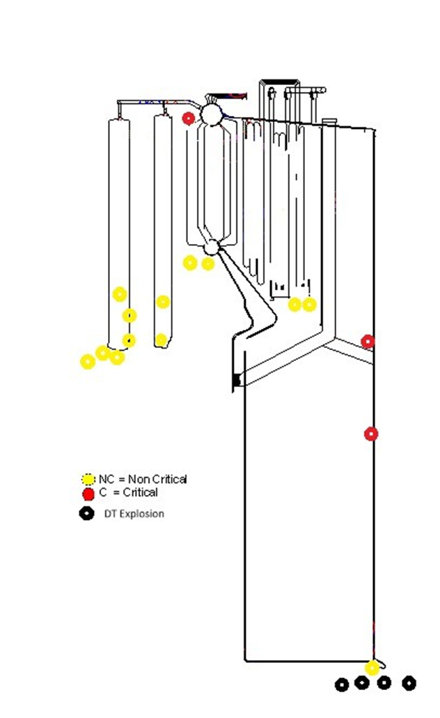

Slides 6 – 11 in Appendix II show the trend in number of leaks since 2004 for each section of the boiler (Economizer, Superheater, Boiler Bank, Screen, Upper furnace and lower furnace). We track these trends looking to see if we have made a difference in the number of leaks in each section based on improved OEM design, repair practices, procedures, etc. We have not seen significant downwards trends. These trends are not adjusted for changes in the number of boilers in operation by year.

Slide 12 is a total over the years from 2004 to present showing the total number of leaks per section and the average in each section. This is a 20.5 year total. It is good to see that leaks in the more critical areas of the boiler are lower in frequency on the chart. The order has seemed to remain the same, although as I said, we have not seen as many SH leaks recently.

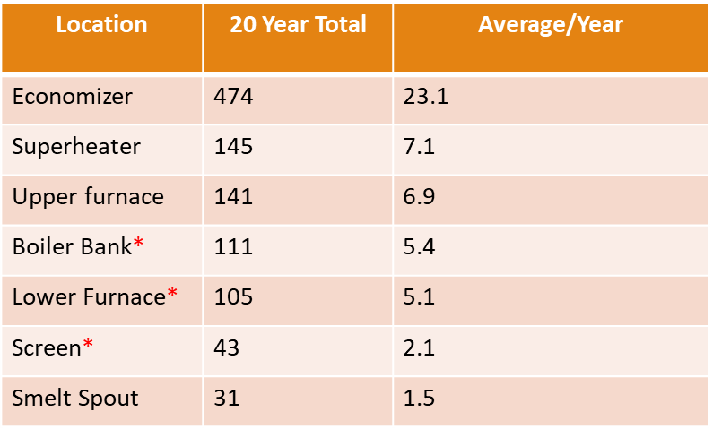

We had 8 leaks reported in a one drum boiler, 12 leaks in a two drum boiler and 0 leaks in a three drum boiler. There were 15 leaks in large economizer boilers, 5 in a cascade boiler, and 0 in cyclone boilers reported. The larger number in large economizer boilers is likely due to a larger number of these type boilers being in service but is clear that several Direct Contact Evaporator Units are still in operation.

The reported cause of leaks were 4 thinning failures, 1 fatigue failures, 3 SAC/SCC failures, 1 mechanical damage, 5 weld failures and 1 unknown. We continue to see a high number of SAC/SCC failures which is a mechanism to watch for with an aging fleet and large numbers of thermal cycles. We have also seen a larger portion with weld failures this session. This has not been a large trend recently but one worth watching.

There were 10 leaks found during operator walkdowns, 2 leaks found on hydro, 2 and 2 leaks discovered from the observing instrument readings in the control room. Operator walkdowns continue to be largest percentage of leak discoveries indicating that the operators are maintaining their diligence.

There were 8 leak detection systems installed on the units reporting issues (40%).
No leaks were initially indicated by the leak detection systems, and none were confirmed by the systems.

The time from first discovery of a leak, to the time the unit was ESP’d ranged from 45 seconds to 189 minutes. The median time was 56 minutes. As we all know, the time to act to ESP the unit on an actual leak is critical, and training and education may help improve these times.

This chart shows the trend in Critical incidents to date and it should be noted that 2024 only represents half the year.

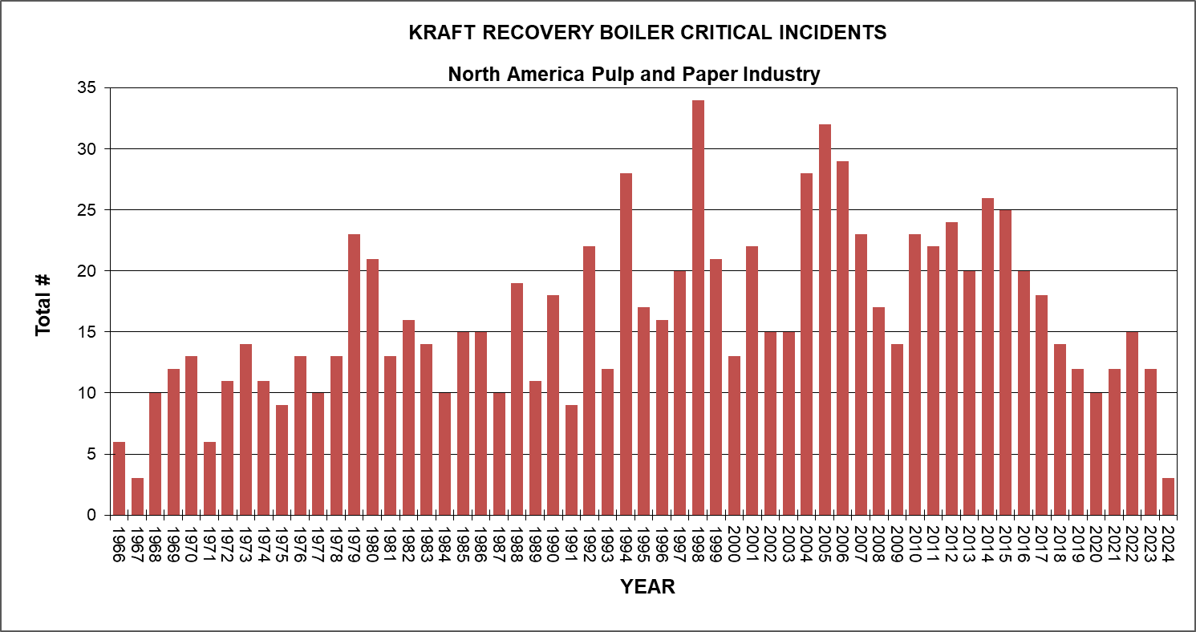

Boiler explosion history is shown in the next chart. Explosions due to pyrolysis gas explosions and aux fuel explosions have been almost eliminated by the implementation of the Guidelines for Safe Firing of Black Liquor and Aux Fuel.

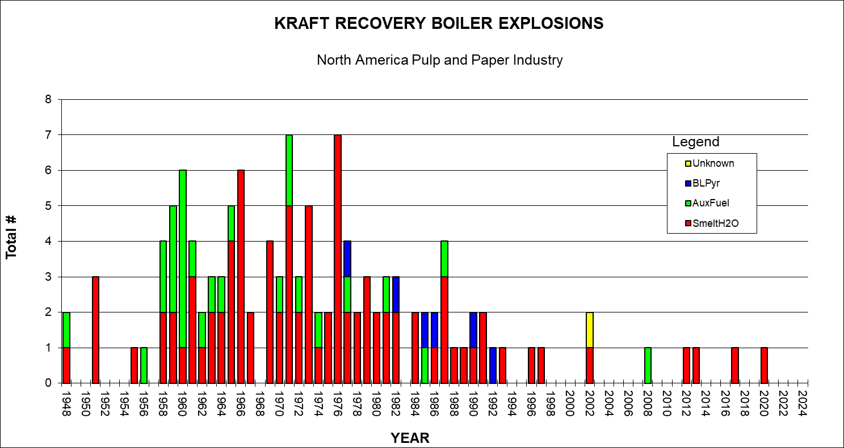

Dissolving tank explosions are shown in this chart with four explosions reported just this spring. We know that not all Dissolving tank incidents are being reported and we have heard rumors of recent explosions that have not been reported and know of past issues that have not been reported. We are now encouraging dissolving tank near misses/plugged spouts be reported so we can understand the issues leading to these incidents and be more preventative.

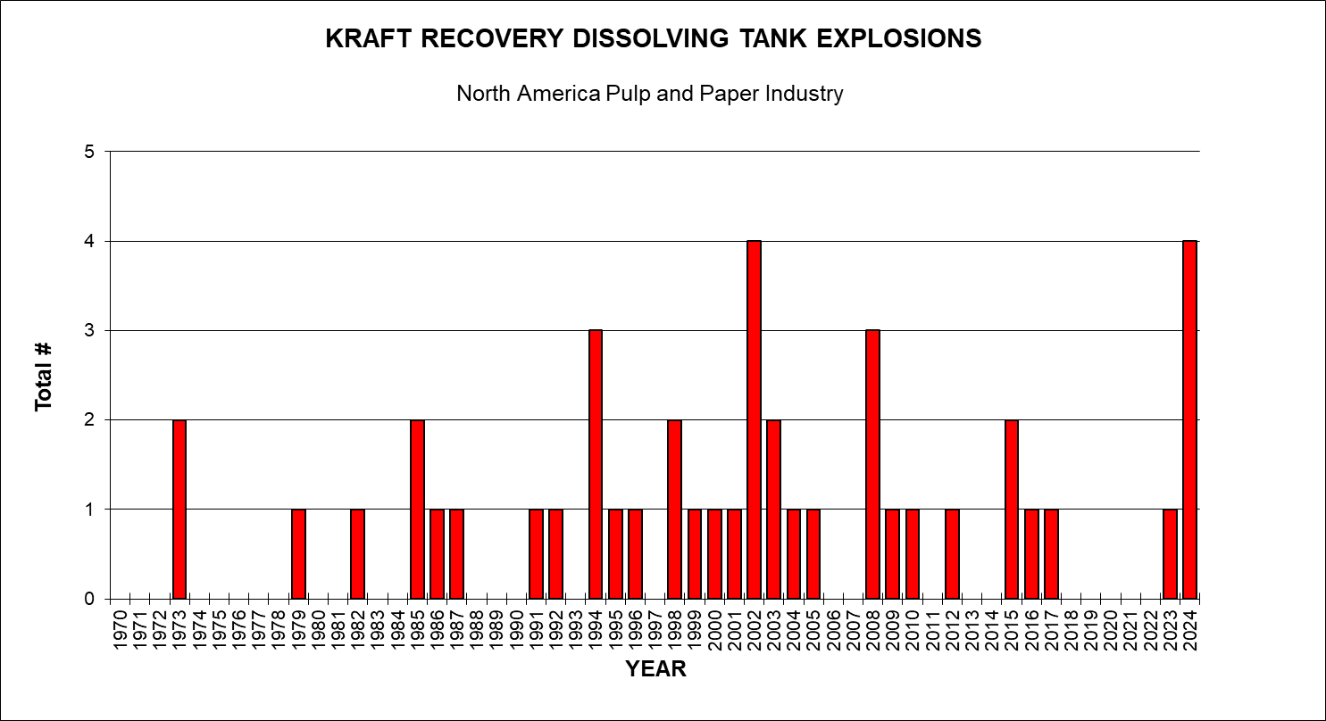

Explosion history 5 year running average indicates that we continue to see one to two explosions in a five-year period.

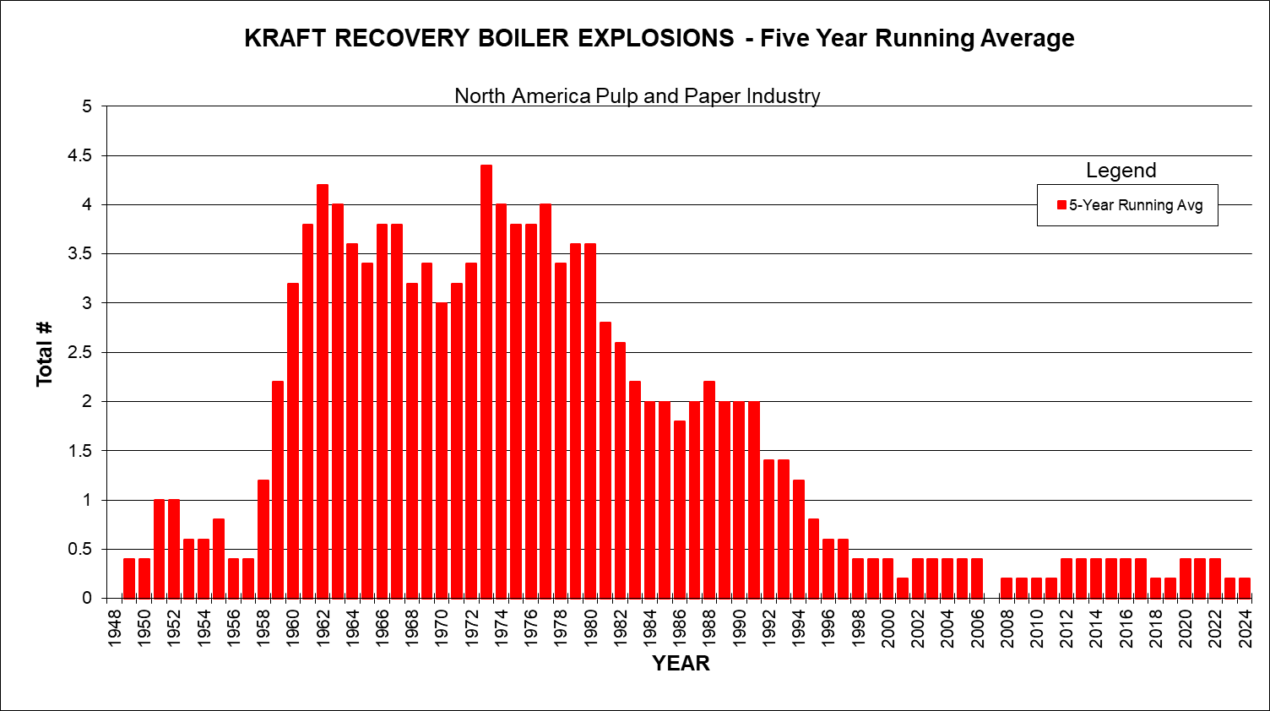

Explosions History per 100 operating years is a statistical representation of the chance of a particular having an explosion. We are currently showing 0.43 smelt water explosions in 100 years of operation for a unit and 0.82 explosion for all reasons, including Dissolving tanks. Again, this is just a statistical evaluation and does not mean that you are have to wait more than100 years to have an explosion.

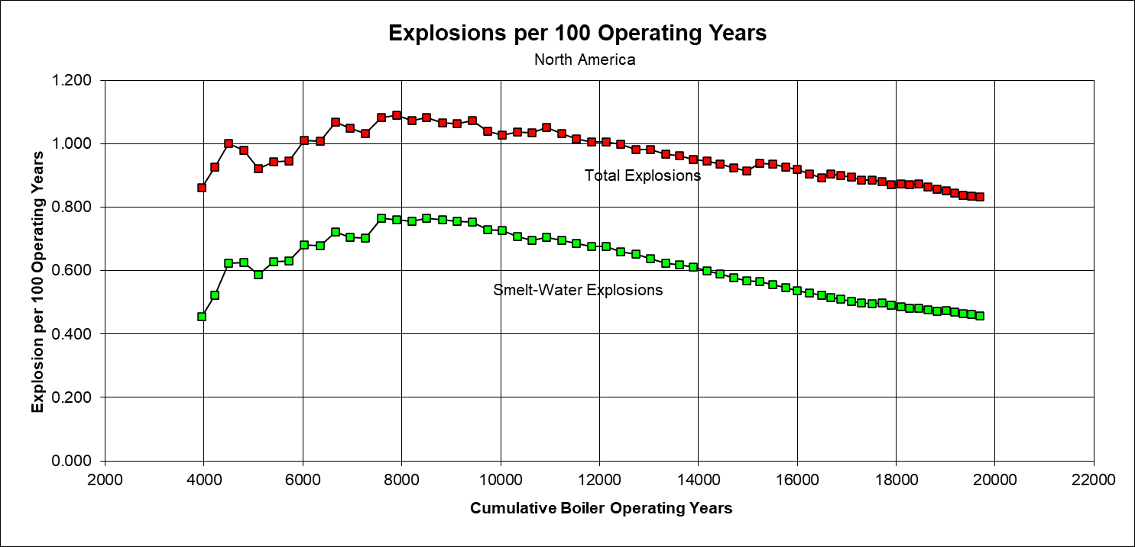

We have 131 units in the US and 38 in Canada for a total of 169. The average age in the US is 44.9 years and in Canada is 47.5 years. The maximum age in the US is 72 years and in Canada is 77 years. The oldest unit in operation is the Kruger Three rivers unit and is a 1947 unit. Dean Clay maintains this database and it is available as a spreadsheet that can be obtained on the BLRBAC website. Please send any updates to Dean

We collect some of the learnings that are obtained from the reported incidents in order to spread the word so future problems may be prevented. Here are some of the learnings from this meeting:

- Spout Deck should be solid surface preferably concrete.
- Dissolving tank agitator low amp alarms should be set to alarm if belts burn off or if agitator blades fall off.
- Management of Change procedures should be used when making changes to boiler arrangement.
- Limits on liquor firing rates based on number of spouts open should be emphasized to operators.
- Utilize a “Guard Goose” to observe the bed and smelt pool when there are smelting issues even if spouts appear to be open.
- Establish a maximum time limit for firing liquor if there is no smelt flow – even if spouts appear to be open. (See Guard Goose above) If liquor is being fired and nothing is coming out, it must be building up somewhere (hopefully not in the superheater)
- Consider redundant DT level indications – especially if DT level is controlled automatically.
- Obtain a copy of AFPA “Recommendations for Dissolving Tank Safety” for training and procedures review.
- If you need to cut off shatter jet steam to look inside the dissolving tank plug the spout first.
- Review high furnace pressure trip settings. They may be set to protect the furnace structure rather than personnel around the unit. Consider a staged trip with an instantaneous trip for furnace protection and a lower trip setting with slight time delay to limit blowout and to trigger the Large Leak Logic.
- For screen tube panels that go to front wall, consider a breaker bar on top tube to provide some protection from large slag falls from the upper furnace. Utilize OEM for proper design and installation.
- Make sure that qualified repair supervision is involved with making leak repairs. Follow the proper weld procedure for those repairs.
- Make sure that repair is not an SOFL (Site of Future Leak). Many pinhole leaks may be a result of internal cracking that probably will not be fully removed by welding the pinhole.

The review of incident reports for boiler leaks, dissolving tank incidents and other boiler issues are critical to the activities of the ESP Subcommittee and important to gather the learnings for the rest of the industry so please submit an incident report for any boiler issues that occur. The latest Questionnaire is available from the BLRBAC website and Dean makes regular updates of the form so be sure to get the latest off the website for submittal of a report.

Look for confirmation from Dean Clay that it was received.

The collection of Incident Learnings from Spring 2005 to 2022 compiled by Dean Clay is also available to download from the website. The document was shown along with a description of how it is organized and the benefits of the document. This as a good learning tool for management and operators for the prevention of future incidents.

7.3 FIRE PROTECTION IN DIRECT CONTACT EVAPORATORS- Stephen Cox

No report

7.4 INSTRUMENTATION – John Browning

BLRBAC ISC Spring 2024 meeting minutes: April 8, 2024
Morning session:
8:00 Opened meeting with members and guest introducing themselves.
- Review BLRBAC anti-trust statement.
- Pass around sign in sheets for members and visitors.
  - Had 11 members and 10 visitors. (Ran out of seating)
- Discuss committees desire for new members:
The following attendees asked to join the committee:
  - Daniel Guarnieri with Sylvamo will replace Mike Bruce who is moving to the ESP committee.
  - Adam Marickovich with GP will replace Chris Daily from Georgia Pacific.
  - Deshan Naidoo with SAPPI
  - Patrick Buyck with SAPPI
Committee voted unanimously to accept new members.
- Read and approved Fall 2023 ISC minutes. Minutes were approved by motion and seconded.
9:20 Break
- Daniel Albert from Rotorq and Keith Carter from Augusta Valve (Principle) presented the latest (Rev 9) document that covers the wiring, programming, and configuration for an IQ3s use in rapid drain application. (Rev 6 currently posted)
  - After the presentation, some comments and recommendations were made to enhance the document for the end user. When Daniel completes the comment additions, Adam Marickovich and David Boudreau will do a final review. When complete, it will be submitted for posting on BLRBAC site.
  - Need to propose possible new verbiage around bypassing torque switches for the new smart valve actuators since it is done electronically and not with a switch.
  - New member Deshan Naidoo asked if we have considered the use of Profibus with the IQ-3s for the secondary or another means of ESP valve operation. This could provide valuable information to a DCS concerning valve status and condition as well as be used for initiating a rapid drain.
- The posted ISC document dated 2014 is missing Sections J1, J2, J3, K, L, M, N, and O. They have been added back in from a 2014 dated copy but will require review of the Waste Stream document to determine if any additional update / changes to those sections need to be made.

Afternoon session:
8 members and 6 visitors
- Continue document review and discussion from this morning.
- Open discussion and questions from committee and guests.
  - We discussed functional testing execution and tracking.
  - Andy with FPS brought up the inconsistent temperatures of the reference leg used for a DP transmitter on drum level. We might need to look at elevated the 100-120F temperature as an assumed value.
  - Can BLRBAC schedule be moved out of the Spring and Fall outage windows?
  - Some companies are using electronic means of tracking BLRBAC requirements. Would it be possible to post a spreadsheet or other document listing only changes that have been approved?

- Meeting adjourned at 2PM for viewing of Eclipse.

7.5 MATERIAL & WELDING – Jesse Worsham

The Materials and Welding (M&W) Subcommittee met in Open Session on Monday morning, April 8,2024.

The meeting was opened with a review of the BLRBAC Anti-Trust Statement.

Attendance
Five (5) members out of twelve (12) attended. There were eighteen (18) guests.
.

Discussions

- Opened meeting with a Review of the BLRBAC Anti-trust Statement.
- Introduction of attendees
- Reviewed minutes from last meeting and accepted.
- General discussion of portable hardness testing.

7.6 PERSONNEL SAFETY – John Fredrickson

The Personnel Safety Sub-committee met in an "open” session at 8 am on Monday, April 8, 2024, and in a closed session at 1 pm as well. There were 7 (out of 11) committee members plus approximately 30 guests in attendance during the open meeting and 5 committee members and 1 guest in attendance at the closed meeting.

Open Meeting started 0800.

Representation at our meeting by regular members and guests included 4 original equipment manufacturers (Andritz, B&W, GE and Valmet), 3 Product/Service Providers (Gore, Clyde Industries, 3S) and AF&PA and insurance company representatives. Operating company representation included 25 people from 8 different operating companies, Sylvamo, Georgia-Pacific, ND Paper, PCA, Pixelle, SAPPI NA and SA, Irving Pulp, Domtar and WestRock.

The BLRBAC anti-trust statement was read. Individuals introduced themselves and a sign-in sheet was passed around for a record of attendance and contact information.

The minutes of the last meeting (October 2023) were distributed in hard copy.

Planned Agenda Topics
- Smelt spout robots technology and recent installation update.
  - B&W/Diamond Power – Smelt auto cleaner technology update presentation – Simon Youssef and Dennis Wickholm
  - Andritz – Smelt robot technology update presentation – Sam Miller
  - Valmet – Smelt robot technology presentation and recent installation at Pixelle – Dan Morrison
- Smelt spout PPE update.
  - Gore/Valmet/ – Smelt protection garment update, smelt head protection product and update on multi-haz garment (focused on steam protection testing). – Jim Ellis
- Notes/comments from presentations
  - B&W/Diamond Power has 2 new installations in service. Not at liberty to reveal the owner but shared some details about the application and performance so far.
  - Valmet shared an update on the Pixelle project and lessons learned so far. Pixelle continues to be pleased with the project.
  - Andritz shared an update on their recently installed robot. They provided insight to the safety risk reduction as well as the other benefits from the installation of the robots over and above improved protection for the operators.
  - Regular automated cleaning by robots will prevent periods of neglect when operators are busy in other areas of the boiler and might otherwise miss their standard cleaning rounds. This will stabilize the process and provide other benefits.
  - Gore presented convincing test data for protection from steam heat burns using their multi-haz garment. They also reviewed the heat protection option that they have developed. Feedback was that they should consider making sure it will adapt to the hard hat spec used for construction, mountain climbing, etc. (chin strap) as that is showing momentum towards being implemented in manufacturing as well. They said that Paulson had a version of the hard hat/visor with a chin strap as well. There continues to be a lot of interest in the new head/face shield product.

Safety Incidents Review

Purpose is to increase awareness of how people have been injured around the recovery area so we can prevent it from happening to others. If this is successful it may become a standing agenda item each meeting and used to focus future committee efforts. Sharing incidents could be used in annual refresher training.

- Committee member Steve Morrison reviewed the GP Cedars Springs Incident. There was discussion that followed. This has been submitted to BLRBAC using the incident report and should be available on the website.
- Committee member Jake Dowland shared a recent incident regarding safety around the green liquor sampling station. Committee members and guests shared their arrangements and experience with this concern.

- The meeting ended at Noon.

- Next BLRBAC: October 7-9, 2024 Potential topics for the Spring subcommittee meeting:

  - We will have the regular morning open session and a closed afternoon session in April.

There were no requests for clarification or interpretation in the last six months.

In closing, we are always welcome to new committee members who can participate in any capacity even if you can only attend meeting intermittently.

7.7 PUBLICITY & NEWS – Matt Paine

BLRBAC continues to inform the membership as well as perspective members and meeting attendees of upcoming meeting details by: (1) posting meeting notices on industry website event calendars such as PaperAge and TAPPI; (2) continuing with the BLRBAC-TAPPI cross promotion program advertising events on each other’s webpages; and (3) reaching out to previous attendees via email.

7.8 SAFE FIRING OF BLACK LIQUOR – Vernon Blackard

8:30 am—Noon Safe Firing of Black Liquor Subcommittee – (CLOSED)
1 pm to 4 pm Safe Firing of Black Liquor Subcommittee - (OPEN)

Proposed Agenda:
- Open the meetings. Both Closed and Open.

- Reviewed BLRBAC Anti Trust statement. Both closed and open meeting.

- Introduce members and guests. 13 members in closed and 56 members/ guests in open.

- Review and approve the Fall 2023 minutes. Approved.

- Review any open items brought up to the subcommittee before the Spring 2024 Meeting.

- Start new revisions after our Fall 2023 document was approved and posted.

- Items brought up since Fall 2023 meeting.
- High solids firing considerations for BLRBAC SFBL documents (Valmet concern). Sarah, Daniel, Wes Vernon and Peter will work on possible language for SFBL.

- Continue discussions from Fall 2023 meeting (Refer to minutes).

- DT incidents to be reviewed. IP Sav, IP Mansfield, Domtar Ashdown, GP Cedar Springs

Domtar – All spouts plugged fire with high load.
GP CS – Agitators out with buildup. More than one density.
IP Mans- Too fast start with gummy spouts. Smelt rush damage #4 spout hood.
IP Sav – lost level, stm shattering off then fill tank..#4 spout splashed. More than 1 DT level.

- Open item discussion from members.
- Any new items will be discussed.
- Functional test of RB Dissolving tank overflow capacity to be discussed. Normal set up and maximum reasonable flow set up. Set up for shatter jet working properly at DT overflow level.
- Other functional tests on DT. Check water sources off on crystallization event.
- Vernon, Daniel, Brian and Wes to work on.
- AFPA DT Explosion venting work with Jeff Wagoner check by Vern.
- Open discussion from guests
- Guest questions?
- Explosion videos…Will share any submitted. Have IP Power point of RB history of explosions (share visual only. No copies or files shared).
- Close meetings as needed (closed and open).

7.9 WASTE STREAMS - Kevin Sapp for Paul Seefeld

The Waste Streams Subcommittee opened our meeting at 9:00 with six members present and three members joining on MS Teams. Two members have retired from the subcommittee since the last session. There were five guests attending the session.
The anti-trust statement was read, and we reviewed the proposed agenda. The meeting minutes from the October 2024 meeting were reviewed and accepted.

New Business:
- Chip Bin Section 8.2.1 recommends a 90degF high temperature interlock after the chip bin source cooler in HVLC systems that process softwoods. The question has been posed if this is an appropriate guideline, as it is possibly too conversative and contrary to other guidelines outside of BLRBAC. Specifically, the target would require the use of a water chiller and this outlet temperature target is cooler than recommended on turpentine collection systems.
  - Jarmo Kaila - Reviewed calculations with Vapor Pressure of Alpha-Pinenes at 0.8%v/v is 88.6degF saturation and include 4% H2O. This assumes no dilution of additional streams blending.
    - If we go to 110degF we would need 1:1 volumetric dilution (approximate).
    - If we go to 120degF we would need 2:1 volumetric dilution (approximate).
  - P. Seefeld and other committee members recommended revising 8.2.1 to add language to clarify that an LEL monitor could be used as a surrogate and that dilution should be considered to allow for higher temperatures. Verbiage was added to a draft section for the executive committee to review.
- DNCG Reheating language has some concerns / confusion from some Operators. Is the 150degF a hard number or is the focus more on relative humidity. Others had previously heard 170degF.
  - There were no recommended changes.

Old Business:
- 15% MCR for DNCG treatment in the furnace from 30%. The subcommittee is submitting both chapter 4 and chapter 8 drafts for the Executive Committee commentary.
  - Members of the subcommittee had no additional input that needs to be added.
- Figure 1 and Figure 6 are still pending updates.
  - J. Kaila will be taking the lead and asking other subcommittee members for comments.
  - Format for new figures will be in MS Visio.

Questions/Comments:
- While the document refers to Softwood and Hardwood. The document does not make considerations for blended pulping systems, where SWD and HWD are both utilized, either continuously blended or in campaigns.
  - Paul Seefeld would recommend that if any SWD is run with HWD, the more conservative safeguard should be applied (SWD).
  - Kevin Sapp agreed with this POV. Added that HWD is rich in MeOH, which can also contribute to changes in stream composition, but the SWD safeguards are more conservative, it covers both adequately.
  - No other committee members present had further comments.
- An operating company had a significant near miss with a chip bin-integrated dilute system. Details were not available to share at this time but may be discussed further in the next subcommittee meeting.

The general meeting adjourned at 10:37am.

7.10 WATER TREATMENT – Tom Przybylski

Spring 2024 Meeting Attendees:
Tom Przybylski/PSA  Dylan Price /Bodman  Frank Destefano/3D  Michael Bayse/Bodman  Tom Meehan/FM  David Tjaarda/WestRock  Plus 16 guests | Fred Call/Buckman  Don Downey/Purolite  Jim Gannon/Nalco  Rick Baxter/RMR  Trevor Murray/Iriving Pulp

- The water treatment subcommittee met in open session for morning and afternoon sessions with 11 of 15 subcommittee members in attendance. There were 16 guests.

- Membership information was updated: Dylan Price (RMR) has joined the committee, representing RMR.

- The session started with a review of the BLRBAC antitrust statement.

- Meeting minutes from last fall were approved.

- Membership had submitted suggestions for the chemical cleaning document prior to this meeting. We had a lengthy discussion surrounding the time based/deposit based determination to chemically clean. We ultimately decided that there were too many variables by owner/operators to make our recommendation more forceful. We implemented a couple other minor wording change suggestions. This included adding more detail to tube sample labeling. Finally, we discussed whether to make any edits to the recommendation on chemically cleaning the economizer; we elected to leave this section as is. We will submit the edits to the executive committee in the fall.

- Production resumed on the water testing and sampling document. Don Downey from Purolite volunteered to supply a generic one-line diagram for this section.

- We worked on clarifying the iron testing portion of the document.

- We edited our section on turbidity meters and particle counters to state that they identify contaminants, of which iron can be one.

- Our definition of jar testing was lacking, so we updated it for clarity.

- We discussed calibration intervals for critical instruments and reviewed manufacturer recommendations for calibration to ensure that our recommendations aligned with what we expect to see from the instrument manufacturers.

- An audience member suggested that we recommend a checklist for reagent inventory and expiration dates for water tests. A recommendation for validating reference solutions and reagents on pH meters.

- We added some ESOPs for instrumentation and a couple maintenance items as well.

- This Sampling and Testing document is largely complete. We intend to make one additional run through this section and vote if it is ready to submit to the executive committee in the fall.

- We closed out the session by discussing out two remaining sessions: make-up water and clarification/filtration. Don Downey has committed to sending an outline with bullet items for make-up water.

- The meeting was adjourned at 2:40PM

8.0 AMERICAN FOREST & PAPER ASOCIATION RECOVERY BOILER REPORT – Wayne Grilliot (See Appendix III – Slide Presentation)

The American Forest & Paper Association (AF&PA) Recovery Boiler Program was established in 1974 to help identify the root cause of recovery boiler critical incidents and explosions. The AF&PA Recovery Boiler Program assists companies in improving the safety, integrity, and reliability of recovery boiler operations. Recovery Boiler Program membership is open to all companies that operate recovery boilers. Program activities are funded by member company dues.

The Recovery Boiler Program is under the direction of a Steering Committee which includes Karl Morency (Georgia-Pacific), Frank Navojosky (International Paper), Jeff Wagoner (International Paper), and Wes Hill (Georgia-Pacific). The Steering Committee sets Program priorities based on Member Company Input, BLRBAC Incidents, and Industry Needs

The Recovery Boiler Program provides a forum for companies to develop information to help evaluate Safe Operating Procedures, Organization and Training, Maintenance Programs, Specifications and Construction, and Research & Development Programs. Documents developed by the Program include Reference Manuals, Audit Guidelines, Best Practices, Training Aids, Checklists, Textbooks, and Studies. The Program sponsors R&D projects for Safety Improvements and Process Improvements. This helps drive improvements in Safety, Operations, Maintenance, and Recovery Boiler Integrity.

The AF&PA Recovery Boiler Program has two (2) Standing Subcommittees. The Operation & Maintenance (O&M) Subcommittee is Co-Chaired by Frank Navojosky (International Paper) and Wes Hill (Georgia-Pacific). The Research & Development (R&D) Subcommittee is Co-Chaired by Karl Morency (Georgia-Pacific) and Jeff Wagoner (International Paper). Subcommittee Membership is made up of Representatives from the Member Companies.

In 2018, the AF&PA Recovery Boiler Program was opened to all Canadian Mills that operate Recovery Boilers. We currently have 22 member companies in the AF&PA Recovery Boiler Program. Our membership currently represents 94% of USA and 30% of Canadian Chemical and Semi-chemical pulp production.

Both the Operation & Maintenance Subcommittee and the Research & Development Subcommittee are working to develop best practices around dissolving tank related issues. The Research & Development Subcommittee is sponsoring some very exciting research projects at the University of Toronto. The 4 projects focus on Dissolving Tank key operating conditions and advanced monitoring techniques to further improve safety and reduce operational risks. The program is building on past studies sponsored by the AF&PA Recovery Boiler Program and related research underway at the University, which is currently funded by a consortium of 26 companies. We are very pleased to have Dr. Markus Bussmann of the University of Toronto leading these studies.

Available documents on the AF&PA Recovery Boiler Website include Publications, Studies, Training Aids, Standards, and General Program Information.

AF&PA Recovery Boiler Program Website:
http://www.afandpa.org/our-industry/recovery-boiler-program

9.0 TAPPI ENERGY, RECOVERY, RECAUST (ERR) Committee REPORT - ERR Committee Chair Wei Ren

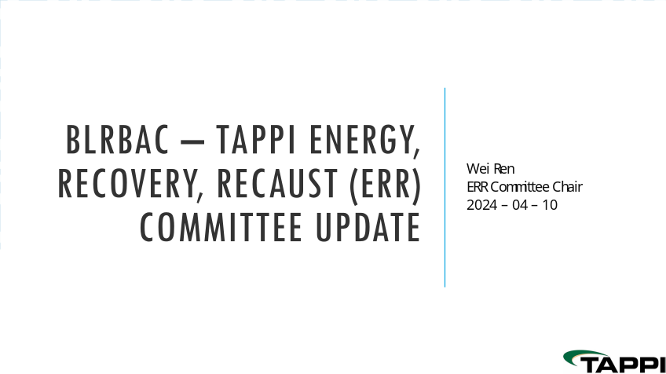
*Click on presentation to open

10.0 WESTERN CANADA BLRBAC REPORT

No report

11.0 ACTIVITIES OUTSIDE NORTH AMERICA REPORTS

No Report

12.0 OPERATING PROBLEMS SESSION REPORT – Gregory Burns for Frank Novojosky

The session began at 1:00 PM on 4/9/24 and was facilitated by Gregory Burns of Domtar Paper Company. There were 26 questions submitted and all questions were covered. There were 6 questions dealing with green liquor and dissolving tanks and their instrumentation. There were four questions on the subject of NCGs/SOG/methanol. Two questions on liquor guns/gun gates. Other questions covered on generating bank pluggage, tramp air corrosion, hydrostatic testing, sootblower wall boxes, smelt spout PPE, OEM support of 18-24 month outages, sulfidity control after a mill outage, rapid drain valves, steam driven FW pumps, vibrators on hoppers, and compressed air for smelt shattering.

During the session I shared the Domtar guidelines for dissolve tank TTA control. This was to illustrate the possible actions to take when TTA levels are increasing. This table was developed to provide guidance to Domtar mills in developing procedures to comply with Section 10.3 paragraph 6 of the BLRBAC Safe Firing of Black Liquor Recovery Boilers guidelines.

CLOSING COMMENTS:
CHAIRMAN: David von Oepen:

That concludes our Main Committee Meeting this morning. Thank you all for your attendance and your time away from home and work. Our next meeting will be October 7th, 8th, 9th 2024 and it will be at the Hilton Hotel. The Executive Committee strongly encourages you to register and stay at the Hilton. Be on the lookout for that registration email in July. Please spread the word to increase participation in these meetings. We really need more participation from the mills.
With that I'll now entertain a motion to close the Main Committee meeting. Second? The Main Committee Meeting is now closed. We will have our Technical Presentations starting in about 15 minutes.
Thank you all and have a Safe trip back!

APPENDIX I
INCIDENT LIST

dISSOLVING TANK

Dissolving Tank
SPRING 2024-01
Classification: | Dissolving Tank Explosion, #40
Co, Mill, Location: | International Paper, Mansfield Mill, Mansfield, Louisiana
Unit Data: | RB#1,1982, Babcock and Wilcox, PR-199, Drums - 2, DCE - NO, Floor - Sloped to rear
Unit Size: | 3.2 MMlb DS/day, 488 lb/hr steam, 1275 PSIG, 900ºF, 1475 PSIG Design
Incident Date/Time: | February 22, 2024, Earliest Indication: 2/22/2024 at 1:47 pm
Downtime hrs, leak/total: | 60 hours liquor to liquor downtime
ESP? | NO
Leak/Incident Loc: | Dissolving Tank, #4 spout
How discovered: | Walkdown, Operator making a round noticed a loud blowing sound (air or steam) around the spout deck. During investigation, the operator noticed the dissolving tank violence. Operator contacted the control room operator and Area Process Manager. Team inspected spout deck and found the blowing sound was the #4 spout shatter jet steam supply. We began cutting liquor firing immediately after finding shatter jet was no longer in adequate operation. The damage to the spout mini hood took place while cutting liquor firing and stabilizing the boiler.
Wash adjacent tube: | NO
Root cause: | Other, Suspected smelt rush
Leak detection: | YES
Bed cooling enhanc | NO
Last full inspection: | February 18, 2024
Sequence of events: | The mill was starting up from an annual outage on #1 Recovery Boiler. On February 22nd at 5:08 AM, liquor was introduced to the boiler for the first time since February 12th at 7 AM. We increased liquor firing over the next 80 minutes until we reached 200 gpm. We reduced liquor firing back to 140 gpm because of low black liquor temperature due to condensate evacuation issues on the IDLH. We increased liquor firing back to 220 gpm at 7:30 AM once the BL temperature returned to normal operation. At 7:45 AM we pulled the remaining auxiliary fuel out of the boiler due to low steam load in the mill. Liquor firing was up to 250 gpm at 11:57 AM, Increased secondary air flow from 230 to 250 from 12:04 to 1:26. Throughout the startup period smelt flow from 2 of the spouts (#2 and #3) was intermittent and the operators rodding the spouts reported to the control room that the smelt was thick and viscous – ropey or jelly-rolling. #2 spout had eventually plugged and #3 spout was sluggish. Operators were routinely keeping the spouts rodded out and flowing till #2 spout plugged. The first indication that we had a problem was 1:47 PM when the boiler could be heard paying off smelt heavily. There was an operator on the spout deck at the time rodding out the #3 spout and that person evacuated the deck and reported to the control room that the #4 spout was paying off. The control room operator began to reduce liquor firing and called for gas burners to be put in service. The outside operator who was putting gas burners in noticed a blowing sound (air or steam) around the spout deck and inspected the spout deck and found the blowing sound was one of the #4 spout shatter jet steam dual supply hoses was sheared off. The operator also reported observing dissolving tank violence evidence with green liquor on the spout deck. The operator contacted the control room operator and Area Process Manager to get involved. We continued introducing auxiliary fuel into the boiler from 1:51 to 2:00 PM. Plugging of the spout was considered not an option due to the spout still paying off heavily and the condition of the remaining spouts not flowing well. The actual damage to the spout mini hood took place while cutting liquor firing and adding auxiliary fuel. The adding of the auxiliary fuel led to a secondary smelt rush to a now reduced capacity shatter jet. Liquor was completely out of the boiler at 2:06 PM and auxiliary fuel was out of the boiler at 2:24 PM. The boiler was then allowed to cool to make assessment of damage and make repairs.
Repair procedure: | Shut down boiler same afternoon of the incident to allow cooling during the night. Maintenance contractor began work the following morning.
Future prevention: | Operator training on bed management, enhanced start up procedures for annual outage, install spout deck cameras

Dissolving Tank
SPRING 2024-02
Classification: | Dissolving Tank Explosion, #41
Co, Mill, Location: | Georgia Pacific, LLC, Cedar Springs, Cedar Springs, GA
Unit Data: | RB#3,1974, B&W, PR-160, Drums - 2, DCE - NO, Floor - Sloped to rear, 4 spouts
Unit Size: | 3.0 MMlb DS/day, 470,000 lb/hr steam, 850 PSIG, 850ºF, 1025 PSIG Design
Incident Date/Time: | August 14, 2023, Earliest Indication: 8/13/2023 at 7:45 PM
Downtime hrs, leak/total: | 33 days
ESP? | NO
Leak/Incident Loc: | Dissolving Tank, No Tube Leak
How discovered: | Other, smelt water reaction/explosion
Wash adjacent tube:
Root cause: | Diss Tank Explosion, Limited open/smelting spouts compared to the firing rate + low agitator RPMs + insufficient smelt shattering allowed for poor dissolving of the smelt. This resulted in the failure of two (2) of the three (3) agitators. With the two agitators offline, the dissolving ceased and allowed for a period of rapid crystallization/mounding/accumulation of live smelt. The live smelt resulted in a smelt water reaction/explosion either by itself or through the trigger of a doghouse buildup coming loose and falling into the tank.
Leak detection: | YES
Bed cooling enhanc | NO
Last full inspection: | May-22
Sequence of events: | PRIOR:  - Dissolving tank top to deck had been replaced at some point in the past, likely 1985, minimizing the space between dissolving tank top and surface (grating).  - Sheaves on mechanical agitators had been reduced at some point in the past (less RPMs and less mixing power)  12:00pm-3:00pm: Process running with some variability of the smelt properties.  Spout #4 (South) is the only reliably open and smelting spout. Operators are having difficulty with two other spouts that are open, but not flowing reliably.  3:50pm: Density Control Hi-Hi alarm (25)  Density shifts down and oscillates within range.  5:50pm: Increase liquor firing to 275+gal/min  Some smelt from spout #4 not shattering/dissolving – increased pressure waves and/or mounding near agitator #1 (South)  ~7:42-7:49pm: #1 agitator alarms and loses its belt  Density measuring 23, molten smelt from spout #4 continuing to mound/crystallize between agitators #1 and #2  ~10:48-11:43pm: #2 agitator alarms and loses its belt  Density measuring 21, molten smelt from spout #4 continuing to mound/crystallize south end of tank  11:00pm: Weak-wash flow dropping off periodically and by 11:15pm the weak-wash flow deviates from correlation to green liquor out, tank level, and tank density (rapid crystallization/accumulation begins)  ~11:30pm: Build up noted in dog-house(s) (#4 at a minimum)  Console operator and field operator discuss how a sizable build up is present in dog-house #4 and will need to be dealt with carefully  11:40pm-12:00am: Shift change discussions for console operators  New console operator coming on shift notices only spout #4 open and asks field operators to assess/address, mentions to crew lead, field operator heads to the smelt deck to address issues {specific location where operator standing is unknown but was near the explosion hatch(s)  ~12:23am: Smelt water reaction/explosion occurs, debris/liquor/steam ejected with smelt deck clouded, field operator is injured  12:24am: Field Operator calls for a liquor divert; E&I tech reaches him first and takes him to safety shower near recovery boiler #2  E&I tech ensures paramedics contacted immediately, site response executes, paramedics respond.
Repair procedure: | Replaced spout deck grating with steel, increased agitator speed, improved agitator amp readings and set permissives/alarms/interlocks based on operating envelope, added zero speed switches to agitators, replaced shatter jets, installed DT temperature transmitter, redirected explosion relief out of employee space, repaired #1 spout doghouse, updated PPE requirements
Future prevention: | Above completed before start-up

Dissolving Tank
SPRING 2024-03
Classification: | Dissolving Tank Explosion, #42
Co, Mill, Location: | Domtar, Ashdown Mill, Ashdown, Arkansas
Unit Data: | RB#2,1979, CE, 27477, Drums - 2, DCE - NO, Floor - Decanting
Unit Size: | 3.9 MMlb DS/day, 600,000 lb/hr steam, 850 PSIG, 850ºF, 1075 PSIG Design
Incident Date/Time: | October 6, 2023, Earliest Indication:
Downtime hrs, leak/total: | 48 hrs, 0 leaks
ESP? | NO
Leak/Incident Loc: | Dissolving Tank, No Leak
How discovered:
Wash adjacent tube:
Root cause:
Leak detection:
Bed cooling enhanc
Last full inspection:
Sequence of events: | BACKGROUND:  9/27/23 - 10/4/23 - No.2 Recovery Boiler Outage Start-up followed by a power failure.  On the night of 10/4/23, the No.2 RB had been operating for approximately 7 days following a major inspection outage and % sulfidity of the liquor was low (21-22% range on TTA Basis). During this low sulfidity period, the mill was experiencing intermittent gelling of smelt and high smelt run-offs from both the No.2 RB and the No.3 RB. During this week, emulsified sulfur was being injected into the heavy liquor being sent to a recovery boiler. The sulfur was initially being injected into the No.2 RB liquor but had been transitioned to the liquor going to the No.3 RB during the week, due to the intermittent gelling issues being more prevalent with the No.3 RB.  On the day shift of 10/4/23, there was a perception that the intermittent issues smelt run issues were improving. At 9:50 PM on the night of 10/4/23, the mill experienced a complete power failure due to a lightning strike. At the time of the power failure, the No.2 RB was burning 3.5 mmlbs/day of liquor with no auxiliary fuels and steaming in the range of 530 klbs/hr. Recordings of 2RB bed cameras and 2RB spout flows cameras just prior to the power failure do not indicate high bed condition, nor intermittent smelt run-offs at the time.  Within 4 hrs of the power failure a gas fire was re-established in the No.2 RB. Mill steam demand was then supported with auxiliary fuel only (all load burners and all starting burners) in No.2 RB for approximately 34 hours prior to resuming liquor burning in the No.2 Recovery Boiler.  10/6/23 RESUMPTION OF LIQUOR FIRING AND ISSUES WITH NO SMELT REMOVAL FROM BOILER:  Just after 12:00 noon on 10/6/23, liquor firing was resumed in the No.2 RB. The operator and crew were aware that only 2 of the 4 spouts were open. The crew met in the control room to discuss burning liquor and agreed to proceed since two spouts were open and prior experience was that once smelt flow was established, the other two spouts would come unplugged. Prior to firing liquor, both dissolving tanks were pumped down to normal operating level. From the recorded video, the hot smelt bed can be seen up through the N/E and S/E spouts, but not up through the N/W and S/W spouts. Looking at the recorded video, it is likely that there was ridge of glowing gelled smelt in the way of a clear path to the liquid smelt bed.  The first liquor gun (North) was fired at 12:13 PM and 2 of the 4 load burners were removed. The second liquor gun (South) was fired at 12:18 PM and the other 2 of 4 load burners were removed. Due to high 850 header pressure, 4 of 6 starting were removed by 12:25 PM.  Between 12:20 PM and 12:21 PM, smelt started to run into both the N/E spout and the S/E spout.  Within 3 minutes (approx. 12:24 PM) smelt stopped flowing into the N/E spout and the glow of the bed could not be seen in the camera. The No.2 RB Helper can be seen in the video making an unsuccessful attempt to rod the N/E spout at 12:38.  Between 12:21 and 12:40, smelt flow for the other spout (S/E) cycled up and down. At 12:40, the 2RB helper can be seen in the camera attempting to establish a more steady flow with the spout rod. However, the attempts to rod it out had the opposite effect and smelt flow fell off to nearly nothing.  Crews continued to work to get a spout flowing focusing on the S/E and N/E spouts.  Between 1:01 PM and 1:06 PM, the 4 starting burners that had been removed were put back in, in an attempt to get the smelt bed hotter.  At 1:23 PM, liquor firing was removed from the boiler, as smelt flow had yet to be re-established on any of the spout.  At 2:00 PM, the dissolving tank pumps were shut down to prevent contaminating the mill green liquor system with weak wash/water.  At 2:03 PM, all 4 load burners were put back in to support the mill steam demand.  HIGH RUN-OFF EVENT:  For about 2 hours, with all burners in 2RB, operating crews and leadership worked to get the N/E spout open, using a torch and a spout rod and sledge hammer. At 4:45 PM, personnel took a break from working to clear the N/E spout.  At 4:50 PM, the N/W spout began to flow heavy for an extended period of time. Cyclical start and stops of heavy smelt flow created intense smelt/water reactions in the top of the dissolving tank, creating significant fuming in the area and impeding the camera view. At this time, the operator started the dissolving tank pumps and opened the weak wash and emergency water valves 100%. The dissolving tank level was already high from the dog-house showers and scrubber stack wash water that typically remain in service but increased due to the influx of dilution. At the beginning of the heavy runoff, employee opened secondary shatter spray nozzle and notices that the level in the dissolving tank was right at the nozzle which indicated that the overflow and pump out was not sufficient to handle the volume of dilution entering the tank. At this point, the ESP lights were activated, and the boiler was cleared.  Around 5:15 PM, a fairly steady smelt flow continued and operators began assessing noticeable damage to equipment in the proximity of the N/W spout.
Repair procedure: | On the following morning, all fire was removed from 2RB, crews plugged the spouts on the North side of the boiler and performed lockout for maintenance to make repairs to damage that occurred in the vicinity of the N/W spout. Repairs were made to shower water supply piping, hand rails, to the top of the dissolving tank, and to insulation lagging for the vestibule. Due to the damage to the N/W spout hood, enough repairs were made to be able to affix the designed “long-term” spout plug into the spout opening.
Future prevention: | At the time of the incident, the mill had not reviewed the AF&PA recommendations that were published approximately 25 days prior to this incident. However, this guideline was a key resource in the investigation that followed, as well as in the development of action plans to prevent recurrence. Note, AFPA document is available at: https://www.afandpa.org/sites/default/files/2023-09/RecoveryBoilerRecommendationsforDissolvingTankSafety12s23.pdf

Dissolving Tank
SPRING 2024-04
Classification: | Dissolving Tank Explosion, #43
Co, Mill, Location: | International Paper Savannah, GA Mill
Unit Data: | RB#15, Tampella, 17441, Drums - 1, DCE - NO, Floor - Decanting
Unit Size: | 7.4 MMlb DS/day, 1,066,000 lb/hr steam, 1500 PSIG, 910ºF, 1500 PSIG Design
Incident Date/Time: | November 2, 2023, Earliest Indication: 11/2/2023 at 4:30 PM
Downtime hrs, leak/total: | 0
ESP? | NO
Leak/Incident Loc: | Dissolving Tank,
How discovered: | Other, Smelt Dissolving Tank (SDT) level instrument stayed at the top of the range following a routine maintenance PM to purge the taps
Wash adjacent tube: | N/A
Root cause: | Diss Tank Explosion, Failed level instrument
Leak detection: | YES
Bed cooling enhanc | N/A
Last full inspection: | Feb-23
Sequence of events: | The boiler firing rate and firing conditions throughout the incident were stable and maintained at 75% MCR and spouts were stable (no smelt rushes). The dissolving tank level instrument that was in control was a traditional dP transmitter that had been in service for many years. A routine PM to purge the taps on the level instrument twice per week had been put in place at some point in history and had been completed routinely.  The green liquor density is measured and controlled using a dual external standpipe configuration and has been in control since August 2023. It was installed as part of a recent upgrade of the density measuring system. The apparatus also provides a level indication that was recently added to the DCS (early August). At the time of the incident, the level indicating portion of the instrument had not been commissioned and no training was given to operators to use this level and no alarms were configured on it. This level instrument was used to troubleshoot the event only after the fact.  2:50PM –  The event started when the smelt dissolving tank (SDT) level instrument stayed at the top of the range following a routine maintenance PM to purge the taps. Level control was in manual and operations worked with maintenance to troubleshoot actual level. As part of the High/low dissolving tank level procedure, the control room operator asked the outside operator to visually verify the level. The outside operator reported that he closed the shatter jet steam to one of the spouts (#4 spout) in an attempt to visually verify the level and reported it was difficult to confirm, but estimated 75% level to the control room. The control room operator continued to attempt to manually control the level while maintenance was troubleshooting the level indication and attempting to purge to remove suspected pluggage. Manual Baume checks were reported to confirm the density instrument reading was in good range.  4:07PM (From Control Room operator perspective and interviews)  With the level still showing at top of the range, operators reported erratic pumpout flow (confirmed by flowmeter and pump amps). Control room operator asked the outside operator to again verify level and proceeded to get additional help from management.  4:10PM-4:32PM (From outside operators)  2 outside operators were dispatched for a second time to visually verify the level in the tank at the request of control room operators that were concerned about erratic pumpout flow. Another 2 outside operators came to assist. The lead outside operator stated that he once again closed the steam off to the #4 spout shatter jet in an attempt to visually verify the level and had completed the inspection, which was inconclusive. The operator then turned to exit the area when a loud reaction happened in the tank that knocked him down and exposed him and two other workers to green liquor. Operator statements and visual observation of the spout deck area indicate that the green liquor release was predominantly from the #4 spout area  At 4:23PM, the control room operator significantly increased weak-wash flow and further reduced the pumpout flow in an attempt to flood the dissolving tank.  It is estimated the smelt water reaction/green liquor release occurred between 4:28-4:32PM. By all accounts, there was one significant smelt water reaction that released green liquor through the spout hoods from the Dissolving Tank.  4:35PM – 4:45PM (Post incident evaluation)  Immediately after the incident, the control room operator was advised to shut the green liquor pumpout pump down to expedite flooding the tank. Operator also added emergency water for less than a minute but then closed it off. The tank was confirmed to be flooding out the overflow at approximately 4:45 PM.  Density meter and manual Baume readings were stable and at target after pump out flow was reestablished. Agitator amps returned to normal range.
Repair procedure: | Repaired Instrumentation, procedure revision
Future prevention: | Dual level indication, Training, Policies and Procedures

ECONOMIZER

Economizer
SPRING 2024-05
Classification: | Noncritical
Co, Mill, Location: | Georgia Pacific, Monticello, Monticello, MS
Unit Data: | RB#2,1967, CE, 20765, Drums - 2, DCE - Cascade, Floor - Decanting
Unit Size: | 3.5 MMlb DS/day, 450,000 lb/hr steam, 850 PSIG, 825ºF, 1035 PSIG Design
Incident Date/Time: | August 26, 2023, Earliest Indication: 8/26/2023 at 8 pm
Downtime hrs, leak/total: | 26 hrs
ESP? | NO
Leak/Incident Loc: | Economizer, Left side, front economizer first tube #1 at fin
How discovered: | Walkdown, leak noted during operator rounds on outside of economizer casing
Wash adjacent tube: | NO
Root cause: | Fatigue, Root cause not fully identified but believed to have originated at weld between baffle and tube fin and then propagated into tube
Leak detection: | YES
Bed cooling enhanc | NO
Last full inspection: | Oct-24
Sequence of events: | On 8/26 at ~8 pm during operator rounds, a leak was noted on the external side wall at the bottom of the economizer section, no ESP was performed based on the location of the tube leak. At ~8:20, liquor was pulled from the Recovery boiler, and the boiler was systematically shutdown. The boiler was fully down at ~10 pm. Contractors were called in to pull the boiler casing off of the tubes in the leak area for further examination Boilermaker contractor was called in to examine and repair the leak and a hydroblast contractor was called in preparation water washing economizer if entry was determined to be required. By 5:45 am on 8/27 the boiler casing had been fully removed and it was confirmed that this leak could be repaired externally. The tube was weld repaired with the understanding that come the October Outage when the boiler was down for a planned major outage, a dutchman would be installed.
Repair procedure: | Weld repair and PT on 8/26/23
Future prevention: | Replaced with dutchman during the annual outage in October 2023

Economizer
SPRING 2024-06
Classification: | Noncritical
Co, Mill, Location: | Harmac Pacific, Nanaimo, BC
Unit Data: | RB#6,1963, B&W, 5315, Drums - 2, DCE - NO, Floor - Decanting
Unit Size: | 3.3 MMlb DS/day, 465,000 lb/hr steam, 600 PSIG, 750ºF, 775 PSIG Design
Incident Date/Time: | September 29, 2023, Earliest Indication: 9/29/2023 at 8:30PM
Downtime hrs, leak/total: | 43 hours
ESP? | NO
Leak/Incident Loc: | Primary Economizer
How discovered: | Operator rounds
Wash adjacent tube: | NO
Root cause: | ¼” indication, with no evidence of thinning. Awaiting final report
Leak detection: | NO
Bed cooling enhanc | NO
Last full inspection: | Jun-23
Sequence of events: | Leak was observed during round on night shift. Took furnace off liquor firing, went on aux fuel to observe leak. Bed burned out and off line approx. 15 hrs. after initial discovery. Window cut into casing on 3rd floor economizer south side for access. No water wash required. Unit hydro tight and returned to service
Repair procedure: | Damaged area was repaired with weld metal build up
Future prevention: | Nondestructive examination of tubes during next opportunity

Economizer
SPRING 2024-07
Classification: | Noncritical
Co, Mill, Location: | International Paper, Valliant, Valliant, Oklahoma, USA
Unit Data: | RB#2, 2006, Andritz, 400084, Drums - 1., DCE - None., Floor - Decanting.
Unit Size: | 6.3 MMlb DS/day, 943,000 lb/hr steam, 1500 PSIG, 925.ºF, 1800 PSIG Design
Incident Date/Time: | Earliest Indication: 12-26-23 at 10:30am; 12-26-23 at 19:02 liquor out
Downtime hrs, leak/total: | 66.25 total hours downtime liquor-to-liquor
ESP? | No
Leak/Incident Loc: | No. 1 Economizer; Approximately 10’ above the inlet header at the baffle wall transition between Eco1 and Eco2 on the 21st platen from south wall. This occurred at a scallop bar on the baffle wall.
How discovered: | Recovery operator found water in economizer #1 hopper during rounds
Wash adjacent tube: | No
Root cause: | Thinning External, due to manufacturing interference
Leak detection: | The boiler is equipped with leak detection; the leak was not big enough to detect it
Bed cooling enhanc | No
Last full inspection: | September 2023
Sequence of events: | No ESP. On 12/26/23 before 11:00am an operator noticed water coming out of the bottom of the Eco1 hopper at the conveyor on the 4th floor. Operators did not ESP due to the inability of water to get to the furnace from this section of the boiler. Multiple operations and IP SMEs were called for notification and the boiler was planned for shut down. Plans were made to take the boiler down the evening of 12/26 so work could begin the morning of 12/27. The Eco1 tube leak was found to be above the bottle headers at the baffle transition on the wall between Eco1 and Eco2. At the transition, there is a scallop bar that was not cut back from the tube when installed. There was not a weld on the scallop bar to the tube, but the corner of the scallop bar was tight against the tube. The crack/hole was at this location. Maintenance cut the scallop bar back, ground out the indication, did weld repair then verified with WFMT. The scallop bar was re-installed, it was cut back from the tube to prevent a recurring issue. Due to the location it had to be accessed from inside of Eco2 so this caused some delay before repair could begin.
Repair procedure: | The leak was repaired by grinding out the indication and pad welding (GTAW) using B&R WPS 6016 Rev5
Future prevention: | Remove the lower baffle plates across the economizer to inspect other tube-scallop bar connections.

Economizer
SPRING 2024-08
Classification: | Noncritical
Co, Mill, Location: | Domtar, Hawesville, Ky
Unit Data: | RB#3,1987, Ahlstrom, 39445, Drums - 2, DCE - NO, Floor - Decanting
Unit Size: | 2.1 MMlb DS/day, 360,000 lb/hr steam, 1250 PSIG, 860ºF, 1475 PSIG Design
Incident Date/Time: | January 1, 2024, Earliest Indication: 1/1/2024 at 8:00 PM
Downtime hrs, leak/total: | 43 Hours Liquor Out to Liquor In
ESP? | NO
Leak/Incident Loc: | Economizer,
How discovered: | Walkdown
Wash adjacent tube: | NO
Root cause: | Unknown
Leak detection: | NO
Bed cooling enhanc | NO
Last full inspection: | Sep-23
Sequence of events: | The tube leak on the #1 Economizer, #3 Recovery Boiler that was found on 1/1/24 was on the edge of a pad weld repair made on 7/15/22. Inspection of feedwater flow trends did not indicate a leak. Liquor was pulled at 9:00 pm to inspect the leak. A plan was built to do a controlled shut beginning the night of 1/1/2024 and begin repairs the next morning at 11 am; the leak was monitored very closely throughout the night via conveyor inspections to ensure it was not getting bigger or jeopardizing the boiler. The location of the leak was just above the IK on the 5th floor, Northeast corner of the boiler. We were able to remove the casing from the East side of the boiler to access the leak, which was in the fin-to-tube weld on the first/outside (Eastern-most) row of tubes. Once entry was made the following morning, engineering was able to make the repair after 24 hours, and boiler passed hydro at 5:00 pm on 1/3/24.
Repair procedure: | Leak was ground out and rewelded with a pad weld repair
Future prevention: | Rear economizer is planned to be replaced in the next few years.

Economizer
SPRING 2024-09
Classification: | Noncritical
Co, Mill, Location: | Domtar, Hawesville, Ky
Unit Data: | RB#3,1987, Ahlstrom, 39445, Drums - 2, DCE - NO, Floor - Decanting
Unit Size: | 2.1 MMlb DS/day, 360,000 lb/hr steam, 1250 PSIG, 860ºF, 1475 PSIG Design
Incident Date/Time: | February 6, 2024, Earliest Indication: 2/4/2024 at 8:00 PM
Downtime hrs, leak/total: | 26 Hours Liquor Out to Liquor In
ESP? | NO
Leak/Incident Loc: | Economizer,
How discovered: | Walkdown
Wash adjacent tube: | NO
Root cause: | Thinning, External
Leak detection: | NO
Bed cooling enhanc | NO
Last full inspection: | Sep-23
Sequence of events: | The tube leak in the #1 Economizer, #3 Recovery Boiler that was found on 2/4/24 was on the bottom edge of an existing pad weld. The leak was located on the North side of the bottom #1 economizer header, 30th tube from the East wall. Located in the IK path, many of these tubes have a pad-weld in the elbow as a past remedy for thinning from sootblower cleaning. Inspection of feedwater flow trends did not indicate a leak. Liquor was pulled to inspect the leak. A plan was built to do a controlled shut beginning the night of 2/5/2024 and begin repairs the next morning at 7 am; the leak was monitored very closely throughout the night via conveyor inspections to ensure it was not getting bigger or jeopardizing other tubes. Once entry was made the following morning, engineering was able to make the repair in about 8 hours, and boiler passed hydro at 4:00 pm on 2/6/24.
Repair procedure: | Leak was ground out and rewelded with a pad weld repair
Future prevention: | Rear economizer is planned to be replaced in the next few years.

Economizer
SPRING 2024-10
Classification: | Noncritical
Co, Mill, Location: | Domtar, Hawesville, Ky
Unit Data: | RB#4,1998, Ahlstrom, 59072, Drums - 1, DCE - NO, Floor - Decanting
Unit Size: | 2.7 MMlb DS/day, 525,000 lb/hr steam, 1250 PSIG, 860ºF, 1250 PSIG Design
Incident Date/Time: | February 9, 2024, Earliest Indication: 2/8/2024 at 11:00 AM
Downtime hrs, leak/total: | 22 Hours Liquor Out to Liquor In
ESP? | NO
Leak/Incident Loc: | Economizer,
How discovered: | Walkdown, Water in ash conveyor
Wash adjacent tube: | NO
Root cause: | Stress Assisted Corrosion (SAC)
Leak detection: | NO
Bed cooling enhanc | NO
Last full inspection: | Sep-24
Sequence of events: | Leak in #4 boiler north economizer was found during walkdown by operator at 11:00 am on 2/8/24. No indication could be seen via Parcview trends. Liquor was taken out of boiler to inspect location of leak and determined to not be impinging on any other tubes. The decision was then made to have a controlled shutdown beginning that night. Ops took liquor out of the boiler at 12:00am 2/9. At 12:30 am ops began taking gas burners out and following the cool down curve. Engineering made repairs and we passed hydro at 3:45pm and began bringing boiler back up. Fireside unsecured and started warm-up curve in boiler at 6:30pm. Liquor back in at 11:20 pm.
Repair procedure: | The leak was ground out and re-welded
Future prevention: | Will replace tubes at the next extended outage.

Economizer Header Inspection Access
SPRING 2024-11
Classification: | Noncritical
Co, Mill, Location: | HSPP, Port Mellon, BC
Unit Data: | Recovery ,1990, B&W, 7618, Drums - 1, DCE - NO, Floor - Sloped to rear
Unit Size: | 5.72 MMlb DS/day, 900,000 lb/hr steam, 9050 Kpa,1380 PSIG, 1500 PSIG Design
Incident Date/Time: | January 20, 2024, Earliest Indication: 5/24/2022 at 08:00
Downtime hrs, leak/total: | 76 hrs
ESP? | NO
Leak/Incident Loc: | Economizer Header Inspection Access, Lower Header west
How discovered: | Walkdown, routine inspection of economizer hopper conveyor
Wash adjacent tube: | NO
Root cause: | Weld Failure, defect porosity in weld at handhole cap fillet weld
Leak detection: | YES
Bed cooling enhanc | NO
Last full inspection: | Sep-23
Sequence of events: | During inspection of Economizer hopper worker noticed evidence of water inside the hopper conveyor. Liquor Firing was stopped and external inspection was conducted. With Sootblower stopped the North Hopper access door opened the leak was observed at location on the back side of header appearing to be at handhole cap location. Controlled shutdown of the boiler was planned to burn down the bed and bring the boiler offline. Shutdown procedure followed. Shutdown, cooldown, isolation and lockouts completed. CSE initiated for access to erect scaffold and provide access to the location. Inspection conducted cleaned area and identified porosity at the outer fillet weld of the handhole cap. Repair plan developed to grind out porosity defect and determine removal to parent metal, PT, then welded with PT final. UT was also conducted on adjacent tubes and headers. No high wastage areas, all tubes headers well above minimum thickness and required no repairs in the area.  Boiler unlocked filled for Hydro. Test completed. Complete unlocking and prepared for startup.  Follow start up procedure warm up and bring boiler back online.
Repair procedure: | Grind out defect, inspect, weld and NDT, Hydro
Future prevention: | Include inspections of similar locations in upcoming annual, cut out handholes on each of the headers and complete internal inspections as well

ECONOMIZER EXTERNAL
SPRING 2024-12
Classification: | Noncritical
Co, Mill, Location: | International Paper, Container Board Mill, Bogalusa, LA
Unit Data: | RB#21,1989, B&W, PR-211, Drums - 1, DCE - NO, Floor - Sloped to rear
Unit Size: | 3.3 MMlb DS/day, 504,600 lb/hr steam, 875 PSIG, 825ºF, 1050 PSIG Design
Incident Date/Time: | January 2, 2024, Earliest Indication: 1/2/2024 at 5:00 AM
Downtime hrs, leak/total: | 24
ESP? | NO
Leak/Incident Loc: | Economizer, Drain external to gas path in ESP drain line
How discovered: | Walkdown, Field operator making rounds
Wash adjacent tube: | NO
Root cause: | Stress Assisted Corrosion (SAC),
Leak detection: | YES
Bed cooling enhanc | NO
Last full inspection: | Apr-23
Sequence of events: | 5:00 am – Leak reported by operating team to RB Area Process Manager – detected during field operator walkdown. Crew adjusted liquor temp and air to begin burning the bed out for an orderly shutdown.  7:32 am – Lit gas burners and decreased liquor firing to complete bed burn out  9:40 am – Boiler taken completely off liquor  11:17 am – Fire out  4:04 pm – Pressure off boiler – contractors began work. Preliminary NDT performed  9:00 pm – Locks off – crew unlocking and walking down boiler  9:24 pm – Filling boiler  10:50 pm – Water level up to the drum  12:00 pm – Vents closed  12:49 pm – Hydro complete – no leaks detected  1:30 am – Fire in  11:30 am – RB21 back in the header
Repair procedure: | Replaced pipe segment
Future prevention: | Improve pipe support

SUPERHEATER

Superheater
SPRING 2024-13
Classification: | Noncritical
Co, Mill, Location: | Canadian Kraft Papers, The Pas, Manitoba, Canada
Unit Data: | RB#1,1970, CE, CA-6910, Drums - 2, DCE - Cascade, Floor - Decanting
Unit Size: | 1.9 MMlb DS/day, 240,000 lb/hr steam, 700 PSIG, 800ºF, 775 PSIG Design
Incident Date/Time: | October 26, 2023, Earliest Indication: 10/26/2023 at 08:30
Downtime hrs, leak/total: | n/a
ESP? | NO
Leak/Incident Loc: | Superheater, Secondary Superheater
How discovered: | Other, Discovered through open manway while filling boiler for hydro
Wash adjacent tube: | NO
Root cause: | Thinning External
Leak detection: | NO
Bed cooling enhanc | NO
Last full inspection: | Oct-23
Sequence of events: | The boiler had been down since October 9, 2023 for our annual maintenance turn around. We began filling the boiler early in the morning of October 26 and began back filling the superheater section at 08:00 to prepare for the hydrostatic test later that day. At approximately 08:30 a leak was discovered in platen 18 (closest to the left wall) of the secondary superheater, the leak was easily seen from the 4th floor manway adjacent to it. Due to the age of the component it was surprising to find a leak in this area so we had a UT survey done on the rest of the secondary superheater as well as the intermediate superheater on the same bend. The intermediate had no abnormal findings but we found an additional 7 platens on the secondary that had varying degrees of localized thinning in the same location as platen 18. The decision was made to weld metal buildup the 4 platens with the least amount of thinning and replace the section of tube on the 4 worst platens.
Repair procedure: | Tube Replacement/Overlay
Future prevention: | Enhanced monitoring, future protection TBD (Overlay, metal spray, etc.)

Superheater
SPRING 2024-14
Classification: | Noncritical
Co, Mill, Location: | Canadian Kraft Papers, The Pas, MB, Canada
Unit Data: | RB#1,1970, CE, CA 69108, Drums - 2, DCE - Cascade, Floor - Decanting
Unit Size: | 1.9 MMlb DS/day, 240,000 lb/hr steam, 700 PSIG, 800ºF, 800 PSIG Design
Incident Date/Time: | January 25, 2024, Earliest Indication: 1/25/2024 at 11:30pm
Downtime hrs, leak/total: | 120
ESP? | NO
Leak/Incident Loc: | Superheater, Primary Superheater, bend above protection loop
How discovered: | Hydro Test, Visual water spray
Wash adjacent tube: | NO
Root cause: | Weld Failure, Leak on an overlay buildup
Leak detection: | NO
Bed cooling enhanc | NO
Last full inspection: | Oct-23
Sequence of events: | During the Hydro test after a completed repair the boiler was brought to and held at 700 PSI. After this the internal inspection was done and there was a fine mist spray coming from platen 15 of the primary superheater in an area that had weld metal build up applied at our annual shutdown in October 2023.
Repair procedure: | PUP tube for new section
Future prevention: | Re-design protection loop

BOILER BANK

Boiler Bank
SPRING 2024-15
Classification: | Noncritical
Co, Mill, Location: | Westrock, West Point, West Point VA
Unit Data: | RB#5, 1992, B&W, PR-219, Drums - 1, DCE - NO, Floor - Sloped to rear
Unit Size: | 3,000,000 lb DS/day, 497,000 lb/hr steam, 1225 PSIG, 900ºF, 1450 PSIG Design
Incident Date/Time: | April 2, 2023, Earliest Indication: 4/2/2023 at 10:00 pm
Downtime hrs, leak/total: | 0/0
ESP? | NO
Leak/Incident Loc: | Boiler Bank, leak was located in a header to tube #2 (LR) attachment weld on the lower gen bank inlet header.
How discovered: | Hydro, during inspection of boiler during the after annual outage hydro water was discovered in the left gen bank ash hopper. Upon further inspection a leak was found on the gen bank feed header to #2 (LR) Tube attachment weld
Wash adjacent tube: | NO
Root cause: | Pinhole in the tube to header attachment weld that we believe came from a weld defect during original construction.
Leak detection: | NO
Bed cooling enhanc | NO
Last full inspection: | Mar-23
Sequence of events: | At approximately 10:00 pm, on April 2nd, during the after annual outage hydro water was found to be entering the left generating bank hopper. Upon inspection a leak was discovered on tube #2 where tube attaches to generating bank feed header.
Repair procedure: | The affected weld was removed by grinding, verified cleared by PT and repaired. See attached picture.
Future prevention: | During the next down annual outage, scheduled for August 2024, all the tubes attached to this header will be checked using MT.

Boiler Bank
SPRING 2024-16
Classification: | Noncritical
Co, Mill, Location: | Westrock, West Point, West Point Va.
Unit Data: | RB#5, 1992, B&W, PR-219, Drums - 1, DCE - NO, Floor - Sloped to rear
Unit Size: | 3.0 MMlb DS/day, 497,000 lb/hr steam, 1225 PSIG, 900ºF, 1450 PSIG Design
Incident Date/Time: | August 25, 2023, Earliest Indication: 8/25/2023 at 4:00 pm
Downtime hrs, leak/total: | 64/64
ESP? | NO
Leak/Incident Loc: | Boiler Bank, 1st leak was located in a header to feed tube (#3) attachment weld on the lower gen bank inlet header. 2nd leak was located on feed tube (#2) (left to right)
How discovered: | During walk down 2nd Assistant notice water in the generating bank ash hopper
Wash adjacent tube: | YES
Root cause: | 1st leak in feed tube #3 appears to have been caused by improper welding during construction. 1st leak then cut tube #2
Leak detection: | NO
Bed cooling enhanc | NO
Last full inspection: | Mar-23
Sequence of events: | At approximately 4:00 PM on August 25, 2023, while performing a boiler walkdown the 2nd Assistant noticed water in the generating bank ash hopper. Sootblowing was discontinued and by sound it was determined that there was a leak in the lower generating bank section. Once the leak was verified liquor firing was discontinued and the bed was burnt out. Liquor firing was discontinued at 5:30 PM and boiler was taken offline at 11:02 PM on the 25th.
Repair procedure: | The affected weld was removed by grinding, verified cleared by PT and repaired. See attached repair report.
Future prevention: | During the next annual outage, scheduled for August 2024, tubes #2 & #3 will be replaced with dutchmen and all the remaining tubes attached to this header will be checked using MT/PT.
Boiler Bank
SPRING 2024-17
Classification: | Critical #966
Co, Mill, Location: | Canadian Kraft Papers, The Pas, Manitoba, Canada
Unit Data: | RB#1,1970, CE, CA 69108, Drums - 2, DCE - Cascade, Floor - Decanting
Unit Size: | 1.9 MMlb DS/day, 240,000 lb/hr steam, 700 PSIG, 800ºF, 775 PSIG Design
Incident Date/Time: | January 22, 2024, Earliest Indication: 1/22/2024 at 12:45
Downtime hrs, leak/total: | 84 hours
ESP? | YES
Leak/Incident Loc: | Boiler Bank, Top row generating bank tube on the cold side of the boiler
How discovered: | Control Room, Boiler went positive and spoutman was on round when flames shot out liquor nozzle ports, operator noticed immediate loss of drum level and positive draft and initiated ESP
Wash adjacent tube: | NO
Root cause: | Unknown, Tube to be sent for analysis
Leak detection: | NO
Bed cooling enhanc | NO
Last full inspection: | Oct-23
Sequence of events: | During the time preceding the incident the boiler was firing at a rate of 1.7 MMlbs DS/day, no auxiliary fuel was in use, the steam flow was 196,000lbs/hr at normal operating pressure and temperature, the drum level was stable and the furnace pressure was -0.4” WC. All prior conditions were normal and there were no indications of a leak. At 12:44:35 the furnace pressure went into high alarm and the spoutman came running in the control room stating that flames were shooting out the liquor nozzles ports. The operators first reaction was to shut off the FD fan to trip the boiler and eliminate the positive condition. As this was happening the drum level went into low alarm and the operator noticed how fast the level had dropped and correctly identified this as a large leak situation. The operator immediately initiated the ESP at 12:45:18. All ESP valves, alarms and systems worked as they should and the departments evacuation procedure was followed. As the bed cooled floor tubes were monitored, some reached 550-560°F and then began to cool, no temperatures were observed that would affect the integrity of the metal.
Repair procedure: | Remove damaged tubes and plug in drums
Future prevention: | Enhanced NDE program targeting gen bank tubes

FURNACE SCREEN

Furnace Screen
SPRING 2024-18
Classification: | Critical #967
Co, Mill, Location: | Dryden Fibre Canada ULC, Dryden, ON.
Unit Data: | RB#4, 2004, Kvaerner, 17549, Drums - 1, DCE - NO, Floor - Decanting
Unit Size: | 3.7 MMlbs DS/day, 682 771 lb/hr steam, 1265 PSIG, 900ºF, 1640 PSIG Design
Incident Date/Time: | January 7, 2024, Earliest Indication: 1/7/2024 at 1:40 pm
Downtime hrs, leak/total: | 168 hrs. liquor to liquor
ESP? | YES
Leak/Incident Loc: | Furnace Screen, top screen tube on platen #17 at 8th floor elevation
How discovered: | Walkdown, initial indications from DCS such as feedwater/steam deviation alarm, high opacity alarm, low drum level alarm, ID fan alarm.
Wash adjacent tube: | NO
Root cause: | Ash Fall, salt cake boulder found on top of screen tube
Leak detection: | NO
Bed cooling enhanc | NO
Last full inspection: | Jun-23
Sequence of events: | Pre ESP:  On Sunday January 7th, the recovery crew was on their second day shift of a 4 on 4 off 12-hour schedule rotation. Recovery boiler conditions were at reduced firing rate following a Lime Kiln drive issue. All operating conditions at time of incident noted in section 3a. At 1:40 pm a few DCS alarms came in such as low drum level, high opacity, feedwater/steam flow deviation. Control Room Engineer (operator) notified the Shift Engineer (supervisor) of the situation right away. After some field verification Shift Engineer ordered an orderly shutdown of the boiler by pulling liquor at approximately 1:55 pm and activating Master Fuel trip at 2:02pm suspecting a potential leak in economizer/generating bank area. It was shortly after that a smell of char was noticed in the operating area and a visual change in spouts smelt color going from bright to dim color. Further field verification revealed water coming out of the boiler man door at the 8th floor elevation. Shift Engineer ordered boiler ESP to Control Room Engineer. ESP was activated by the Control Room Engineer at 2:34 pm.
Repair procedure: | The failed tube section was cut-out from 9” from the Front Wall to 77” from the Front Wall. The cutline locations were selected to remove an additional dent at 65” from the Front Wall and to achieve acceptable ovality at the weld. The original membrane between tubes 1-2 in the area that tube 1 was cut-out was completely removed and the membrane weld ground back to the bare tube surface of tube 2. Tube 2 was inspected with MT by Acuren and no indications were found. Visual inspection showed Tube 2 did not suffer any denting damage from the salt cake impact and was suitable for long term service. The existing membrane between tubes 2-3 was inspected with PT in the area where tube 1 was removed. The inspection showed a linear indication along the membrane side toe of the LHS attachment weld to tube 3. The crack indication was on the membrane only and not close to the tube. The penetrant bleed out was minor indicating that the depth of the crack was shallow. The bleed out was most prevalent in the area directly below the impact damage on tube 1, suggesting that the crack was related to the impact. There was not a risk of this crack propagating into the tube, so it was left unrepaired. This location will be re-inspected on the 2024 Shutdown and ground out and weld repaired as required. New 2.375” OD x .248” MWT SA 210-A1 tube stock was obtained from Mill Stores. The tube was clearly identifiable by a stock number that corresponded to the correct tube material description in the Mill Stores database. The tube was also clearly identified with the correct dimensions and material. A heat number (570360) was identified on the tube; however, a corresponding MTR could not be located. The tube wall thickness was confirmed with UT. A section of the tube is being sent for lab analysis to confirm the material as SA 210-A1. See sect #11 for scope of analysis for the new tube section installed. The new tube section was fit and welded. The new tube was bent with a tube bender on site to match the profile of the existing downward deflection of Screen Platen 17. This was to ensure that the membrane width in the gap between tubes 1-2 was < 1.25” to provide adequate cooling of the membrane. The original membrane width is 5/8”. The final width of the new membrane section installed was between .375” to .75”. The tube butt welds were inspected 100% with RT by Acuren. All were acceptable with no repairs. The membrane welds were inspected and MT by Acuren. A pressure test was performed by operating personnel after repairs were complete.
Future prevention: | 1.Modify and increase frequency of 4 soot blowers (IK # 1,2,75,76) within the soot blower logic program to shed deposits before they become large enough to cause impact damage. 2.Procure portable IR camera for online boiler monitoring of deposition. This will allow operation team to adjust air system, liquor spray and starting burner operation in periods of upset liquor chemistry cycles where deposits occur. 3.Conduct lab failure analysis of failed tube. The fractured surface had an apparent definite change in morphology mid-way through the tube wall suggesting tube being already vulnerable to failure on impact. 4.Expand screen tube inspection scope at next inspection/maintenance shut down including lidar scan. Replace tube section on tube #1 of platen 7, 16, 19, 21 for long term reliability. 5.Continue with existing formal annual training program on Emergency Shutdown Procedures with operating personnel.

uPPER FURNACE, ABOVE HIGHEST AIR ENTRY

Upper Furnace, above highest air entry
SPRING 2024-19
Classification: | Critical #968
Co, Mill, Location: | Canadian Kraft Papers, The Pas, Manitoba, Canada
Unit Data: | RB#1, 1970, CE, CA-6910, Drums - 2, DCE - Cascade, Floor - Decanting
Unit Size: | 1.9 MMlb DS/day, 240,000 lb/hr steam, 700 PSIG, 800ºF, 775 PSIG Design
Incident Date/Time: | October 28, 2023, Earliest Indication: 10/26/2023 at 23:00
Downtime hrs, leak/total: | n/a
ESP? | NO
Leak/Incident Loc: | Upper Furnace, above air entry, Waterwall Tube at 3rd Floor Elevation
How discovered: | Other, Discovered through open manway while under pressure during hydro
Wash adjacent tube: | NO
Root cause: | Other, Cracked from buckstay attachment weld
Leak detection: | NO
Bed cooling enhanc | NO
Last full inspection: | Oct-23
Sequence of events: | The boiler has been down since October 9, 2023 for our annual maintenance turn around. During the second hydro of the boiler we were at 400PSI when a contractor noticed water leaking down the inside wall in the front-left corner of the boiler. On closer inspection it was found to be originating from the third floor elevation where there are buckstay attachments. After it was exposed the leak was confirmed, the indication was ground out and repaired and a pad welded on top to reattach to the buckstay.
Repair procedure: | Repair crack, add attachment pad, to be PUP’d at next TA
Future prevention: | Consider buckstay inspection program

LOWER FURNACE, BELOW HIGHEST AIR ENTRY

Lower Furnace, below highest air entry
SPRING 2024-20
Classification: | Noncritical
Co, Mill, Location: | Domtar, Plymouth, Plymouth NC
Unit Data: | RB#5,1975, CE, 20673-V2R, Drums - 2, DCE - NO, Floor - Decanting
Unit Size: | 6.24 MMlb DS/day, 917,000 lb/hr steam, 850 PSIG, 825ºF, 875 PSIG Design, 1040PSIG MAWP
Incident Date/Time: | February 13, 2024, Earliest Indication: 2/13/2024 at 8:30AM
Downtime hrs, leak/total: | 3 days, 17 hours, 8 min
ESP? | YES
Leak/Incident Loc: | Lower Furnace, below highest air entry, RHSW, 9 tubes from front spout towards rear, below furnace floor, external
How discovered: | Walkdown, Operators noticed steam/vapor coming from all around the front spout on RHSW.
Wash adjacent tube: | NO
Root cause: | Thinning External, Leak appears to be external corrosion from original construction through a gouge in the tube.
Leak detection: | YES
Bed cooling enhanc | NO
Last full inspection: | Jul-23
Sequence of events: | At approximately 8:30am on 2/13/24, the field operator notified supervision there was steam/vapor coming up from around the Southwest spout. Boiler conditions at the time were normal, initially firing 5.36 mmlbs/day before slowing to 4.02 mmlbs/day to be able to block off the North wall spouts. #2 fuel oil was added to support steam demand in the mill. The smelt bed was normal, but began to burn down when oil was fired. The field operator, supervisor, and Asst. Supt’s began to troubleshoot the cause. Mass balance was checked and no obvious steam/water separation was detected. Nalco Trasar had dropped some, but was not to the alarm stage yet. The spout was plugged off, and then shattering steam was cut off to see if the steam/vapor would stop. After no change was seen, the curtain shower was cut off, and still no change. It was then decided to sacrifice the spout and shut off spout cooling water to that spout only. After this was done, no change in the steam was observed, and therefore the location of the leak could NOT be determined to NOT be coming from the furnace. This boiler has the older style CE “doghouses” which makes identification even more difficult. Decision was made to ESP at 11:38AM. ESP was initiated at 11:39AM. POST ESP checksheet was used, and all equipment functioned as required.
Repair procedure: | Removed shield plate in front of leak, tube 9 did full penetration weld repair with corrosion resistance weld overlay after defects removed by grinding; Tube 10 added corrosion resistance weld overlay on worn clad area; For leaks at RHSW header (caused by the ESP), performed 2 full penetration weld repairs on RHSW tubes 10 & 11 at tube to lower header socket weld on cold side, defects were fully removed by grinding. The shield was then replaced and seal welded once repairs to the tubes were complete.
Future prevention: | Repair damage on tube to lower header socket welds for Tubes 8 & 9. A larger window in the shield/curtain shower (than what was removed on the ESP) will be cut to examine the header under the South West and center Spouts to check for damage. A similar window will be cut underneath the North Center and Northwest Spouts to check for similar damage (the Center Spout experienced a refractory failure in the center smelt mounting box in 2017 while the sidewall seals near the NW spout area also experienced leaks in that same year; the lower vestibule is inspected annually in these areas, but this will be to examine the condition of the external portion of the header to identify any potential damage similar to that seen during the 2024 ESP event).

iNTERNATIONAL INCIDENT

Economizer
SPRING 2024x1181
Classification: | By ESP Subcommittee
Co, Mill, Location: | Sappi Ngodwana 1209, N4, Southern Africa
Unit Data: | RB1, Babcock, B56/80841, Drums - 2, DCE - NO, Floor - Sloped to Front
Unit Size: | 3.3 MMlb DS/day, 465,000 lb/hr steam, 600 PSIG, 750ºF, 775 PSIG Design
Incident Date/Time: | January 12, 2023, Earliest Indication: Not known at 1/12/23 13:35pm at 8:30PM
Downtime hrs, leak/total: | 54.27 hours
ESP? | NO
Leak/Incident Loc: | Economizer; Element 19 was leaking
How discovered: | Walkdown, Walkdown by shift superintendent and operator
Wash adjacent tube: | YES
Root cause: | Other, Suspect tube grinding defect
Leak detection: | NO
Bed cooling enhanc | YES
Last full inspection: | Jun-24
Sequence of events: | What Happened  On 12 January 2023, at ~12h00, a water leak was observed at the Economizer conveyor. The feedwater to steam balance showed a water deviation of 7 - 8 tph. Upon inspection, the primary leak on element 19 due to a mechanical damage was observed. Element 18 was also noted to have secondary damage.  There were: No injuries; Downtime of 2 days, 6 hours and 17 minutes; Immediate Actions _ Immediate controlled shutdown of furnace for inspection and repair.
Repair procedure: | The tubes were repaired by a weld overlay technique by Babcock
Future prevention: | NDT and Tube inspections during annual shut

APPENDIX II
ESP POWER POINT PRESENTATION

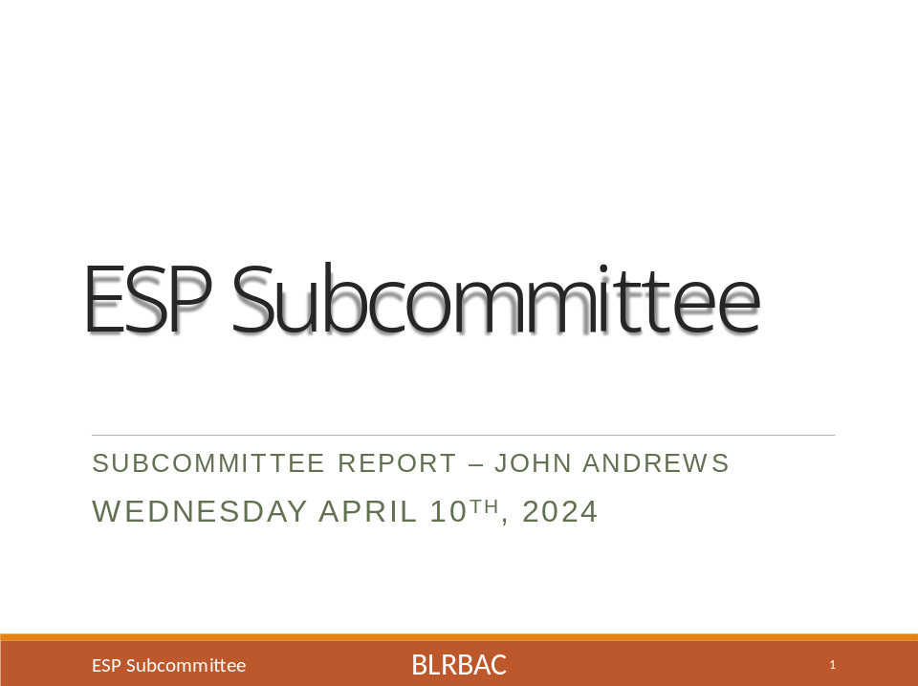

*Click on presentation to open.

APPENDIX III
AF&PA Presentation
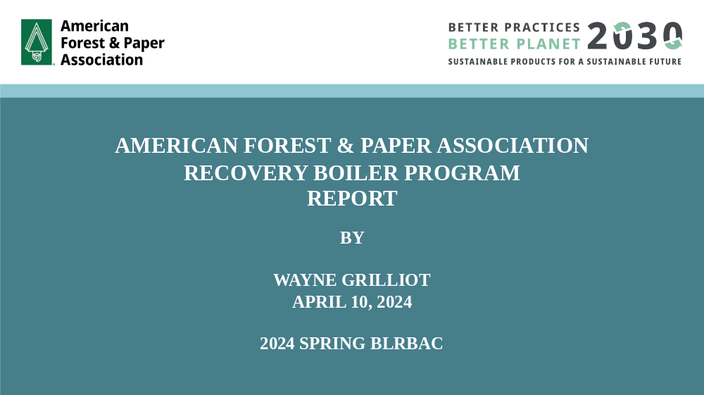

- Click on presentation to open

