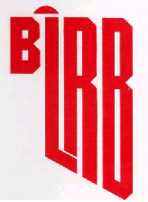
BLACK LIQUOR RECOVERY BOILER
ADVISORY COMMITTEE

MINUTES OF MEETING

April 9, 2025
OBJECTIVE
BLRBAC’s objective is to promote improved safety of chemical recovery boilers and their auxiliaries through the interchange of technical knowledge, experience, and data on past and any future recovery boiler incidents. Bylaws - 2.1

OFFICERS

Chairman: Gregory Burns
Mt Pleasant, SC Cell: 843-991-7192
Domtar gregory.burns@domtar.com

Vice-Chair: David Tjaarda
Smurfit Westrock Cell: 503-728-2550
Charleston, TN dave.tjaarda@smurfitwestrock.com

Secretary: Daniel Franco
Recovery Specialist Cell: +573113001079
Cali, Colombia danielf721@gmail.com

Treasurer: Brad Osbourne
Electron Machine Cell: 352-267-0118
Umatilla, FL brad@electronmachine.com

REGULAR MEMBERSHIP
Organizations operating, manufacturing, or insuring chemical recovery boilers are eligible.

ASSOCIATE MEMBERSHIP
Organizations having a direct interest or role in the safety of chemical recovery boilers are eligible.

CORRESPONDING MEMBERSHIP
Companies residing outside of the United States which finds it impractical to attend meetings on a regular basis because of distance and expenses, but desires to be involved and informed of BLRBAC activities.
Bylaws - 3.1

BLRBAC INTERNET ADDRESS: ---- www.blrbac.net
IRS Employer ID/Tax ID (IRS E.I.N.T./T.I.N.) ----
EXUTIVE COMMITTEE

Gregory Burns Jimmy Onstead
BLRBAC Chairman Insurance Representative
Domtar FM Global
Mt Pleasant, SC Frisco, TX
Cell: 843-991-7192 Tel: 972-731-1656
gregory.burns@domtar.com Cell: 903-744-2734
jimmy.onstead@fmglobal.com

David Tjaarda Evangelos Townsend (Ev)
BLRBAC Vice Chairman Manufacturing Representative
Smurfit Westrock Babcock & Wilcox
Charleston, TN Melissa, TX
Cell: 503-728-2550 Office: (281) 405-6825
dave.tjaarda@smurfitwestrock.com Mobile: (469) 815-8395
emtownsend@babcock.com

Daniel Franco Scott Moyer
BLRBAC Secretary Operator Representative
Recovery Specialist Smurfit Westrock
Cali, Colombia Jacksonville, FL
Cell: +573113001079 Mobile: 904.437.7149
danielf721@gmail.com scott.moyer@smurfitwestrock.com

Brad Osborne
BLRBAC Treasurer
Electron Machine
Umatilla, FL
Cell: 352-267-0118
brad@electronmachine.com

BLRBAC SUBCOMMITTEES

AUXILIARY FUEL  Tom DeBeer – Chairman  LCK Consultants  5001 Willow Creek Drive  Woodstock, GA 30188  Cell:(404) 218-8613  tdebeer2024@gmail.com | BLACK LIQUOR, SAFE FIRING OF  Vernon Blackard, Chairman  International Paper  Roy, MT 59471  Cell: 251-284-3471  vernon.blackard@ipaper.com
EMERGENCY SHUTDOWN PROCEDURES  Frank Navojosky, Chairman  BSI  Loveland, OH  Cell: (513) 334-9999  fcnavojo@gmail.com | FIRE PROTECTION IN DIRECT  CONTACT EVAPORATORS  Stephen Cox - Chairman  International Paper  Maumelle, AR  Tel: 409-779-7104  stephen.cox@ipaper.com
INSTRUMENTATION  John Browning, Chairman  Georgia Pacific  Atlanta, GA  Tel: 251-593-6096  john.browning@GAPAC.com | MATERIALS & WELDING  Laura Nicol–Chairperson ‡  Babcock & Wilcox  1200 E Market St, Ste 650  Akron, OH 44305  Cell: 330-361-0217  lsnicol@babcock.com
PERSONNEL SAFETY  Ward Benjiman - Chairman  Sappi North America  Skowhegan, ME  Tel: 207-238-7686  Benjiman.Ward@sappi.com | PUBLICITY & NEWS RELEASE  Matt Paine, Chairman  FM  Norwood, MA  Tel: 781-255-4733  matthew.paine@fmglobal.com
WASTE STREAMS  Paul Seefeld, Chairman  A.H. Lundberg Associates, Inc.  Jacksonville, FL  Tel: 904-614-6492  paul.seefeld@lundberg-us.com | WATER TREATMENT  Tom Przybylski, Chairman  Power Specialists Associates  Somers, CT  Tel: 860-763-3241  tom.@psaengineering.com

FUTURE BLRBAC MEETINGS

Fall | October | 6,7,8 | 2025
Spring | April | 6,7,8 | 2026
"Bring Operator(s). Give them a chance to hear firsthand!"
Past Chairman Frank Navojosky

*****************************
* NOTE: For varying reasons, the previously published meeting dates have been changed at the
discretion of the Executive Committee.

BLRBAC has established its own website at: www.blrbac.net

At this website you will find a copy of past Meeting Minutes and the next Meeting Notice. Therefore, each Representative and Associate Representative is asked to inform their people of this WEB site. This is where they can obtain the following BLRBAC documents:

BLRBAC MEETING NOTICE
COVER LETTER General Information

REGISTRATION FORM Will be available on the website with a link to register and pay on line.

HILTON Airport Blocked room dates, pricing, address, hotel phone numbers

SCHEDULE List of subcommittee activities on Monday and Tuesday

AGENDA Reports given to Joint BLRBAC Meeting on Wednesday

OPERATING PROBLEMS Mail/e-mail completed questionnaires to David Tjaarda

QUESTIONNAIRE The Vice Chairman and he will see that your concerns are brought up and discussed during the Operating Problems session at the next meeting.

These are available at the BLRBAC INTERNET ADDRESS: www.blrbac.net
BLRBAC Guidelines & Recommended Practices
LEGAL NOTICE

Recommended Good Practice For Design, Operation, and Testing of the Emergency Shutdown System for Black Liquor Recovery Boilers
(Dated: October 2024)

Safe Firing of Black Liquor in Black Liquor Recovery Boilers
(Dated: October 2023)

Materials & Welding Guidelines
(Dated: April 2013)

Safe Firing of Auxiliary Fuel in Black Liquor Recovery Boilers
(Dated: February 2012)

Fire Protection in Direct Contact Evaporators and Associated Equipment
(Dated: February 2024)

Personnel Safety & Training
(Dated: April 2018)

Application of Rotork Actuators on Black Liquor Recovery Boilers
(Dated: April 2025)

Boiler Water Management Guidelines for Black Liquor Recovery Boiler
(Dated: April 2023)

Instrumentation Checklist and Classification Guide for Instruments and Control Systems Used in the Operation of Black 9Liquor Recovery Boilers (Dated: April 2023)

Thermal Oxidation of Waste Streams in Black Liquor Recovery Boilers
(Dated: April 2021)

If you have any questions, contact:

Secretary: Daniel Franco Tel: +576023258865
Recovery Specialist Retired Cell: +573113001079
Cali, Colombia danielf721@gmail.com

AUXILIARY FUEL SUBCOMMITTEE
Tom DeBeer – Chairman‡
LCK Consultants
5001 Willow Creek Drive
Woodstock, GA 30188
Cell:(404) 218-8613
tdebeer2024@gmail.com

David Frazier New Member‡ International Paper | John Lewis‡  General Electric Vernova  200 Great Pond Drive G3W4  Windsor, CT 06095  Tel:(860) 285-2918  john.c.lewis@ge.com | Michael Bekech  CECO - CCA Combustion Systems  884 Main St.  Monroe, CT 06468  Tel: (203) 268-3139 x 137  Cell: (203) 895-4822  mbekech@onececo.com
Mike Bruce  Sylvamo  104 Putnam Center Road  Putnam Station, N.Y. 12861  Tel: (518) 586-6954  mike.bruce@sylvamo.com | Rick Dooks  Fossil Power Systems Inc  10 Mosher Drive  Dartmouth, Nova Scotia B3B 1N5  Canada  Cell: 1-902-499-0546  dooksr@fossil.ca | Chris Finnemore  Georgia Pacific  Fernandina Beach, FL 32034  Cell: (904) 321-6861  Chris.finnemore@GAPAC.com
Travis Flower  Babcock & Wilcox Company  P. O. Box 351  Barberton, OH 44203-0315  Tel: (330) 860-6042  taflower@babcock.com | Derrick Gossen‡  FM  301 Freedom Ct.  Mishicot, WI 54228  Cell: (920) 619-1750  derrick.gossen@fmglobal.com | Brook M. Holland  Bodman Services LLC  Cell: (828) 421-0487  brookmholland@gmail.com
Greg Imig‡  Andritz  5405 Windward Pkwy, Suite 100W  Alpharetta, GA 30004  Tel: (770) 640-2633  Cell: (404) 545-9076  greg.imig@andritz.com | Carlos Rojas  Smurfit Westrock (Colombia)  (TBD)  Colombia, S. America  Phone: +573113009193  carlos.rojas@smurfitwestrock.co

‡ = | Denotes attendance at last meeting, April 9, 2025
* = | Denotes a new/replacing member

EMERGENCY SHUTDOWN PROCEDURES SUBCOMMITTEE

Frank Navojosky– Chairman‡
BSI
Cell: (513) 334-9999
fcnavojo@gmail.com

Dean Clay, Secretary‡  Boiler Services & Inspection, LLC  BSI  Cell: (513) 497-9070  dclayesp@gmail.com | Scott Crysel‡  FM  One Cowboys Way, Suite 600  Frisco, TX 75034  Tel: (972) 731-1658  Fax: (972) 731-1820  scott.crysel@fmglobal.com | James Franks‡  AXA XL Risk Consulting  855 Dogwood Road  Somerville, TN 38068  Tel: (901) 465-0771  Fax: (888) 964-7348  james.franks@axaxl.com
Mike Bruce‡  Sylvamo  104 Putnam Center Rd  Putnam Station, NY  Cell: 518-586-6954  mike.bruce@sylvamo.com | Mike Bates  WCBLRBAC Chairman  Domtar Crofton  Office (250) 246-6176  Cell (236) 594-6458  mike.bates@domtar.com | John DeFusco‡  Babcock & Wilcox Company  4 Essex Drive  Yarmouth, ME 04096  Cell: (207) 776-0954  jpdefusco@babcock.com
Gregory Burns‡  Domtar  Cell: (843) 991-7192  Office: 803-802-8077  Fort Mill, SC  gregory.burns@domtar.com | Scott Moyer, Vice Chairman‡  Smurfit Westrock  1660 Prudential Drive, Ste. 202 Jacksonville, FL 32207  Cell: 904-437-7149  scott.moyer@smurfitwestrock.com | Greg Zavadoski‡  Georgia Pacific  Cell: 715.432.2470  greg.zavadoski@gapac.com
John Phillips‡  Andritz Pulp & Paper  5405 Windward Parkway, Suite 100W  Alpharetta, GA 30004  Tel: (770) 640-2434  Fax: (770) 640-2521  john.phillips@andritz.com | Dan Cudmore‡  GE Vernova  1420 Blair Towers Place  Suite 500  Ottawa, ON K1J 9L8  Tel: (613) 298-5021  dan.cudmore@ge.com | Dave Gadai‡  Valmet Inc  3440 Torington Way  Suite 300, Bldg 3  Charlotte, NC 28277  Cell: (704) 560-3575  dave.gadai@valmet.com  Jeremiah Yoder, Alternate
‡ Denotes attendance in Spring 2025 meeting

PUBLICITY & NEWS RELEASE SUBCOMMITTEE
Matt Paine - Chairman
FM
Johnston, RI
Cell: 781-255-4733
matthew.paine@fmglobal.com

FIRE PROTECTION IN DIRECT CONTACT EVAPORATORS
AND ASSOCIATED EQUIPMENT SUBCOMMITTEE

Stephen Cox - Chairman
International Paper
6318 Highway 139
Bastrop, La 71220
Tel: 409-779-7104
Stephen.cox@ipaper.com

Kevin Huelsbeck - Vice Chair  FM Global Property Insurance  Forest Products Operations  W4893 Cliff View Drive  Sherwood, WI 54169  Tel: 920-205-5529  kevin.huelsbeck@fmglobal.com | Robert Orender  Georgia Pacific  133 Peachtree Street NE  Atlanta, GA 30303  Robert.orender@gapac.com | Robert Goddard  XL Group  129 Drive 1143  Tupelo, MS 38804  Tel: 662 844-5897  robert.goddard@axaxl.com
Joseph Lynch
Swiss Re America Holding Corporation
1150 Sanctuary Parkway, Suite 425
Alpharetta, GA 30009
Tel: 1770-569-8706
Joe_Lynch@swissre.com
Mike McKenzie(new for spring 2024)
International Paper
Bogalusa Mill
Tel: 19857328723
Michael.McKenzie1@ipaper.com

‡Denotes attendance at the meeting in Fall 2024. Did not meet In Spring 2025

INSTRUMENTATION SUBCOMMITTEE
Spring 2025 members and attendance
‡JC Browning, Jr (1998) – Chairman
Georgia Pacific
133 Peachtree St. NE (30303) Atlanta, GA 30348-5605
Tel: 251-593-6096 john.browning@gapac.com

‡ Attended New Member Leaving Member

C.A. Vossberg (<2000?) ‡ Vice Chairman P  Electron Machine Corp.  P.O. Box 2349  Umatilla, FL 32784  Tel: 352-406-1351  ca@electronmachine.com | Ben Bunner (2020?) Secretary Andritz  5404 Windward Parkway  Suit 100W  Alpharetta, GA 30004  Cell: 678-907-7617  ben.bunner@andritz.com | David T. Boudreau (2007) P  SAPPI (S.D. Warren Company)  1329 Waterville Road  Skowhegan, ME 04976  Tel: 207-314-8024  dave.boudreau@sappi.com
Joel Byrd (2015?)  International Paper Company  12515 Choctaw Rd  Bogalusa, La 70427  Tel:985-516-1110  Joel.byrd@ipaper.com | Gordon L. Vandenburg (2000?)  Liquid Solids Control, Inc.  P.O. Box 259, Farm St.  Upton, MA 01568  Tel: (603) 833-8536  gordie@liquidsolidscontrol.com | Jari Sopanen (1995?)  Jari Consultoria de Automacao Ltda  Rua Rio Grande do Sul, 505  Agua Verde, Curitiba  Brazil 80620-080  Tel:+55413244-7059  jari@jariautomation.com
Kevin Huelsbeck (2010?) ‡  FM Global P  W4893 Cliff View Drive  Sherwood, WI 54169  Cell: 920-205-5529  kevin.huelsbeck@fmglobal.com | Ricky Henderson (2024)  Vaisala Inc.  3 Van de Graaff Drive.  Burlington, MA 01803  (P) 713-550-2534  ricky.henderson@vaisala.com | Andy Clement (2019?) ‡  10 Mosher Drive P  Dartmouth, Nova Scotia  Canada B3B 1N5  Tel:902-468-2743 ext.245  clementa@fossil.ca
Adam Marickovich (2024) ‡  Georgia-Pacific P  133 Peachtree St. NE (30303)  Atlanta, GA 30348-5605d  Adam.Marickovich1@gapac.com | Daniel Albert - (2019?) Rotork 675 Mile Crossing Boulevard Rochester NY 14624  (585) 247-2304  Daniel.Albert@Rotorq.com | Daniel Guarnieri (2024) SYLVAMO  Rodovia SP 340 KM171 | Mogi Guacu, SP, Brazil 13845-901  T: +55 19 3861-8972 | M: +55 19 97102-1290  daniel.guarnieri@sylvamo.com
Patrick Buyck (2024) SAPPI North America P 2201 Avenue B, PO Box 511, Cloquet, MN 55720  Patrick.Buyck@sappi.com | Deshan Naidoo (2024) SAPPI  25 Heron Way Yellowwood Park  Durban , South Africa 4004 Deshan.Naidoo@sappi.com | Andrew Kirk (2024) PCA even.saumer@smurfitwestrock.com
Chris Clements (2024)  Smurfit Westrock Chris.clements@smurfitwestrock.com | Dave Avery P

PERSONNEL SAFETY SUBCOMMITTEE

Ward Benjiman - Chairman‡
Sappi North America
Skowhegan, ME
Tel: 207-238-7686
Benjiman.Ward@sappi.com

Sam Dean  Rayonier Advanced Materials  4470 Savannah Highway  Jesup, GA 31545  Tel: (912) 427-5103  samuel.dean@rayonierAM.com | Steve Morrison‡  G-P  Cell – (404) 268-6573  Team – (404) 652-7141  Steve.morrison@gapac.com | Tom Edwards  B&W  twedwards@babcock.com
 | David Von Oepen  Smurfit West Rock  28270 U.S. Highway 80 West  Demopolis, AL 36732-5121  Tel: (334) 289-6315  dvonoepen@smurfitwestrock.com | Mathew Glenn‡  Irving Pulp & Paper, Limited  Recovery Superintendent  P.O. Box 3007  408 Mill Street  Saint John, New Brunswick  Tel: (506) 634-4234  glenn.matthew@irvingpulp.com
Grey Gurkin  International Paper  International Paper Co. | Zack Payne‡  Andritz  5405 Windward Parkway  Suite 100W  Alpharetta, GA 30004-3894  Tel: (706) 344-9006  zack.payne@andritz.com | Francisco Britt‡  FM  One Cowboys Way  Suite 600  Frisco, TX 75034  Tel: (972) 731-2145  Francisco.britt@fmglobal.com
Brook Holland‡  G.H. Bodman  228 Wild Rose Lane  Canton, NC 28716  Tel : (828) 421-0487  brookmholland@gmail.com | Jake Dowland‡  ND Paper | Sam Miller‡  Andritz

‡Denotes attendance at the April 2025 meeting

MATERIALS & WELDING SUBCOMMITTEE
Laura Nicols – Chairperson ‡
Babcock & Wilcox
1200 E Market St, Ste 650
Akron, OH 44305
Cell: 330-361-0217
lsnicol@babcock.com

‡ Attendance this meeting
Materials and Welding Committee Members
Jesse Worsham: Vice Chairman ‡  Domtar Paper  Tel: (843) 479-0200 Ext 8879  Jesse.Worsham@Domtar.com | *Maxime Simard ‡  FM  Cell: (418) 435-1551  maxime.simard @fmglobal.com  *Alt: Mark Jackson  Mark.Jackson@FMGlobal.com | Scott Lowrie ‡  Andritz, Inc.  Scott.Lowrie@andritz.com  *Alternate - Mark LeBel ‡  Cell (678) 577-8613  Mark.LeBel@andritz.com
Brent Griffin ‡  Georgia-Pacific LLC  Cell: (850) 910-1259  brent.griffin@gapac.com  *Alt: Chad Harrod ‡  Cell: (404) 395-3064  Chad.Harrod@gapac.com | Jennings Bird  Valmet  Tel: 803 235 8091  Jennings.bird@valmet.com  *Alt: Ron Reed ‡  Tel: (704) 281-3073  Ron.reed@valmet.com | Billy Collett ‡  National Boiler Services, LLC.  Cell: (423) 582-6958  bcollett@nationalboiler.com  *Alt: Steve Harville  Cell: (251) 591-7850  Sharville@NationalBoiler.com
Jed Merritt ‡  RMR Mechanical  Tel: 601-508-9084  Jed.merritt@rmrmechanical.com  *Alt: Ben Rogers  Ben.Rogers@rmrmechanical.com | Chris Rawls  Applied Technical Services  Tel: 757-218-8465  crawls@atslab.com  Alt: Thomas Kapperman  Tel: (678)231-8025  tkapperman@atslab.com | Stacy Power ‡  Midstate SMS  Tel: (843) 957-2111  Cell: (843) 297-1987  spower@smsmidstate.com
William Burns ‡  ND Paper – Rumford  Cell: 207-743-1029  William.Burns@us.ndpaper.com | TBD  Acuren

SAFE FIRING OF BLACK LIQUOR SUBCOMMITTEE

‡Vernon Blackard - Chairman
International Paper
Cell: 251-284-3471
vernon.blackard@ipaper.com

Clif Barreca  International Paper  Tel: 252-633-7696  clif.barreca@ipaper.com | ‡Tim Hicks  Billerud  Tel. 901-468-5058  Tim.hicks@Billerud.com | Joel Byrd  International Paper  Tel: 85-516-1110  Joel.byrd@ipaper.com
‡Sarah Henke – Vice-Chair  Valmet  Tel: 919-454-3441  Sarah.henke@valmet.com | ‡Peter Donahue  Fossil Power Systems, Inc.  Tel: 902-468-2743, Ext. 251  Cell: 902-877-9312  donahuep@fossil.ca | Len Erickson  Power Specialist Assoc.  Tel: 208-841-4246  len.erickson@PSAengineering.com
Jason Saulsbury  Green Bay Packaging  Tel: 902 908 0495 | ‡Wes Hill  Georgia Pacific  Tel 360-607-4189  Wes.hill@gapac.com | ‡Daniel Franco  Recovery Specialist  Cell: +57 3113001079  danielf721@gmail.com
‡Guy Labonte  FM Global  Tel: 514-876-7412  Cell: 514-942-3651  guy.labonte@fmglobal.com | ‡Doug Murch  Smurfit Westrock  Tel: 804-444-5245  Cell: 804-787-0781  douglas.murch@smurfitwestrock.com | ‡Alarick Tavares  Smurfit Westrock  Tel - 678 492-1107  alarick.tavares@smurfitwestrock.com
Mark Sargent  Bodman Services, LLC  Tel: 514-543-0480  Mark.sargent@rmrmechanical.com | ‡Pasi Miikkulainen/ Sam Miller substitute  Andritz  p: +1 770 640 2414  m: +1 678 230 1525 Pasi.Miikkulainen@andritz.com | ‡ Brian Rawson  International Paper  Cell: 850-266-5259  brian.rawson@ipaper.com
 | Rudy Haraga –  Fornax Services  Tel: 860-268-1871  Rudy.haraga@thefornax.com | ‡Olli Kujanpaa –  Georgia Pacific  Tel: 404-432-8281  Olli.kujanpaa@gapac.com
  ‡Jason Lewis
  ND Paper
  m: 207-557-0952
  Jason.lewis@us.ndpaper.com
Ryan P Henry  Green Bay Packaging Inc.  Tel: 501-306-8330  rhenry@gbp.com | Keijo Pyorala  Vaisala  keijo.pyorala@vaisala.com | ‡David Tjaarda  Smurfit Westrock  Tel – 503 728-2550  dave.tjaarda@smurfitwestrock.com
Justin Helton  Andritz  Tel: 470-416-1342  Justin.helton@andritz.com | ‡Evangelos Townsend  B&W  Office: 281-405-6825  Mobile: 469-815-8395  Emtownsend@babcock.com | ‡Jay Dilworth  Pixelle Specialty Solutions  Tel 717 225 4711  James.Dilworth@pixelle.com

‡Denotes attendance at the meeting in Spring of 2025.

WASTE STREAMS SUBCOMMITTEE

*Paul Seefeld – Chairman
LDX Solutions
9246 Audubon Park Ln S
Jacksonville, FL 32257
Cell: 904-614-6492

PSeefeld@LDXSolutions.com

Raquel Posada  Smurfit Westrock  Columbia  Raquel.posada@smurfitwestrock.co | *Neil Chaudhuri  FM Global  100 New Park Place, Suite 200  Vaughan ON Canada L4K OH9  Tel: 647-894-5680  Neil.chaudhuri@fmglobal.com | *David Frazier  International Paper  Technology  6285 Tri-Ridge Blvd  Loveland, Ohio 45140  Cell: 706-305-5321  David.frazier@ipaper.com
Cobb Golson  Westrock  Jacksonville, FL  Tel: 904-826-7430  Cobb.golson@westrock.com | *John Lewis  Fluor  100 Fluor Daniel Drive  Greenville, SC 29607-2762  Tel: 864 517-1683  john.lewis@fluorgov.com | Pasi Miikkulainen  Andritz  5405 Windward Parkway  Alpharetta, GA 30004  Tel:770-640-2414  Cell: 678-230-1525  Pasi.miikkulainen@andritz.com
*Oscar Guevara  Domtar  100 Kingsley Park Drive  Fort Mill, SC 29715  Tel: 479-871-0970  Oscar.guevara@domtar.com |  | Greg Wass  LDX Solutions  8271 154th Ave NE  Redmond, WA 98052  Office: 425-283-5070  Cell: 425-503-2747  gwass@LDXSolutions.com
*Kevin Sapp – Vice Chairman  Georgia Pacific  Atlanta, GA  Tel: 387-227-1038  Kevin.sapp@gapac.com | *Wayne Bucher  NORAM  Wayne.bucher@gmail.com
*Denotes attendance for the Fall 2024 meeting; Did not meet in the Spring 2025 meeting

WATER TREATMENT SUBCOMMITTEE
Spring 2025

‡Tom Przybylski
Power Specialists Assoc. Inc.

tom.przybylski@psaengineering.com

‡Jeff Armstrong  Solenis  E-mail Address  xxx | ‡Rick Baxter  Valmet  E-mail Address  richard.baxter@valmet.com | ‡Michael Bayse  George H. Bodman, Inc.  E-mail Address  bbayse@aol.com  (Substitute: Gene Cotton)
‡Fred Call  Buckman  E-mail Address  fccall@buckman.com | ‡Frank Crumpler  Nalco  E-mail Address  fcrumpler@ecolab.com  alternate: Jim Gannon | Susan Childress  RMR  E-mail Address  susan.childress@rmrmechanical.com
‡Frank Destefano  3D  E-mail Address  DestefanoFrank55@gmail.com | ‡Don Downey  Purolite  E-mail Address  don.downey@purolite.com | Peter Fogg  Georgia Pacific  E-mail Address  peter.fogg@gpac.com
Nick Wildey  Georgia Pacific  E-mail Address  nicholas.wildey@gpac.com | ‡Tom Meehan  FM Global  E-mail Address  thomas.meehan@fmglobal.com | ‡Trevor Murray  Irving Pulp and Paper  E-mail Address  murray.trevor@irvingpulp.com
Dylan Price  RMR  E-mail Address  Dyline.price@rmrmechanical.com | ‡Dave Tjaarda  Smurfit WestRock  E-mail Address  dave.tjaarda@smurfitwestrock.com

‡ = Denotes attendance at meeting Spring 2025
- Denotes new subcommittee member on this list; previously added to subcommittee.

Registration List*
BLRBAC Spring 2025 Meeting - FINAL TOTALS - Tuesday 4/8/25 12:00pm
First Name | Last Name | Company
George | Pyszynski | 3S TEAM, LLC
Jake | Shelton | Acoustic Cleaning Systems
Todd | Harley | Acuren
David | Dunn | Acuren Inspection
Wayne | Grilliot | AF&PA
Scott | Markrof | Ahlstrom
Rickey | Bazelle | Alabama River Cellulose (GP)
Jeremy | Nicholson | Alabama River Cellulose (GP)
Tyler | Stanley | Alabama River Cellulose (GP)
Ben | Fredrick | Allnorth Americas
John | Hornsby | Andritz
Greg | Imig | Andritz
Mark | LeBel | ANDRITZ
Samuel | Miller | Andritz
Zachary | Payne | Andritz
Aaron | Rose | Andritz
Greg | Swayne | Andritz
Preston | Morgan | Andritz Inc
Paul | Ceravolo | Andritz Inc.
John | Phillips | ANDRITZ Inc.
Scott | Lowrie | Andritz, Inc.
Cameron | Davies | Aon
Bill | Castle | Applied Technical Services
Harrison | McLarty | AXA XL
Allen | Broadus | AXA XL Risk Consulting
James | Franks | AXA XL Risk Consulting
Tom | Edwards | B&W
John | DeFusco | Babcock & Wilcox
Greg | Sallee | Babcock & Wilcox
Evangelos | Townsend | Babcock & Wilcox
Laura | Nicol | Babcock and Wilcox
Matthew | Ackerman | Bama River Cellulose (Georgia Pacific)
Tim | Hicks | Billerud
Dean | Clay | BSI
Frank | Navojosky | BSI - Boiler Services and Inspection
Fred | Call | Buckman
Brent | Bourassa | Clearwater Paper
Ishaq | Jameel | Clyde industries
Daniel | Franco | Consultant
Daniel | Roddy | Core Refractory Systems
James | Biggs | Crenshaw Machine Systems
Juan | Reyes | Crenshaw Machine Systems
Jordan | Spicer | Diamond Power International Inc. -
Carlo | Tomassetti | DiVal Safety / CoreMAX FR
Oscar | Guevara | Domtar
Kolby | Stockton | Domtar
Gregory | Burns | Domtar Corporation
David | Avery | Domtar Paper
Herman | Haywood | Domtar Paper
Silas | Whitehead | Domtar Paper Company
Jesse | Worsham | Domtar Paper Company, LLC
Gerald “Trey” | Nail | E & E Tech
Matthew | Jones | E and E Tech
Ryan | Smith | E and E Tech
Oliver | Baumann | Ecolab
Don | Downey | Ecolab
Brad | Osborne | Electron Machine
CA | Vossberg | Electron Machine
Scott | Pettigrew | Enero Solutions
Jennifer | Sandstrom | Enero Solutions
Nicholas | Ferri | Environmental Energy Services
Christian | Steiner | Explosion Power GmbH
Andrew | DOrazio | Factory Mutual
Jeremy | Rader | Factory Mutual Insurance Company
Resham | Adhikari | FM
Andre | Beaulieu | FM
Francisco | Britt | FM
Neil | Chaudhuri | FM
Chris | Combs | FM
Scott | Crysel | FM
Josh | Fetting | FM
Derrick | Gossen | FM
Chris | Hovanec | FM
Kevin | Huelsbeck | FM
Steven | Kern | FM
Guy | Labonte | FM
Pedro | Marcello Godinho | FM
William | Matisak | FM
Paul | Murphy | FM
Jimmy | Onstead | FM
Matthew | Paine | FM
Daniel | Pope | FM
Nicholas | Quigley | FM
Maxime | Simard | FM
Jason | Sirros | FM
Kimberley | Yulo | FM
Thomas | Meehan | FM Global
Andy | Clement | FPS
Peter | Donahue | FPS
Yoram | Schaker | GE Steam Power Inc.
Dan | Cudmore | GE Vernova
John | Lewis | GE Vernova
Michael | Rushing | General Electric
Ethan | Blair | Georgia Pacific
JC | Browning | Georgia Pacific
Jake | Dowland | Georgia Pacific
Brent | Griffin | Georgia Pacific
Adam | Marickovich | Georgia Pacific
Tom | Meadows | Georgia Pacific
Steve | Morrison | Georgia Pacific
Robert | Orender | Georgia Pacific
John | Price | Georgia Pacific
Luke | Coutinho | Georgia Pacific LLC
Greg | Zavadoski | Georgia Pacific LLC
Chad | Harrod | Georgia-Pacific
Wes | Hill | Georgia-Pacific
Gregg | Lentz | Georgia-Pacific
Olli | Kujanpaa | GP
Bruce | Pease | Graphic Packaging International
Angelo | Porchetta | howe sound pulp and paper Domtar
Kevin | Phillips | Integrated Global Services
Vernon | Blackard | international paper
Derrick | Clarke | International Paper
Stephen | Cox | International Paper
David | Frazier | International Paper
Robert | Miller | International Paper
Paul | Peters | International Paper
Brian | Rawson | International Paper
Trevor | Murray | Irving Pulp and Paper
Matt | Glenn | Irving Pulp and Paper Ltd
Danny | Mott | Irving Pulp and Paper Ltd
Brendan | Dooley | J.D. Irving
Steve | Campbell | Jansen Combustion and Boiler Technologies, Inc.
Douglas | Giarde | Jansen Combustion and Boiler Technologies, Inc.
Mark | McCabe | Jansen Combustion and Boiler Technologies, Inc.
Jerrel Bobby | Johnston | Johnston Construction LLC
Shannon | McKenzie | Kadant Black Clawson LLC
Richard | Salliss | Keit Industrial Analytics
Thomas | DeBeer | LCK Consultants
Michael | Sweeney | Liquid Solids Control, Inc.
Christopher | Skorton | Liquid metal Industrial Solutions
Paul | Seefeld | Lundberg LLC
Glenn | Hanson | Metso
Rob | Richards | Metso USA Inc.
Stacy | Power | MidState SMS LLC
Roger | Lawton | Milhous
Frank | Crumpler | Nalco
Billy | Collett | National Boiler Service, Inc.
William | Burns | ND Paper
Joseph | King | ND Paper
Jason | Lewis | ND Paper
Dan | Robinson | ND Paper
Kurtis | Barnett | ND Paper Inc
Wayne | Bucher | Noram
Christian | Cote | Paragon Risk Engineering
Benjamin | Roberge | Paragon Risk Engineering
James | Dilworth | Pixelle Specialty Solutions
Anna | Racine | Pixelle Specialty Solutions
Tom | Przybylski | Power Specialists Assoc., Inc.
Vince | Barreto | Power Plus Cleaning Systems
Carl | Wise | Power Plus Cleaning Systems
David | Fuhrmann | Precision Reliability LLC
Logan | Baker | Process Barron
Derek | McCallum | Process Barron
Jennifer | Smith | Process Barron
Tripp | Whatley | Process Barron
Alex | Claverie | PSA
Mike | McGregor | Radian Chemicals
Rick | Baxter | RMR Mechanical, LLC
Mike | Bayse | RMR Mechanical, LLC
Kyle | Boucher | RMR Mechanical, LLC
Brook | Holland | RMR Mechanical, LLC
Jenny | Joyce | RMR Mechanical, LLC
Jed | Merritt | RMR Mechanical, LLC
Dylan | Price | RMR Mechanical, LLC
Donnie | Wilson | RMR Mechanical, LLC
Daniel | Albert | Rotork
Patrick | Buyck | Sappi
Benjiman | Ward | Sappi
David | Boudreau | Sappi Fine Paper
Bernie | Abramczyk | SEI-Group
Steve | Lessard | Sigma 7/Paragon Risk Engineering
Scott | Moyer | Smurf it Westrock
Kyra | Attridge | Smurfit WestRock
Christopher | Crocker | Smurfit Westrock
Robert | Edens | Smurfit Westrock
Brian | Hudson | Smurfit Westrock
Deshawn | Kraemer | Smurfit Westrock
Michael | Merino | Smurfit Westrock
Douglas | Murch | Smurfit Westrock
Evan | Saumer | Smurfit Westrock
Alarick | Tavares | Smurfit Westrock
David | Tjaarda | Smurfit Westrock
Randy | Tompkins | Smurfit Westrock
Scott | Holloway | Solenis
Jim | Meredeth | SOLENIS
David | Wolfanger | Solenis
Jeff | Armstrong | Solenis LLC
Mike | Bruce | Sylvamo
Nick | Folster | The Babcock & Wilcox Company
James | Monette | The Babcock & Wilcox Company
Frank | DeStefano | Thermax
David | DiCorpo | Vaisala
Ricky | Henderson | Vaisala Inc
Keijo | Pyörälä | Vaisala Oyj
Casey | Beirne | Valmet
Zackary | Fanelty | Valmet
Dave | Gadai | Valmet
Abby | George | Valmet
Rob | Goggins | Valmet
Sarah | Henke | Valmet
Daniel | Lishbrook | Valmet
Matthew | Sparks | Valmet
Cameron | Weir | Valmet
Jeremiah | Yoder | Valmet
Travis | Conner | Valmet Automation
Ronald Joseph | Reed | VALMET INC.
Neal | Powell | Valmet, Inc.
Timo | Karjunen | Varo Industrial Services Ltd
Jason | Beaudoin | WestRock
David | von Oepen | WestRock
Wade | Shirley | Westrock mahrt mil
Sammy | Wiggins | Westrock mahrt mil

MAIN COMMITTEE MEETING

- Introduction – (Gregory Burns – Chairman)

Good morning! Welcome to the Spring 2025 BLRBAC Main Committee Meeting! Thank you all for being here and participating this week. This is our second meeting at the Hilton Hotel and I hope everyone found things to their satisfaction. As this is our second meeting at the Hilton, and I think it went well maybe a little better than the Fall but I realize things are not perfect. We will continue to work with the Hilton Hotel to close any gaps. Please provide us feedback as to how your experience has been so we can improve any areas that are lacking. I will be preparing a survey to be sent out so we can get feedback. We had a good week with a lot of excellent participation, especially in our Sub Committee meetings, which were well attended. BLRBAC has thrived over the years from its face-to-face interactions at these meetings. A lot of discussions and exchange of good information. We continue to build momentum on our BLRBAC meeting participation. This week’s meeting had a very good turnout. We had 213 members register. Our average has been around 200-210.

With that we will carry on with our business. The Main Committee Meeting is now officially open. This meeting is being held in strict compliance with BLRBAC’s Anti-Trust Policy.

PLEASE REMEMBER THAT ALL BLRBAC MAIN AND SUBCOMMITTEE MEETINGS INCLUDING THIS SESSION ARE TO BE HELD IN STRICT COMPLAINCE WITH THE BLRBAC ANTITRUST POLICY. DISCUSSIONS INVOLVING PRICE, PRICING POLICY, AND ANY RESTRAINT ON COMPETION ARE NOT ALLOWED DURING THESE MEETINGS.

I’ve reviewed the registration list and found that we have 19 Regular Member companies at this meeting and therefore, I am declaring that we have a quorum for today’s Main Committee meeting.
We will begin with some introductions from the executive committee members this morning. We will introduce ourselves one-by-one. Some of the faces are different than last fall. With Frank Navojosky retiring from International Paper the executive committee voted to move myself, Gregory Burns from vice chairman to Chairman, Dave Tjaarda to Vice Chair and placed Scott Moyer in as the operational representative to serve for the remainder of the term in accordance with the BLRBAC articles of association and bylaws.
I am Gregory Burns, I am the BLRBAC Chairman. I am also the Director for Power, Recovery and Energy Optimization for Domtar Paper and I am a member of the ESP subcommittee.

2.0 Old Business (Gregory Burns)

ACCEPTANCE OF THE FALL2024 MEETING MINUTES –

With that we will move into old business and acceptance of the Fall 2024 meeting minutes. The Meeting Minutes for the Fall 2024 BLRBAC session have been posted on the BLRBAC web site. The website is blrbac.net. Does anyone else have comments or discussion regarding the Fall 2024 meeting minutes as posted?
Can I get a motion to accept the Minutes as posted? We have a motion. Second? All in favor of accepting the minutes as posted? Anybody opposed? Thank You! The Fall 2024 Meeting Minutes have been approved. Is there any other old business that we need to bring to light?

3.0 New Business Report (Daniel Franco)

The Executive Committee met to discuss new member applications. No new applications received and are Rebuilding the old list for voting and alternate representatives from member Companies.

4.0 Executive Committee Report (Gregory Burns)

The executive committee met yesterday in a closed session. We discussed the budget as Brad will detail next. Basically, the financial position of BLRBAC is sound. We spent a lot of time discussing the move to the Hilton and the issues that have come to our attention and as I said earlier a survey will be sent out to all attendees to provide feedback. I think we are all in agreement to hold the Fall meeting here at the Hilton but that there is work to be done to make the process smoother and remove the bugs that have plagued those trying to register.

The executive committee also voted to move the Instrumentation Guidelines to a vote by the membership. We have John Browning review those changes during the Instrumentation Subcommittees presentation prior to a full vote by the membership.

5.0 Treasurer’s Report Brad Osborne

As of April 8, 2024, the balance in our checking account was $122,824.99. Our estimated gross meeting revenue for this meeting is $106.875. Our estimated expenses for the Spring meeting are 70,000 to the hotel and $26,000 to Metro, there will also be a few admin fees we need to account for such as legal reserves and secretarial work. We have prepaid $10,000 to the hotel before the meeting, I expect a hotel balance of approximately $60,000, but we should add approximately $7,000 to our checking account after the Spring meeting. This would have the account at $129,000 before the Fall 2025 meeting. This would complete our goal for the account to carry a balance of one full meeting plus a small reserve. The members booking though our hotel registration link was completed but will need to continue to keep our hotel cost in check. We will be in the Hilton for the Fall. The committee continues to evaluate the bank balance and conference cost. If meetings continue at the Hilton, maintaining a bank balance that accommodate any unforeseen expenses, and the prepayment of the conference is necessary.

We had 201 advance registrations and there were 15 at door registrations and three cancelled for a total of 213. Participation was down from the fall but increased from Spring 2024. There were 23 attendees from outside the US. With 17 people from Canada, 2 UK, 2 from Finland, one person from Switzerland, and one person from Columbia.

Balance as of April 5th, 2025 | $122,824.99
Estimated Spring Gross Meeting Revenue | $ 106,875
Estimated Expenses for Spring | $99,800
Fall Meeting Hilton and AV | $ 70,000.00
Metroconnections | $26,000
ESP | $ 3,000.00
Office | $ 800.00
Other Expenses from Budget | $5,000
Total | $92,800
Estimated Meeting Revenue | $7,075
Prepayment | $10,000
Estimated EOM Checking Balance | $ 129,899
6.0 Secretary’s Report (Daniel Franco)

MEMBER COMPANY ACQUISITION

MEMBERSHIP COMPANY STATUS CHANGES – None at this time.

{Secretary’s Note: The Company Membership List posted on the BLRBAC website may be out of date and not reflecting all the mergers, acquisitions, and name changes that have occurred. Anyone who sees something that needs changing should bring it to the attention of the BLRBAC Chairman and Secretary.

7.0 SUBCOMMITTEE REPORTS

7.1 AUXILIARY FUEL – Tom DeBeer – Chairman
BLRBAC Safe Firing of Auxiliary Fuels Subcommittee
April 7, 2025, Meeting
The Aux fuels committee met in the morning and the afternoon.
9:40- 11:45 in open session. Due to lack of quorum a work group meeting has held.
The BLRBAC anti-trust statement was read and revied.
Two guests and Three committee members were present.
13:00 – 15:30 in closed session
The BLRBAC anti-trust statement was read and revied.
Zero guests and five out of eight committee members were present.
Bruce Knowlen Subcommittee Chair retired from International Paper with over 30 years of service to the Safe Firing of Auxiliary Fuel Committee. His knowledge, wisdom and guidance will be missed. The committee wish Bruce all the best in his well-deserved retirement.
The committee reviewed changes proposed to the document for over twenty figures and over ten tables.
Each item was reviewed and voted on by the committee. All proposed changes were approved unanimously. The committee will finalize the changes to the document at the fall meeting and will submit it to the executive committee for approval.

7.2 ESP SUBCOMMITTEE – Frank Navojosky – Chairman

ESP subcommittee meeting report out 4/9/25

ESP SUBCOMMITTEE REPORT – Frank Navojosky – BSI (Boiler Services & Inspection LLC)

Closed ESP subcommittee meeting 4/7/25

The closed meeting was called to order at 8:00 AM Monday 4/7/25 by ESP Chairman Frank Navojosky and the Antitrust Slide was read

Membership attendance
We had 12 members present out of 13 active members with 1 absent (Mike Bates of WCBLRBAC).

Regular Business
- Reviewed and Approved the Previous Minutes – October 7th, 2024
- Reviewed the 20 Assigned US and Canada Incidents reported and 1 International incident
- Discussed proposal of changes to our latest ESP Guideline Document.
- Rapid Drain valve - Rotork configuration – Adjusted wording based on ISC feedback to send to Executive committee for approval.
- ESP Logic – Air changes desired on ESP – Working on logic block and document wording to allow mills the flexibility to address the critical functions of both cutting combustion air off to reduce bed activity after ESP and providing purge airflow to remove combustibles. This is needed as a result of various port design elevations and air operating strategies.
- Mike Bruce and Frank Navojosky have volunteered to continue the updating of the BLRBAC historical lessons learned document on the website.
- We have encouraged reports of near misses/smelt rushes with DT’s. We had 1 report this session to discuss. It was classified as an explosion due to damaged auxiliary equipment.
- Dean updated the BLRBAC incident report document to make it clearer for reporting all DT incidents not just explosions. It was approved and will be placed on the website for use.

New Business
Scott Moyer was selected as the new Committee Vice Chair.

Meeting was Adjourned at approximately 3:30 PM 4/7/25
Open ESP subcommittee meeting 4/8/25

The open meeting session was called to order 4/8/25 by ESP Chairman Frank Navojosky - BSI at approximately 8:30 AM

START OF OPEN ESP COMMITTEE MEETING
1.0 Introduction – (Frank Navojosky BSI – ESP Subcommittee Chair)
Good morning.
Welcome to the Fall 2024 BLRBAC Open ESP Session. The Fall Session is now officially open.
My name is Frank Navojosky of BSI (Boiler Services and Inspection), and I am the Chair of this ESP Subcommittee.
Some of you also remember that I was voted in as BLRBAC Executive Chair. But due to our bylaws, the Chairman position must be held by a member company. Member companies are: Operating companies, Recovery Boiler Manufacturers and Insurance companies. All other members are Associate members.
Due to my recent retirement from International Paper Company, I am no longer with a member operating company and therefore stepped down from the Executive Chair role. I may have the shortest tenure in the history of BLRBAC.

PLEASE REMEMBER THAT ALL BLRBAC MAIN AND SUBCOMMITTEE MEETINGS INCLUDING THIS SESSION ARE TO BE HELD IN STRICT COMPLAINCE WITH THE BLRBAC ANTITRUST POLICY. DISCUSSIONS INVOLVING PRICE, PRICING POLICY AND ANY RESTRAINT ON COMPETION ARE NOT ALLOWED.

At this point, I would like to have the ESP Subcommittee introduce themselves.
We have one member absent, Mike Bates of Western Canada BLRBAC.

With that, we will now begin the ESP subcommittee open session with discussion of the first incident. The Panel will present the Economizer and Superheater incidents. For these incidents, if there is someone from the mill that is present, who can answer any questions, please speak up.
For other incidents, if there is a person from the mill that is present, who would like to present the incident, please step to the microphone when asked. A reminder: Refrain from taking photos or screen shots. Material appropriate for sharing will be published in the meeting minutes on the BLRBAC website.
(See Appendix I – Incident List and Appendix II ESP Presentation)

7.3 FIRE PROTECTION IN DIRECT CONTACT EVAPORATORS- Stephen Cox– Chairman

Did not meet in the Spring 2025

7.4 INSTRUMENTATION – John Browning – Chairman

SPRING 2025 BLRBAC INSTRUMENTATION SUBCOMMITEE MEETING
April 7, 2025, J.C. Browning, Chairman
Notes from C.A. Vossberg
8:00am EDT, meeting called to order
- BLRBAC Antitrust policy reviewed.
- Membership roll call, 9 members of 17, enough for a quorum. Had 17 visitors
- Introduction of members and guests.
- Reviewed minutes from Fall of 2024, motion was made with a second to approve.
- Had discussion about primary and alternate means for rapid drain valves. Discussed and reviewed details concerning proper configuration for the various Rotork MK1, 2, and 3 valves.
Daniel Albert from Rotorq reviewed Rotorq IQ documentation for BLRBAC applications. A change was made for settings on the Feedwater Valve configuration. Motion made and seconded to send to the Executive Committee, for posting. This has taken awhile (years) to get done.
- Discussion about the path forward, as a sub-committee, for making timely updates to update ISC Recommended Practice document.

We have for years tried to reconcile the ISC document with all of the other recommended practices with mixed results due to many of the members retiring or leaving.
I will be setting up a monthly TEAMS call and start reconciling sections. Each meeting, we will submit sections that have been updated for posting to our current document.

Dave Boudreau reviewed section G of our document he prepared to show all on the committee the format we were using.

The format includes: “First Out Date” and “Research Notes” columns have been added. Changes have been added in red color with other subcommittee documents referenced. Additional changes need to be made since some of the practices have changed.

- Open roundtable: what issues does this subcommittee need to be addressing. Discussion about the following subjects was discussed:
  - Redundant measurement technology for critical measurements especially during start-up. Reliability contributes to safety.
  - Combustion analyzers (CO vs. Combustibles vs. O2)
  - Airflows, tramp air, furnace pressures, etc.
  - Class I (required) verses Class 2 (recommended) in our document.
  - Dissolving tank density and agitation: Some operating companies have internal permissive requirements above and beyond BLRBAC recommendations, specifically in regard to minimum agitation.
  - Instrumentation field device calibration and functional checks. Critical instruments versus informational.
  - Switches verses transmitters. Transmitters can be trended, can see if active / functional, and provide process insight that switches cannot.
  - The importance of performing full functional tests.
  - MFT nuisance trips: relays that have failed to change states, terminal connections of field devices that have loosened over time, etc. PM’s need to be in place to recognize and prevent.
  - Importance of supervising instrumentation contractors to ensure proper maintenance is being performed during shut-downs and equipment is ready to be returned to service after maintenance is performed.
  - Existing base of Rotork IQ valves that may not be properly configured.
For mills with IQ Rotork valves in service: Recommend contacting Rotork Daniel Albert, (Rotork product manager for pulp and paper) or Rotork Site service team) for on-site review of installations. When ordering Rotork valves for recovery boilers, customers must state that it is intended for BLRBAC applications.

11:20am EDT, Lunch Break
1:00pm EDT, Afternoon session
9 committee members and 3 visitors
- Open discussion about the following:
  - Review of Rotorq discussion from morning session and real-world experiences and potential failure scenarios.
  - Discussion about Contractors performing shut-down calibration of instruments.
  - Green liquor dissolving tank density measurement. Maintaining constant density (and temperature) control helps in minimizing scaling in the pipeline. Automated Titration instruments require regular maintenance to remain in service. Past experiences with real-world problems regarding dissolving tank operation and measurement.
  - Casual discussion about various topics relating to BLRBAC.
    - Has the possibility of moving BLRBAC from Mon-Wed to Tue-Thurs?
1:50pm EDT Meeting adjourned

7.5 MATERIAL & WELDING – Laura Nicol – Chairman

MATERIALS & WELDING Subcommittee Meeting REPORT

The Materials and Welding (M&W) Subcommittee met in Open Session on Monday morning, April 7, 2025.

The meeting was opened at 8:01 am with a review of the BLRBAC Anti-Trust Statement.

Attendance
Nine (9) members and one (1) voting alternates out of eleven (11) attended. There were two (2) non-voting alternates and seventeen (17) guests.
- Added William (Bill) Burns of ND Paper

Discussions

- Opened meeting with a Review of the BLRBAC Anti-trust Statement.
- Introduction of attendees
- Reviewed minutes from last meeting and approved.
- Review the updated Material and Welding Guidelines
  - Published for general review at https://blrbac.net/documents-for-review-comment/
  - A review by members found additional information would be helpful in a couple of sections
    - General forward now mentions backing rings but is not discussed elsewhere in the document. May require a new section
      - Action Item: Maxime Simard (FM) was requested to help draft language.
    - A new sentence was added to Section 3.3 about repairs of pressure boundary materials (weld build up) in this revision cycle.
      - Action Item: need to add additional information in Section 4.3. Laura Nicol of B&W to add pictures from NBS report on burn through. NBS has agreed to the use of their pictures.
- Presentation on Grade T24 (CC 2540-1) Material Experience – Bill Burns of ND Paper
  - 2.5Cr-1Mo-V-B-Ti
  - Reviewed ASME Section I Code Case 2540
  - Discussed using a higher preheat temperature (400F vs. 300F)
- Reviewed additional agenda items:
  - Deciding factors on when to make tube weld repair – item was covered by adding the new sentence in Section 3.3.
    - Action Item: In October 2025, review Laura Nicol’s modifications to Section 4.3.
  - Neutral axis fatigue cracking in bends
    - Discussion from Mark LeBel of Andritz: Stress Assisted Corrosion (SAC) can occur in bend if there is enough residual stress and the water chemistry is bad enough. Background: a package boiler at a paper milled suffered a failure at a bend.
    - Action Item: Determine if this information should be added, and if so, where?
  - Discuss issues with beveling weld overlaid tubes that have been cut with an abrasive disc (metabo)
    - Bill Burns (ND Paper): use a Z tool to remove weld overlay and expose the OD of the carbon steel tube
      - Prefers to leave ~1/8” carbon steel land to prevent overlay contamination
      - 825 is harder to peel back than stainless or 625
    - Bobby Johnston (Johnston Construction): peel back is harder on Weld Overlay (WOL) than composite tubes
      - Will use a burr bit to clean up the peel back
- Discussion on cracking at a composite floor to carbon steel membrane bar welds.
  - Maxime Simard (FM) has a customer dealing with this issue
  - Mark LeBel (Andritz): this was a known issue in the 1990’s. Oak Ridge National Laboratories did extensive work on 304L.
    - Action Item: Locate old ORNL reports
  - Bill Burns (ND Paper): Cracking can depend on how hot the lower furnace is (air input). Cracking susceptibility on temperature goes: carbon steel to stainless to 625/825
- Discussion on tube rolling hardness.
  - Yes, there is such a thing as too soft
  - Most agreed that SA-210 A1 should have hardness range in 72 -75 range to allow easy rolling.
    - Paper mills need to request extra heat treatment of rolled tubes to ensure this hardness range is met
  - Do not go down below 69 HRB or the ASME minimum tensile properties requirements will be violated
  - Showed the hardness to tensile table located in ASTM A370.
    - Action Item: Laura Nicol (B&W) to develop presentation for Fall 2025
- Discussion on training information and resources
  - Action Item: Mike Rushing has been requested to develop a presentation for Fall 2025.
    - Discussed training sessions put on by ASME Code

Meeting adjourned at 10:06 am

7.6 PERSONNEL SAFETY – Ben Ward – Chairman

Personnel Safety Sub-committee
Spring 2025 Meeting Minutes 4-9-25
Committee chair Ben Ward

The Personnel Safety Sub-committee met in an "open” session at 8 am on Monday, April 7, 2025, and in a closed session at 1 pm as well. There were a total of approximately 45 attendees at the meeting, 5 members of the committee were present during the open meeting and 8 committee members attendance at the closed meeting.

Open Meeting started 0800.

Representation at our meeting by regular members and guests included
- 2 original equipment manufacturers (Andritz, and Valmet)
- 6 Product/Service Providers (Gore, Bodman Services, Varo industrial services, Kadent, Teknik, 3S)
- AF&PA and insurance company representatives
- Operating company representation included 24 people from 10 different operating companies, ND Paper, Ahlstrom, Domtar, Georgia-Pacific, Pixelle, SAPPI NA, International Paper, GPI ,Clearwater and Smurfit WestRock.
- We had at least 6 engaged operators present.

The BLRBAC anti-trust statement was read. Individuals introduced themselves and a sign-in sheet was passed around for a record of attendance and contact information.

The minutes of the last meeting (October 2024) were reviewed and accepted.

Main Topics of discussion
  - Safety Moment shared – “safety starts with me” ~ “Care enough to act” – Ben Ward
  - Safety incident share
    - Sappi – spout and port rodding ergonomics – shared training improvement – use of occupational therapist to review video of operators and developed document to improve training for proper ergonomics
    - Clearwater paper – Ladders safety related incidents resulting in falls – unmanaged ladders in remote areas of the plant
    - Domtar – hand caught in nip on conveyor trying to clear plug with a tool – resulting in significant injuries - focused on improved guarding audit – installation of guarding reduction of overall risk.
    - Good open conversation on new employee challenges and rapid promotion through line of progression – discussed improved SOPs and check lists – challenges with the experience gap
    - Brief discussion on Hexavalent chromium – what people are seeing what proactive measure are taken place – discussed education approach what to look for
    - Discussed use of personnel air monitoring devices – what areas are required
    - Entry protocols check lists after water wash
    - Safety improvement projects – example from Cloquet spout shield
  - Valmet - Smelt protection garment update, smelt head protection product and update on multi-Haz garment (focused on steam protection testing). – Nick Dellinger and Cameron Weir
  - CoreMAX FR – Carlo Tomasetti
  - Johan Engvall – with Teknik Support presented their automatic spout cleaner – currently 3-4 installations in Sweeden
  - Spring grove still open to host visits to view Valmet robot installation.
  - Discussed plan to review the personnel safety guidance document
  - Asked for potential topics for future meetings
    - “new” operators as well as managers and challenges with rapid advancement
    - Questions about leak detection – training and procedures
      - TAPPI TIP for leak detection
    - Review and move from people centric to system centric

- The meeting ended at 11:30.

- Closed meeting began 1:00 – 8 members present
Sam Miller
Jake Dowland
Ben Ward
Steve Morrison
Zach Payne
Francisco Britt
Mathew Glenn
Brook Holland
- Reviewed morning session
- Discussed potential topics for next year
  - Continued encouragement to share personnel safety incidents and near misses
  - Challenges with the experience gap
- Began Review of guidance document and begin updating
  - Made it through page 15/72 of the document
- Member contact info update
Jake Dowland‡  Georgia Pacific  Tel: (229) 202-4188  Jake.dowland@gapac.com | Sam Miller‡  Andritz  5405 Windward Parkway  Suite 100W  Alpharetta, GA 30004-3894  Tel: (678) 533-9431  Samuel.miller@andritz.com

Will set up a method to share in between meetings

There were no requests for clarification or interpretation in the last six months.

In closing, we are always welcome to new committee members who can participate in any capacity even if you can only attend meeting intermittently.

7.7 PUBLICITY & NEWS – Matt Paine– Chairman

Report here from the publicity subcommittee….

BLRBAC continues to post meeting notices on industry website event calendars such as TAPPI and Paper Age.

Kind Regards,
Matt

Matt Paine | Staff Engineering Specialist | Chief Engineer’s Group, Specialty Industries
FM | 270 Central Ave. | Johnston, RI 02919 | Office 401 415 2274 | Mobile 503 319 1815

7.8 SAFE FIRING OF BLACK LIQUOR – Vernon Blackard– Chairman

BLRBAC SFBL MEETING DRAFT MINUTES –

April 2025

Monday April 7th - 8:30 am – 11:30 am
8:30 am --Noon Safe Firing of Black Liquor Subcommittee – (CLOSED)
1 pm to 4 pm Safe Firing of Black Liquor Subcommittee - (OPEN)

Proposed Agenda:
- Open the meetings. Both Closed and Open.

- Reviewed BLRBAC Anti Trust statement. Both closed and open meeting.

- Introduce members and guests. 18 members in closed and approx. 56 members/ guests in open.

- Review and approve the Fall 2024 minutes. Approved

- Review any open items brought up to the subcommittee before the Spring 2025 Meeting.

- Continue new revisions after our Fall 2023 document was approved and posted.

- Review Spring 2025 Draft:
Ch 3.5 LTL Logic…consider closing feedwater valve on ANY high FP or low DL event.

Do all mills use tube leak check sheet with LTL logic?

Not much response…

Consider interlock on any low drum trip.

Ch 9.15 Spout leaks. Consider changing spout if cooling water off over 24 hours. Immediate attention. Close off water to spout and plug immediately after any loss of cooling water flow.

Ch 10.1 DT Plugged spouts – Black out conditions. If you cannot get your primary ports open within 48 hours (immediate attention) then do orderly shutdown, cool bed, and wash out the furnace and clear ports.

How many mills have Flush mounted vs inserted?
24 or 48 hours to shut it down? Next outage?
Losing the seal at the furnace is the concern that needs to be considered.
Discussion about a rod in the spout with a small leak.
Discussion about how long to wait after plugging to go in the area. To adjust shatter spray? Broken bracket?

More than xx plugged primary ports? Spouts might acted erratic. Damage has been witnessed. Burning casting.

Ch 10.2 DT design- Item 4 have two density devices , Item 5 have two level devices.
Good idea, not expensive and much safer.

Ch 10.3 DT Operation – item 5 on loss of DT primary agitator. Do not run over 48 hours with back up agitation unless OEM approval. Steam spargers plug after a while so should be checked every week. What is the definition of an adequate back up for primary agitatiion? Why 48 hours? Then what? Should this be removed? No time? Require immediate attention? Doe it depend on sample location? Should each mill be required to get the OEM suggestion of what is adequate back up?
Should individual modeling for each SDT be done?
Discussion about circulation modeling in a SDT when 1 of 3 agitators goes down.

- Items brought up since Fall 2024 meeting:

- Tim Hicks discussion.
1-minimum hearth burners required for “stable firing”.
As solids come up less burners are needed, and also when coming down with the boiler.
Exposed or covered floor changes the % of MCR required to have the proper heat in lower furnace.
In some cases even 10% is enough. 70% solids…
Looking for a guideline of what is safe?
If the steam flow drops below 30% but at least one aux burner is in it’ll be a liquor divert but not a MFT.
Operators need to pay stricter attention when introducing liquor to be sure it is burning. Natural gas increases the challenge to get the % of MCR up and get the heat down in the lower in the furnace.
Operator Initiated MFT’s? Is shutting off the primary air a good idea, or will it cause more operational and safety issues?

Is tertiary air needed for a boiler purge? Prove all FD fans and some flow thru all windboxes with damper open to some extent.

2- MFT what actions should be taken during an MFT.

- Continue discussions from Spring 2024 meeting (Refer to minutes). CONTINUE DISCUSSION FOR HIGH SOLIDS FIRING WITH SARAH INPUT. Some consider external heating of liquor pipes to prevent plugging on trips. Continue discussion next meeting.

Black liquor divert changes:
Specifically for high solids firing.
What if 1 of the 2 valves doesn’t reach its closed limit?
Right now we shut off a valve and pump.
Pressurized tanks to accept the high solids liquor form the lines to keep them from plugging. 80-83% solids increases the problem.

- DT incidents to be reviewed:
Reviewed Mansfield incident. 3rd time something similar has happened at this mill recently. But not the same spout or same boiler. Rear wall slag/debris fell off in front of spout. Smelt pool came loose?
Sulfidity should be added to the BLRBAC form.
The question of could the operation of the scrubber system cause this, was brought up.
Classified as a SDT explosion.

Rumford Me mill ND:
Missing refractory at bottom of spout caused the issue.
Filling smelt box with refract, contractors may have left an air pocket in the refract.
Normally 12 months, but tried going 18 months.
Good idea to inspect this area during or right after the water wash.

- Mike Bruce SYLVALMO Comments put into draft document. Time to run after PAP black out and time to run after spout cooling water shut off.
Need more engineering around SDT’s.

- AFPA DT VENT STUDY – UPDATE ON STATUS

Three type of DT venting design requirements. Normal at full liquor firing rate, smelt rush at normal firing rate, DT explosion venting when percussions occur.

5’6” for shatter jet space
43” of freeboard from surface to bottom of overflow line.

- DT FUNCTIONAL TESTING – UPDATE ON STATUS.

One mill uses air to cool the shaft of the DT agitators rather than water.
All should make sure they can isolate all water to the DT from a safe distance.

Homework:

GETTING OEMS TO DESIGN OVERFLOW FOR MMLBDS BL/DAY BASIS WITH PROCEDURES.

WHAT DO OEMS RECOMMEND FOR VAPOR SPACE ABOVE BOTTOM OF DT OVERFLOW? 43”

WHAT DO OEMS RECOMMEND FOR SMELT SHATTERING SPACE ABOVE BOTTOM OF DT OVERFLOW?

Sam presented.
Agitator diameter added to the CL of the agitator should be ‘0’ level of the tank.
Main concern is the geometry of the shatter jet.
Worst case scenario should be considered when doing the engineering.
Have all numbers available to any new supplier of spouts if changing.
DT Overflow should be sealed to prevent tramp air short circuiting to the scrubber fan.
How are we handling loss of weakwash and putting firewater or millwater on? Emergency procedure addresses this? How much do you turn on water, and do you continue to check baume?

- Open item discussion from members.
- Any new items will be discussed:

- Other functional tests on DT. Check water sources off on crystallization event.

Shut off agitators and all water sources.
Hood wash water isolation
Peter says there doesn’t seem to be anything in out document diagrams to address isolating waste streams during a purge. In the liquor, not the combustion air.

- Open discussion from guests
- Guest questions?

- Explosion videos…Will share any submitted. Have IP Power point of RB history of explosions (share visual only. No copies or files shared).

- Close meetings as needed (closed and open).

Thanks, Vernon Blackard of IP.

7.9 WASTE STREAMS - Paul Seefeld– Chairman

Did not meet in the Spring 2025 Meeting

7.10 WATER TREATMENT – Tom Przybylski – Chairman

Spring 2025 Meeting Attendees:
Tom Przybylski/PSA  Frank Destefano/3D  Michael Bayse/Bodman  Dave Tjaarda/Smurfit WestRock  Tom Meehan/Factory Mutual  Frank Crumpler/Nalco  Plus 10 guests | Fred Call/Buckman  Don Downey/Purolite  Trevor Murray/Iriving Pulp  Rick Baxter/RMR Mechanical  Jeff Armstrong/Solenis

- The water treatment subcommittee met in open session for morning and afternoon sessions with 11 of 14 subcommittee members in attendance. There were 10 guests.
- The session started with a review of the BLRBAC antitrust statement.

- Meeting minutes from last spring were approved.

- Jeff Armstrong from Solenis was approved as the new representative from Solenis.

- The morning session started with a final review of testing and sampling document.

  - Numerous edits were made for readability and clarity.
  - A discussion about the need for adherence to temperature requirements ensued for conductivity constraints. Specifically, is 25°C only important for low conductivity water, or would it apply to boiler water that has higher conductivity. We reviewed pertinent ASME documents and discussed internally before striking the conductivity stipulations from this recommendation.
  - There was a question about steam sampling. Where is isokinetic sampling necessary and how necessary is it? We also had discussions about when/where to condense a steam sample. We reviewed our existing guidance and opted to make no changes.
  - A question arose regarding whether there were sufficient ESOPs in this testing and sampling document. Since this portion of the guidelines cover technique more than specific parameters that are out of bounds, we agreed that there were no additional ESOPs warranted in this section, aside from the addition of an ESOP for a lack of water testing reagents.
  - We added some comments about consideration for failure modes on critical instrumentation and what happens when an instrument goes outside of its design range.
  - There were two references to testing every shift. We agreed that shifts vary by facility and opted to strike references to shift-testing.
  - We added some recommendations about following MOCs and jumper policies for critical instruments.
  - We removed an SOP about copper testing as it did not apply to the content of this section.

- Following lunch, we started the make-up water section. In discussing bounds, we felt it was better to rename this the deionization section.
- Once a quorum returned to the meeting, we returned to the Testing and Sampling Document and voted to approve this for submission to the executive committee.
- We returned to the deionization section following the vote.
  - Boundaries and variations from a typical system were debated.
  - The subcommittee decided that the scope of this section should only include typical demineralizer and RO systems.
    - A rough outline of the section was assembled.
    - Brainstorming around failures, inspection, and monitoring generated lists of items that will be detailed in a future session.
- We adjourned at 3:20PM

- 8.0 AMERICAN FOREST & PAPER ASOCIATION RECOVERY BOILER REPORT – Wayne Grilliot - (See Appendix III – Slide Presentation)
The American Forest & Paper Association (AF&PA) Recovery Boiler Program was established in 1974 to help identify the root cause of recovery boiler critical incidents and explosions. The AF&PA Recovery Boiler Program assists companies in improving the safety, integrity, and reliability of recovery boiler operations. Recovery Boiler Program membership is open to all companies that operate recovery boilers. Program activities are funded by member company dues.

The Recovery Boiler Program is under the direction of a Steering Committee which includes Stephen Cox (International Paper), Jeff Wagoner (International Paper), Greg Burns (Domtar) and Wes Hill (Georgia-Pacific). The Steering Committee sets Program priorities based on Member Company Input, BLRBAC Incidents, and Industry Needs.

The Recovery Boiler Program provides a forum for companies to develop information to help evaluate Safe Operating Procedures, Organization and Training, Maintenance Programs, Specifications and Construction, and Research & Development Programs. Documents developed by the Program include Reference Manuals, Audit Guidelines, Best Practices, Training Aids, Checklists, Textbooks, and Studies. The Program sponsors R&D projects for Safety Improvements and Process Improvements. This helps drive improvements in Safety, Operations, Maintenance, and Recovery Boiler Integrity.

Available documents on the AF&PA Recovery Boiler Website include Publications, Studies, Training Aids, Standards, and General Program Information.

AF&PA Recovery Boiler Program Website:
http://www.afandpa.org/our-industry/recovery-boiler-program

9.0 TAPPI ENERGY, RECOVERY, RECAUST (ERR) Committee REPORT – ERR Committee Daniel Franco


Daniel Franco
ERR Committee Vice Chair
2025 – 04 – 09

Recovery and Power Boiler Subcommittee
Ray Reno
Water Treatment Subcommittee
Fred Call
Lime Kiln & Recaust Subcommittee
Wei Ren Nikolai De Martini

Energy Subcommittee
Ben Bunner

ERR Steering & Main Committee

TAPPI Engineering
Division

Chair: Wei Ren, FPInnovations
Vice Chair: Daniel Franco, Smurfit Kappa
Technical Program Chair: Alexander Moline, Domtar
TIP Coordinator: Ben Bunner, Andritz

This committee provides a forum to collect information and disseminate the information as a guideline for energy management, sharing ideas on conserving energy, and increasing efficiency. We publish Technical Information Papers (TIPs). We focus on pulp and paper mills and power plants in areas of energy management and energy consumption, including electrical, steam, condensate and efficient heat exchange.

Chair: Ray Reno, Volodyne LLC

The objective of this subcommittee is to develop and disseminate information and provide best practice guidelines related to the design and operation of recovery boilers, liquor evaporators, non- condensable gas systems, and related equipment. As well as to develop and disseminate information relating to steam generation from fossil or refusable fuels, either purchased or from on-site sources.

Chair: Fred Call, Buckman

The subcommittee aims to develop and disseminate information relating to the management of water quality throughout the power plant cycle. This includes the management of water supplies, boiler feedwater, condensate, cooling water, and industrial cleaning.

Chair: Ben Bunner, Andritz

The objective of the subcommittee is to develop and disseminate information relating to design, application, and operations in areas of power generation drive equipment’ energy policies affecting price and availability; power plant conceptual thermal cycle; and economical and effective energy management technology.

Chair: Wei Ren, FPInnovations
Chair: Nikolai De Martini, University of Toronto

The committee will focus on the design and operation of kilns and causticizing equipment in the pulp and paper industry. The goal will be to identify critical needs and develop pathways to increase understanding in key areas to help the industry to meet its goals in manufacturing efficiency and productivity. The committee will promote ongoing collaboration and alignment of industry owners and operators, equipment suppliers, and research organizations.

- Minneapolis, MN | May 4 – May 7, 2025

- New Program Format - Topics
  - Equipment, Processes & Operations
  - Emerging Technologies & Methodologies
  - Corporate Citizenship, Sustainability & Environmental Impact
  - Innovative Technology for Products & Processes
  - Talent Development, Safety & Best Practices
  - Pulp & Fiber Innovations, Alternative Materials and Applications

- Schedule to be determined due to changes to TAPPI conference schedule

- 2025 Spring Meeting to be hosted at TAPPICON

- 2025 Fall Meeting to be hosted after BLRBAC (TBD)

TIPs contain specialized information (e.g., data, software, calculations) used in the manufacture, evaluation and description of pulp, paper, and related products.

TIPs may contain testing procedures or methods used to evaluate equipment but do not contain pulp and paper testing procedures or methods.

- Recovery boiler soot blowers: practical guidelines
- Key to successful chemical cleaning of boilers
- Evaluating reverse osmosis for treating makeup to the boiler feedwater in a pulp and paper mill
- Guidelines for replacement of generating bank tubes with expanded joints in two-drum boilers
- Water treatment-related opportunities for energy conservation in a paper mill powerhouse
- Energy checklist: pulp mill
- Nitrogen oxide emissions control from biomass and kraft recovery boilers in the pulp and paper industry
- Best practice for recovery boiler inspection (optimizing inspection scope)
- Explanation of recovery boiler leak indications

HOPE YOU CAN MAKE IT TO TAPPICON IN MINNEAPOLIS

THANK YOU

10.0 WESTERN CANADA BLRBAC REPORT - No report

11.0 ACTIVITIES OUTSIDE NORTH AMERICA REPORTS Finish Recovery Boiler Committee - Timo Krjunen



12.0 OPERATING PROBLEMS SESSION REPORT – David Tjaarda

The session began at 1:00 PM on Tuesday April 8th, 2025 and was facilitated by Dave Tjaarda of Smurfit Westrock, Vice Chair of the BLRBAC Executive Committee.

There were 37 questions submitted in writing and 2 from the floor for a total of 39 questions. We were able to share and talk through all the questions. The questions were related to the following topics:
- Hexavalent chrome, are folks inspecting for it, where is it being found, have the sources been identified
- Manual blow down, still done, frequency
- Emissions related to CNCGs & LVHCs, in particular SO₂ emissions
- Smelt spout refractory failure, how common / frequent, alternative new refractory materials being developed
- Sodium analyzers, installation, reliability
- Top of nose arch seal box attachment inspection
- Cascade evaporator automated response to drum stopping, fire suppression and boiler MFT
- Feedwater steam drum inlet line thermal liner, leaks and maintenance of
- Long flow panel economizer, weld repair vs. dutchman vs. tube plugging
- Composite to carbon weld line corrosion above the weld line, exposure temperature & sulfidity impacts on corrosion rate
- Smelt Dissolving tank high density EOPs, specify density at which boiler is MFT’d
- Use in Nalco Corrosion Stress Monitoring in place of DO meter, use for closed loop control
- Recovery boiler dry out, use of air heaters vs. auxiliary fuel, dry out duration & outage duration when needed
- Troubleshooting tools used by operators, IR guns (attach to phone), acoustic devices / cameras, vibration pens, etc.
- Smelt Dissolving tank vent explosion damper safety
- Liquor header flushing
- Methanol firing in recovery boiler, mixed into liquor vs. independent burner
- Liquor gun ports safety, gates and barriers to keep folks out of the line of fire while allowing reasonable egress
- Smelt Dissolving tank agitators, brands used, problems, maintenance
- Steam valves, cast vs. forged, ASME specification
- Sootblowers, branch vs. individual blower isolation valves
- Mill return condensate treatment, polishers, cartridge filters, magnetic filters, chemical
- Superheater vents, flow indications, positioners on control valves, means to ensure tubes are clear
- Steam flow meters, type used, calibration frequency
- Maintaining drum level during mill power failure
- Cooling towers, weather inversions, ice related issues
- Port rodder maintenance, work done by contractors
- Smelt Dissolving tank draft, controlling
- Smelt Dissolving tank emergency steam agitation, frequency of testing, minimizing scaling of nozzles
- Leak detection systems, how are mills setting their alarm points
- Recovery boiler inspection for SAC, where have folks inspected, AF&PA document forthcoming
- Use of grade 24 materials in recovery boilers
- Rotork audit of iQ model rapid drain valves
- Secondary FD fan shut down as part of ESP, experience with combustibles
- Recovery boiler large leak trip logic implementation, example of activation

CLOSING COMMENTS:
CHAIRMAN: Gregory Burns

BLRBAC would like to recognize several members who have served BLRBAC over the years in leadership roles. Its kind of like being elected to the BLRBAC hall of fame,

Those to be honored today are:
David Von Oepen
John Fredrickson
Everette Hume
John Kulig
Mike Blair
Bruce Knowlen – Plaque needs correction
David Avery – No Plaque

That concludes our Main Committee Meeting this morning. Thank you all for your attendance and your time away from home and work. Our next meeting will be October 6th, 7th And 8th 2025 and it will be here at the Hilton Hotel. The Executive Committee strongly encourages you to register and stay at the Hilton. Be on the lookout for that registration email in August. Please spread the word to increase participation in these meetings. We really need more participation from the mills.
With that I'll now entertain a motion to close the Main Committee meeting. Second? The Main committee Meeting is now closed. We will have our Technical Presentation starting in about 15 minutes.
Thank you all and have a Safe trip back!

APPENDIX I
INCIDENT LIST

NO LEAK

No Leak
Spring 2025A01
Classification: | No Leak
Co, Mill, Location: | Clearwater Paper, Lewiston ID
Unit Data: | RB#4,1971, Babcock and Wilcox, PR-149, Drums - 2, DCE - NO, Floor - Sloped to rear
Unit Size: | 1.48 MMlb DS/day, 235,000 lb/hr steam, 600 PSIG, 740ºF, 720 PSIG Design
Incident Date/Time: | December 31, 2023, Earliest Indication: 12/31/2023 at 7:05am
Downtime hrs, leak/total: | 5 days 5 hours
ESP? | YES
Leak/Incident Loc: | No Leak
How discovered: | Delta V Trend Feed Water to Steam Differential
Wash adjacent tube: | NO
Root cause: | No Leak,
Leak detection: | YES
Bed cooling enhance | NO
Last full inspection: | Nov-22
Sequence of events: | On December 31, 2023 at 7:05am the FW/Steam differential spiked from 0 to 8.3. Operations starting performing a walk down to visually and audibly inspect for a leak. After a walkdown was performed the supervisor called the Asst. Superintendent to notify the issue. A conversation was had on if anyone had opened any manual blowdown valves and if PO4 was dropping? P04 had been stable with no significant drop. P04 was trending between 16.8-17 and operations had not performed any manual blowdowns. ID Fans showed no signs of significant increases. All other trends unchanged for flue gas concentration and precip function.  9:20 AM – TRASAR System alarm came into the system for PO4/concentrated boiler water leak  After another walk down with no findings or indications of where a leak may be located on the boiler, the boiler was ESP’d at 9:56am.  The boiler bed was then probed for temperatures over the next several days until the temperature was under 800 degrees.  The boiler was water washed on 1/3/24 at 6:46pm.  1/4/24 AM – Hydro test started - Pressure was held at 600psig starting at 7:43am. Hydro was held for 2hrs 5mins at the 600psig pressure. No internal findings could be identified.  External lagging was removed on the boiler to inspect for suspected leak at a buckstay 4 floors below sootblowers. No findings were present and water was determined to be residual from water washing.  Hydro pressure increased at 9:48am to 650psig this was held until 11:12pm and no leak indications could be found. Ops group discussed any other areas that could have been missed on the walk down and decided to hold pressure at 600psig one more time to make sure no leaks were present from 1:01pm to 2:34pm. At this point a dry hydro was called.  The boiler was then brought up on the curve and back online pushing steam at 1/5/24 at 12:25am.
Repair procedure: | No Leak Found
Future prevention: | SOP refined for detailed walkdown on suspicion of leak

SMELT SPOUT/Dissolving Tank

Smelt Spout, No Leak
Spring 2025A02
Classification: | No Leak
Co, Mill, Location: | ND Paper, Rumford Mill, Rumford, Maine
Unit Data: | RB#PR-197,1981, B&W, BW-24523, Drums - 2, DCE - NO, Floor - Sloped to Front
Unit Size: | 4.4 MMlb DS/day, 640,000 lb/hr steam, 1300 PSIG, 849ºF, 1450 PSIG Design
Incident Date/Time: | October 3, 2024, Earliest Indication: 10/3/2024 at 05:00pm
Downtime hrs, leak/total: | 30hrs
ESP? | NO
Leak/Incident Loc: | Smelt Spout, Wall box refractory washed out, no leak.
How discovered: | Other, On completion of the waterwash on a walkdown.
Wash adjacent tube: | NO
Root cause: | Fatigue, Refractory wash out on smelt spout wall box.
Leak detection: | NO
Bed cooling enhanc | NO
Last full inspection: | Sep-23
Sequence of events: | The event occurred during a scheduled waterwash on the Rumford Mill’s C-Recovery Boiler on October 3rd, 2024.The Recovery unit was down at the time of the discovery for the waterwash with no pressure on the boiler and temperature at normal room temperature. Upon completion of the waterwash it was discovered on a walkdown of the boiler that the #4 smelt spout had water running out of the flange around the portion of the smelt spout that was bolted to the furnace side wall. Refractory wash-out was suspected to be the culprit. The #4 smelt spout was removed and we identified erosion on the refractory behind the smelt spout.
Repair procedure: | Pulled spout off, Hydroblasted and repoured refractory in wall box. Hydro-blasted refractory from Spout refractory wall box and furnace seal area in front of the smelt spout. Replaced missing furnace refractory and repoured wall box. The existing smelt spout was reused.
Future prevention: | Inspect smelt spout thoroughly during waterwashes

Dissolving Tank Explosion
Spring 2025A03
Classification: | Dissolving Tank Explosion #45
Co, Mill, Location: | International Paper, Mansfield Mill, Mansfield, Louisiana
Unit Data: | RB#1,1982, Babcock and Wilcox, 524-0199, Drums - 2, DCE - NO, Floor - Sloped to rear
Unit Size: | 4.052 MMlb DS/day, 488,000 lb/hr steam, 1275 PSIG, 900ºF, 1475 PSIG Design
Incident Date/Time: | December 25, 2024, Earliest Indication: 12/25/2024 at 9:45 am
Downtime hrs, leak/total: | None
ESP? | NO
Leak/Incident Loc: | Dissolving Tank, #3 Spout upper mini hood damage
How discovered: | Other, After noise from dissolving tank violence stopped, operator inspected spout deck and found damage
Wash adjacent tube: | NO
Root cause: | Other, Build up on the rear wall (boiler has a sloped floor with spouts on rear wall) sloughed off in front of #3 spout, formed a dam and led to an excess smelt run off event.
Leak detection: | YES
Bed cooling enhanc | NO
Last full inspection: | February 2024
Sequence of events: | The incident occurred 12/25/2024 approximately 9:45 am. Neither day nor night shift operator saw any signs of excessive smelt flow or noisy dissolving tank activity leading up to the event. Shatter jets were reported to be in good operating condition and doghouse showers had adequate flow prior to the event. The violence at the spout lasted approximately 15 minutes. We immediately reduced fuel to the boiler and when it became safe to access the area, we mechanically plugged the spout. Boiler operation was then returned to normal as the smelt flow per spout was within the OEM guidelines. Partial repair of the damage and restoring shatter jet capability was completed on a field day and the full repair has since been completed. Currently back at a four-spout operation. Cooling water flow to the plugged opening spout was left on.
Repair procedure: | Plugged the spout mechanically and plan to run until annual outage. Partial repair restoring shatter jet capability in case the plug failed was completed on a field day.
Future prevention: | Follow up with OEM to further investigate better shatter jet designs to handle smelt rushes and evaluate the impact of the scrubber fan on air flow disturbances to smelt stream that prevent proper shattering. Evaluate changes on liquor nozzles and holders to improve liquor distribution to the bed that minimize excessive wall shedding.

ECONOMIZER

Economizer
Spring 2025A04
Classification: | Noncritical
Co, Mill, Location: | Clearwater Paper, Lewiston ID
Unit Data: | RB#4,1971, Babcock and Wilcox, PR-149, Drums - 2, DCE - NO, Floor - Sloped to rear
Unit Size: | 1.48 MMlb DS/day, 235,000 lb/hr steam, 600 PSIG, 740ºF, 720 PSIG Design
Incident Date/Time: | March 13, 2024, Earliest Indication: 3/13/2024 at 2:45pm
Downtime hrs, leak/total: | 36 hours
ESP? | NO
Leak/Incident Loc: | Economizer Expansion Loop #11 from south, Economizer II
How discovered: | Operator Round
Wash adjacent tube: | NO
Root cause: | Stress Assisted Corrosion (SAC),
Leak detection: | YES
Bed cooling enhance | NO
Last full inspection: | Nov-22
Sequence of events: | On 3/13/24 at approximately 2:45pm the Junior Field Operator was making rounds and found water running down the northwest corner of the south Economizer Hopper. They then called the Senior Field Operator to verify thereafter. With confirmation from both employees, they called the assistant superintendent to confirm as well.  The control room was called and asked to pull the 1st spray at 3:01pm. The second spray was pulled at 3:21pm. After pulling the sprays and letting the boiler clear up the team was able to locate the leak. It was located in off the south wall 11 expansion tubes in on the hot side of the economizer.  The boiler was then planned to conduct a controlled shut down burning out the bed and being able to bring a power boiler online to transfer mill steam demand onto to sustain mill run ability. The boiler was taken offline at 3:21am. The boiler was then cooled out in preparation for a boiler wash. The boiler wash was completed at 2pm on 3/14/24. Fireside and Waterside Lockouts were complete at 7pm. Initial inspection showed a pinhole leak on the expansion portion of the 11th pendant in from the south side.  Contractors cut the tube above the existing butt weld and below on the compromised tube. A new expansion tube was installed. NDT inspection was completed using PT and RT on the weld out. RT was also done on the three tubes to the north and found no indications.  Hydro started at 3/15/23 6:46am holding pressure above 600PSIG. Hydro passed at was completed at 7:25am. The boiler then started on the curve with gas in at 9:25am. Boiler online pushing steam at 2:06pm and liquor in the boiler at 3:52pm.
Repair procedure: | Sectioned tube and replaced with new economizer expansion loop.
Future prevention: | Performed RT on older style existing expansion loops in June outage, as a result replaced 3 other expansion loops based on RT.

ECONOMIZER
Spring 2025A05
Classification: | Noncritical
Co, Mill, Location: | Mercer Celgar, Castlegar BC, Canada
Unit Data: | RB#2, 1993, Gotaverken, 61270  Drums - 1, DCE - NO, Floor - Sloped to Rear
Unit Size: | 3.3 MKG DS/day, 545 MT/hr steam, 6200 kPaG, 450ºC, 10,800 kPaG Design
Incident Date/Time: | Earliest Indication: 6/12/2024 at 9:00 am
Downtime hrs, leak/total: | 72 hours off liquor to gas on
ESP? | NO
Leak/Incident Loc: | #2 Economizer
How discovered: | Water in ash hopper
Wash adjacent tube: | NO
Root cause: | Fatigue at seal weld on Economizer outlet tubing and casing
Leak detection: | NO
Bed cooling enhanc | NO
Last full inspection: | October 2023
Sequence of events: | The field operator noticed water in the ash hopper and notified the Shift Engineer. The Steam Chief was called shortly after and notified of the leak, and started investigating if there was any indication of water entering the furnace. Further discussion was held with the SE and since there were no indications that there was water in the furnace, an orderly shutdown was started.  As the boiler pressure reduced and the leak was identified to be on a weld between the furnace casing and economizer outlet.
Repair procedure: | The leak was repaired by excavation of the defect and WMBU. There was no tube sent out for lab analysis.
Future prevention: | Further inspection of adjacent joints and reinforcement of #2 Economizer in 2025 Outage

Economizer
Spring 2025A06
Classification: | Critical #972
Co, Mill, Location: | Canfor Pulp Limited, Northwood RB5, Prince George, BC
Unit Data: | RB#5, Started 1982, CE, CA-79120, Drums - 2, DCE - NO, Floor - Decanting
Unit Size: | 3.45 MMlb DS/day, 558,800 lb/hr steam, 652 PSIG, 752ºF, 800 PSIG Design
Incident Date/Time: | August 15, 2024 Earliest Indication: 8/12/2024
Downtime hrs, leak/total: | 60 hours (2 days 12hrs)
ESP? | NO
Leak/Incident Loc: | Economizer, upper economizer tube, very close to upper header connection.
How discovered: | Leak Detection System, Operator walkdowns pinpointed exact leak location
Wash adjacent tube: | NO
Root cause: | SAC
Leak detection: | YES
Bed cooling enhanced: | NO
Last full inspection: | Sep-23
Sequence of events: | The leak detection balance trend showed there was likely a leak several days before the leak was visually identified (Figure 4 below). None of the boiler water residuals or chemical pump speeds were unusual so it was determined that the leak was likely in the economizer section. Several walk downs were completed with the sootblowers off over the next several days with no observable leaks or leak noises.  #5 Recovery Boiler was operating at 3.2mmlb/day when the leak detection warning alarm activated in the control room at 1:30am on Aug 12th. The operating crew proceeded to shut down the sootblowers and do an acoustic walk down of the furnace. An audible steam leak was noted around the upper area of the furnace.
Repair procedure: | Weld overlay
Future prevention:

Economizer
Spring 2025A07
Classification: | Noncritical
Co, Mill, Location: | Paper Excellence (Domtar), Skookumchuck, British Columbia Canada
Unit Data: | RB#1,1993 start up, ABB CA91105, Drums - 1, DCE - NO, Floor - Decanting
Unit Size: | 3.1 MMlb DS/day, 460,000 lb/hr steam, 630 PSIG, 750ºF, 900 PSIG Design
Incident Date/Time: | October 22, 2024, Earliest Indication: 10/22/2024 at 14:15pm
Downtime hrs, leak/total: | 36 hrs
ESP? | NO
Leak/Incident Loc: | Economizer, rear economizer, 1st stage tube 64, Row2, lower horizontal header to tube connection
How discovered: | Walkdown, Economizer conveyor wet saltcake.
Wash adjacent tube: | NO
Root cause: | Weld Failure, root weld undercut
Leak detection: | NO
Bed cooling enhanc | NO
Last full inspection: | May-24
Sequence of events: | October 22 at approximately 14:15pm Operator found wet saltcake in the Recovery boiler rear economizer hopper and reported it to the Shift Engineer immediately and water was verified in the hopper. Chief Engineer was contacted, and the decision was made to take the mill down in an orderly fashion.  October 22 22:50hours the Recovery boiler was shutdown.  October 23 11:00hours the leak was found in the lower righthand side, Tube 64, Row 2, 23:30hours weld repairs complete and final NDT passed.  October 24 04:15am Hydro complete.  October 24 10:50am Flame in Recovery boiler.
Repair procedure: | GTAW/SMAW with preheat
Future prevention: | Further NDT inspections

Economizer
Spring 2025A08
Classification: | Noncritical
Co, Mill, Location: | Georgia Pacific, Brewton Al
Unit Data: | RB#No.4 ,2016, Andritz, A10166, Drums - 1, DCE - NO, Floor - Decanting
Unit Size: | 5.4 MMlb DS/day, 842,000 lb/hr steam, 1500 PSIG, 860ºF, 1875 PSIG Design
Incident Date/Time: | 10-26-24 1:30 am Earliest Indication: 10/25/2024 at 1 am (Looking back through trends)
Downtime hrs, leak/total: | 24
ESP? | NO
Leak/Incident Loc: | Economizer, Supply tube to header weld in #1 economizer, 2nd platen from left wall
How discovered: | Leak Detection System,
Wash adjacent tube: | NO
Root cause: | Weld Failure, Site of previous weld failure and repair. Original root cause was indetermined but thought to be a weld defect. (Fatigue from possible plugged header expansion seals was also considered).
Leak detection: | YES
Bed cooling enhanc | NO
Last full inspection: | Oct-23
Sequence of events: | RBLI Mass alarm went off. Crews Called dept area leader to report that at the time water was not visible but crews found wet ash in econ 1 hopper. Team immediately reviewed trends found drop in Econ flue gas temp on same side (right). Plan developed for controlled shutdown 1.5 days out. RB4 was shut down for repair on 10/29 at 06:00.
Repair procedure: | Ground out and repaired weld
Future prevention: | Replacement of section of supply tube at header in April 2025 and inspection / clean-out of header expansion seals at casing.

ECONOMIZER
Spring 2025A09
Classification: | Noncritical
Co, Mill, Location: | Mercer Celgar, Castlegar BC
Unit Data: | RB#2, 1992, Gotaverken, GO61270  Drums - 1, DCE - NO, Floor - Sloped to rear
Unit Size: | 3.3 MKG DS/day, 545 MT/hr steam, 6200 kPaG, 450ºC, 10,800 kPaG Design
Incident Date/Time: | Earliest Indication: 12/12/2024 at 2:00 pm
Downtime hrs, leak/total: | Boiler was already down for non-related repairs
ESP? | NO
Leak/Incident Loc: | #2 Economizer upper section,
How discovered: | During pressure test completed to check for leaks
Wash adjacent tube: | NO
Root cause: | Stress Assisted Corrosion (SAC) (not confirmed by tube analysis).
Leak detection: | YES
Bed cooling enhanc | NO
Last full inspection: | October 2023
Sequence of events: | There were no indications of a leak on any of our leak detection software, furnace pressure, noise, or id fan speeds.  Boiler was down for non-related repairs. A pressure test was carried out to ensure boiler integrity. During the pressure test an internal leak was detected at the top of the #2 Economizer.
Repair procedure:
Future prevention: | Replacement of tube and further inspection by UT (phased array)

Economizer
Spring 2025A10
Classification: | Noncritical
Co, Mill, Location: | International Paper, Mansfield Mill, Mansfield, Louisiana
Unit Data: | RB#1,1982, Babcock and Wilcox, 524-0199, Drums - 2, DCE - NO, Floor - Sloped to rear
Unit Size: | 3.2 MMlb DS/day, 488 lb/hr steam, 1275 PSIG, 900ºF, 1475 PSIG Design
Incident Date/Time: | December 14, 2024, Earliest Indication: 12/12/2024 at 12:00 am
Downtime hrs, leak/total: | 69 hours liquor to liquor downtime
ESP? | NO
Leak/Incident Loc: | Economizer, one rupture tube leak in rear economizer row 4, tube #43 from the east and one tube plug leak in economizer row 3, tube #42 from the east.
How discovered: | Boiler Trip,
Wash adjacent tube: | YES
Root cause: | Weld Failure, A nearby previously plugged tube weld failed at the top plug weld causing water to spray on the adjacent tube that eventually thinned and failed with a fish mouth rupture.
Leak detection: | YES
Bed cooling enhanc | NO
Last full inspection: | February 18, 2024
Sequence of events: | On Saturday December 14th at 3:53 PM, #1 Recovery Boiler tripped on High Furnace Draft. The outside recovery operator was out on the boiler assisting the recovery specialist with removing gas burners on the 2nd floor when he first noticed hot water pouring out of the floor drains. He started to investigate the source of hot water and found similar hot water flows at the 3rd and 4th floor drains. The operator continued to investigate until he found the source of the water to be the wet hopper (economizer). The wet hopper flush pump was down at the time and he suspected an economizer tube leak. He immediately went to the control room to tell the control room operator what he was seeing. At the time, the outside operator was unaware of the boiler trip.  When the outside operator entered the control room, the control room operators were reviewing the boiler trip “first out” list. After communicating the observed water at the wet hopper, and based on the location of the water leak, the operators initiated an immediate shut down in lieu of an ESP.  Data indicates that the weeping tube plug leak started about midnight on December the 12th. There was a rise of approximately 1KPPH in leak trends. This would not have been registered as a leak on the operator 4-hour review of leak trends. At the time of the tube rupture the leak trends did show a sudden significant deviation in mass flow.
Repair procedure: | The boiler contractor plugged the failed tube per guidance, repaired the leaking plug weld, and plugged three additional tubes due to thinning caused by washing as a result of the initial leak from the tube plug.
Future prevention: | The area of the leak is the site of three prior leaks, one of which was shortly after installation of the new economizer. Detailed inspection and investigation of manufacturing records did not clearly identify a root cause but suspect original manufacturing flaw and then repair flaws that leaked. The 2025 outage will include a more detailed inspection of the area, with refurbishment of some of the emergency plugs that were installed to ensure reliability. Inspection will look for porosity in welds at toe of the tube to header fillet weld.

RISER. TUBE ABOVE ROOF TUBES

Riser, Tube Above Roof Tubes
Spring 2025A11
Classification: | Noncritical
Co, Mill, Location: | Billerud Quinnesec Mill, Quinnesec, MI
Unit Data: | RB##1,1985, B&W, PR203, Drums - 2, DCE - NO, Floor - Sloped to rear
Unit Size: | 4.68 MMlb DS/day, 634,000 lb/hr steam, 600 PSIG, 750ºF, 800 PSIG Design
Incident Date/Time: | June 11, 2024, Earliest Indication: 6/11/2024 at 10:30 AM
Downtime hrs, leak/total: | 91.1 hrs
ESP? | NO
Leak/Incident Loc: | Riser, External to penthouse, crack at weld to penthouse
How discovered: | Walkdown, Operator noticed water on floor and investigated and found water dripping from boiler casing
Wash adjacent tube: | NO
Root cause: | Stress Assisted Corrosion (SAC)
Leak detection: | YES
Bed cooling enhanc | NO
Last full inspection: | May-24
Sequence of events: | At about noon June 11, an operator reported water dripping to the floor from the boiler casing on the 9th floor. Department management went up to investigate. We removed some casing and insulation and at 13:03 were able to determine that the water was spraying from a riser tube, external to the penthouse, at the point where the riser tube penetrated through the penthouse casing. We made a call to our COE support to discuss what we had found and determine if an ESP was necessary. Were advised that an ESP seemed unnecessary but that we should execute an orderly but quick shutdown. We began reducing firing rate at 14:15 and were completely off liquor by 15:20. Smelt flow stopped at 15:50. All fuel was out of the boiler at 16:47.
Repair procedure: | Approximately 4 ft section of riser tube was removed and replaced
Future prevention: | To be determined – new tube was not welded to penthouse casing

SUPERHEATER

Superheater
Spring 2025A12
Classification: | Noncritical
Co, Mill, Location: | Harmac Pacific, Nanaimo, British Columbia
Unit Data: | RB#5,1953, Combustion Engineering, CA-51126, Drums - 3, DCE - NO, Floor - Decanting
Unit Size: | 1.4 MMlb DS/day, 204,600 lb/hr steam, 600 PSIG, 750ºF, 675 PSIG Design
Incident Date/Time: | September 4, 2024 00:29
Downtime hrs, leak/total: | 59 HOURS
ESP? | YES
Leak/Incident Loc: | Superheater
How discovered: | Walkdown, Discovered during routine leak check
Wash adjacent tube: | NO
Root cause: | Fatigue, Two pin hole cracks were found at the top row of finger bar attachment welds on the low temperature superheater platens 16 and 19 at tube 23
Leak detection: | NO
Bed cooling enhanc | NO
Last full inspection: | Apr-24
Sequence of events: | 00:10 September 4, 2024  • Shift Engineer was informed by radio of a possible tube leak in #5 Recovery Boiler Generating Bank below the Steam Drum. The Recovery Assistant operator had just opened a furnace door as part of a routine leak check and thought he could hear a leak.  • The Shift Engineer met the operator on the 6th floor at the door near the suspected leak  • Opening the door, the Shift Engineer believed that he could see steam jetting from the Generating Bank tubes.  00:29  • ESP was initiated
Repair procedure: | The cracks were excavated, and weld metal build up repair was implemented
Future prevention: | Full replacement of the superheater is being planned.

Superheater
Spring 2025A13
Classification: | Noncritical
Co, Mill, Location: | International Paper, Pensacola Mill, Cantonment FL
Unit Data: | RB#2,1975, Babcock & Wilcox, 21-0868, Drums - 2, DCE - NO, Floor - Sloped to rear
Unit Size: | 3.06 MMlb DS/day, 455,000 lb/hr steam, 850 PSIG, 850ºF, 1000 PSIG Design
Incident Date/Time: | September 20, 2024, Earliest Indication: 9/20/2024 at 3:51 PM
Downtime hrs, leak/total: | 3hrs
ESP? | NO
Leak/Incident Loc: | Superheater, Superheater tube right under roof tube/penthouse shingle plates
How discovered: | Other, Boiler contractor and Reliability engineer noticed water leak while boiler was filling for hydro.
Wash adjacent tube: | NO
Root cause: | Other, Cutting torch caught a superheater tube while roof tubes were being cut out and replaced during annual outage.
Leak detection: | YES
Bed cooling enhanc | NO
Last full inspection: | Sep-24
Sequence of events: | The leak was found on September 20, 2024 at approximately 3:51 PM. The boiler was being filled for a hydrostatic test following annual outage maintenance and capital pressure part work. The boiler was not online, and had no fire in the furnace, therefore no ESP was needed. Reliability engineer and contracted Boiler Maintenance (RMR) were making rounds while the boiler was filling and first noticed water entering the furnace, followed by water entering the penthouse from under a roof tube shingle plate as well. After the shingle plate was removed and the leak location was confirmed, operations stopped filling and started draining the boiler. The boiler maintenance contractor (RMR) then made the necessary repair. The leak was on the straight part of the upper superheater tube located roughly 1-2 feet under the roof tube shingle plate. The hole was roughly a 1–2-inch gash on the straight tube surrounded by good wall thickness
Repair procedure: | Weld Restoration
Future prevention: | Monitor and replace superheater tube section with Dutchman in future annual outage if it is warranted. Capital plan currently has a project to replace the superheater in the near future.

Superheater
Spring 2025A14
Classification: | Noncritical
Co, Mill, Location: | Canfor Pulp Limited, Northwood RB5, Prince George, BC
Unit Data: | RB#5, Started 1982, CE, CA-79120, Drums - 2, DCE - NO, Floor - Decanting,
Unit Size: | 3.45 MMlb DS/day, 558,800 lb/hr steam, 652 PSIG, 752ºF, 800 PSIG Design
Incident Date/Time: | October 29, 2024, Earliest Indication: 10/29/2024
Downtime hrs, leak/total: | 144 hours (6 days)
ESP? | NO
Leak/Incident Loc: | Superheater, Found during hydrotest at stitch weld
How discovered: | Hydro Test,
Wash adjacent tube: | NO
Root cause: | Fatigue, Stitch weld cracking is common for this superheater
Leak detection: | NO
Bed cooling enhanced: | NO
Last full inspection: | Jul-22
Sequence of events: | On October 29th, 2024 a hydrotest was being performed following an economizer section chemical clean. A leak was noted during the hydro inspections in the middle superheater platen 5, Tube 20 at one of the hinge pins (approx.7th floor elevation) (tie is actually a stitch weld). There were also 6 more hinge pin cracks on Platen 4 nearby that appeared close to opening up that the boiler makers repaired. This superheater has had several stitch weld cracks found during hydrotesting over the years so this is not uncommon for us.  • Verified the leak, middle SH, platen 5, tube 20, left side, top row of stitch welds at the bottom toe of the weld.  Platen #4 Top Row of Stitches (Set 8) Indications/non leaking cracks all on the bottom toes of the welds  •Tube 16 (Stitch 16-17)  •Tube 19 (Stitch 19-20)  •Tube 20 (Stitch 20-21)  •Tube 21 (Stitch 21-22)  •Tube 23 (Stitch 23-24)  •Tube24 (Stitch 24-25)
Repair procedure: | Removing stitch weld, repairing crack, and installing new hinge pin above or below
Future prevention:

bOILER BANK SCREEN

Boiler Bank Screen
Spring 2025A15
Classification: | Critical #973
Co, Mill, Location: | Domtar, Crofton, Crofton BC
Unit Data: | RB#3,1974, B&W, BW 70810, Drums - 2, DCE - NO, Floor - Sloped to rear
Unit Size: | 2.6 MMlb DS/day, 355,000 lb/hr steam, 600 PSIG, 725ºF, 750 PSIG Design
Incident Date/Time: | October 24, 2024, Earliest Indication: 10/24/2024 at found on internal inspection
Downtime hrs, leak/total: | Leak was fixed during our outage.
ESP? | NO
Leak/Incident Loc: | Other, Rear wall hanger tube.
How discovered: | Other, during internal inspection of the boiler after it was shut down for annual outage.
Wash adjacent tube: | YES
Root cause: | Weld Failure, Old patch welded. SOFL
Leak detection: | YES
Bed cooling enhanc | NO
Last full inspection: | Mar-23
Sequence of events: | Unfortunately, this leak was not noticed until the boiler was down and locked out for entry. Our NBIC inspector was crawling through the boiler and noticed the eroded metal around the tube and took the attached pictures. Given the amount of erosion, it is suspected the leak was there for some time.
Repair procedure: | Tube section was replaced
Future prevention: | Other tubes beside it were replaced. Washed tubes examined for wastage. Some WMBU on one tube.

FURNACE SCREEN
Furnace Screen
Spring 2025A16
Classification: | Critical #974
Co, Mill, Location: | Clearwater Paper, Lewiston ID
Unit Data: | RB#4,1971, Babcock and Wilcox, PR-149, Drums - 2, DCE - NO, Floor - Sloped to rear
Unit Size: | 1.48 MMlb DS/day, 235,000 lb/hr steam, 600 PSIG, 740ºF, 720 PSIG Design
Incident Date/Time: | December 7, 2023, Earliest Indication: 12/7/2023 at 9:20 AM
Downtime hrs, leak/total: | 68 hours
ESP? | YES
Leak/Incident Loc: | Furnace Screen, Pendant #1 top tube of 4 vertically stacked
How discovered: | Leak Detection System, Nalco TRASAR System alarmed operator
Wash adjacent tube: | NO
Root cause: | Fatigue, Fatigue crack per metallurgist
Leak detection: | YES
Bed cooling enhance | NO
Last full inspection: | Nov-22
Sequence of events: | On 12/7/23 at 9:20 Operator received alarm from TRASAR system for chemical balance. Operations began reviewing trends. It was seen that STM/FW differential increased around 7:10 AM that morning, with trend staying elevated but still below the normal alarm point for the system of 25 KPPH. ID fan was relatively unchanged with very slight increase. TRASAR blowdown concentration was shown to be decreasing starting at the same time. Operations started a walk down of the boiler with no findings. Hand valves were checked with mud drum blow downs being performed daily around the time of the suspected leak occurrence.  10:30 AM – liquor was pulled from the boiler. PO4 tests started to be taken every half hour showing slight decrease lining up with the online system, drawdowns performed on chemical feed pumps showed no change in feed rate.  12:17 PM – boiler was ESP’d for suspected concentrated boiler water leak with PO4 hand test falling from 16 at start of shift, to 14.1, 13.4, 12.1 approximately 30-45 minutes apart.  4:30 PM – Boiler was entered after 4 hour re-entry time  5:15 PM – All clear was given for entry into building, boiler was inspected with no visible internal signs of leakage.  12/8/23  3:30 PM - Bed measured to be cooled down below 800 Deg F  4:00 PM – Waterwash started  12/9/23  12:30 AM – Waterwash completed, boiler dry out started and filling for hydrotest started.  4:35 AM – Boiler up to pressure for hydro, walk down revealed leak on water cooled screen tube adjacent to left wall.  7:00 AM – Boiler drained; scaffold started to access repairs  10:00 AM – Scaffold in place, inspection confirmed leak at attachment weld where 5/8” square stock is used to hold screen section together vertically.  11:00 AM – Dutchman repairs started on 2” OD tube  5:30 PM – Dutchman repairs completed  8:00 PM – NDE completed with RT on welds, MT on other clips in the area on 4 similar accessible pendants with no other findings. Scaffold removal started.  12/10/23  1:30 AM – Hydro test passed post repairs.  3:30 AM – Boiler on the curve  8:00 AM – Boiler pushing steam to the header.  4:00 PM – First liquor spray in the boiler.
Repair procedure: | Sectioned tube and replaced with dutchman
Future prevention: | Performed MT on adjacent tubes accessible by scaffold in the furnace with no findings, plan to evaluate remaining attachments on upcoming full mill outage. During June 2024 outage no other findings were detected.

uPPER FURNACE, ABOVE HIGHEST AIR ENTRY

Upper Furnace, above highest air entry
Spring 2025A17
Classification: | Noncritical
Co, Mill, Location: | International Paper, Pensacola Mill, Cantonment FL
Unit Data: | RB#2,1975, Babcock & Wilcox, 21-0868, Drums - 2, DCE - NO, Floor - Sloped to rear
Unit Size: | 3.06 MMlb DS/day, 455,000 lb/hr steam, 850 PSIG, 850ºF, 1000 PSIG Design
Incident Date/Time: | September 20, 2024, Earliest Indication: 9/20/2024 at 12:36 PM
Downtime hrs, leak/total: | 1hr
ESP? | NO
Leak/Incident Loc: | Upper Furnace, above air entry, Water wall tube around buckstay area & soot blower panels
How discovered: | Walkdown, Boiler contractor & operations noticed small pin hole leak while boiler was filling up for hydro.
Wash adjacent tube: | NO
Root cause: | Fatigue, Metal flexing / weld heat zone from capital soot blower panel replacement next to tube leak area
Leak detection: | YES
Bed cooling enhanc | NO
Last full inspection: | Sep-24
Sequence of events: | The leak was found on September 20, 2024 at approximately 12:36 PM. The boiler was being filled for a hydrostatic test following annual outage maintenance and capital pressure part work. The boiler was not online, and had no fire in the furnace, therefore no ESP was needed. Operator, Reliability engineer, and contracted Boiler Maintenance (RMR) were making rounds while the boiler was filling and noticed water was coming out from under a buckstay strap on the outside of the boiler water wall were the water wall tube meets the membrane wall. After the leak location was confirmed, operations stopped filling the boiler and the boiler maintenance contractor (RMR) made the necessary repair once the water level drained down below the leak location. The leak was on the cold side of a water wall tube where the tube is connected to the membrane metal on the right-hand side wall close to sootblower panels. The hole was about 1/16” diameter, surrounded by good wall thickness, including the adjacent tubes and membrane with no signs of further damage.
Repair procedure: | Weld Restoration
Future prevention: | Conduct further NDE inspection around buckstay area during next annual outage.

Upper Furnace, above highest air entry
Spring 2025A18
Classification: | Critical #975
Co, Mill, Location: | International Paper, Prattville, AL, USA
Unit Data: | RB#1,1967, CE, 1965, Drums - 2, DCE - Cascade, Floor - Decanting
Unit Size: | 2.47 MMlb DS/day, 320,000 lb/hr steam, 900 PSIG, 830ºF, 1040 PSIG Design
Incident Date/Time: | October 17, 2024, Earliest Indication: 10/17/2024 at 4am
Downtime hrs, leak/total: | 0
ESP? | NO
Leak/Incident Loc: | Upper Furnace, above air entry, RH Side Wall 8th Floor Mandoor Wall Box
How discovered: | Hydro Test, Low Pressure Hydro Test at Start of Acid Clean
Wash adjacent tube: | YES
Root cause: | Unknown, believed due to external stress at the closure plate weld in the bend.
Leak detection: | YES
Bed cooling enhanc | NO
Last full inspection: | Oct-23
Sequence of events: | During hydrostatic test in preparation for the acid clean, under low pressure ~180 psi, employee supporting the acid clean hydro walk down noticed the water spray internally. After closer inspection, found a bent tube with a pin hole leak on the inside corner. Noted that the leak had also washed out the adjacent tube.
Repair procedure: | Pad weld prior to acid clean. Replaced tube with straight section post acid clean.
Future prevention: | Replace manway openings of this design.

Upper Furnace, above highest air entry
Spring 2025A19
Classification: | Critical #976
Co, Mill, Location: | Georgia Pacific, Brunswick Cellulose, Brunswick, GA
Unit Data: | RB#5,1972, Babcock and Wilcox, PR-145, Drums - 2, DCE - NO, Floor - Sloped to rear
Unit Size: | 4.1 MMlb DS/day, 551,000 lb/hr steam, 1250 PSIG, 816ºF, 1450 PSIG Design
Incident Date/Time: | October 23, 2024, Earliest Indication: 10/23/2024 at 8:00AM
Downtime hrs, leak/total: | 171.5
ESP? | NO
Leak/Incident Loc: | Upper Furnace, above air entry, two waterwall leaks on left side wall below manway opening above nose arch in SH section. (Manway is directly below a sootblower opening that had multiple leaks and subsequent ESP in July 2023).
How discovered: | Walkdown, Leak discovered by operator walkdown after the boiler had been taken down for maintenance of the primary air system
Wash adjacent tube: | YES
Root cause: | Thinning External, Manway opening was replaced during March 2024 annual outage after visual inspection and NDT indicated tubes below minimum wall. Panel was cut short during installation and leaks occurred in old wall tubes directly below panel.
Leak detection: | YES
Bed cooling enhanc | NO
Last full inspection: | Mar-24
Sequence of events: | On 10/22/23 at approximately 5pm, boiler operators began shutting down recovery boiler to perform maintenance on primary air SCAH, damper and ductwork. After burning down bed, cooling, shutting down fans, and locking out fireside operators discovered leak during routine walkdown the following morning around 8am. The team decided not to ESP since the bed was already burned out and boiler was at 0 psi upon discovery.
Repair procedure: | Ultrasonically tested area around leak to identify extent of thinning and installed dutchmen below manway panel into nose arch. (Also UT’d nose arch tubes adjacent to side wall and found no thinning).
Future prevention: | Install full length 10-tube panel at manway opening fully extended into nose arch dead-air space during April 2025 outage. Continue NDT and visual inspections of all sootblower openings, upper furnace manways and wall tubes, and spot-check cold side corrosion. (Already implemented fire-to dry practices with continuous ignitors and SCAH in 2024).

Upper Furnace, above highest air entry
Spring 2025A20
Classification: | Critical #977
Co, Mill, Location: | Canfor Pulp Limited, Northwood RB5, Prince George, BC
Unit Data: | RB#5, Started 1982, CE, CA-79120, Drums - 2, DCE - NO, Floor - Decanting
Unit Size: | 3.45 MMlb DS/day, 558,800 lb/hr steam, 652 PSIG, 752ºF, 800 PSIG Design
Incident Date/Time: | December 12, 2024 Earliest Indication: 12/12/2024
Downtime hrs, leak/total: | S
ESP? | NO
Leak/Incident Loc: | Upper Furnace, above air entry, rear wall tube near the mud drum
How discovered: | Hydro Test
Wash adjacent tube: | NO
Root cause: | Thinning External,
Leak detection: | YES
Bed cooling enhanced: | NO
Last full inspection: | Sep-23
Sequence of events: | RB5 was already down for an economizer tube leak repair. On the subsequent hydrotest, after repairing the economizer tube, this rear wall tube leak near the mud drum was discovered.
Repair procedure: | Weld metal buildup on failed tube to allow dry fire, but tube replacements will be required. RB5 is currently idle due to the mill reducing to a 1-line operation.
Future prevention: | Modify dry fire procedure and refractory seal

iNTERNATIONAL INCIDENTS

UPPER FURNACE
Spring 2025Ax1184
Classification: | Intl
Co, Mill, Location: | Sylvamo, Mogi Guacu Mill
Unit Data: | RB#4,1957, B&W, PR-208, Drums - 2, DCE - Cyclone, Floor - Sloped to Front
Unit Size: | 0.652 MMlb DS/day, 76941.3 lb/hr steam, 400 PSIG, 680ºF, 496 PSIG Design
Incident Date/Time: | September 1, 2024, Earliest Indication: 9/1/2024 at 06:00 pm
Downtime hrs, leak/total: | 13,40 hrs
ESP? | NO
Leak/Incident Loc: | Upper Furnace, above air entry, Right Wall near the beam opening
How discovered: | Other, During the beam management the maintenance team saw water coming out of the tube
Wash adjacent tube: | NO
Root cause: | Fatigue, External thinning, bad weld
Leak detection: | NO
Bed cooling enhanc | NO
Last full inspection: | Mar-24
Sequence of events: | On the 1st of September during the beginning of a boiler wash with sootblowers the maintenance team were pulling the beams to allow the sootblowers to clean the boiler when they saw a small leaking coming out of the right wall tube. At the time of the detection the boiler was already cooled and with no pressure, the tube leaking was number 21 on the right wall. When the maintenance team saw the leak, they called the operational/inspection team to check the failure and decide how to repair it.
Repair procedure: | Weld tube with an overlay – Plan to replace the tube on 2025 annual outage
Future prevention: | Weld the membrane on the tube side – The tubes mapped with the same condition were already welded to prevent similar failure before next AO

APPENDIX II
ESP PRESENTATION

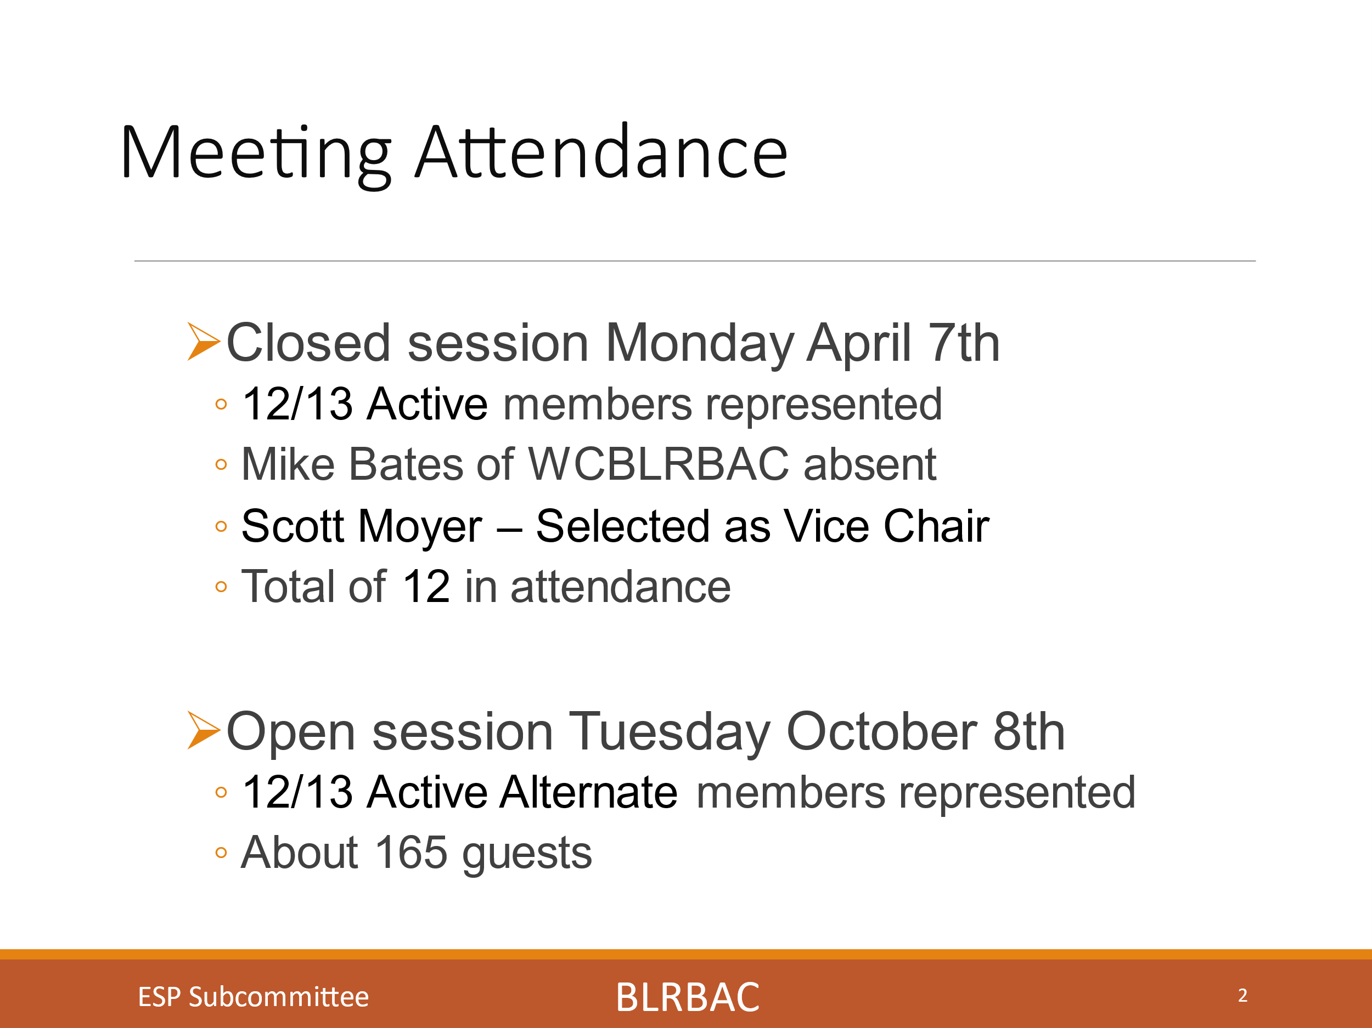
21 Total incidents reported and reviewed (20 US and Canada and 1 International)
There were zero Smelt Water Explosions, 1 ESP with no leak, 1 Smelt leak, 1 DT issue (Classified as an explosion), 11 were Non-critical and 6 incidents were Critical.
Three incidents were ESP’d. 1 with no leak, 1 with a SH leak and 1 Of the 6 critical incidents (6, 15, 16, 18, 19 and 20), one was found during an outage inspection, one was found on a walkdown when there was no bed in the boiler and two were found on a hydro.
Two were critical incidents which occurred in operation with a bed in the boiler.
One was a screen tube and one was an economizer tube behind the generating section with no baffle preventing water from reaching the furnace.
One of the two critical incidents in operation were ESP’d which amounted to 50% of the incidents that should have ESP’d, were actually ESP’d.
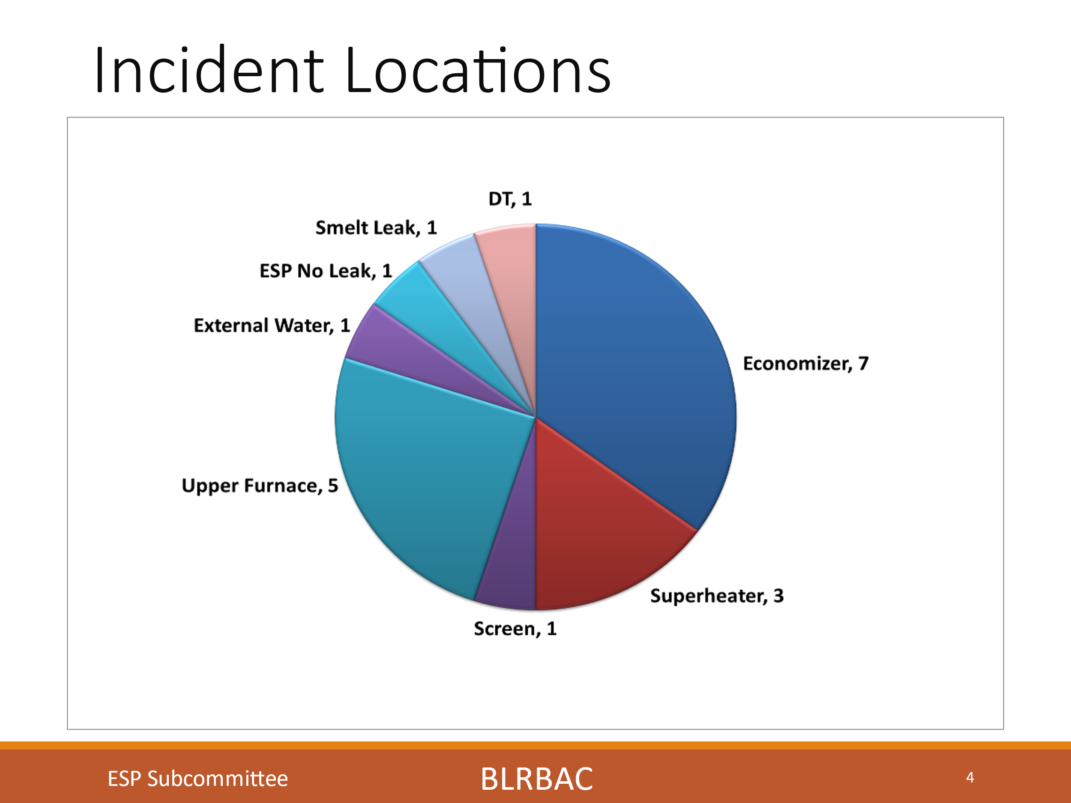
There were 7 economizer leaks, 3 super heater leaks, 1 screen tube leak, 5 upper furnace leaks, 1 external, 1 ESP with no leak, 1 smelt leak and 1 Dissolving tank incident (1 explosion with damage). Superheater and economizer leaks have typically been a larger portion of this chart and continue to be yet we have seen a larger percentage be upper furnace this session.
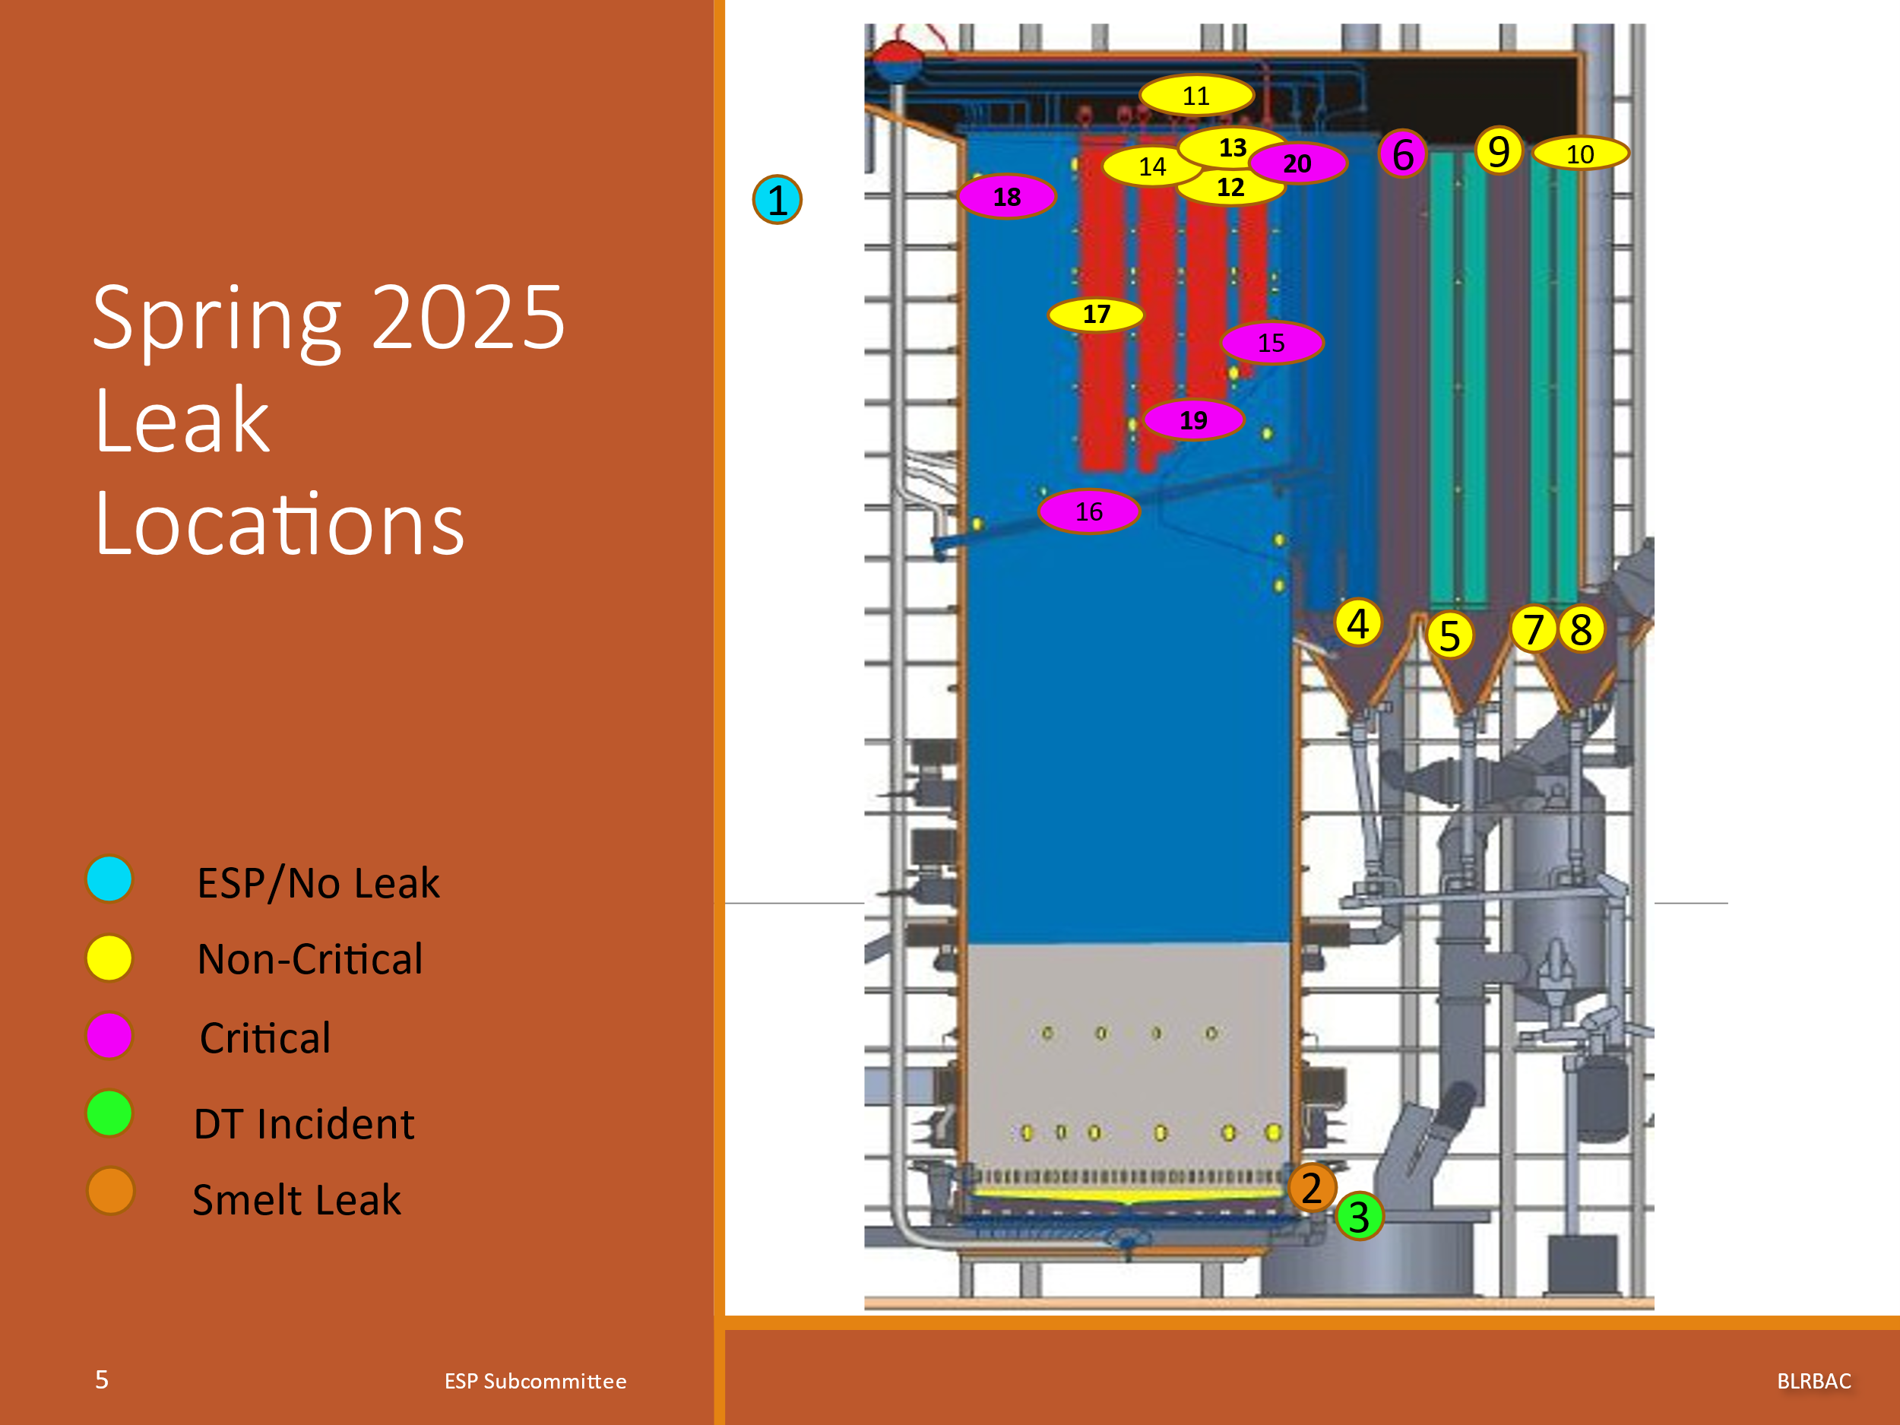
This slide is a side view of a recovery boiler showing approximate location and provides another view of the leak location. Some people like this type of view. It is not fully representative, as it does not also have a front view. Additionally, we now have added the section behind the nose for the generating section showing the location of a typical one drum boiler and two drum boiler leaks will also be shown in this location. The numbers in the circles are the incident numbers.

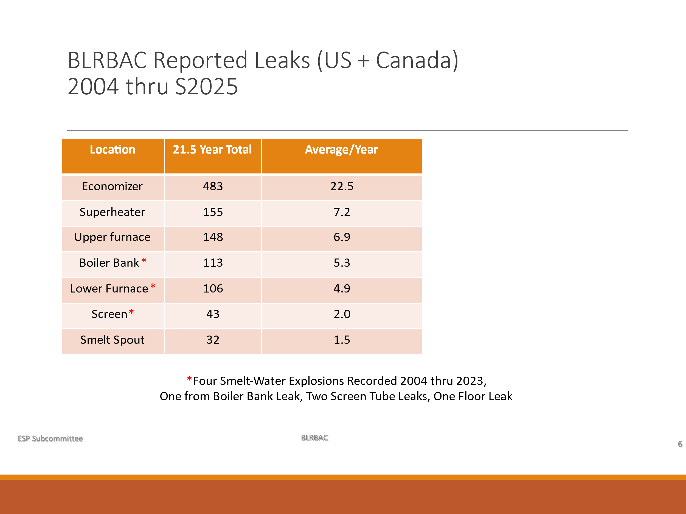
This chart is a total over the years from 2004 to present showing the total number of leaks per section and the average in each section. This is a 21.5-year total. We had 483 Economizer leaks (22.5 average), 155 Superheater leaks (7.2 average), 148 Upper furnace leaks (6.9 average), 113 Boiler bank leaks (5.3 average), 106 Lower furnace leaks (4.9 average), 43 Screen leaks (2.0 average) and 32 Smelt spout leaks (1.5 average). It is good to see that leaks in the more critical areas of the boiler are lower in frequency on the chart. The order has seemed to remain the same although SH and Upper furnace are getting closer.

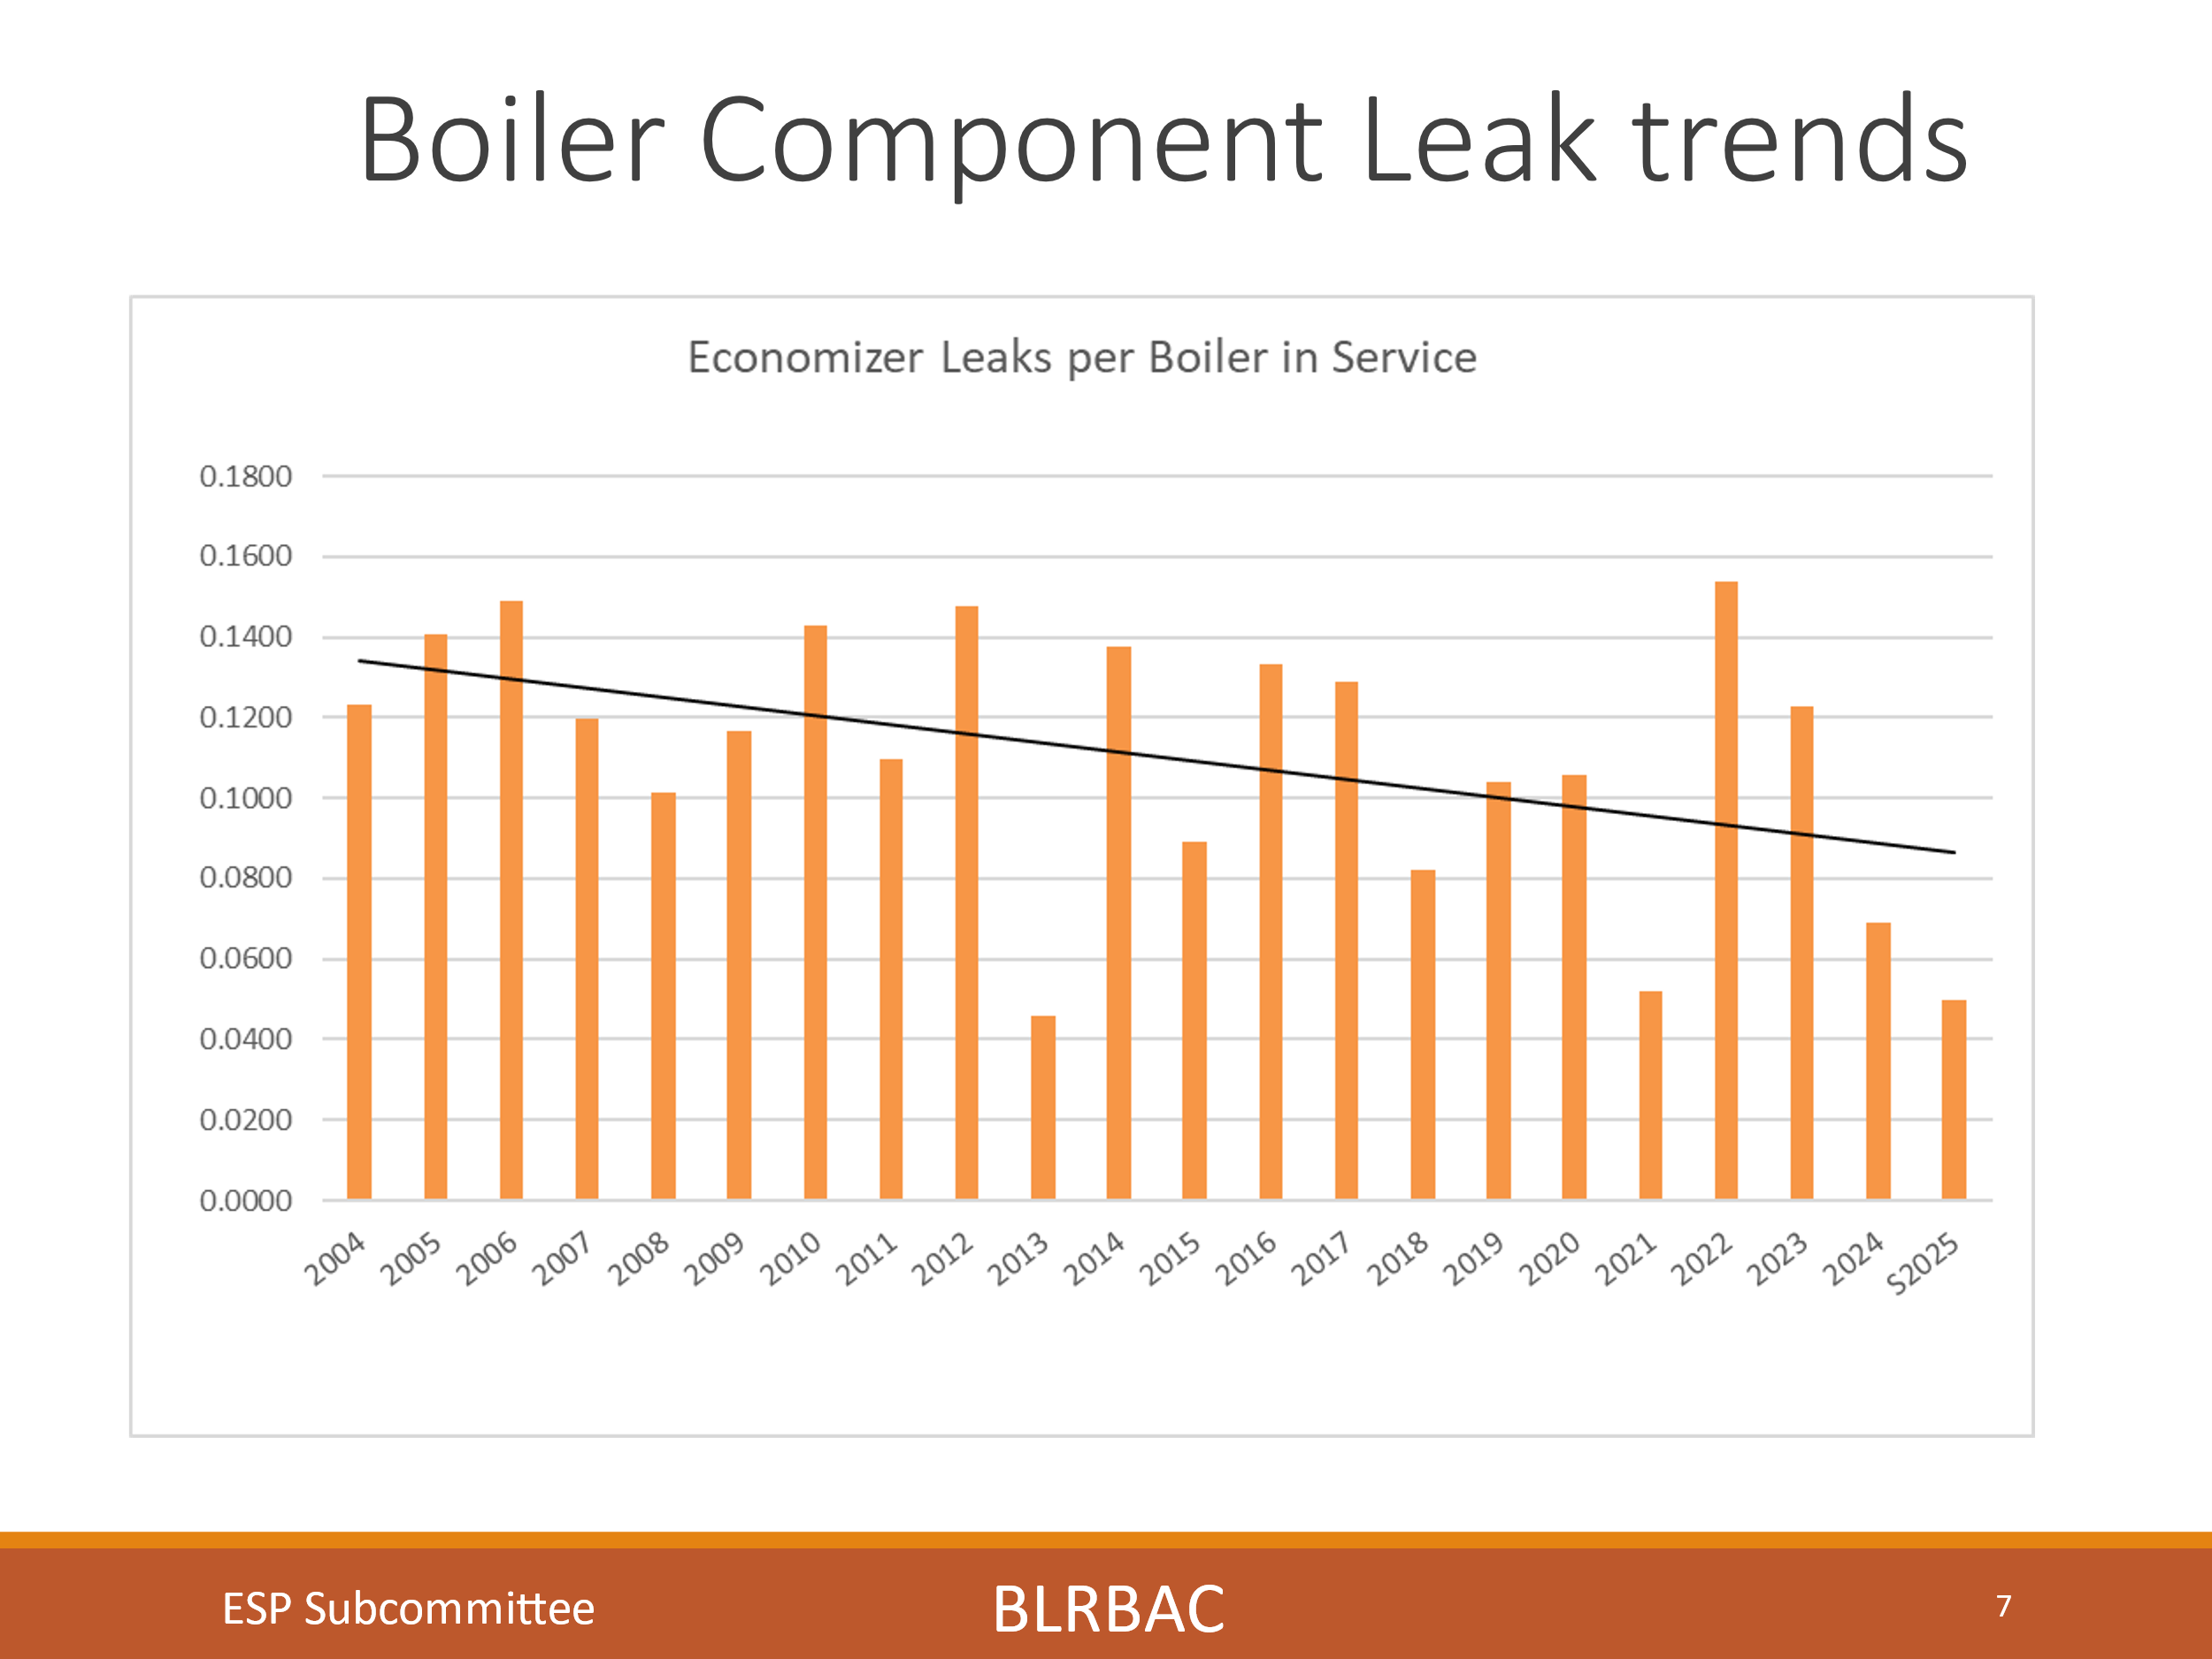
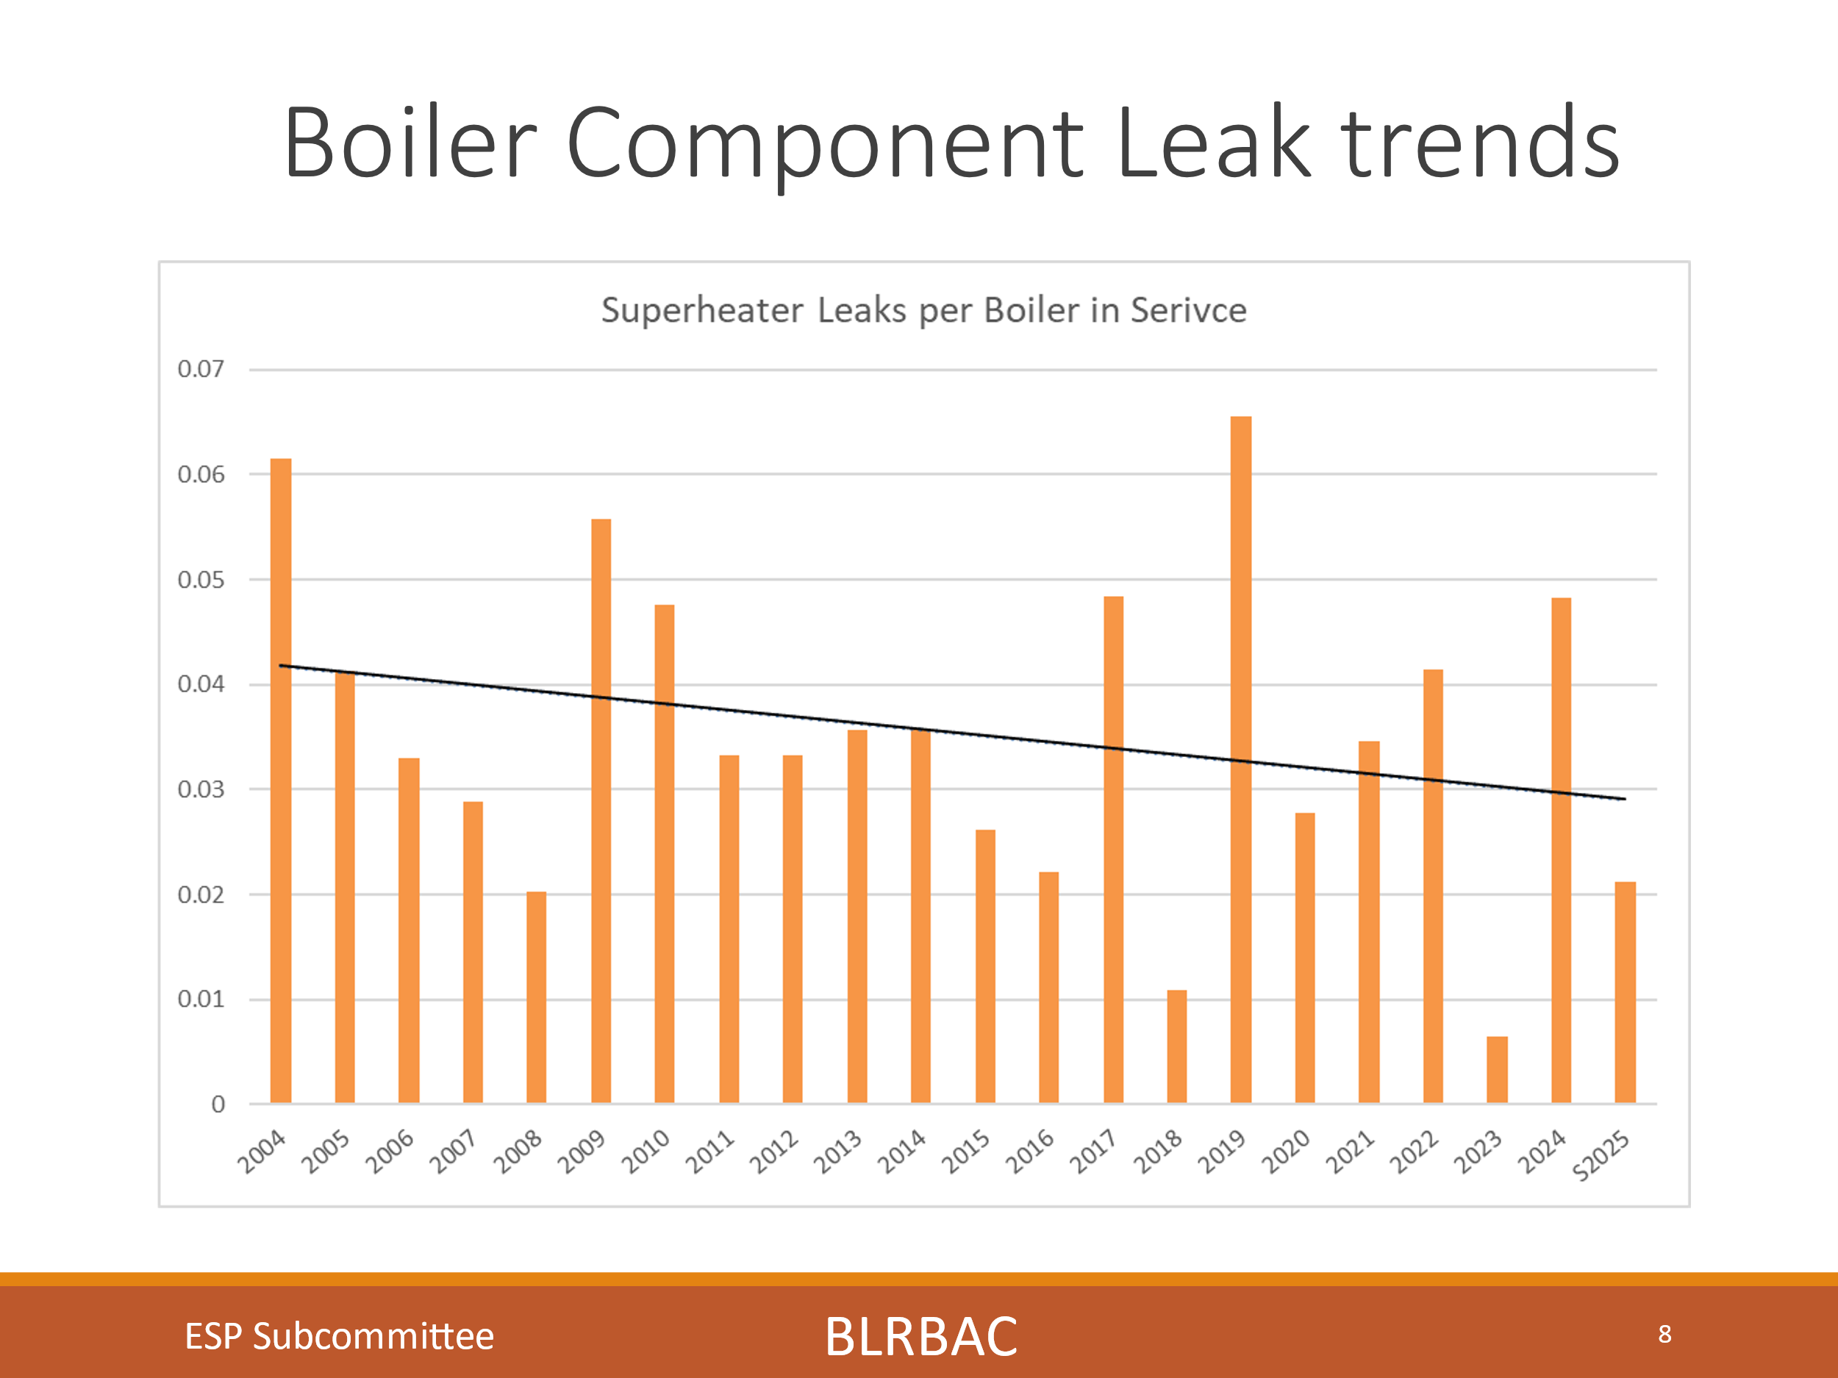
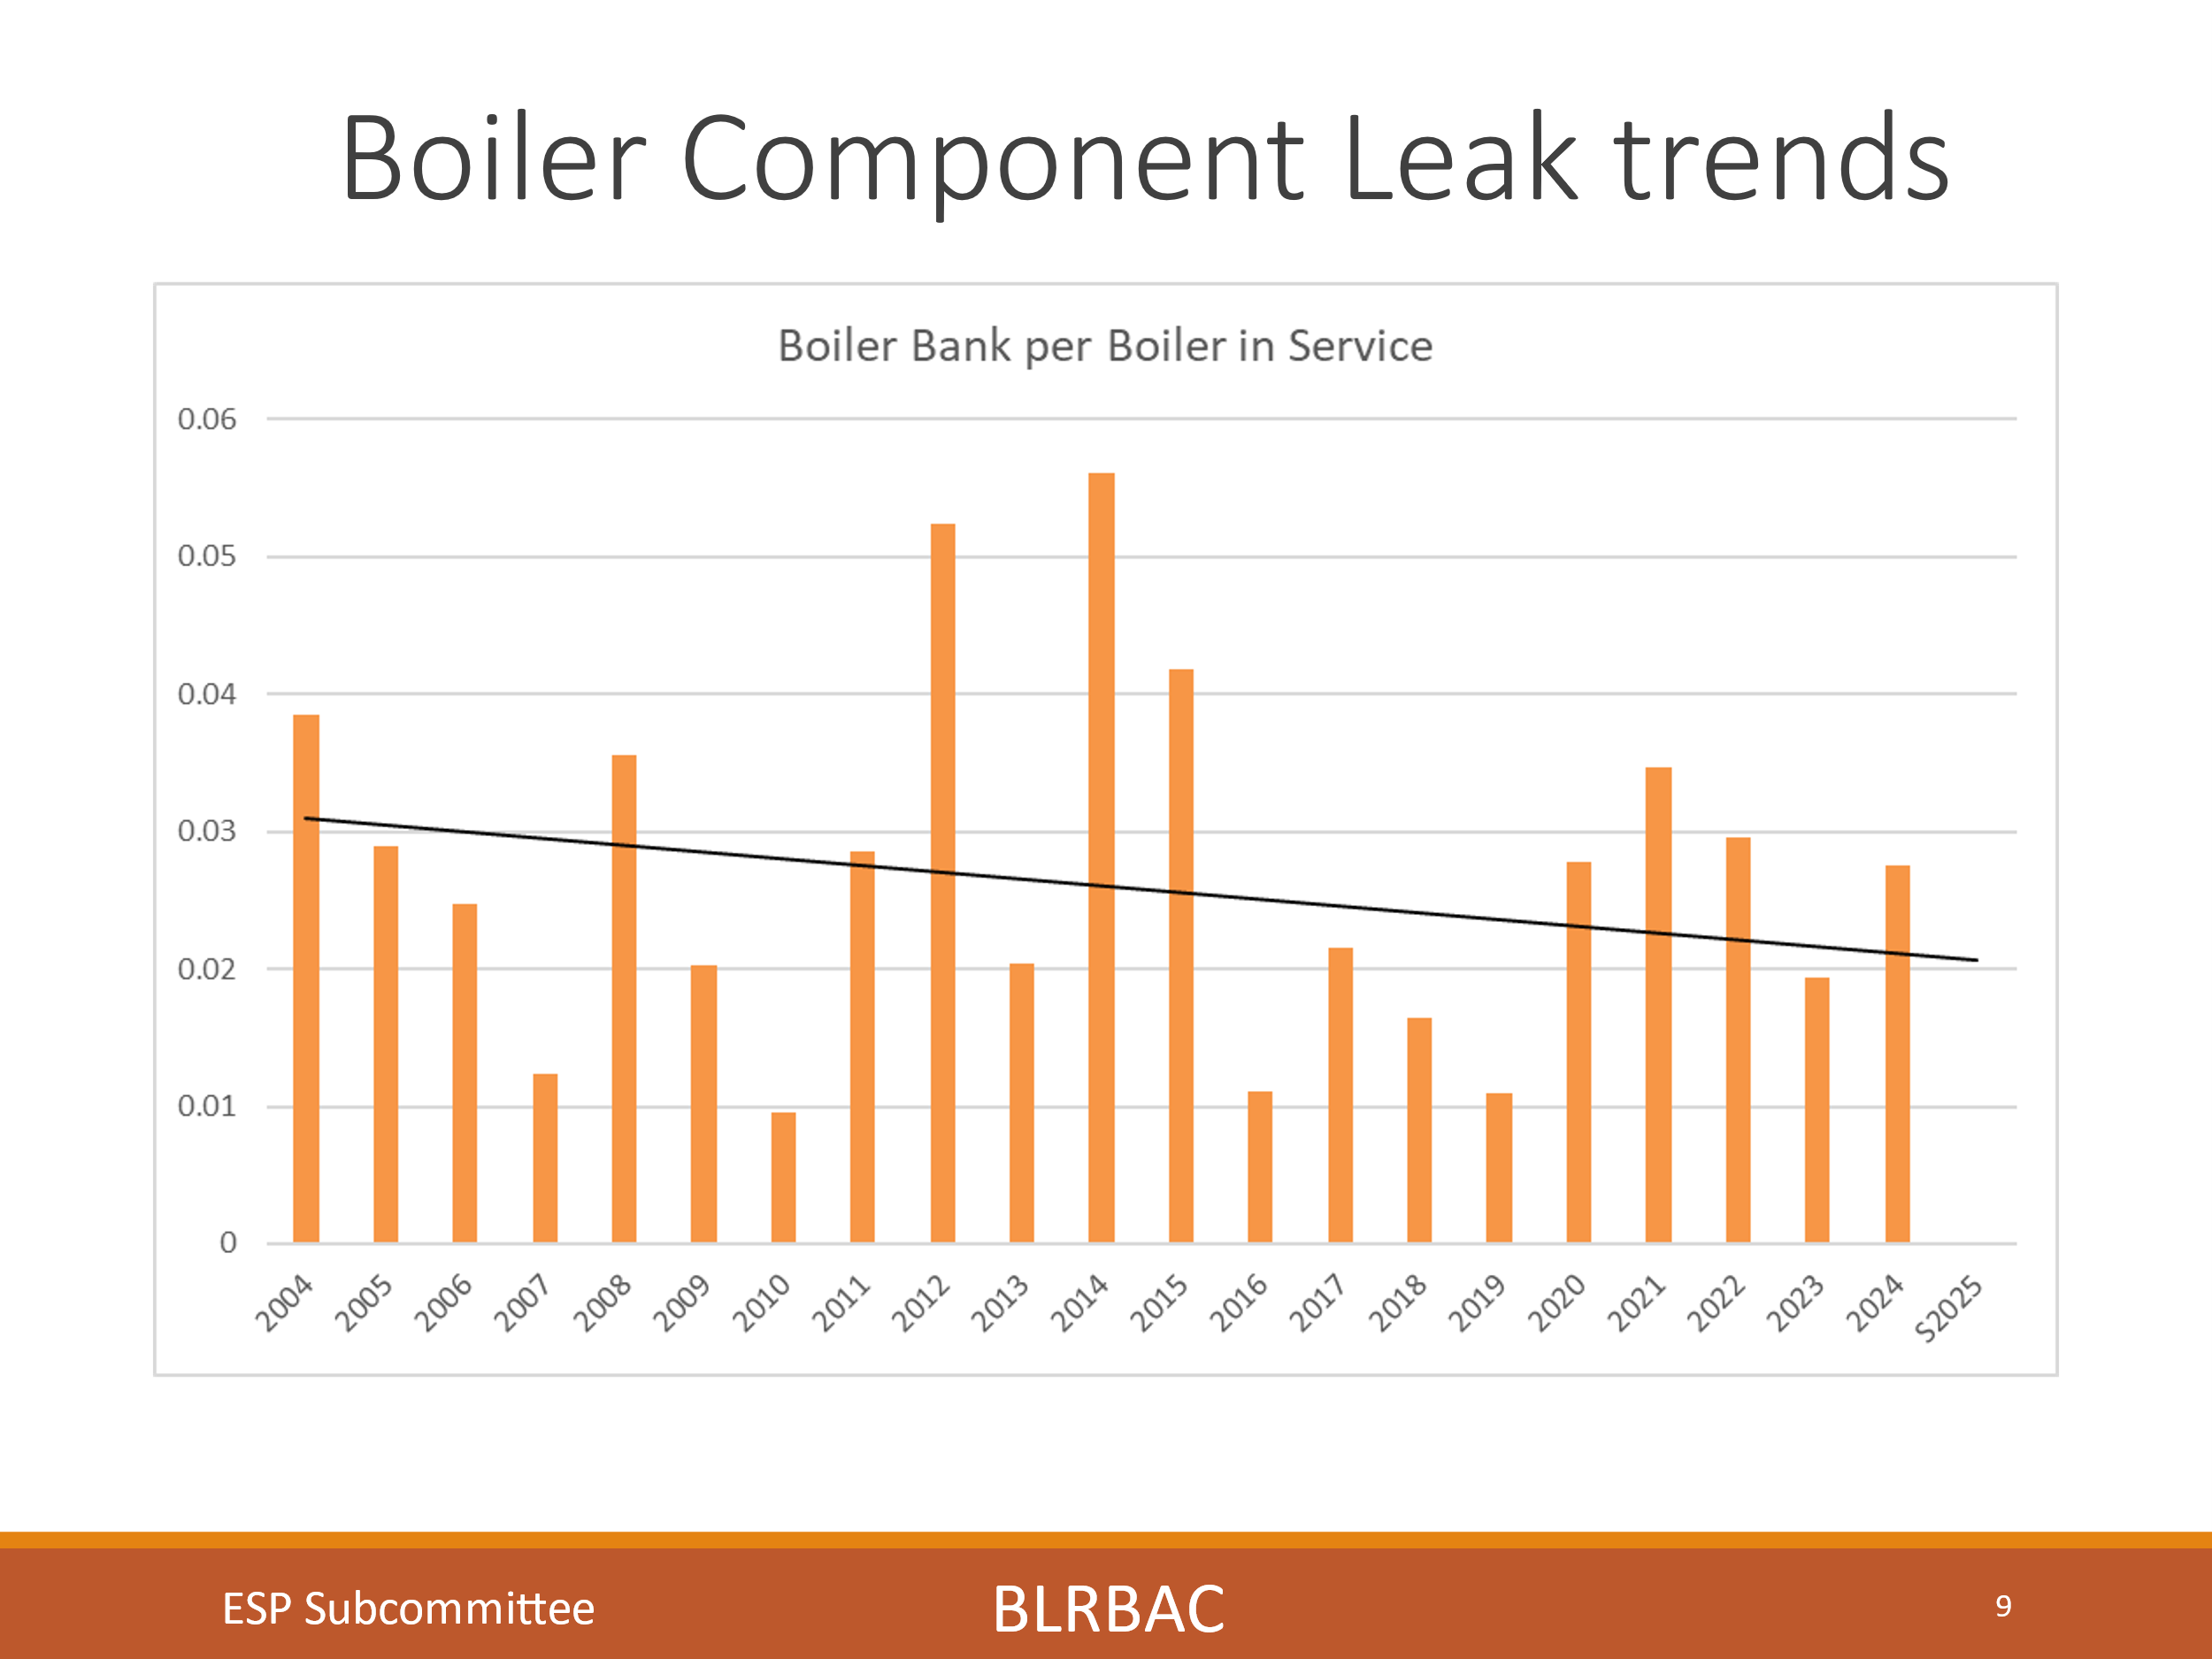
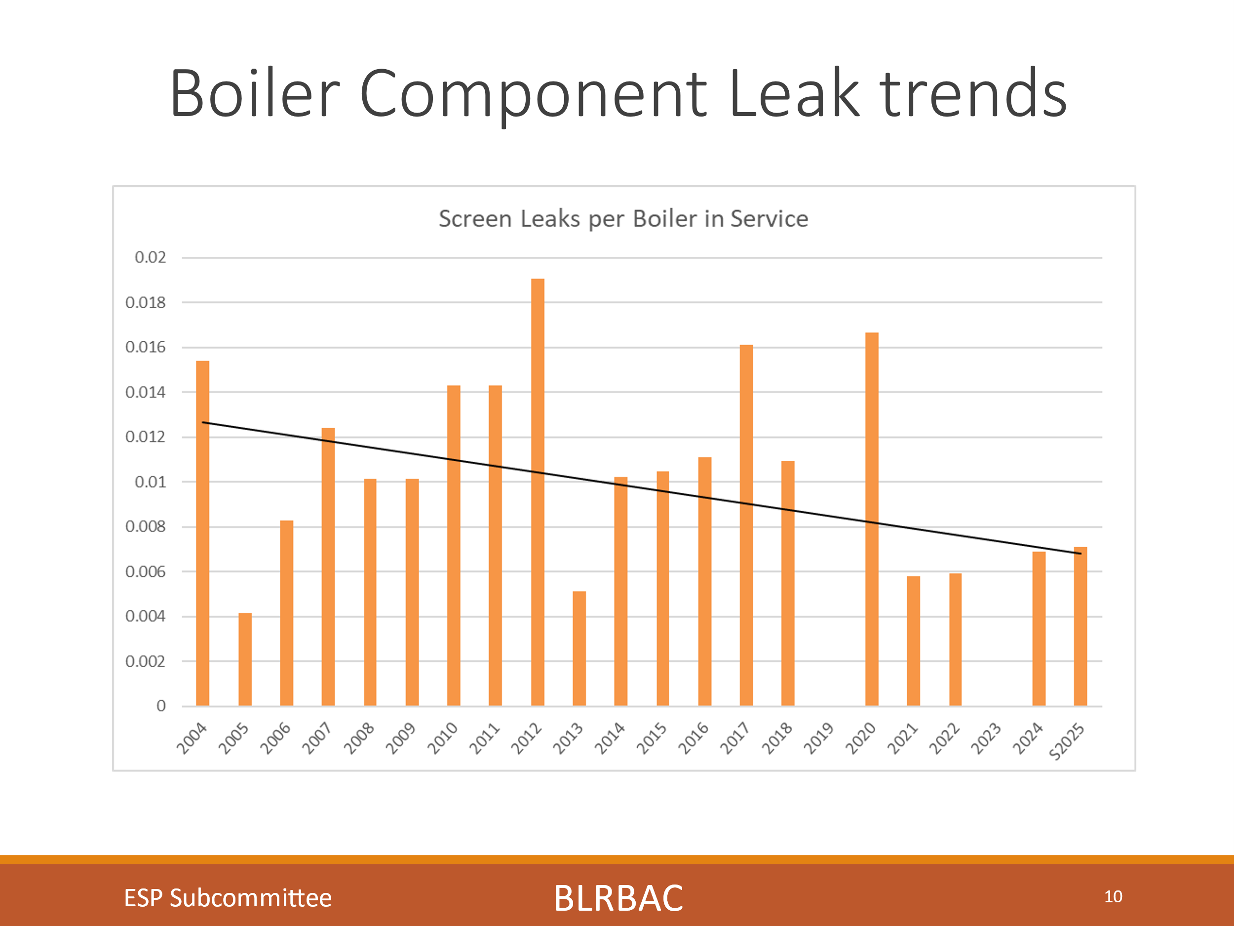

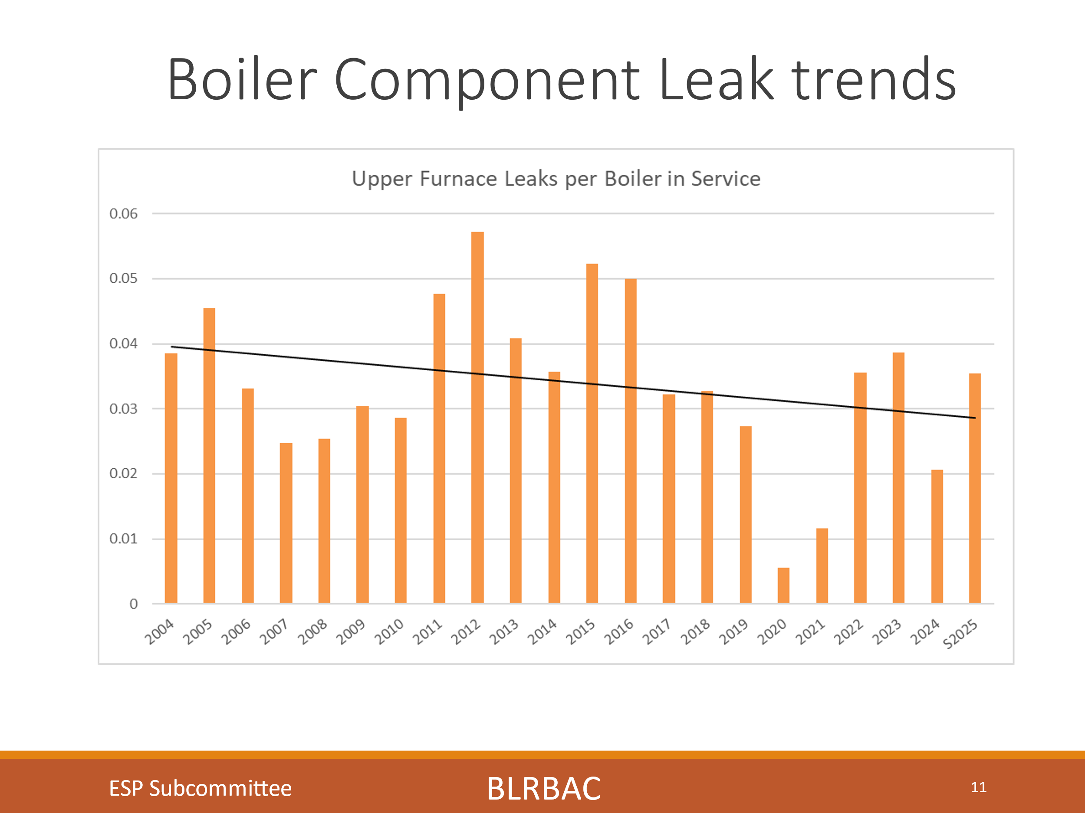
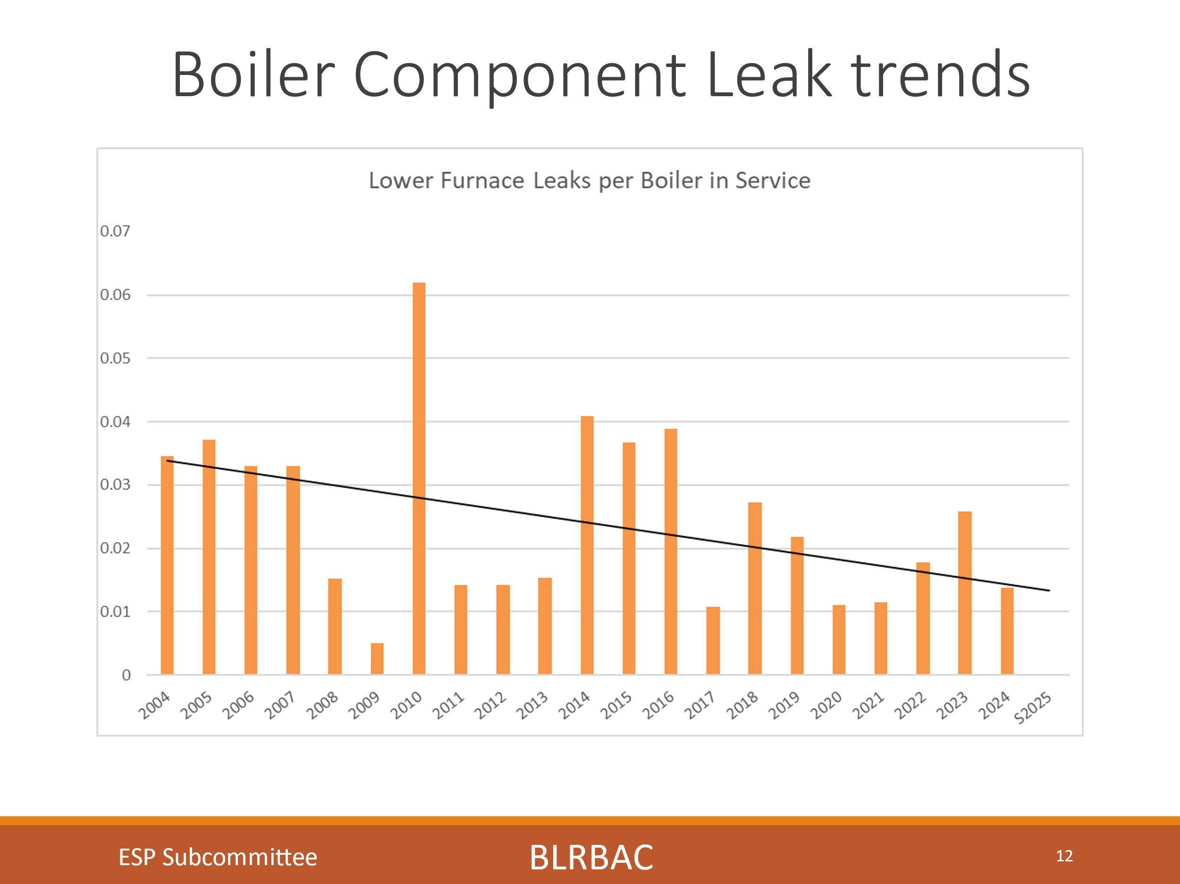
These charts show the trend in number of leaks since 2004 for each section of the boiler (Economizer, Superheater, Boiler Bank, Screen, Upper furnace and lower furnace). We track these trends looking to see if we have made a difference in the number of leaks in each section based on improved OEM design, repair practices, procedures, etc. Previous charts did not take the number of boilers in service that year into account. I have now adjusted for the number of boilers in service that specific year and these trends do not show as drastic an improvement, but still an improvement. I think it is safe to say that although we are always focusing on eliminating leaks, we have not designed, maintained and operated any sections trouble free. Yet you will see later that we have now historically seen less explosions when critical leaks occur, so BLRBAC policies, systems and training have had a significant impact.
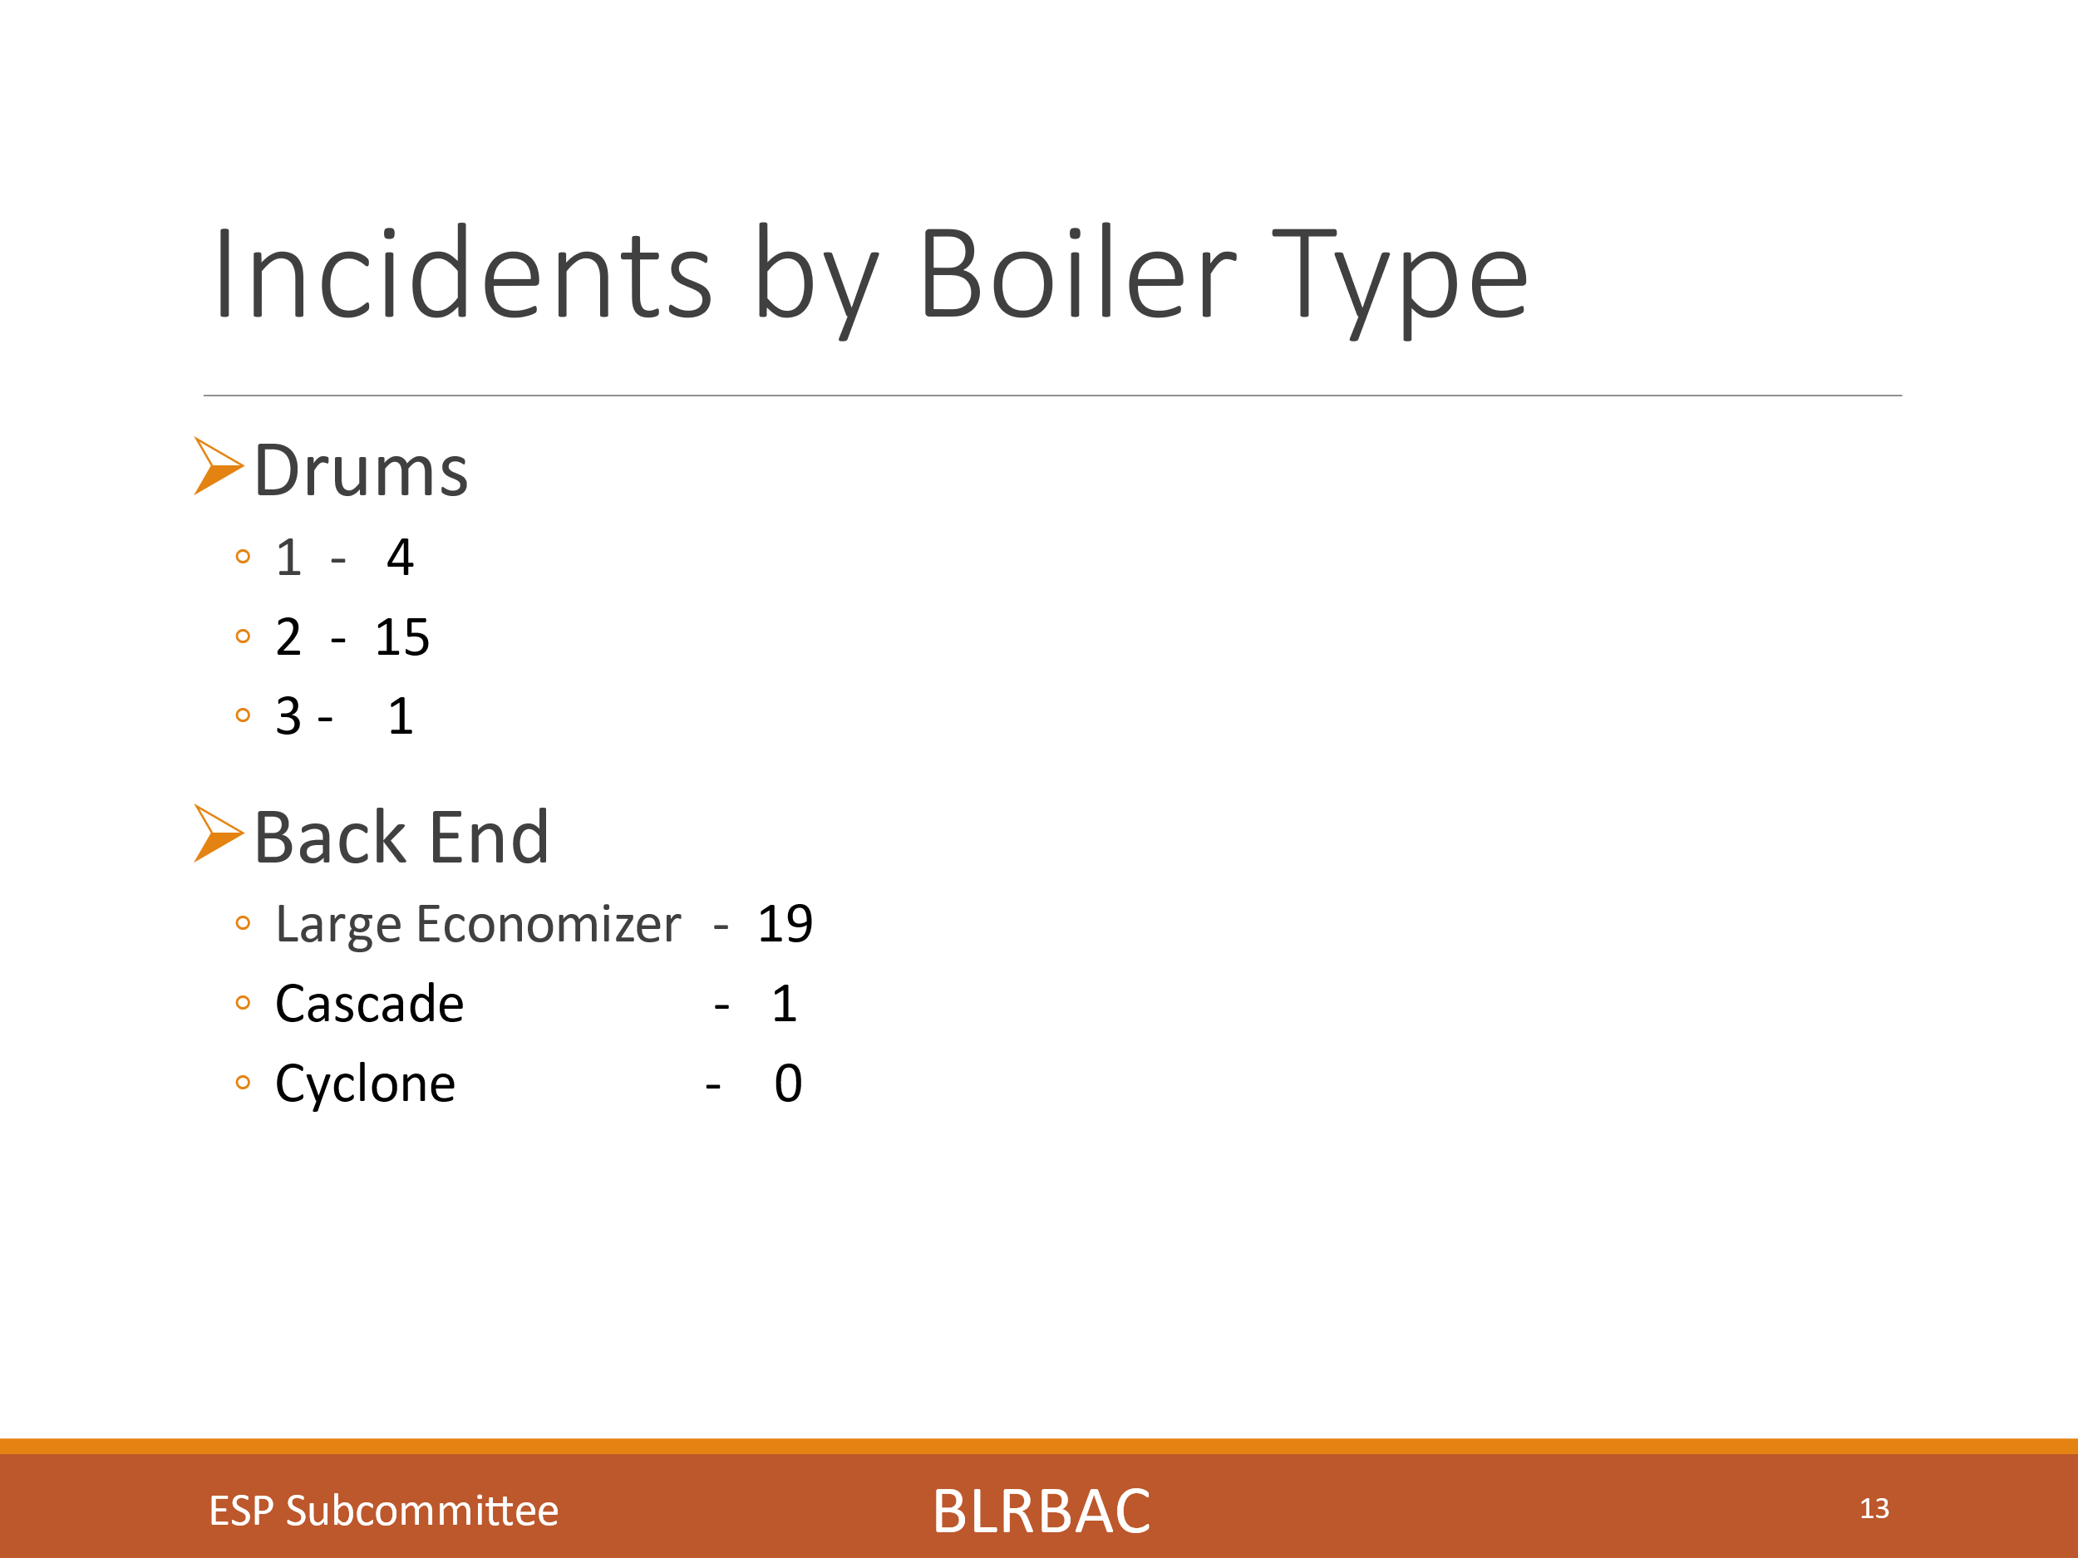
This slide shows incidents by boiler type. We have had 4 incidents reported in a one drum boiler, 15 incidents in a two drum boiler and 1 incident in a three drum boiler. We show 19 incidents in large economizer boilers and 1 in a cascade boiler. The larger number in large economizer boilers is likely due to a larger number of these type boilers being in service.
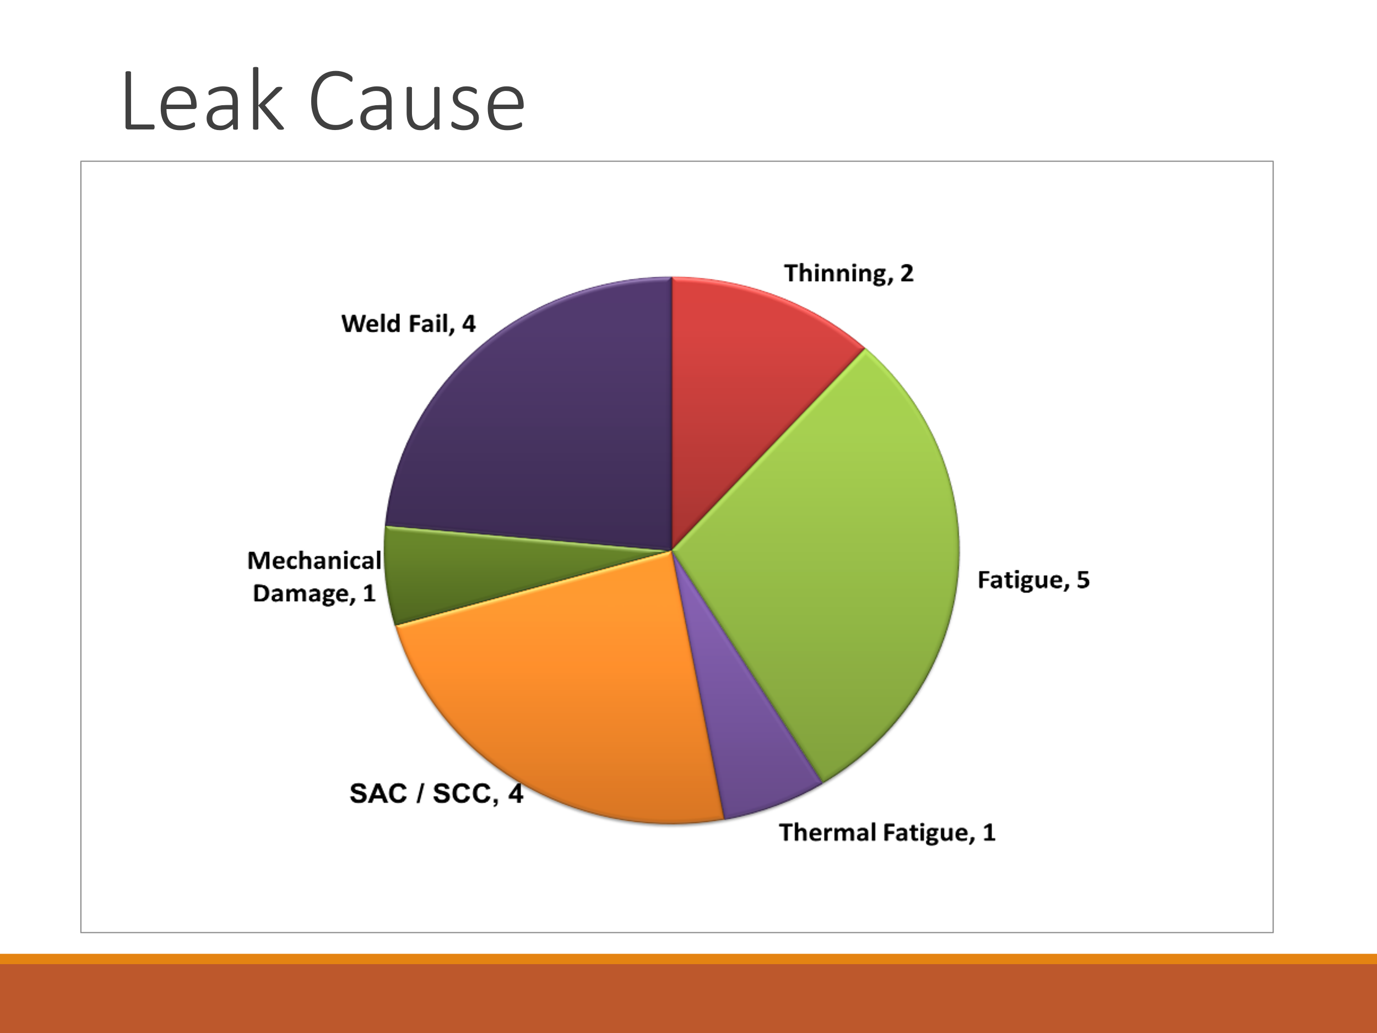
Regarding chart shows root cause of leaks, we had 2 thinning failures, 5 fatigue failures, 1 Thermal Fatigue, 4 SAC/SCC failures, 1 mechanical damage, and 4 weld failures. We continue to see SAC/SCC failures which is a mechanism to watch for with an aging fleet and large numbers of thermal cycles. Yet we are seeing failures due to Fatigue and Weld failures creep up.
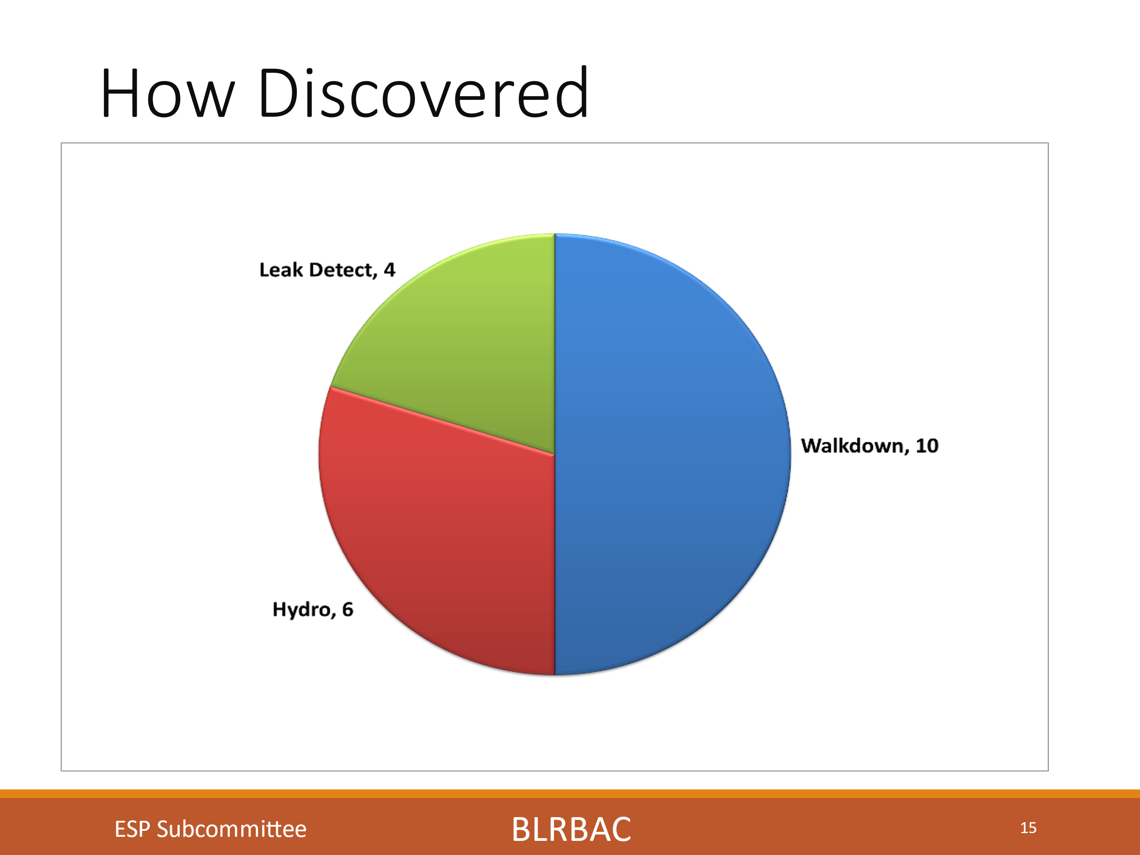
This chart shows how the leaks were detected, and again it shows a high percentage found by the operators on walkdowns. These are typically in the 75% -90% range each session with this session being at just 50%. We had 10 found on walkdowns (One visually during an internal inspection on an outage).
We had 6 leaks reported found on a hydro this session and it begs the question if leak detection systems are sensitive enough. This also stresses the importance of training operators and the value of walkdowns.
We also had 4 leaks found through Leak detection systems.
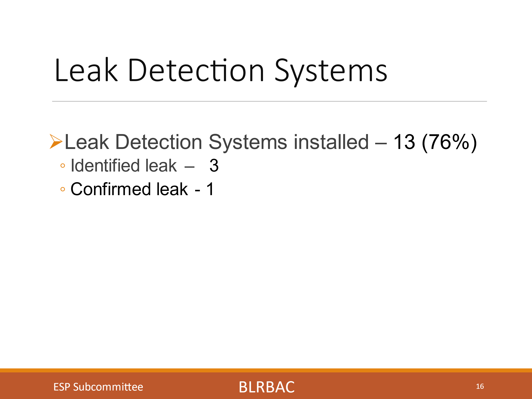
We had 13 incidents reported with leak detection systems installed on the units (76% of the units). Three of the leak detection systems initially identified the leaks. It was identified that one leak detection system was trending upward when going back and looking at the data trends but it had not yet alarmed. As always, system detection sensitivity can play a part in the system’s ability to initially detect a leak or not.
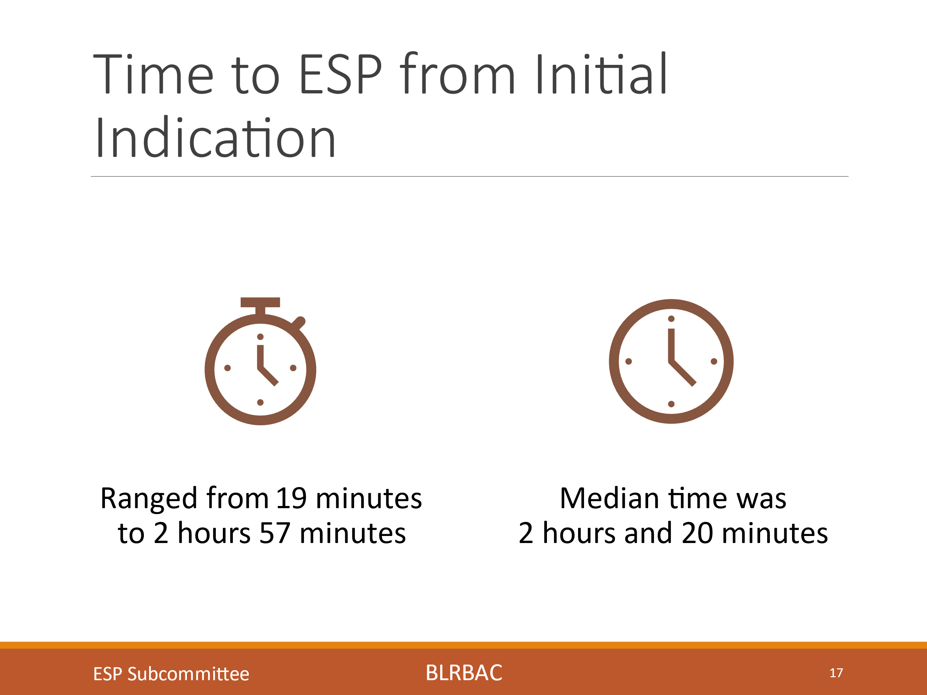

This chart indicates the time from first discovery of a leak, to the time the unit was ESP’d. The time ranged from 19 minutes to 2 hours and 57 minutes. The average time was 2 hours and 20 minutes. As we know, evaluating a leak is a stressful and critical time. The time to act to ESP the unit on an actual leak is critical, and training and education can only help improve these times.
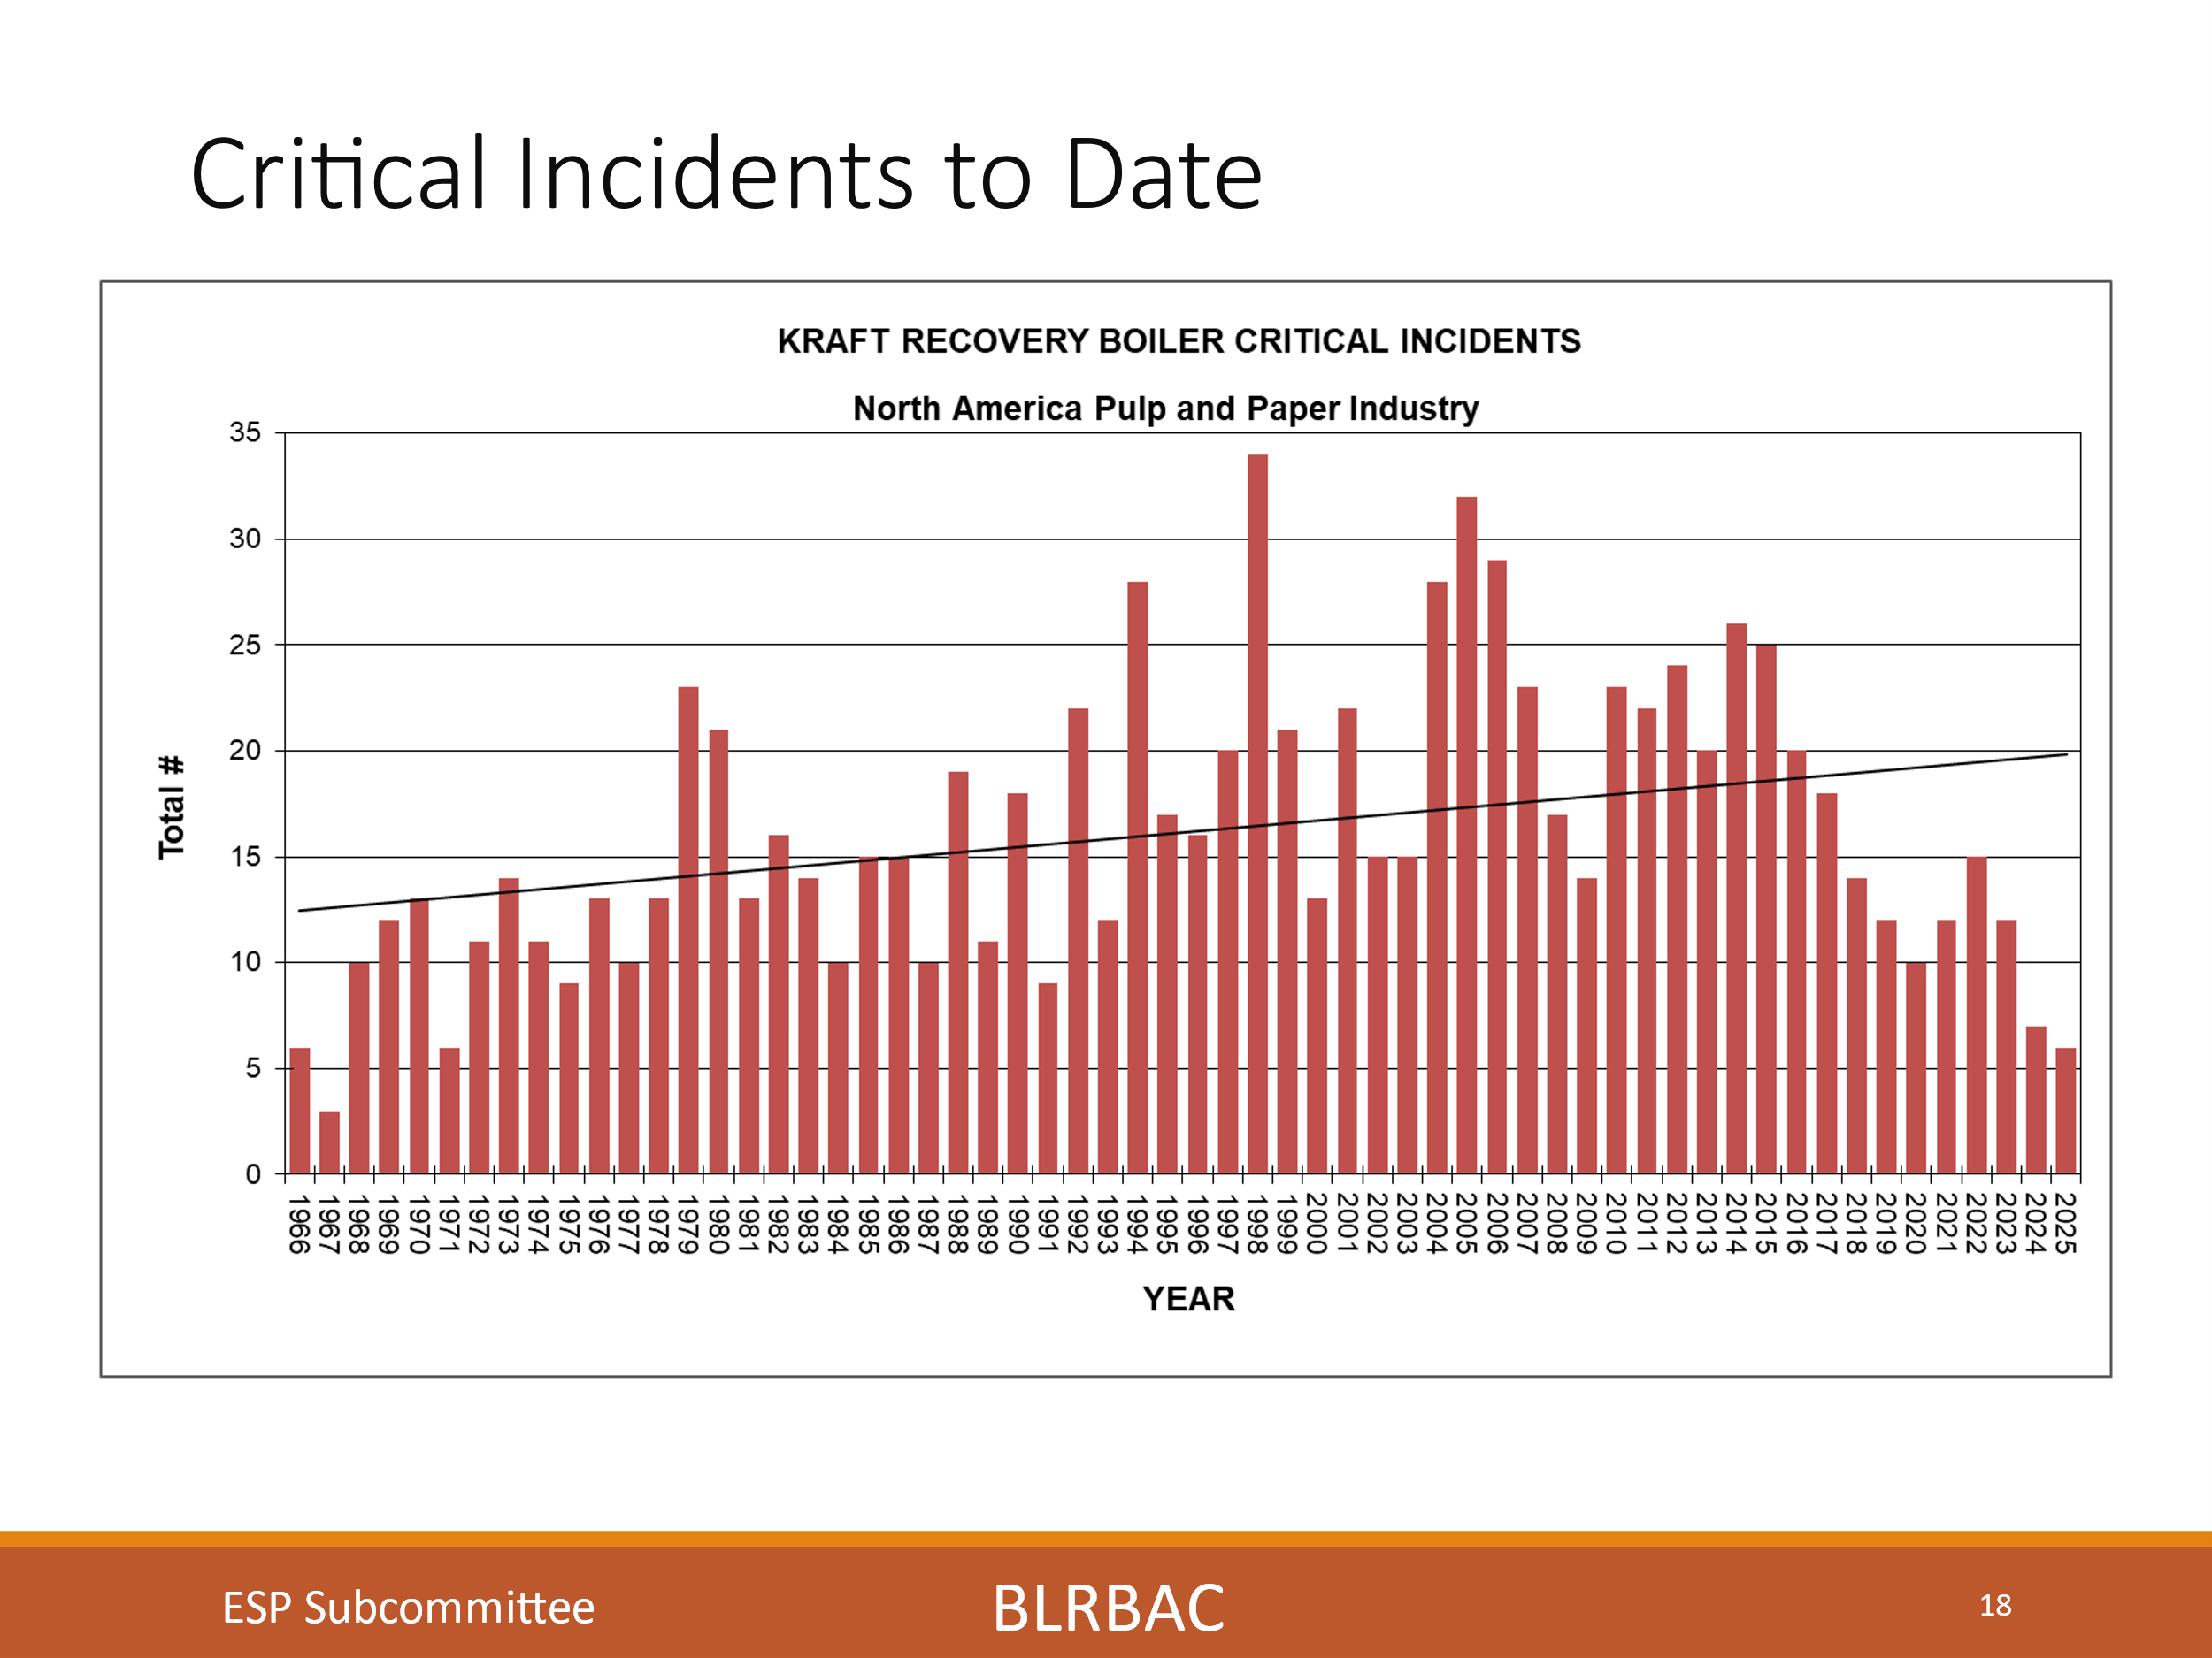
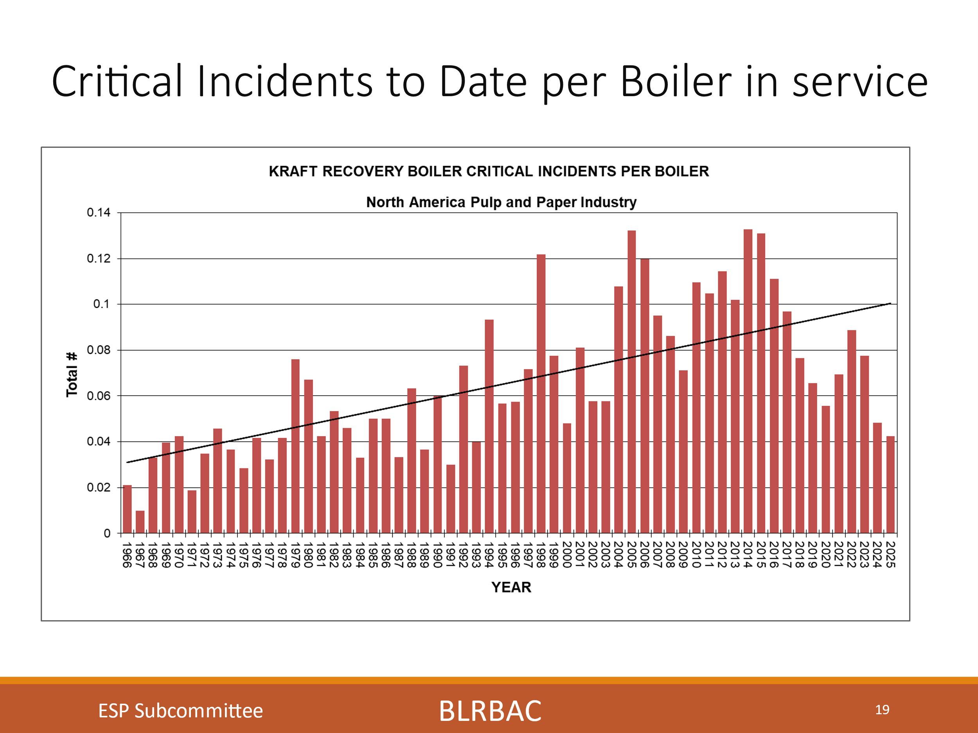
The two charts show Critical incidents to date. The first chart is the way we used to track it, just the straight number of critical incidents per year. I have now adjusted it to show a trend in Critical incidents per boiler. You can now see that it shows much larger rise in the number of critical leaks per boiler now that the number of boilers have been taken into account.
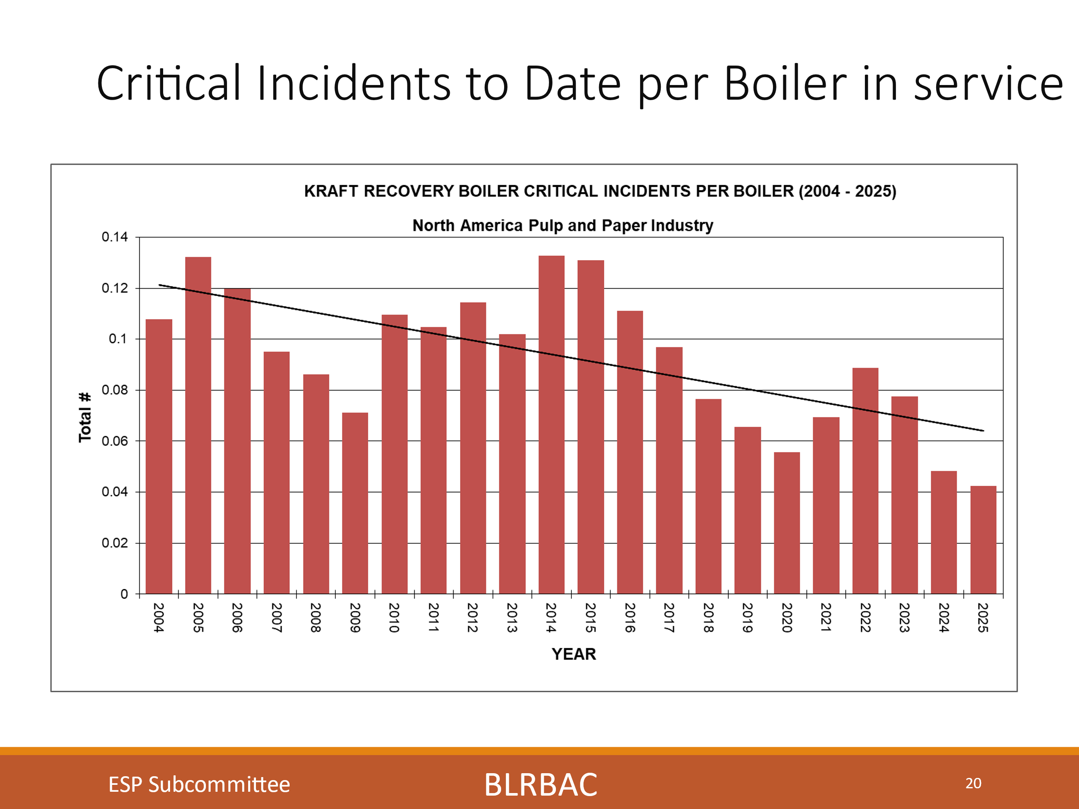
Looking at it solely for the last 20 years (Similar to the basis for the earlier charts), we do see an improved decreasing trend that we need to stay on.
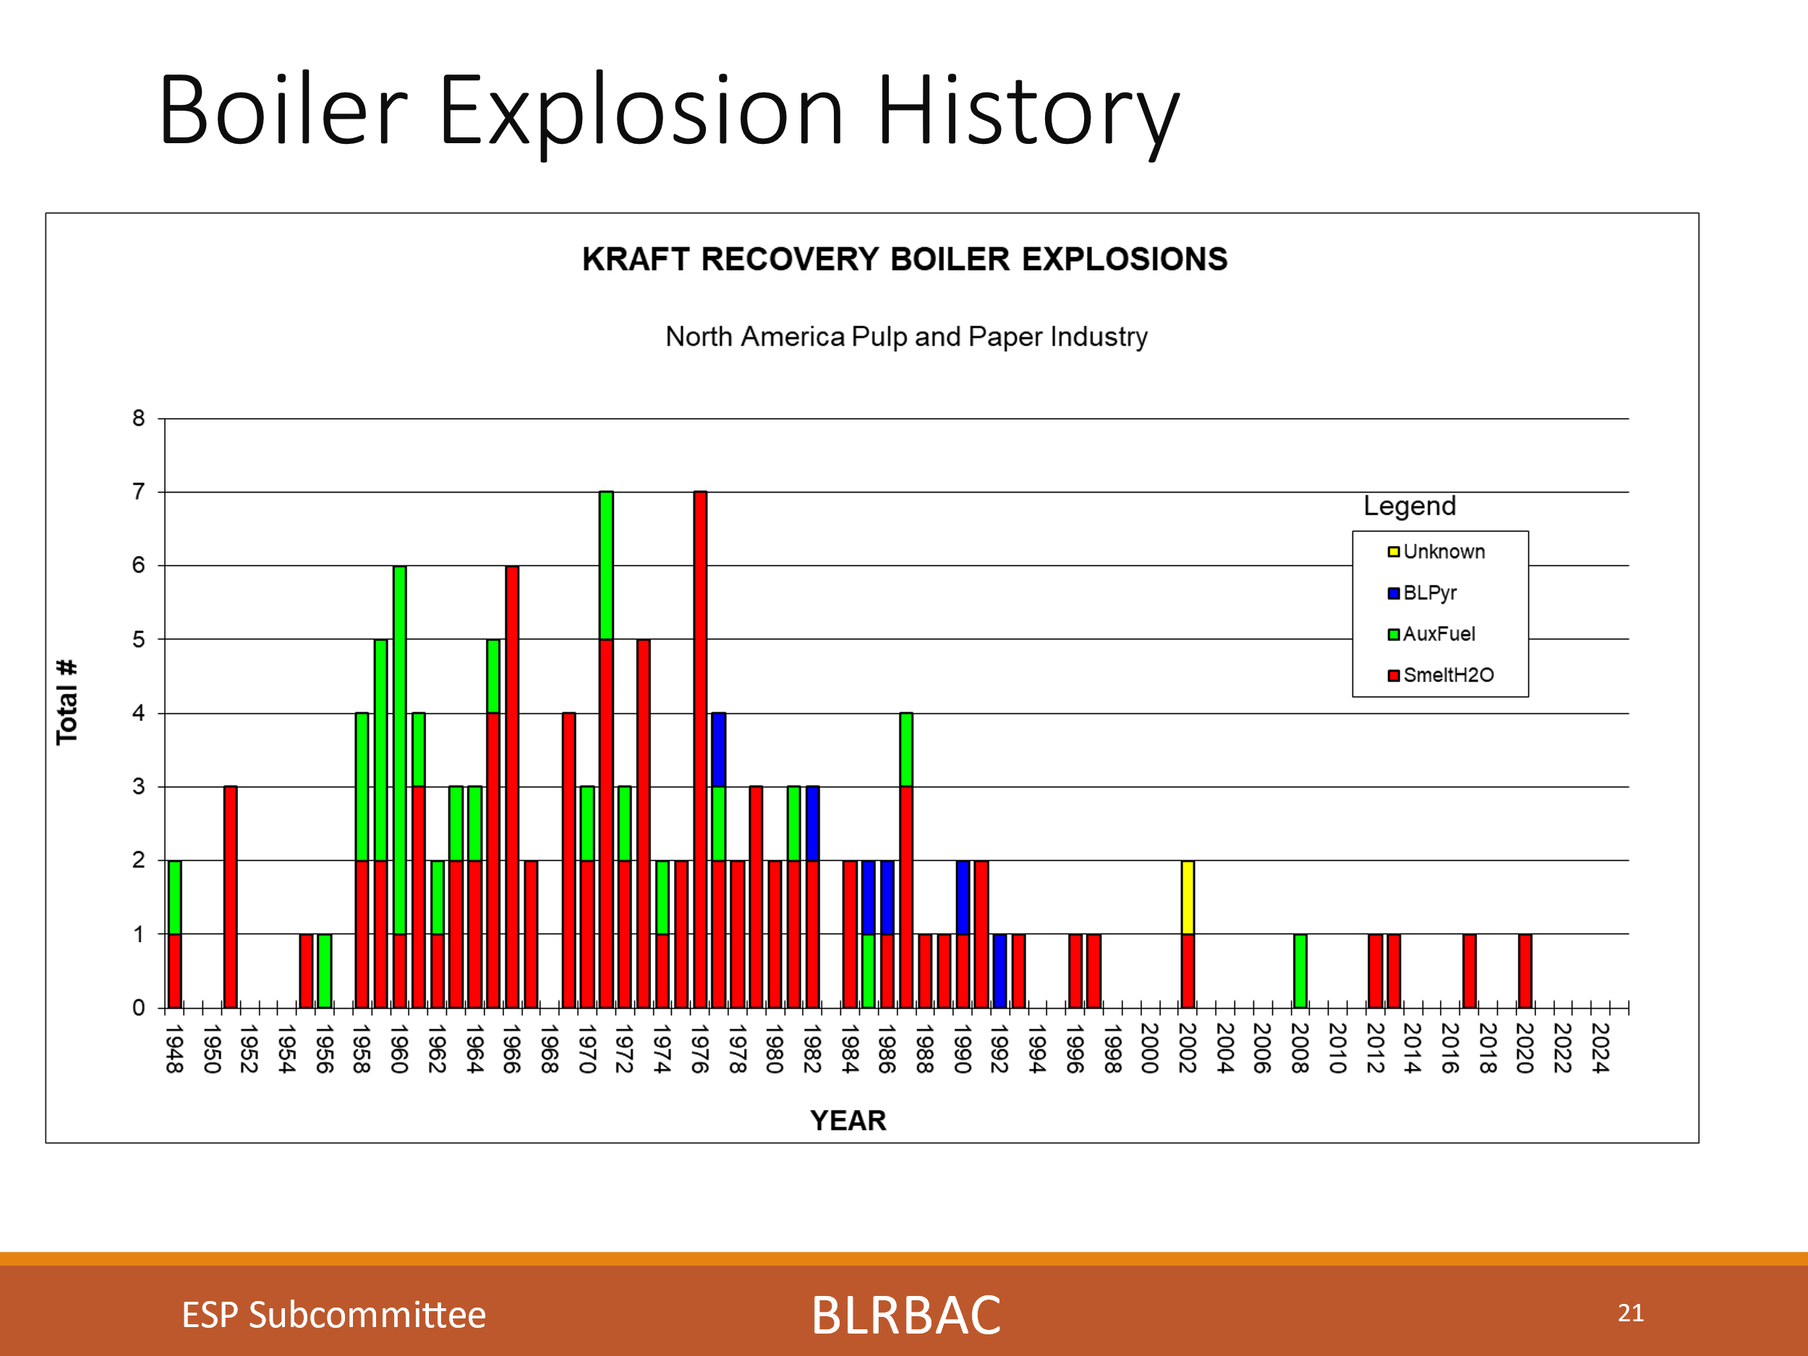
The chart shows Boiler explosion history. So why if the number of critical incidents per boiler increased since 1966, did we see less explosions?
I would dare say that we have instituted better systems, equipment and guidelines to recognize, handle and prevent these incidents from having disastrous consequences.
We have instituted walkdowns as a prime example, which as you have seen, typically find 75 - 90% of leaks. Finding leaks early and reacting to them properly is just one example of the things we as an industry, working through BLRBAC, have done to proactively prevent bad situations from becoming worse.

This is a testament to everyone who has participated in the BLRBAC organization over the years and has been (And continues to be) a part of the constant learning, guideline development and operating diligence that it has taken to affect these results. It is also a testament to the operations people who do these walkdowns and discover leaks early and who have implemented the systems and procedures to handle them.
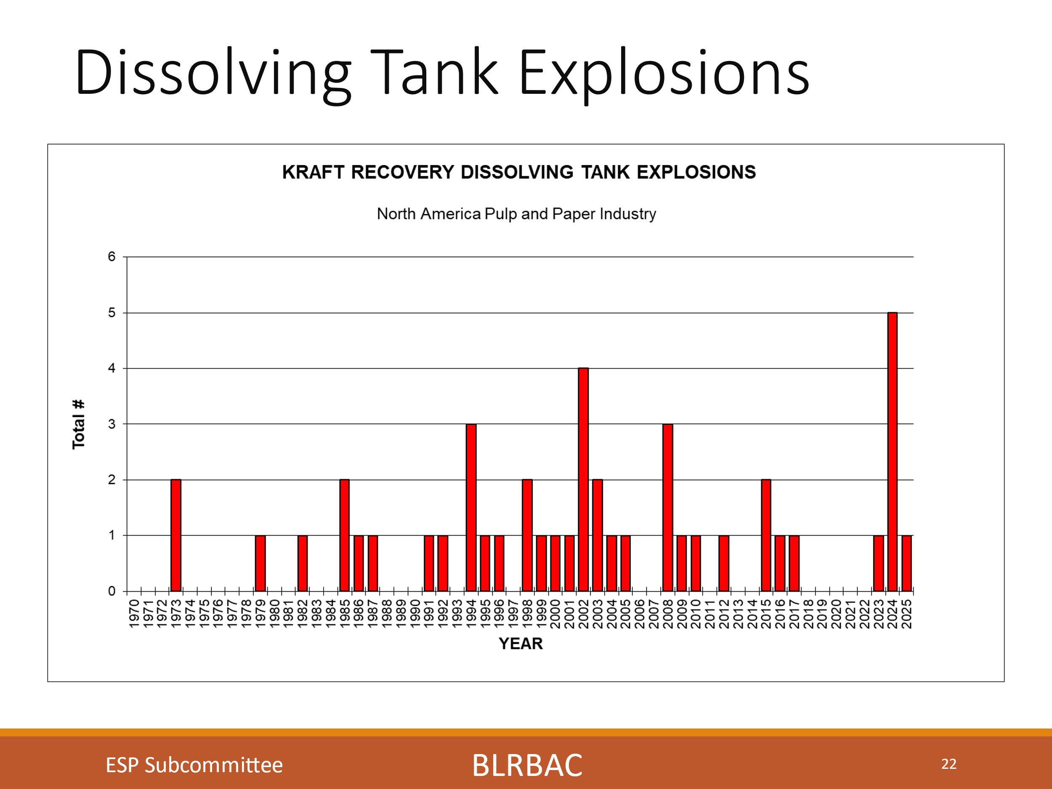
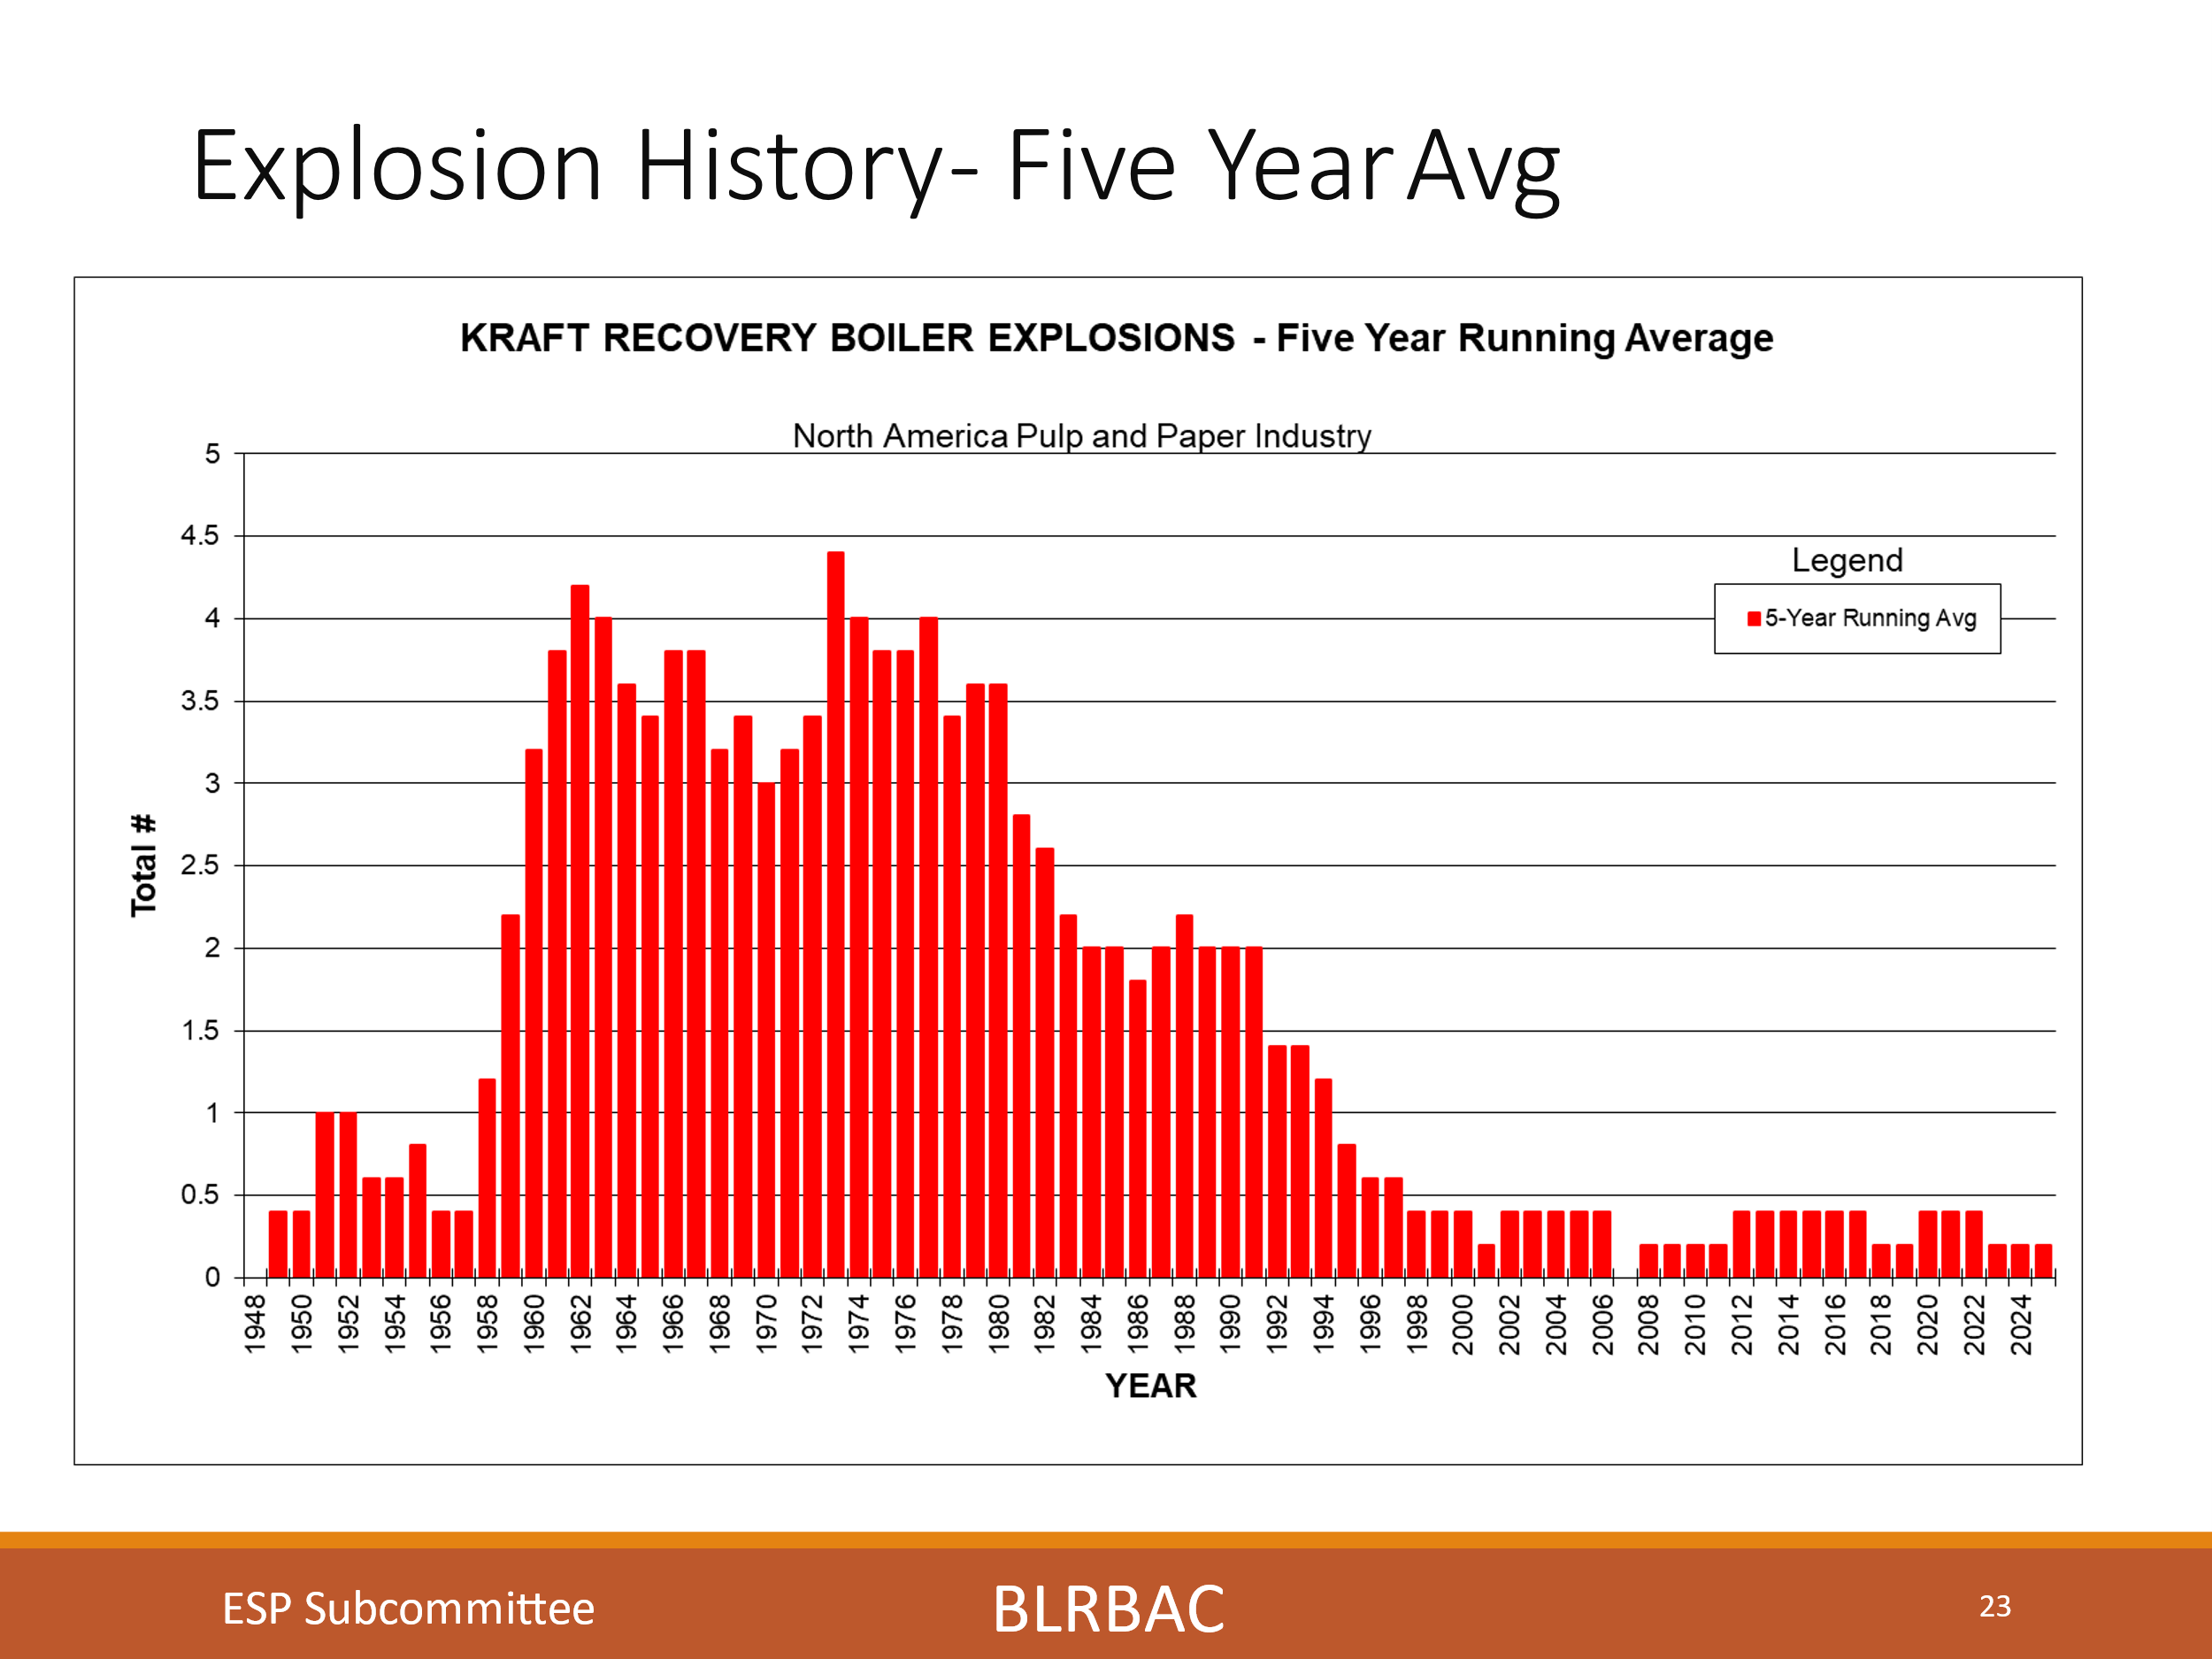
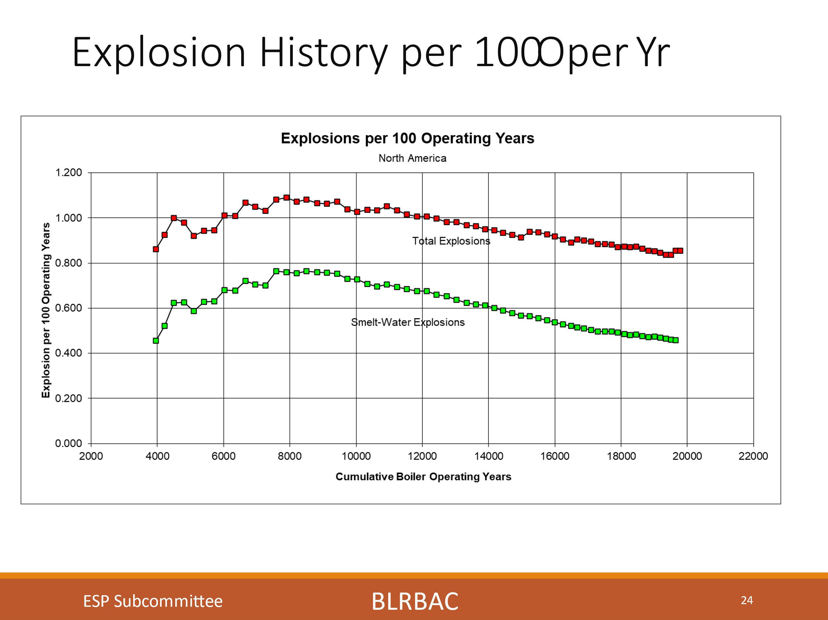
These charts show Dissolving tank explosions, Explosion history 5-year average and Explosions History per 100 operating years. We look at these charts to identify long term trends and improvements made. You see an uptick in the chart for explosions per 100 operating years. This last chart is a combined Recovery Boiler and Dissolving Tank chart. In the future, I will possibly look at separating them.

We know still that not all Dissolving tank incidents are being reported. We continue to encourage reporting dissolving tank near misses/plugged spouts/hood damage as incidents, so we can understand the issues leading to these incidents and be more preventative. We had 1 incident reported this session. We would like to encourage everyone to report these.
With this effort of reporting incidents, not just explosions, I feel we can have the same result as we have had with RB Explosion prevention through education, systems and guideline development.
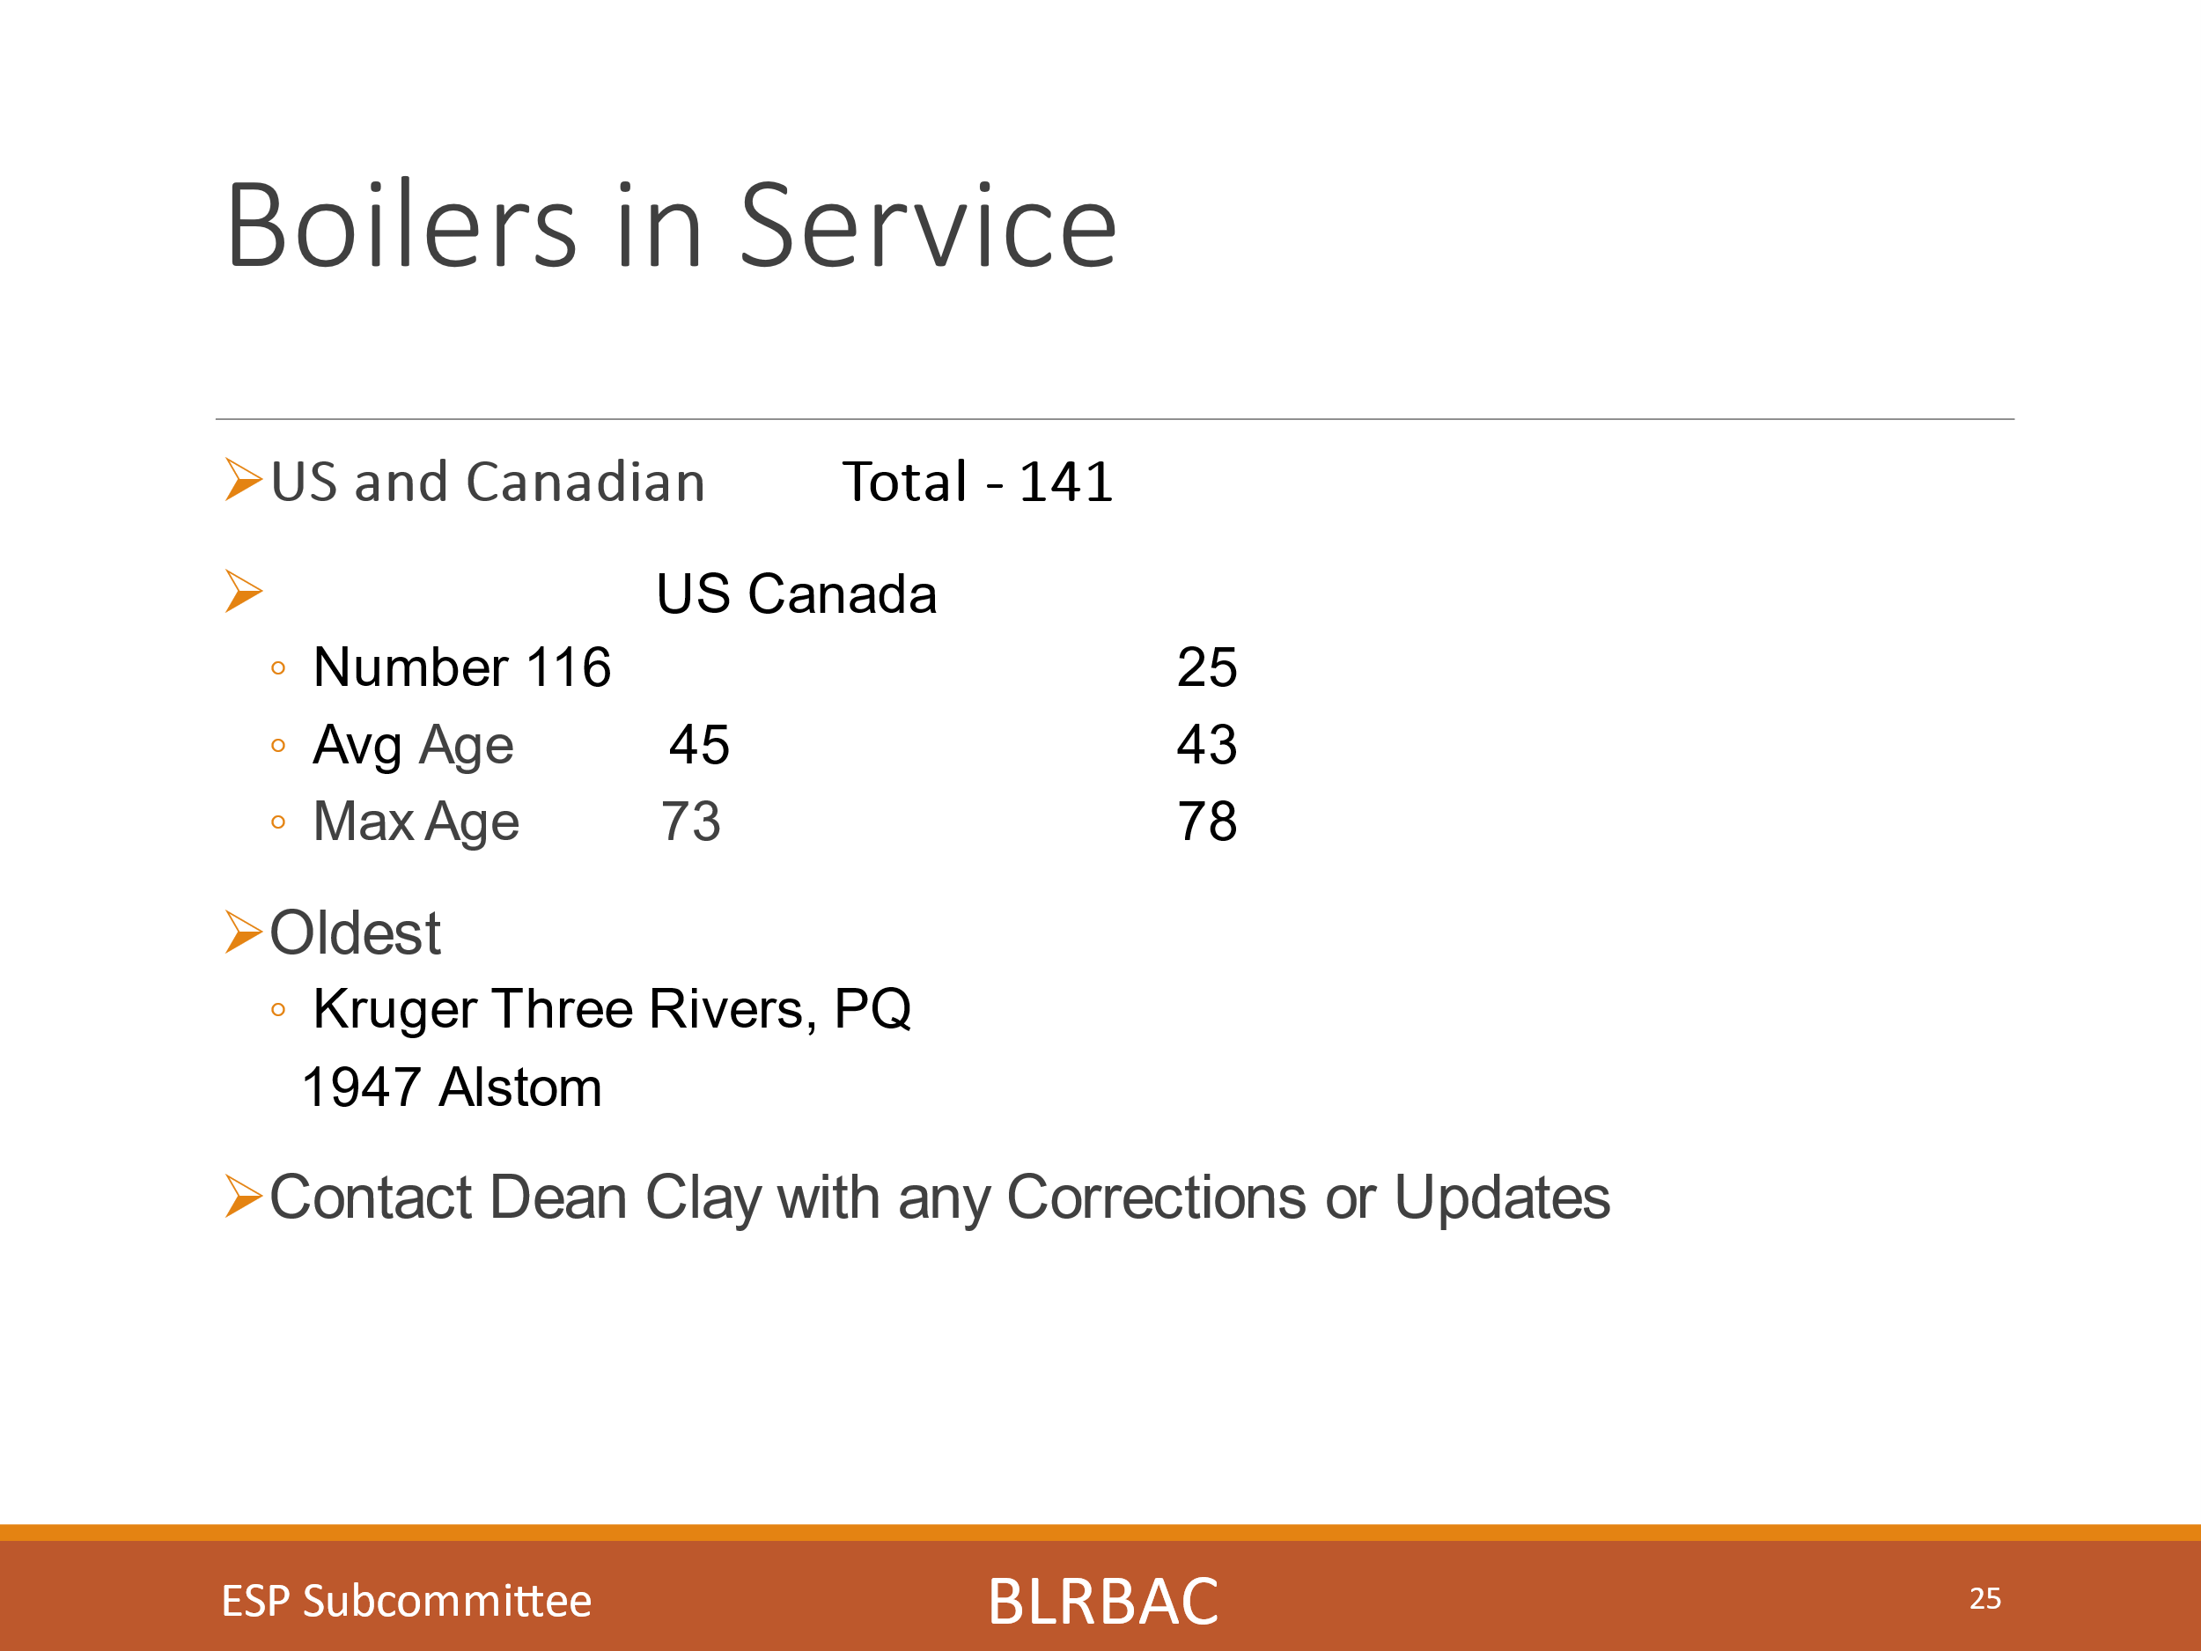
This chart shows the number and age of units in North America. We have 116 units in the US and 25 in Canada for a total of 141. The average age in the US is 45 years and in Canada is 43 years. The maximum age in the US is 73 years and in Canada is 78 years. The oldest unit in operation is the Kruger Three rivers, PQ unit and it is a 1947 Ahlstrom Boiler. Please send Dean any updates.
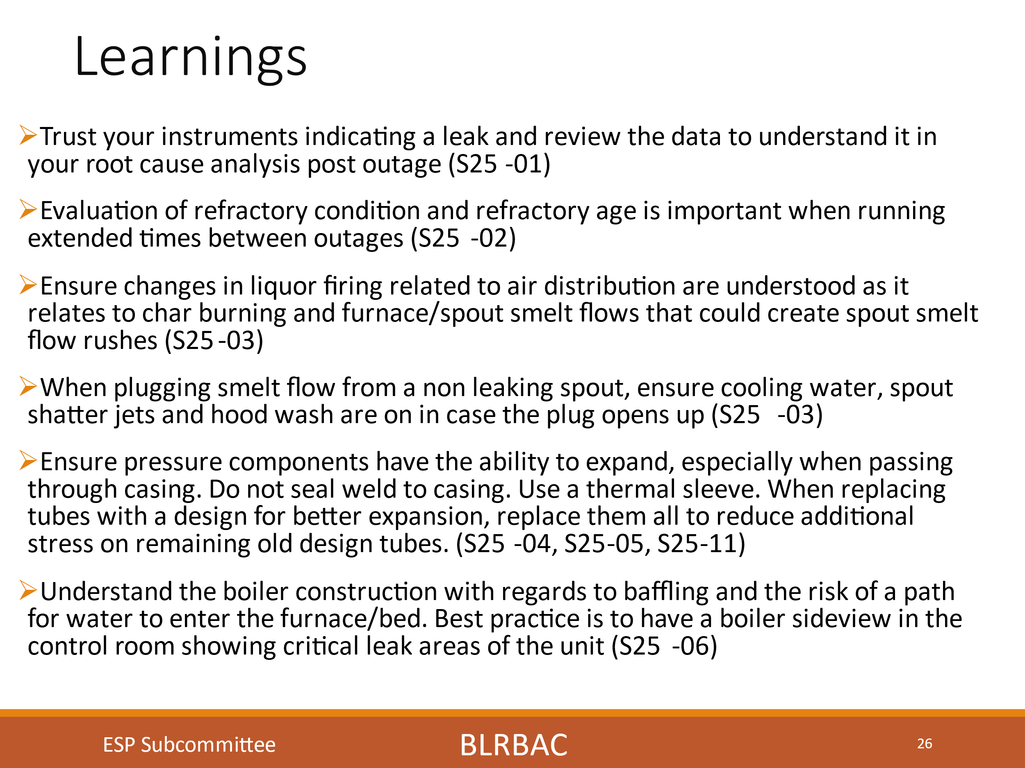
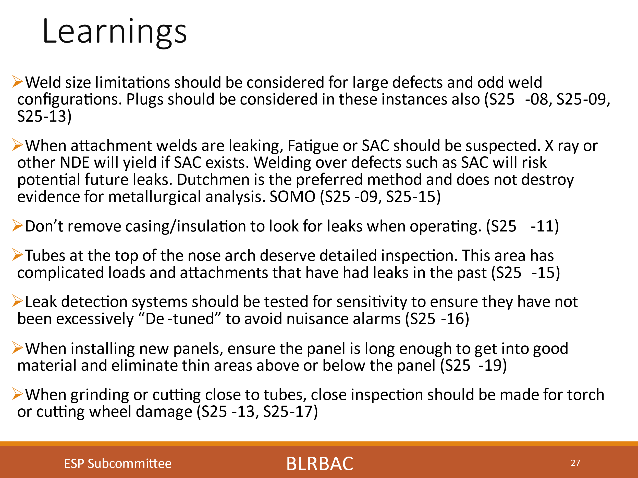

These slides are the captured learnings from the incidents reported this session. I will go through each of these. The numbers at the end of each learning are the incident number from this session. i.e. Spring, 2025 session, incident number 01 (S25-01)
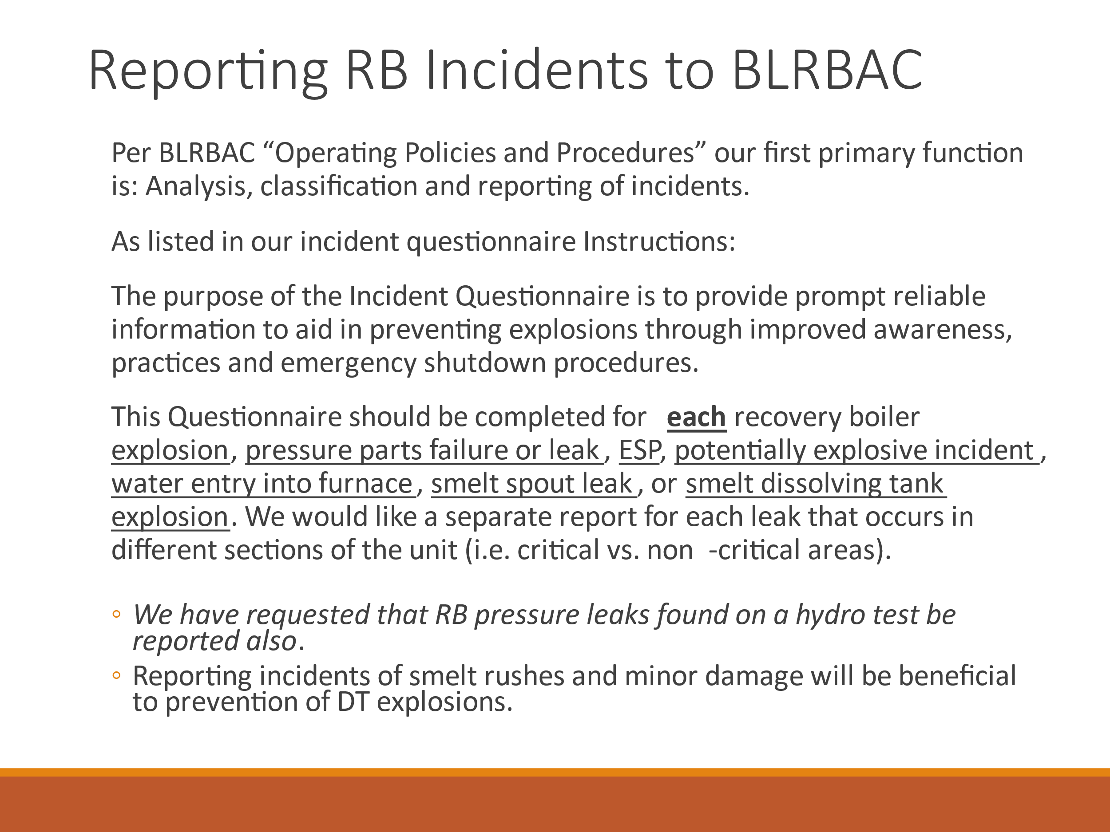

This slide discusses how to report incidents to BLRBAC and that we want incidents reported found on hydro. Even if found on hydro, we will classify these as critical if they are in a critical area even though the unit is not running. Sometimes they may have been leaking when the unit was on the way down. We are again also requesting that dissolving tank near misses also are reported so that we can learn from and address issues proactively. Please try to submit a separate incident when leaks occur in different sections of the boiler as they may be classified as Critical or Non-Critical differently.
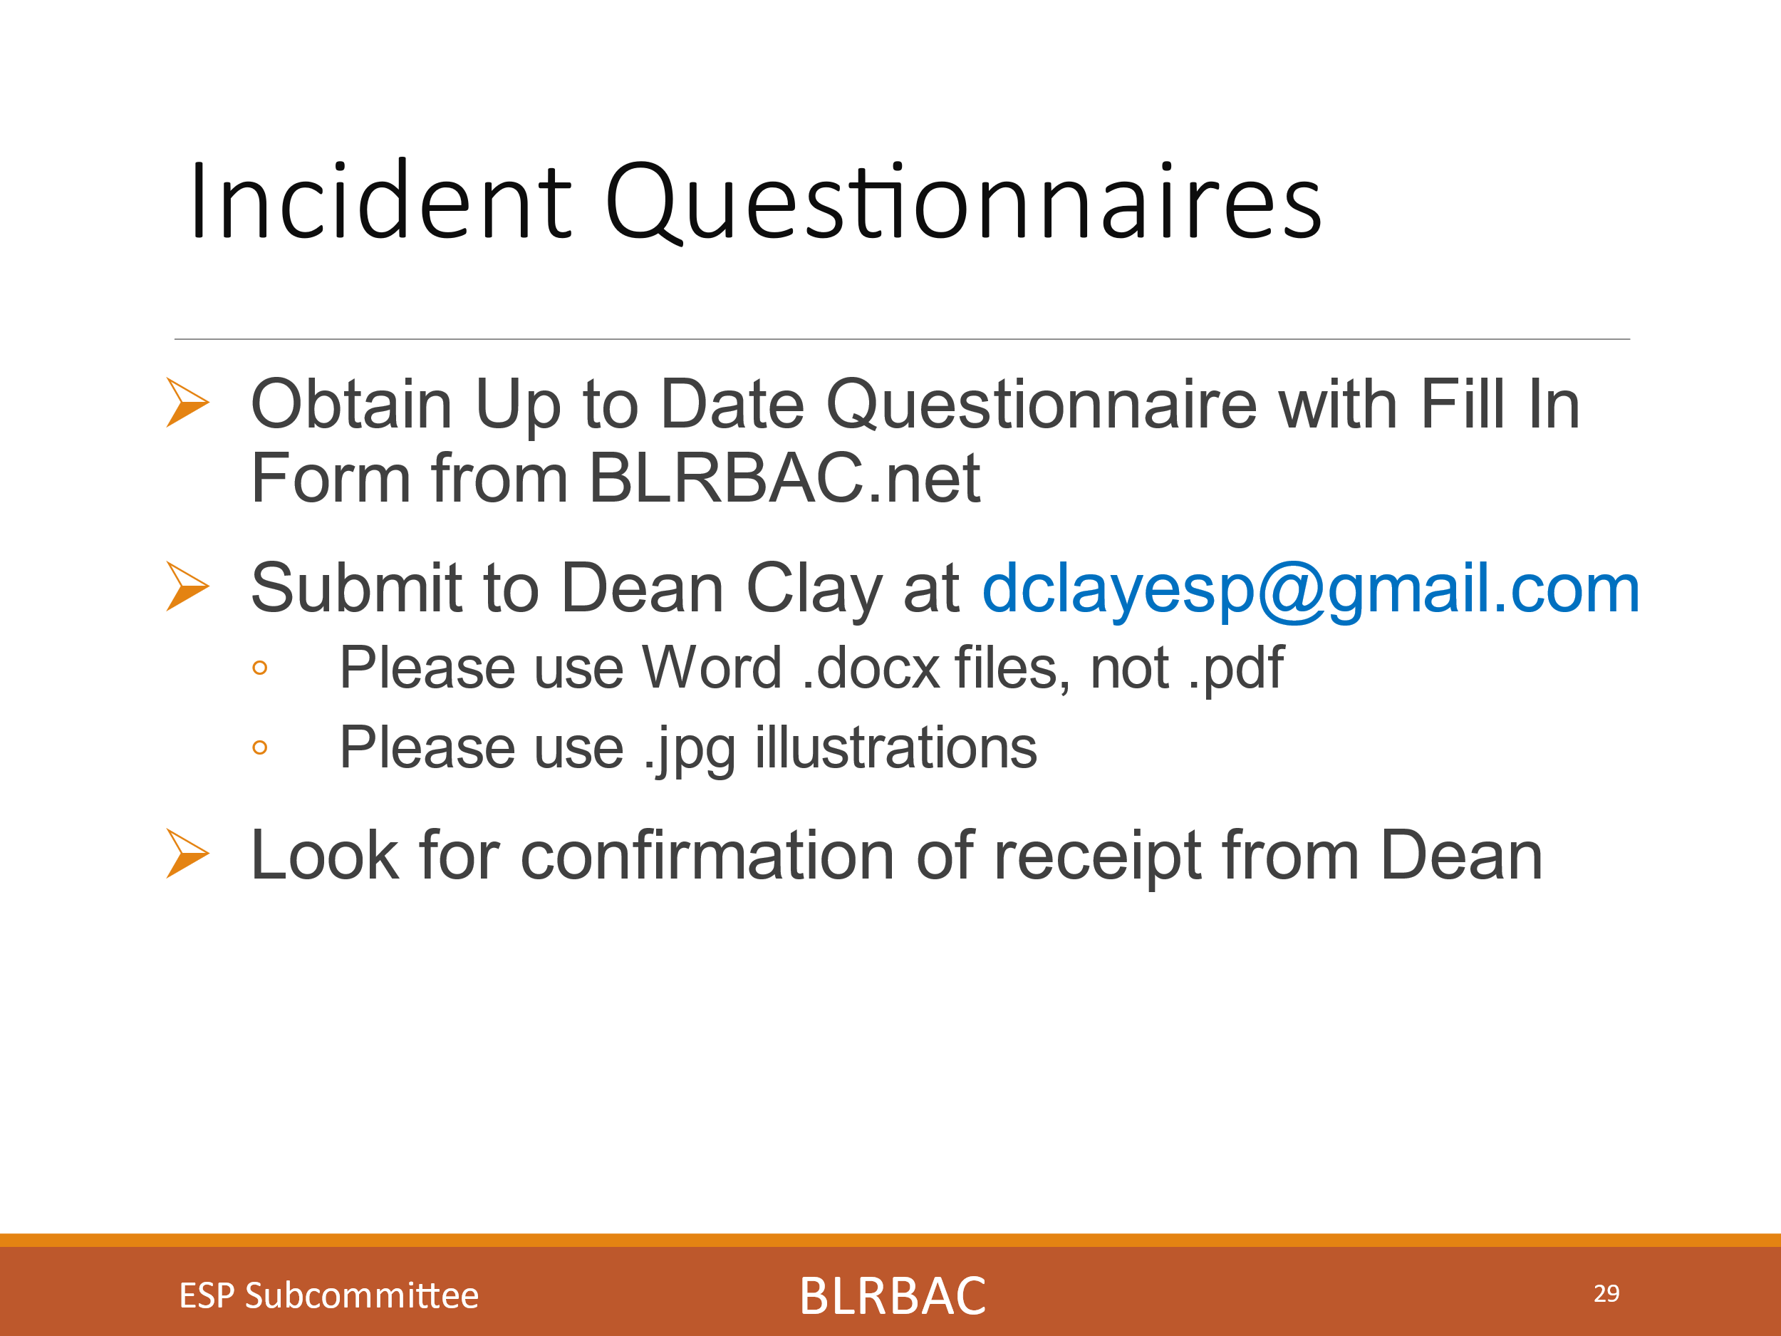

This slide shows the information related to where to find the incident questionnaire and to look for confirmation from Dean Clay that it was received.
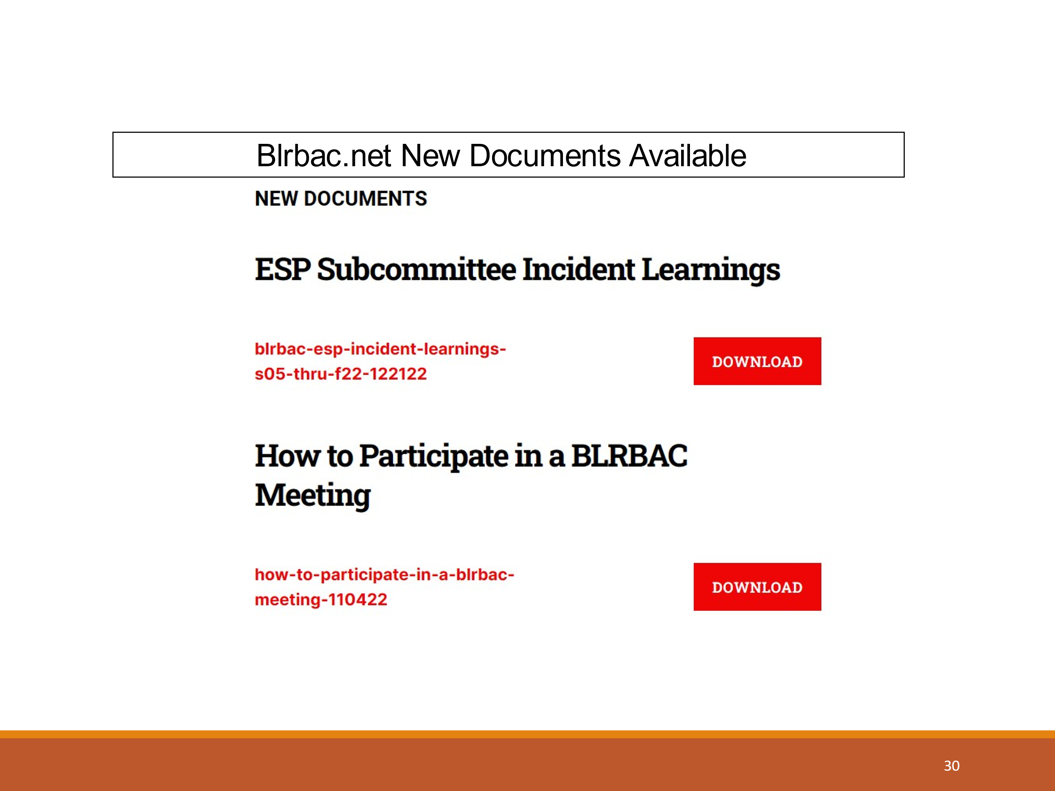

This slide shows where to find the Collection of incident learnings from Spring 2005 to Fall 2022 compiled by Dean Clay and soon to be updated by Mike Bruce and myself. The document describes how it is organized and the collective learnings over the years. I recommend this as a learning tool for management and operators for the prevention of future incidents.
The second item on the slide shows where to find the posted document of “How to get the most out of attending a BLRBAC meeting”. I highly encourage reading it and providing it to anyone in your mills planning on attending BLRBAC.

Downloadable presentation:
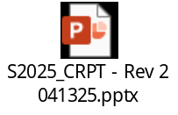

APPENDIX III

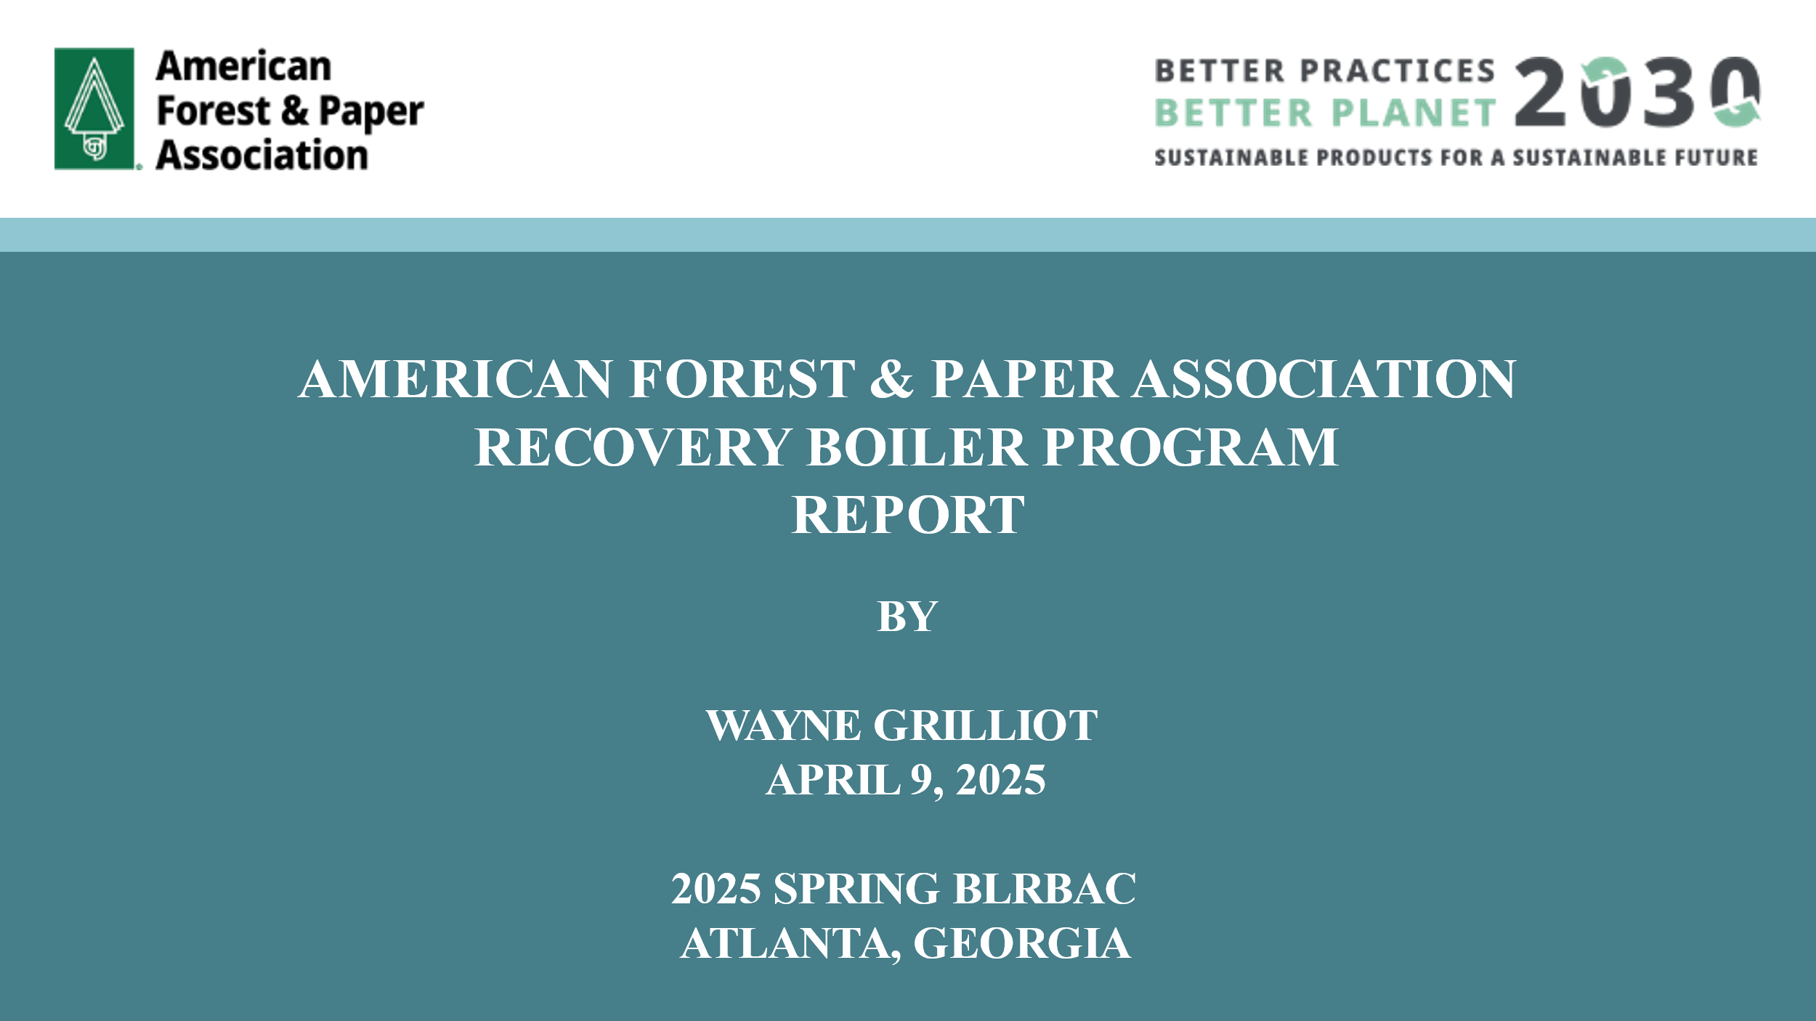

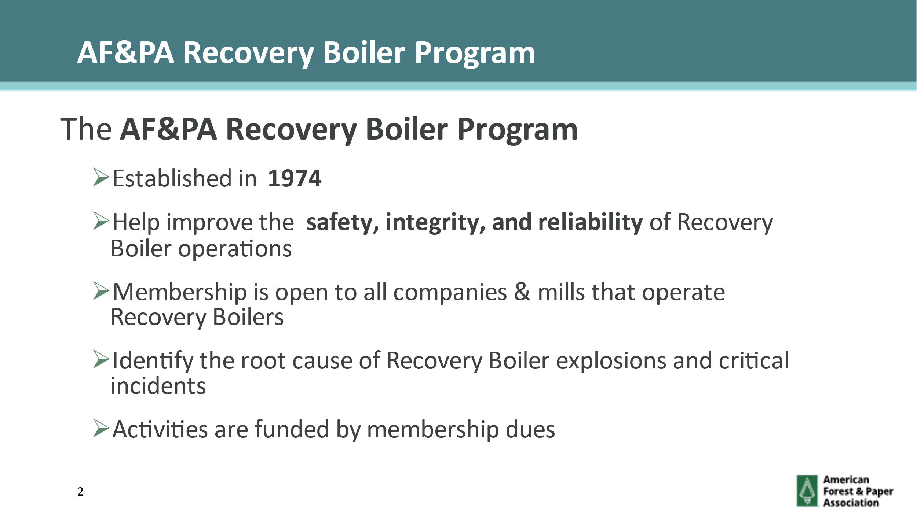
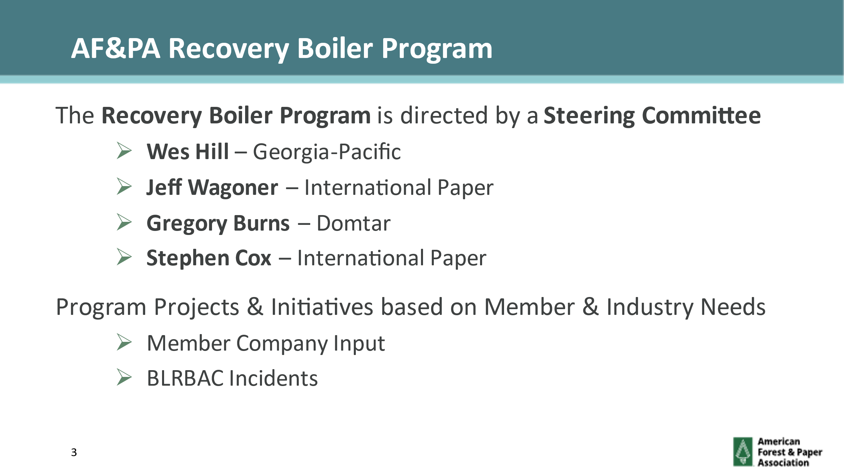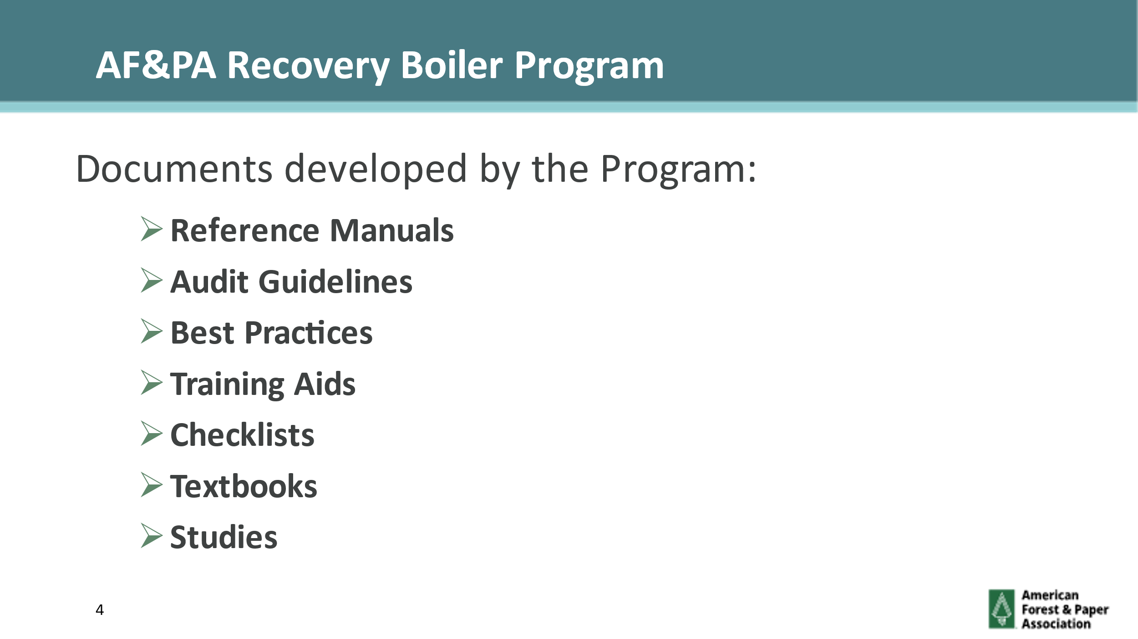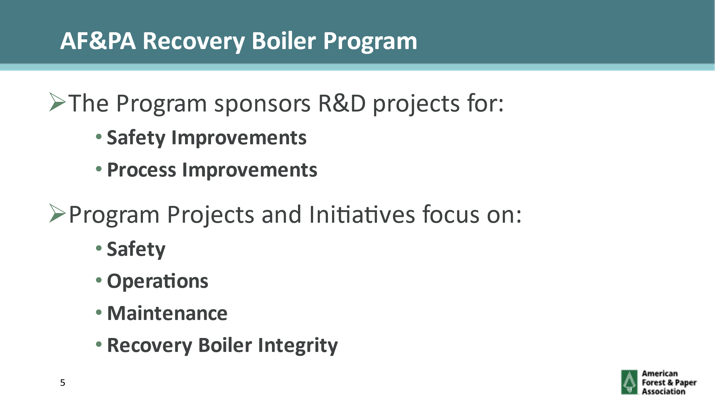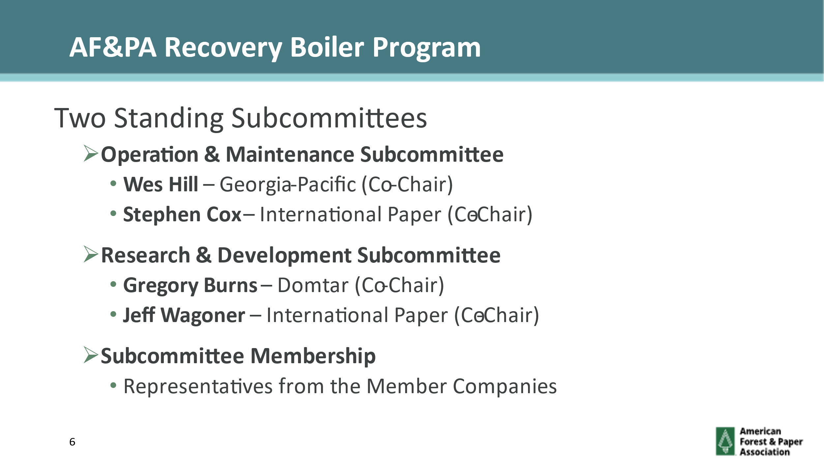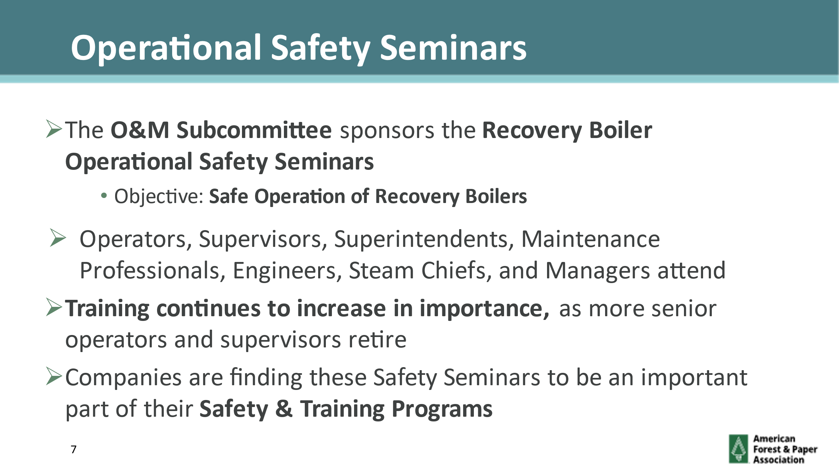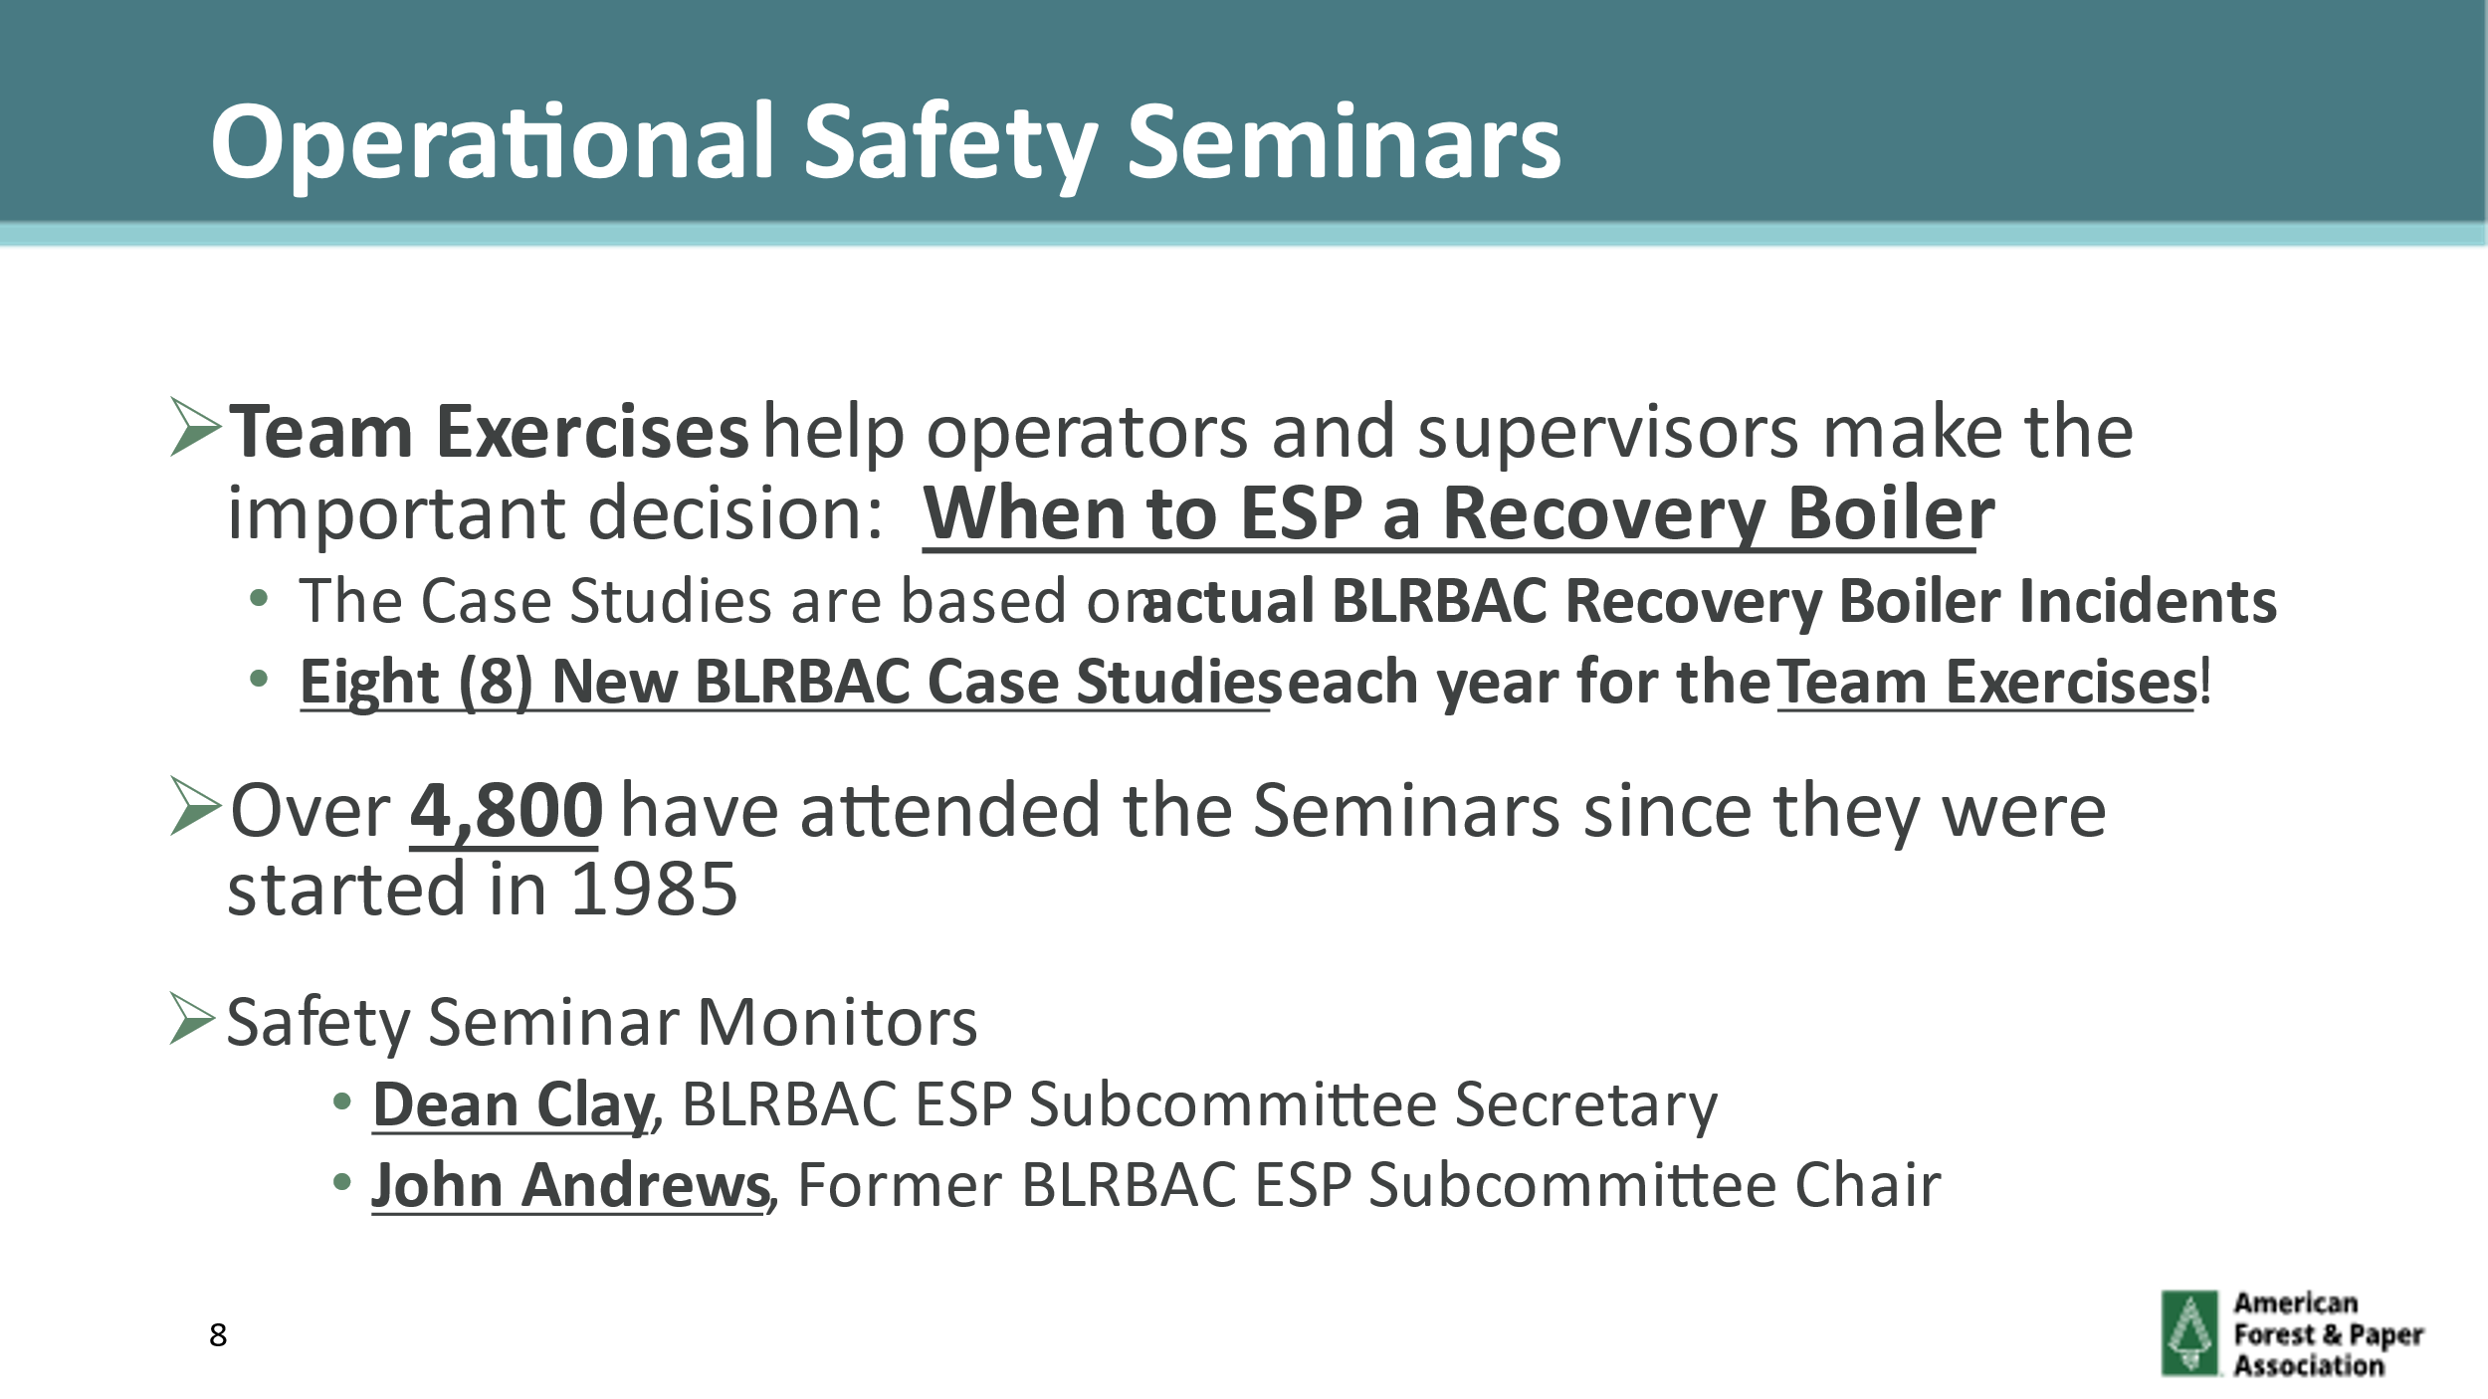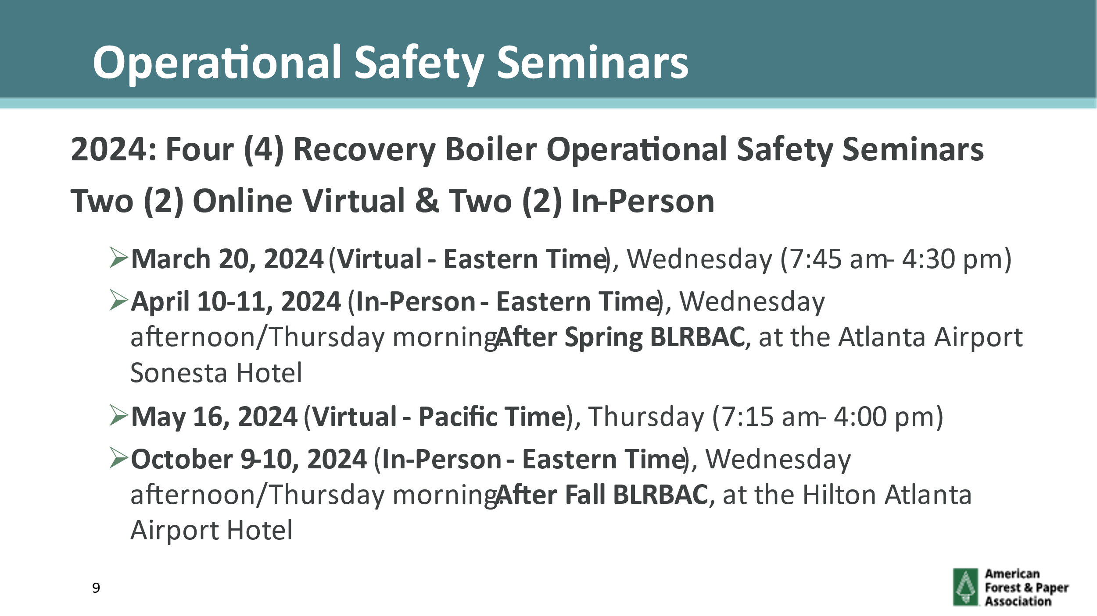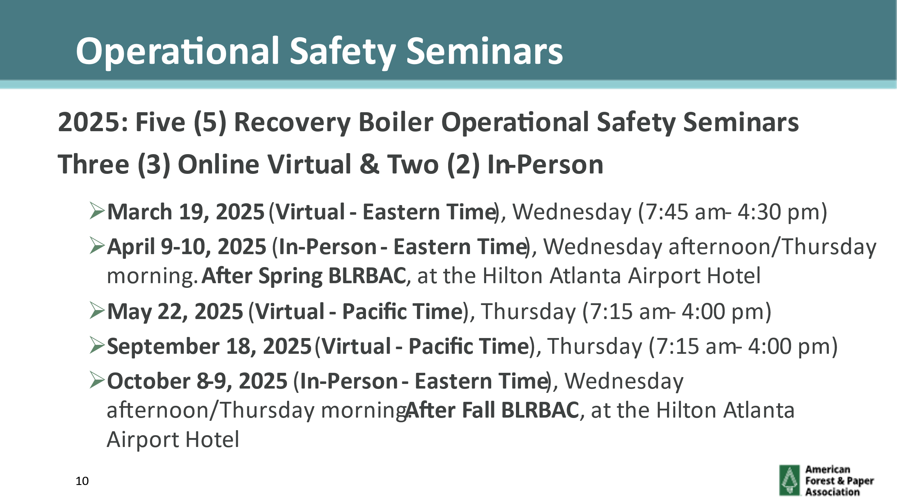

APPENDIX IV

Presentations

- Keit, Richard Salliss, IRmadillo - In-Situ Device for Green and Black Liquor Analysis

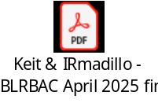

- Teknik Support, Johan Engvall, Smelt Spout Robot - Benefits of Automated Spout Rodding

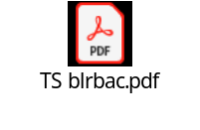

- Valmet, Timo Karjunen, SimSmelt - Smelt Extraction and Floor Protection

