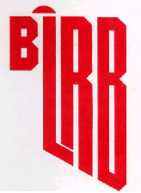
BLACK LIQUOR RECOVERY BOILER
ADVISORY COMMITTEE

MINUTES OF MEETING

October 8, 2025
OBJECTIVE
BLRBAC’s objective is to promote improved safety of chemical recovery boilers and their auxiliaries through the interchange of technical knowledge, experience, and data on past and any future recovery boiler incidents. Bylaws - 2.1

OFFICERS

Chairman: Gregory Burns
Mt Pleasant, SC Cell: 843-991-7192
Domtar gregory.burns@domtar.com

Vice-Chair: David Tjaarda
Smurfit Westrock Cell: 503-728-2550
Charleston, TN dave.tjaarda@smurfitwestrock.com

Secretary: Daniel Franco
Recovery Specialist Cell: +573113001079
Cali, Colombia danielf721@gmail.com

Treasurer: Brad Osbourne
Electron Machine Cell: 352-267-0118
Umatilla, FL brad@electronmachine.com

REGULAR MEMBERSHIP
Organizations operating, manufacturing, or insuring chemical recovery boilers are eligible.

ASSOCIATE MEMBERSHIP
Organizations having a direct interest or role in the safety of chemical recovery boilers are eligible.

CORRESPONDING MEMBERSHIP
Companies residing outside of the United States which finds it impractical to attend meetings on a regular basis because of distance and expenses, but desires to be involved and informed of BLRBAC activities.
Bylaws - 3.1

BLRBAC INTERNET ADDRESS: ---- www.blrbac.net
IRS Employer ID/Tax ID (IRS E.I.N.T./T.I.N.) ----
EXECUTIVE COMMITTEE

Gregory Burns Jimmy Onstead
BLRBAC Chairman Insurance Representative
Domtar FM Global
Mt Pleasant, SC Frisco, TX
Cell: 843-991-7192 Tel: 972-731-1656
gregory.burns@domtar.com Cell: 903-744-2734
jimmy.onstead@fmglobal.com

David Tjaarda Evangelos Townsend (Ev)
BLRBAC Vice Chairman Manufacturing Representative
Smurfit Westrock Babcock & Wilcox
Charleston, TN Melissa, TX
Cell: 503-728-2550 Office: (281) 405-6825
dave.tjaarda@smurfitwestrock.com Mobile: (469) 815-8395
emtownsend@babcock.com

Daniel Franco Scott Moyer
BLRBAC Secretary Operator Representative
Recovery Specialist Smurfit Westrock
Cali, Colombia Jacksonville, FL
Cell: +573113001079 Mobile: 904.437.7149
danielf721@gmail.com scott.moyer@smurfitwestrock.com

Brad Osborne
BLRBAC Treasurer
Electron Machine
Umatilla, FL
Cell: 352-267-0118
brad@electronmachine.com

BLRBAC SUBCOMMITTEES

AUXILIARY FUEL  Tom DeBeer – Chairman  LCK Consultants  5001 Willow Creek Drive  Woodstock, GA 30188  Cell:(404) 218-8613  tdebeer2024@gmail.com | BLACK LIQUOR, SAFE FIRING OF  Vernon Blackard, Chairman  International Paper  Roy, MT 59471  Cell: 251-284-3471  vernon.blackard@ipaper.com
EMERGENCY SHUTDOWN PROCEDURES  Frank Navojosky, Chairman  BSI  Loveland, OH  Cell: (513) 334-9999  fcnavojo@gmail.com | FIRE PROTECTION IN DIRECT  CONTACT EVAPORATORS  Stephen Cox - Chairman  International Paper  Maumelle, AR  Tel: 409-779-7104  stephen.cox@ipaper.com
INSTRUMENTATION  John Browning, Chairman  Georgia Pacific  Atlanta, GA  Tel: 251-593-6096  john.browning@GAPAC.com | MATERIALS & WELDING  Laura Nicol–Chairperson  Babcock & Wilcox  1200 E Market St, Ste 650  Akron, OH 44305  Cell: 330-361-0217  lsnicol@babcock.com
PERSONNEL SAFETY  Ward Benjiman - Chairman  Sappi North America  Skowhegan, ME  Tel: 207-238-7686  Benjiman.Ward@sappi.com | PUBLICITY & NEWS RELEASE  Matt Paine, Chairman  FM  Norwood, MA  Tel: 781-255-4733  matthew.paine@fmglobal.com
WASTE STREAMS  Paul Seefeld, Chairman  A.H. Lundberg Associates, Inc.  Jacksonville, FL  Tel: 904-614-6492  paul.seefeld@lundberg-us.com | WATER TREATMENT  Tom Przybylski, Chairman  Power Specialists Associates  Somers, CT  Tel: 860-763-3241  tom.@psaengineering.com

FUTURE BLRBAC MEETINGS

Spring | April | 6,7,8 | 2026
Fall | October | 5,6,7 | 2026
"Bring Operator(s). Give them a chance to hear firsthand!"
Past Chairman Frank Navojosky

*****************************
* NOTE: For varying reasons, the previously published meeting dates have been changed at the discretion of the Executive Committee.

BLRBAC has established its own website at: www.blrbac.net

At this website you will find a copy of past Meeting Minutes and the next Meeting Notice. Therefore, each Representative and Associate Representative is asked to inform their people of this WEB site. This is where they can obtain the following BLRBAC documents:

BLRBAC MEETING NOTICE
COVER LETTER General Information

REGISTRATION FORM Will be available on the website with a link to register and pay on line.

HILTON Airport Blocked room dates, pricing, address, hotel phone numbers

SCHEDULE List of subcommittee activities on Monday and Tuesday

AGENDA Reports given to Joint BLRBAC Meeting on Wednesday

OPERATING PROBLEMS Mail/e-mail completed questionnaires to David Tjaarda

QUESTIONNAIRE The Vice Chairman will see that your concerns are brought up and discussed during the Operating Problems session at the next meeting.
These are available at the BLRBAC INTERNET ADDRESS: www.blrbac.net

BLRBAC Guidelines & Recommended Practices
LEGAL NOTICE

Recommended Good Practice For Design, Operation, and Testing of the Emergency Shutdown System for Black Liquor Recovery Boilers
(Dated: October 2024)

Safe Firing of Black Liquor in Black Liquor Recovery Boilers
(Dated: October 2023)

Materials & Welding Guidelines
(Dated: April 2025)

Safe Firing of Auxiliary Fuel in Black Liquor Recovery Boilers
(Dated: February 2012)

Fire Protection in Direct Contact Evaporators and Associated Equipment
(Dated: February 2024)

Personnel Safety & Training
(Dated: April 2018)

Application of Rotork Actuators on Black Liquor Recovery Boilers
(Dated: April 2025)

Boiler Water Management Guidelines for Black Liquor Recovery Boiler
(Dated: June 2025)

Instrumentation Checklist and Classification Guide for Instruments and Control Systems Used in the Operation of Black 9Liquor Recovery Boilers (Dated: April 2014)

Thermal Oxidation of Waste Streams in Black Liquor Recovery Boilers
(Dated: June 2021)

If you have any questions, contact:

Secretary: Daniel Franco Tel: +576023258865
Recovery Specialist Retired Cell: +573113001079
Cali, Colombia danielf721@gmail.com
AUXILIARY FUEL SUBCOMMITTEE
Tom DeBeer – Chairman‡
LCK Consultants
5001 Willow Creek Drive
Woodstock, GA 30188
Cell:(404) 218-8613
tdebeer2024@gmail.com

David Frazier International Paper | John Lewis‡  General Electric Vernova  200 Great Pond Drive G3W4  Windsor, CT 06095  Tel:(860) 285-2918  john.c.lewis@ge.com | Michael Bekech  CECO - CCA Combustion Systems  884 Main St.  Monroe, CT 06468  Tel: (203) 268-3139 x 137  Cell: (203) 895-4822  mbekech@onececo.com
Mike Bruce  Sylvamo  104 Putnam Center Road  Putnam Station, N.Y. 12861  Tel: (518) 586-6954  mike.bruce@sylvamo.com | Brett GuShue‡  Babcock & Wilcox FPS Inc  GshueB@fossil.ca | Chris Finnemore  Georgia Pacific  Fernandina Beach, FL 32034  Cell: (904) 321-6861  Chris.finnemore@GAPAC.com
Travis Flower  Babcock & Wilcox Company  P. O. Box 351  Barberton, OH 44203-0315  Tel: (330) 860-6042  taflower@babcock.com | Derrick Gossen‡*  FM  301 Freedom Ct.  Mishicot, WI 54228  Cell: (920) 619-1750  derrick.gossen@fmglobal.com | Brook M. Holland  Bodman Services LLC  Cell: (828) 421-0487  brookmholland@gmail.com
Greg Imig‡  Andritz  5405 Windward Pkwy, Suite 100W  Alpharetta, GA 30004  Tel: (770) 640-2633  Cell: (404) 545-9076  greg.imig@andritz.com | Carlos Rojas  Smurfit Westrock (Colombia)  (TBD)  Colombia, S. America  Phone: +573113009193  carlos.rojas@smurfitwestrock.co | Adam Marickovich‡*  Georgia Pacific  adam.marickovich1@gapac.com

‡ = | Denotes attendance at last meeting, October 8, 2025
* = | Denotes a new/replacing member
EMERGENCY SHUTDOWN PROCEDURES SUBCOMMITTEE

Frank Navojosky– Chairman‡
Boiler Services & Inspection, LLC
BSI
Cell: (513) 334-9999
fcnavojo@gmail.com

Dean Clay, Secretary‡  Boiler Services & Inspection, LLC  BSI  Cell: (513) 497-9070  dclayesp@gmail.com | Scott Crysel  FM  One Cowboys Way, Suite 600  Frisco, TX 75034  Tel: (972) 731-1658  Fax: (972) 731-1820  scott.crysel@fmglobal.com | James Franks‡  AXA XL Risk Consulting  855 Dogwood Road  Somerville, TN 38068  Tel: (901) 465-0771  Fax: (888) 964-7348  james.franks@axaxl.com
Mike Bruce  Sylvamo  104 Putnam Center Rd  Putnam Station, NY  Cell: 518-586-6954  mike.bruce@sylvamo.com | Mike Bates  WCBLRBAC Chairman  Domtar Crofton  Office (250) 246-6176  Cell (236) 594-6458  mike.bates@domtar.com  Alternate: Angelo Porchetta‡  Domtar, Howe Sound  604-414-8677 | John DeFusco‡  Babcock & Wilcox Company  4 Essex Drive  Yarmouth, ME 04096  Cell: (207) 776-0954  jpdefusco@babcock.com
Gregory Burns‡  Domtar  Cell: (843) 991-7192  Office: 803-802-8077  Fort Mill, SC  gregory.burns@domtar.com | Scott Moyer, Vice Chairman‡  Smurfit Westrock  Cell: 904-437-7149  scott.moyer@smurfitwestrock.com | Greg Zavadoski  Georgia Pacific  Cell: 715.432.2470  greg.zavadoski@gapac.com  Alternate:  Robert Orender, GP‡  Robert.orender@gapac.com  470-230-2000
John Phillips‡  Andritz Pulp & Paper  5405 Windward Parkway, Suite 100W  Alpharetta, GA 30004  Tel: (770) 640-2434  Fax: (770) 640-2521  john.phillips@andritz.com | Dan Cudmore‡  GE Vernova  1420 Blair Towers Place  Suite 500  Ottawa, ON K1J 9L8  Tel: (613) 298-5021  dan.cudmore@ge.com | Jeremiah Yoder‡  Valmet Inc  Cell: (704) 408-6825  Jeremiah.yoder@valmet.com
David Frazier‡
International Paper

Cell: 706-305-75321
David.frazier@ipaper.com
‡ Denotes attendance in Fall 2025 meeting
PUBLICITY & NEWS RELEASE SUBCOMMITTEE
Matt Paine - Chairman
FM
Johnston, RI
Cell: 781-255-4733
matthew.paine@fmglobal.com

FIRE PROTECTION IN DIRECT CONTACT EVAPORATORS
AND ASSOCIATED EQUIPMENT SUBCOMMITTEE

‡Stephen Cox - Chairman
International Paper
6318 Highway 139
Bastrop, La 71220
Tel: 409-779-7104
Stephen.cox@ipaper.com

‡Aneeka Mahan – Vice Chair  FM Property Insurance  2100 Reston Parkway; Suite 600; Reston, VA 20191  Tel: (703) 232-8087  aneeka.mahan@fm.com | Robert Orender  Georgia Pacific  133 Peachtree Street NE  Atlanta, GA 30303  Robert.orender@gapac.com | Robert Goddard  XL Group  129 Drive 1143  Tupelo, MS 38804  Tel: 662 844-5897  robert.goddard@axaxl.com
Joseph Lynch
Swiss Re America Holding Corporation
1150 Sanctuary Parkway, Suite 425
Alpharetta, GA 30009
Tel: 1770-569-8706
Joe_Lynch@swissre.com
Mike McKenzie(new for spring 2024)  International Paper  Bogalusa Mill  Tel: 19857328723  Michael.McKenzie1@ipaper.com | ‡Gerald “Trey” Nail (inducted in Fall 2024 with E&E becoming a member company)  E & E Tech  Cell: 662-633-9800  GNail@eandetech.com

‡Denotes Attendance at the meeting in Fall 2025. Did not meet In Spring 2025

INSTRUMENTATION SUBCOMMITTEE

Fall 2025 morning
‡JC Browning, Jr (1998) – Chairman
Georgia Pacific
133 Peachtree St. NE (30303) Atlanta, GA 30348-5605
Tel: 251-593-6096 john.browning@gapac.com

‡ Attended New Member Leaving Member

Ben Bunner (2020) ‡  Vice-Chairman Andritz  5404 Windward Parkway, Suite 100W, Alpharetta, GA 30004  Cell: 678-907-7617  ben.bunner@andritz.com | C.A. Vossberg (<2000) ‡ Secretary  Electron Machine Corp.  P.O. Box 2349  Umatilla, FL 32784  Tel: 352-406-1351  ca@electronmachine.com | David T. Boudreau (2007)  ISC RGP Document Controller  SAPPI  1329 Waterville Road  Skowhegan, ME 04976  Tel: 207-314-8024  dave.boudreau@sappi.com
Gordon L. Vandenburg (<2000) ‡  Liquid Solids Control, Inc.  P.O. Box 259, Farm St.  Upton, MA 01568  Tel: (603) 833-8536  gordie@liquidsolidscontrol.com | Jari Sopanen (<2000)  Jari Consultoria de Automacao Ltda, Avenida Frei Rogerio, 690  Centro, Curitibanos, Brasil 89520  Tel:+55 (47) 9 9672-2332  sopanenjari@outlook.com | Joel Byrd (2015)  International Paper Company  12515 Choctaw Rd  Bogalusa, La 70427  Tel:985-516-1110  Joel.byrd@ipaper.com
Kevin Huelsbeck (2010)  FM Global  W4893 Cliff View Drive  Sherwood, WI 54169  Cell: 920-205-5529  kevin.huelsbeck@fmglobal.com | Daniel Albert - (2019?)  Rotork 675 Mile Crossing Boulevard Rochester NY 14624  (585) 247-2304  Daniel.Albert@Rotorq.com | Andy Clement (2019)  Fossil Power Systems  10 Mosher Drive P  Dartmouth, Nova Scotia  Canada B3B 1N5  Tel:902-468-2743 ext.245  clementa@fossil.ca
Ricky Henderson (2024)  Vaisala Inc.  3 Van de Graaff Drive.  Burlington, MA 01803  (P) 713-550-2534  ricky.henderson@vaisala.com | Daniel Guarnieri (2024) SYLVAMO  Rodovia SP 340 KM171 | Mogi Guacu, SP, Brazil 13845-901  T: +55 19 3861-8972  daniel.guarnieri@sylvamo.com | Deshan Naidoo (2024) ‡ SAPPI  25 Heron Way Yellowwood Park  Durban,  South Africa 4004 Deshan.Naidoo@sappi.com
Patrick Buyck (2024) ‡  SAPPI North America  2201 Avenue B, PO Box 511, Cloquet, MN 55720  Patrick.Buyck@sappi.com | Chris Clements (2024) Smurfit Westrock Chris.clements@westrock.co | Adam Marickovich (2024) ‡  Georgia-Pacific  133 Peachtree St. NE (30303)  Atlanta, GA 30348-5605d  Adam.Marickovich1@gapac.com
Kyle Harper (2025) ‡  Georgia-Pacific  133 Peachtree St. NE (30303)  Atlanta, GA 30348-5605d  Kyle.Harper@GAPAC.com | Josh Crawford (2025) ‡  John H Carter  Josh.Crawford@JohnHCarter.com  Baton Rouge, LA | Ben Roberge (2025) ‡  Paragon  Benrobergo@paragonconsults.com
Sara Prichard‡
Georgia Pacific
sara.pritchard@gapac.com

PERSONNEL SAFETY SUBCOMMITTEE

Ward Benjiman – Chairman
Sappi North America
Skowhegan, ME
Tel: 207-238-7686
Benjiman.Ward@sappi.com

Sam Dean‡  Rayonier Advanced Materials  4470 Savannah Highway  Jesup, GA 31545  Tel: (912) 427-5103  samuel.dean@rayonierAM.com | Steve Morrison‡  Acting Chairman  G-P  Cell – (404) 268-6573  Team – (404) 652-7141  Steve.morrison@gapac.com | Tom Edwards  B&W  twedwards@babcock.com
 | David Von Oepen  Smurfit West Rock  28270 U.S. Highway 80 West  Demopolis, AL 36732-5121  Tel: (334) 289-6315  dvonoepen@smurfitwestrock.com | Mathew Glenn  Irving Pulp & Paper, Limited  Recovery Superintendent  P.O. Box 3007  408 Mill Street  Saint John, New Brunswick  Tel: (506) 634-4234  glenn.matthew@irvingpulp.com
Grey Gurkin  International Paper  International Paper Co. | Zack Payne  Andritz  5405 Windward Parkway  Suite 100W  Alpharetta, GA 30004-3894  Tel: (706) 344-9006  zack.payne@andritz.com | Francisco Britt  FM  One Cowboys Way  Suite 600  Frisco, TX 75034  Tel: (972) 731-2145  Francisco.britt@fmglobal.com
Brook Holland  G.H. Bodman  228 Wild Rose Lane  Canton, NC 28716  Tel : (828) 421-0487  brookmholland@gmail.com | Jake Dowland‡  ND Paper | Sam Miller‡  Andritz

‡Denotes attendance at the Fall 2025 meeting

MATERIALS & WELDING SUBCOMMITTEE
Laura Nicol – Chairperson ‡
Babcock & Wilcox
1200 E Market St, Ste 650
Akron, OH 44305
Cell: 330-361-0217
lsnicol@babcock.com

‡ this meeting
Materials and Welding Committee Members
Jesse Worsham: Vice Chairman  Domtar Paper  Tel: (843) 479-0200 Ext 8879  Jesse.Worsham@Domtar.com  *Alt: | *Maxime Simard ‡  FM  Cell: (418) 435-1551  maxime.simard @fmglobal.com  *Alt: | Scott Lowrie  Andritz, Inc.  Scott.Lowrie@andritz.com  *Alt: Mark LeBel ‡  Cell (678) 577-8613  Mark.LeBel@andritz.com
Brent Griffin ‡  Georgia-Pacific LLC  Cell: (850) 910-1259  brent.griffin@gapac.com  *Alt: Chad Harrod  Cell: (404) 395-3064  Chad.Harrod@gapac.com | Jennings Bird  Valmet  Tel: 803 235 8091  Jennings.bird@valmet.com  *Alt: Ron Reed ‡  Tel: (704) 281-3073  Ron.reed@valmet.com | Billy Collett  National Boiler Services, LLC.  Cell: (423) 582-6958  bcollett@nationalboiler.com  *Alt: Steve Harville  Cell: (251) 591-7850  Sharville@NationalBoiler.com
Jed Merritt  RMR Mechanical  Tel: (601) 508-9084  Jed.merritt@rmrmechanical.com  *Alt: Ben Rogers  Ben.Rogers@rmrmechanical.com | Chris Rawls  Applied Technical Services  Tel: (757) 218-8465  crawls@atslab.com  *Alt: Thomas Kapperman  Tel: (678) 231-8025  tkapperman@atslab.com | Stacy Power ‡  Midstate SMS  Tel: (843) 957-2111  Cell: (843) 297-1987  spower@smsmidstate.com  *Alt: Chris Skorton ‡  cskorton@msindustrialcorp.com
William Burns ‡  ND Paper – Rumford  Cell: 207-743-1029  William.Burns@us.ndpaper.com | TBD  Acuren

SAFE FIRING OF BLACK LIQUOR SUBCOMMITTEE
‡Vernon Blackard - Chairman
International Paper
Cell: 251-284-3471
vernon.blackard@ipaper.com

 | ‡Tim Hicks  Billerud  Tel. 901-468-5058  Tim.hicks@Billerud.com | Joel Byrd  International Paper  Tel: 85-516-1110  Joel.byrd@ipaper.com
‡Sarah Henke – Vice-Chair  Valmet  Tel: 919-454-3441  Sarah.henke@valmet.com | ‡Peter Donahue  Fossil Power Systems, Inc.  Tel: 902-468-2743, Ext. 251  Cell: 902-877-9312  donahuep@fossil.ca | ‡Len Erickson  Power Specialist Assoc.  Tel: 208-841-4246  len.erickson@PSAengineering.com
‡Jason Saulsbury  Green Bay Packaging  Tel: 902 908 0495 | ‡Wes Hill  Georgia Pacific  Tel 360-607-4189  Wes.hill@gapac.com | ‡Daniel Franco  Recovery Specialist  Cell: +57 3113001079  danielf721@gmail.com
‡Guy Labonte  FM Global  Tel: 514-876-7412  Cell: 514-942-3651  guy.labonte@fmglobal.com | ‡Doug Murch  Smurfit Westrock  Tel: 804-444-5245  Cell: 804-787-0781  douglas.murch@smurfitwestrock.com | ‡Alarick Tavares  Smurfit Westrock  Tel - 678 492-1107  alarick.tavares@smurfitwestrock.com
Mark Sargent  Bodman Services, LLC  Tel: 514-543-0480  Mark.sargent@rmrmechanical.com | ‡Pasi Miikkulainen  Andritz  p: +1 770 640 2414  m: +1 678 230 1525  Pasi.Miikkulainen@andritz.com | ‡ Brian Rawson  International Paper  Cell: 850-266-5259  brian.rawson@ipaper.com
 | ‡Rudy Haraga –  Fornax Services  Tel: 860-268-1871  Rudy.haraga@thefornax.com | ‡Olli Kujanpaa –  Georgia Pacific  Tel: 404-432-8281  Olli.kujanpaa@gapac.com
  Jason Lewis
  ND Paper
  m: 207-557-0952
  Jason.lewis@us.ndpaper.com
‡Ryan P Henry  Green Bay Packaging Inc.  Tel: 501-306-8330  rhenry@gbp.com | ‡Keijo Pyorala  Vaisala  keijo.pyorala@vaisala.com | ‡David Tjaarda  Smurfit Westrock  Tel – 503 728-2550  David.tjaarda@smurfitwestrock.com
‡Justin Helton  Andritz  Tel: 470-416-1342  Justin.helton@andritz.com | ‡Evangelos Townsend  B&W  Office: 281-405-6825  Mobile: 469-815-8395  Emtownsend@babcock.com | ‡Jay Dilworth  Pixelle Specialty Solutions  Tel 717 225 4711  James.Dilworth@pixelle.com

‡Denotes attendance at the meeting in Fall of 2025.

WASTE STREAMS SUBCOMMITTEE

Paul Seefeld – Chairman *
LundbergJansen Technologies

9246 Audubon Park Ln S
Jacksonville, FL 32257
Cell: 904-614-6492

Paul.seefeld@lundbergjansen.com

Abby George  Valmet  3440 Toringdon Way, Bldg 3, Suite 300  Charlotte, NC 28277  Tel: 252-308-5330  Abby.George@valmet.com | Neil Chaudhuri*  FM  100 New Park Place, Suite 200  Vaughan ON Canada L4K OH9  Tel: 647-894-5680  Neil.chaudhuri@fmglobal.com | Nicole Crawley*  International Paper  Pensacola, FL  Nicole.Crawley@ipaper.com
Cobb Golson*  Smurfit Westrock  St. Augustine, FL  Tel: 904-826-7430  Cobb.golson@smurfitwestrock.com | John Lewis*  Fluor  100 Fluor Daniel Drive  Greenville, SC 29607-2762  Tel: 864 517-1683  john.lewis@fluorgov.com | Jarmo Kaila  Andritz  5405 Windward Parkway  Alpharetta, GA 30004  Tel: 770-640-2688  Cell:  Jarmo.kaila@andritz.com
Oscar Guevara*  Domtar  100 Kingsley Park Drive  Fort Mill, SC 29715  Tel: 479-871-0970  Oscar.guevara@domtar.com | Wayne Bucher*  NORAM  Birmingham, AL  Tel:  Wayne.bucher@gmail.com | Greg Wass  LundbergJansen  8271 154th Ave NE  Redmond, WA 98052  Tel: 425-283-5070  greg.wass@lundbergjansen.com
Kevin Sapp – Vice Chairman*
Georgia Pacific

Atlanta, GA
Tel: 387-227-1038
Kevin.sapp@gapac.com

 |  | .
*Denotes attendance

WATER TREATMENT SUBCOMMITTEE
Fall 2025

Tom Przybylski
Power Specialists Assoc. Inc.

tom.przybylski@psaengineering.com

‡Jeff Armstrong  Solenis  E-mail Address  xxx | ‡Rick Baxter  RMR  E-mail Address  richard.baxter@valmet.com | ‡Michael Bayse  George H. Bodman, Inc.  E-mail Address  bbayse@aol.com  (Substitute: Gene Cotton)
‡Fred Call  Acting Chairman  Buckman  E-mail Address  fccall@buckman.com | ‡Frank Crumpler  Nalco  E-mail Address  fcrumpler@ecolab.com  alternate: Jim Gannon | Susan Childress  RMR  E-mail Address  susan.childress@rmrmechanical.com
‡Frank Destefano  3D  E-mail Address  DestefanoFrank55@gmail.com | ‡Don Downey  Purolite  E-mail Address  don.downey@purolite.com
 | ‡Tom Meehan  FM Global  E-mail Address  thomas.meehan@fmglobal.com | ‡Trevor Murray  Irving Pulp and Paper  E-mail Address  murray.trevor@irvingpulp.com
Dylan Price  RMR  E-mail Address  Dyline.price@rmrmechanical.com | ‡Dave Tjaarda  WestRock  E-mail Address  dave.tjaarda@smurfitwestrock.com

‡ = Denotes attendance at meeting Fall 2025
- Denotes new subcommittee member on this list; previously added to subcommittee.
Registration List*
BLRBAC Fall 2025 Meeting - FINAL TOTALS - Tuesday 10/7/25 12:00pm
First Name | Last Name | Company
Victor | Porter | 3S Team, LLC
George | Pyszynski | 3S Team, LLC
Bryson | Atkins | Acuren
David | Dunn | Acuren inspection
Wayne | Grilliot | AF&PA
Ben | Fredrick | Allnorth Americas
William | Corr | ANDRITZ
Justin | Helton | Andritz
Greg | Imig | Andritz
Mark | LeBel | ANDRITZ
Samuel | Miller | Andritz
Lucy | Moore | Andritz
John | Phillips | Andritz
Greg | Swayne | Andritz
Brandon | Hamilton | Andritz Inc
John | Hornsby | Andritz Inc
Preston | Morgan | Andritz Inc
Zachary | Payne | Andritz Inc
Robert | Torres | Andritz Inc
Daniel | Villanueva | Andritz Inc
Paul | Ceravolo | Andritz Inc.
Pablo | Corvalan | Andritz Inc.
Pasi | Miikkulainen | Andritz Inc.
Aaron | Rose | Andritz Inc.
Ben | Bunner | Andritz, Inc.
Brandon | The | Andritz, Inc.
Cameron | Davies | Aon
John | Strobel | AWC Inc
James | Franks | AXA XL Risk Consulting
Brad | Pittenger | AXA XL Risk Consulting
John | DeFusco | Babcock & Wilcox
Paul | Griffin | Babcock & Wilcox
DAVID | KITTEL | BABCOCK & WILCOX
Laura | Nicol | Babcock & Wilcox
Greg | Sallee | Babcock & Wilcox
Evangelos | Townsend | Babcock & Wilcox
Eric | Wasson | Babcock & Wilcox
Brett | Gushue | Babcock & Wilcox FPS
Timothy | Hicks | Billerud Corporation
Mike | Bayse | Bodman Services
Dylan | Price | Bodman Services, LLC
Dean | Clay | BSI
Frank | Navojosky | BSI - Boiler Services and Inspection
Fred | Call | Buckman

Blake | Hankins | C&H Services of North GA
Brent | Bourassa | Clearwater Paper
Ishaq | Jameel | Clyde Industries
Bruna | Bof | CMPC
Jackson | Rocha | CMPC
Daniel | Franco | Consultant
Michael | Lykins | Corrosion Probe Inc.
James | Biggs | Crenshaw Machine Systems
Juan | Reyes | Crenshaw Machine Systems
Clay | Thomas | DES Global LLC
Cliff | McClain | DES Global, LLC
Khalid | Abdulsalam | Diamond Power
Daniel | Cole | Diamond Power
Matt | Saunders | Diamond Power
Jordan | Spicer | Diamond Power
Kelli | Tucker | Diamond Power
Simon | Youssef | DIAMOND POWER
Oscar | Guevara | Domtar Corp
Gregory | Burns | Domtar Corporation
Gerald “Trey” | Nail | E & E Tech
Matthew | Jones | E and E Tech
Brad | Osborne | Electron Machine
CA | Vossberg | Electron Machine
Steven | Moore | Envision MCG
John | Lewis | Fluor
Resham | Adhikari | FM
Andrew | Bahnsen | FM
Neil | Chaudhuri | FM
Jose | de la Rosa | FM
Katie | Geisler | FM
Derrick | Gossen | FM
Brian | Korver | FM
Guy | Labonte | FM
Aneeka | Mahan | FM
Jimmy | Onstead | FM
Nicholas | Quigley | FM
Ilan | Saadia | FM
Kimmeng | Seang | FM
Maxime | Simard | FM
Shafia | Ahmad | FM Cleveland
Rudy | HARAGA | FORNAX Services, LLC
Wayne | Yenne | FORNAX Services, LLC
Peter | Donahue | FPS
Rick | Benning | GCF
Dan | Cudmore | GE Vernova
John | Lewis | GE Vernova
Yoram | Schaker | GE Vernova - Steam Power
John | Browning | Georgia Pacific
Jake | Dowland | Georgia Pacific
Kyle | Harper | Georgia Pacific
Adam | Marickovich | Georgia Pacific
Tom | Meadows | Georgia Pacific
Jason | Miller | Georgia Pacific
Robert | Orender | Georgia Pacific
Timothy | Rozek | Georgia Pacific
Kevin | Sapp | Georgia Pacific
Steve | Morrison | Georgia Pacific Paper
Wes | Hill | Georgia-Pacific
Gregg | Lentz | Georgia-Pacific
Sara | Pritchard | Georgia-Pacific LLC
Olli | Kujanpaa | GP
Demery | Bassham | GP Brunswick
clayton | cowman | GP Brunswick
Gino | Hilton | GP Brunswick
Bruce | Pease | Graphic Packaging International, LLC
Jacob | Biniakewitz | Green Bay Packaging - Arkansas Kraft Division
Ryan | Henry | Green Bay Packaging - Arkansas Kraft Division
Jason | Saulsbury | Green Bay Packaging - Arkansas Kraft Division
Jody | Nichols | High Temperature Technologies
Angelo | Porchetta | howe sound pulp and paper
Clark | Conley | Hydro-Thermal Corporation
Kevin | Phillips | Integrated Global Services
JP | Akwuba | International Paper
Vernon | Blackard | international paper
Payton | Busby | International Paper
Mccaleb | Connor | International Paper
Ben | Coulter | International Paper
Stephen | Cox | International Paper
Nicole | Crawley | International Paper
David | Frazier | International Paper
Kip | George | International Paper
Steven | Helms | International Paper
James | Hendrix | International Paper
Melanie | Jimenez | International Paper
Daniel | Krekeler | International Paper
Trey | McDaris | International Paper
Don | Rader | International Paper
BRIAN | RAWSON | International Paper
Mandell | Smith | International Paper
Chris | Thomas | International Paper
Bobby | Wesley | International Paper
Camila | Miranda | IQS
Mr. Matthew | Glenn | Irving Pulp & Paper
Dan | Mott | Irving Pulp & Paper
Tucker | Smith | James Industries
Josh | Crawford | John H. Carter
Jenny | Joyce | Johnston Construction
Bobby | Johnston | Johnston Construction LLC
Thomas | DeBeer | LCK Consultants, LLP
Mike | Sweeney | LIQUID SOLIDS CONTROL
Gordon | Vandenburg | Liquid Solids Control, Inc
Heinrich | Patzen | Liquidmetal Industrial Solutions
Steve | Campbell | Lundberg Jansen Technologies, Inc.
Douglas | Giarde | Lundberg Jansen Technologies, Inc.
Mark | McCabe | Lundberg Jansen Technologies, Inc.
Paul | Seefeld | LundbergJansen
Billy | Mahan | Marmon Industrial Water
Glenn | Hanson | Metso
Robert | Richards | Metso USA Inc.
Stacy | Power | MidState SMS
Roger | Lawton | Milhous
Scott | Ray | Milhous Company - Amherst, VA
Frank | Crumpler | Nalco
William | Burns | ND Paper
Kurtis | Barnett | ND Paper Inc
Clifford | Boynton | ND Paper Inc
Zachary | Martin | ND Paper Inc
Wayne | Bucher | Noram
Derrick Michael | Naidoo | OJI Fibre Solutions
Luke | van Dijk | Oji Fibre Solutions
Aaron | Whyte | Oji Fibre Solutions
Tim | van Kuijk | Packaging Corporation of America
Christian | cote | Paragon Risk Engineering
James | Dilworth | Pixelle Specialty Solutions
Anna | Racine | Pixelle Specialty Solutions
Katherine | Hutton | Power Specialists Assoc., Inc.
Thomas | Przybylski | Power Specialists Assoc., Inc.
Alex | Claverie | Power Specialists Associates
Leonard | Erickson | Power Specialists Associates
Vince | Barreto | PowerPlus Cleaning Systems
Carl | Wise | PowerPlus Cleaning Systems
Robert | Rhyne | Process Barron
Logan | Baker | ProcessBarron
Derrick | McCallum | ProcessBarron
Jenn | Smith | ProcessBarron
Tripp | Whatley | ProcessBarron
Rick | Baxter | RMR Mechanical
Kyle | Boucher | RMR Mechanical
Samuel | Dean | RYAM
Robbie | Thompson | RYAM
Patrick | Buyck | Sappi
Deshan | Naidoo | Sappi
Jacobus | Jonker | Sappi Southern Africa Limited
Bernard | Abramczyk | SEI-Group
Benjamin | Roberge | Sigma 7/Paragon
Chris | Skorton | SMS
Randall | Barnett | Smurf Westrock
Taylor | Barr | Smurfit Westrock
Landon | DeBerry | Smurfit WestRock
Cobb | Golson | Smurfit Westrock
Fabian | Henriques | Smurfit Westrock
Scott | Moyer | Smurfit Westrock
Sébastien | Pronovost | Smurfit Westrock
Alarick | Tavares | Smurfit Westrock
Dave | Tjaarda | Smurfit Westrock
Douglas | Murch | Smurfit Westrock plc
Michael | Strach | Smurfit Westrock, Europe
Thomas | Marshall | Smurfit Westrock
Wade | Shirley | Smurfitwestrock
Martin | Corcoran | Smurfit-Westrock
Jim | Meredeth | Solenis
Jeff | Armstrong | Solenis LLC
Patrick | Griffin | Southern Environmental, Inc.
Nick | Folster | The Babcock & Wilcox Company
Rich | Forster | TR Power Partners
Keijo | Pyorala | Vaisala Oyj
Casey | Beirne | Valmet
Abby | George | Valmet
Rob | Goggins | Valmet
Sarah | Henke | Valmet
Daniel | Morrison | Valmet
Jeremiah | Yoder | Valmet
RONALD JOSEPH | REED JR | VALMET INC.
Cameron | Weir | Valmet, Inc
Nori | George | WestRock
Sammy | Wiggins | Westrock mahrt mill
Ivan | Burdin | WSI
TJ | Gros | WSI
Blair | Carter | Zurich

MAIN COMMITTEE MEETING

- Introduction – (Gregory Burns – Chairman)

Good morning! Welcome to the Fall 2025 BLRBAC Main Committee Meeting! Thank you all for being here and participating this week. This is our third meeting at the Hilton Hotel, and I hope everyone found things to their satisfaction. As this is our third meeting at the Hilton, I am hoping that some of the issues that have plagued us in the past are improving but I realize things are not perfect so we would welcome any feedback you want to share. We will continue to work with the Hilton Hotel to close any gaps. A survey was sent out after the Spring meeting, and we received 86 responses, and I can review that survey later. Please continue to provide us with your feedback as to how your experience has been so we can continue to improve any areas that are substandard. I think we had a good week with a lot of excellent participation, especially in our Sub Committee meetings, which were well attended. BLRBAC has thrived over the years from its face-to-face interactions at these meetings. A lot of discussions and exchange of good information. We continue to build momentum on our BLRBAC meeting participation. This week’s meeting had a very good turnout. We had 226 members register down from the Fall. This exceeds our average attendance, so this is very encouraging.

With that we will carry on with our business. The Main Committee Meeting is now officially open. This meeting is being held in strict compliance with BLRBAC’s Anti-Trust Policy.

PLEASE REMEMBER THAT ALL BLRBAC MAIN AND SUBCOMMITTEE MEETINGS INCLUDING THIS SESSION ARE TO BE HELD IN STRICT COMPLAINCE WITH THE BLRBAC ANTITRUST POLICY. DISCUSSIONS INVOLVING PRICE, PRICING POLICY, AND ANY RESTRAINT ON COMPETION ARE NOT ALLOWED DURING THESE MEETINGS.

I’ve reviewed the registration list and found that we have 20 Regular Member companies at this meeting and therefore, I am declaring that we have a quorum for today’s Main Committee meeting.
We will begin with some introductions from the executive committee members this morning. We will introduce ourselves one-by-one.
I will kick it off, I am Gregory Burns Executive Committee Chairman and I am the Director for Power and Recovery for Domtar,
Dave Tjaarda – Vice-Chairman – Smurfit WestRock
Scott Moyer – Operating Companies rep – Smurfit WestRock
Daniel Franco – Secretary – Retired Consultant
Brad Osborne = Treasurer – Electron Machine Corporation
Ev Townsend – Manufactures rep – Babcock & Wilcox
Jimmy Onstead – Insurance rep – Factory Mutual

2.0 Old Business (Gregory Burns)

ACCEPTANCE OF THE FALL2024 MEETING MINUTES –

Next, we will move into old business and acceptance of the Spring 2025 meeting minutes. The Meeting Minutes for the Spring 2025 BLRBAC session have been posted on the BLRBAC web site. The website is blrbac.net. Does anyone have comments or discussion points regarding the Spring 2025 BLRBAC meeting minutes as posted?

Can I get a motion to accept the Minutes as posted? We have a motion. Second? All in favor of accepting the minutes as posted. Anybody opposed? Thank You! The Spring 2025 Meeting Minutes have been approved. There was no other old business to discuss.

3.0 New Business Report (Daniel Franco)

The Executive Committee discussed and approved Sarah Henke, Valmet replacing Vernon Blackard as SFBL Chairperson and Nick Quigley FM replacing Matt Paine from FM for the Publicity and News Subcommittee.

4.0 Executive Committee Report (Gregory Burns)

The executive committee met in a closed session at 4PM on Tuesday. The meeting was moved back 1 hour to allow members to attend the AF&PA Fall meeting.
- Meeting started at 4PM will all members in attendance.
- We reviewed BLRBAC Financial status and preliminary results to which Brad Osbourne will cover in more detail later.
- We discussed the need to increase operating company involvement in the subcommittees. We have good attendance but some of the committees have low participation from the operating companies.
- We discuss and approved Sarah Henke, Valmet replacing Vernon Blackard as SFBL Chairperson and Nick Quigley FM replacing Matt Paine from FM for the Publicity and News Subcommittee.
- The EC is still working to update the full membership list, and we discussed and approved Zurich Resilience Solutions to a Regular Membership
- We discussed Sharing of BLRBAC incident information
  - AF&PA for the RB Scenario training any changes needed
  - Sharing of BLRBAC dissolving tank incident information as required with AF&PA R&D Subcommittee for research work by the University of Toronto.
- Metroconnections is the company than handles the conference registration. This year we did not have them on site on Sunday. In the past they were here from 1 to 5PM. Based on the feedback we are probably going to bring them in on Sunday in the Spring but have the registration from 5 to 8 PM to better align with the hospitality suites that are open that night.
- We briefly reviewed the Non-scientific survey on member satisfaction with the new facilities.
- Plaques – Any new plaques required. Did Dave Avery’s get completed? Dave Gadai.
- Discussed the two documents that will be voted on this morning. The instrumentation document that was posted with a missing section will be posted to the BLRBAC document section.
- We adjourned the meeting after 5:30PM.

5.0 Treasurer’s Report (Brad Osborne)

As of October 7, 2025, the balance in our checking account was $156,738.17. We had 190 advanced registrations; there were 36 late registrations with 12 of those at-door registrations and three will reschedule for a total of 223. Our estimated gross meeting revenue for this meeting is $106,875. Our estimated expenses for the Fall meeting are 60,000 to the hotel and $26,000 to Metro, there will also be a few admin fees we need to account for such as legal reserves and secretarial work. We have prepaid $10,000 to the hotel before the meeting. After all remaining expenses we should add approximately $15,000 to our checking account after the Fall meeting. This would have the account at $172,000 before the Spring 2026 meeting.

Participation was down from the fall of 2024 by 20 people but increased from Spring 2025. There were 26 attendees from outside the US. With 15 people from Canada, 3 from New Zeeland, 2 from South Africa, 2 from Brazil. 1 from Finland, 1 from Columbia. 1 from Austria, and 1 from Chilie,

We will be in the Hilton again for the Spring. The committee continues to evaluate the bank balance and conference costs; we are considering a few options such as added provisions or reducing registration fees. The goal of EC is to maintain a bank balance that covers at minimum one complete meeting, an appropriate legal reserve and all other expenses that may arise.

Balance as of October 7th, 2025 | $ 156,738.17
Estimated Spring Gross Meeting Revenue | $ 110,900
Estimated Expenses for Spring | $95,300
Fall Meeting Hilton and AV | $ 60,000.00
Metroconnections | $26,000
ESP | $ 3,500.00
Office | $ 800.00
Other Expenses from Budget | $5,000
Total | $95,300
Estimated Meeting Revenue | $15,600
Prepayment | $10,000
Estimated EOM Checking Balance | $ 172,338
6.0 Secretary’s Report (Daniel Franco)

The Executive Committee is still working to update the full membership list, and we also discussed and approved Zurich Resilience Solutions to a Regular Membership.

7.0 SUBCOMMITTEE REPORTS

7.1 AUXILIARY FUEL – Tom DeBeer – Chairman
BLRBAC Safe Firing of Auxiliary Fuels Subcommittee
October 6, 2025, Meeting
12 guests
6 committee members.
The BLRBAC antitrust statement was read
Introductions of members and quest.
Needed a new Vice Chairperson and Secretary asked for volunteers
Vice Chairperson is Derrick Gossen FM derrick.gossen@fm.com
Secretary is John Lewis GE Vernona john.c.lewis@gevernona.com
Reviewed the minutes from Spring 2025. Motion was made and seconded to accept. Motion approved
New Members
Brett Gushue Babcock Wilcox FPS Inc. GuShueB@fossil.ca He replaces Richard Dooks (from same company)
Adam Marickovich Georgia Pacific adam.marickovich1@gapac.com
New Business
Asked for any questions from the guests and there were none so we went into a working session to review the excel sheet RPG SC Questions
Most of the questions seem to fall under other groups such as soot blowers green liquor system etc.
Finished review of spreadsheet with comments.
Old Business
Subcommittee agreed to start reviewing SFAF draft document in open meeting
Decided to complete our review of the aux fuels draft document by 12/1/2025
Reviewed document from the beginning
Chapter 4 2nd paragraph clarify burner not being blocked off
Question was asked about putting in a laser-based CO detector for precipitator trips. Trip is initiated if pyrolosis gas can be produced/detected. SFAF does not currently address laser-based CO detection as an alternative to precipitator trip in current tripping logic.
Tom will fix the Hyperlinks in the Draft SFAF for the document
Table 12:
A1 – wording changed from supply pressure to spout flow
B7 – added agitator stopped
D4 – added (including upper levels)

Tom will update changes listed at the end of the draft SFAF document
Figure 3 for dashed box to align with instrumentation subcommittee comments

Discuss was held on adding double block and bleed on aux fuel gas burners to the document.
May be very expensive for older units and should this apply to new or updated burner systems only?
Tom to check with Executive committee to see if use of new revised burners can be used within the document.

Delete Section 6.2.7 which required a manual plug cock valve that was in addition to the supervisory cock valve. Manual shut off valve is required for each burner prior to the burner safety shut off valve. Current document does not address the use of supervisory cock valves.
The committee discussed supervisory cock valve and the only reference is FM Supervisory Cock Valve that was formerly in FM Data Sheet 6-18 FM Cock Safety-Control System.
The data sheet was retired several years ago.

Spring 2026 meeting will be an open session in the afternoon

7.2 ESP SUBCOMMITTEE REPORT – Frank Navojosky – BSI (Boiler Services & Inspection LLC)

Closed ESP subcommittee meeting Monday 10/6/25

The closed meeting was called to order at 8:00 AM Monday 10/6/25 by ESP Chairman Frank Navojosky and the Antitrust Slide was read

Membership attendance
We had 8 members present out of 13 active members in the closed meeting with 5 absent. (Mike Bates – WCBLRBAC, Scott Crysel of FM, Mike Bruce of Sylvamo, Greg Zavodski of GP, Dave Gadai of Valmet absent). Four substitutes were sent for a total of 12 people in attendance

Voted in Jeremiah Yoder as replacement for David Gadai of Valmet
Added David Frazier of International Paper to the team.

Regular Business
- Reviewed and Approved the Previous Minutes – April 7th, 2025
- Reviewed the 25 Assigned US and Canada Incidents reported and 4 International incidents
- We have encouraged reports of near misses/smelt rushes with DT’s. None reported this session

New Business
- Frank Navojosky and Mike Bruce will update Dean’s multi-year lessons learned document on the BLRBAC website in the future
- We discussed proposed changes to our latest ESP Guideline Document.
- Rapid Drain valve - Rotork configuration (Scott Moyer to provide draft next session)
- ESP Logic – Air changes desired on ESP. (Inconsistency within ESP document)
  - Proposed: Shut off Primary air, Maintain combustible sweep airflow utilizing secondary/tertiary fan and damper configuration for all operating strategies. Proposal submitted and group wants to clarify more and finalize next session.
- Dedicated ESP vs. BMS system – Dean Clay to work with John Browning of ISC to ensure ESP and ISC wording is consistent on ESP vs. BMS system independence is clear

Meeting Adjourned at 2:45 PM 10/6/25

Open ESP subcommittee meeting 4/8/25

The open meeting session was called to order 10/7/25 by ESP Chairman Frank Navojosky - BSI at approximately 8:30 AM

START OF OPEN ESP COMMITTEE MEETING
1.0 Introduction – (Frank Navojosky BSI – ESP Subcommittee Chair)
Good morning.
Welcome to the Fall 2024 BLRBAC Open ESP Session. The Fall Session is now officially open.
My name is Frank Navojosky of BSI (Boiler Services and Inspection), and I am the Chair of this ESP Subcommittee.

PLEASE REMEMBER THAT ALL BLRBAC MAIN AND SUBCOMMITTEE MEETINGS INCLUDING THIS SESSION ARE TO BE HELD IN STRICT COMPLAINCE WITH THE BLRBAC ANTITRUST POLICY. DISCUSSIONS INVOLVING PRICE, PRICING POLICY AND ANY RESTRAINT ON COMPETION ARE NOT ALLOWED.

At this point, I would like to have the ESP Subcommittee Members and alternates introduce themselves.

With that, we will now begin the ESP subcommittee open session with discussion of the first incident. The Panel will present the Economizer and Superheater incidents. For these incidents, if there is someone from the mill that is present, who can answer any questions, please speak up.
For other incidents, if there is a person from the mill that is present, who would like to present the incident, please step to the microphone when asked.

A reminder: Refrain from taking photos or screen shots. Material appropriate for sharing will be published in the meeting minutes on the BLRBAC website.

Please check Appendix I for the incidents discussed in this meeting and Appendix II for the ESP Presentation.

7.3 FIRE PROTECTION IN DIRECT CONTACT EVAPORATORS-Stephen Cox

BLRBAC- Fire Protection for Direct Contact Evaporators
October 6, 2025

Meeting started at 8:30 am Central Time October 6, 2025

Attendees (as best determined):
7 attendees

Reviewed anti-trust document

Introduction:
-Review of Agenda

Role Call of Members: with 3 of 6 present
Stephen Cox, Aneeka Mahan, Gerald Nail present
The other 3 committee members were unable to attend due to other commitments.

Call for new committee members to join.
No new committee members volunteered
Review of Minutes:
Minutes from Fall 2024 session were read
-Motion to accept (Aneeka Mahan). Second (Gerald Nail ). Carried: Minutes Approved.

Review of Operating Boilers with DCE:
The BLRBAC listing of operating boilers with DCE was reviewed with no new changes were made note of needed.

Review outstanding issues
Update the reporting document such that the BLRBAC link is “.net” not “.org”

Recent DCE Events:
Stephen Cox questioned about maybe a site had some questions about steam piping for DCE? None could recall
Did discuss a question from FM regarding inspection of water dispersion nozzles. We reviewed language in the DCE RGP and felt the client of FM could reference the existing language for inspection and testing of the fire suppression system components.

New Issues:
a. better reporting – nothing to note but would bring out in the committee report out that request for incidents to be properly reported so that learnings can be shared across the industry
b. current suggested language – nothing to note
c. review instrumentation subcommittee request –
- reviewed all line items from the IC with group. Stephen kept detailed notes on each line item in an edited version of the document in excel. This has been sent to the Instrumentation Committee.
- DCE RGP proposed changes - Minor cosmetic changes to one definition to be consistent with other committees was suggested but need follow up from FM if this is a fire protection code issue.
- DCE RGP proposed changes - Minor cosmetic changes to testing of some components to exercise them across the full range of control/motion
d. new business – nothing to note

Questions and Comments:
- Discussion was had around fire suppression methods specifically on primary mechanism and secondary between steam/water, automatic and manual. No suggested language was needed as it was educational to existing language for the person asking.

Plan for next meeting:
- It should be spring 2027 unless some incident or required document review should arise.

Motion to Adjourn.
Adjourned 10:38 am Eastern Time.

7.4 INSTRUMENTATION – Ben Bunner

ISC Fall 2025 meeting minutes October 6, 2025
Called meeting to order at 8:15
- Reviewed BLRBAC Antitrust policy
- Membership roll call, had 7 of 15 members present. Pulled one ISC member that will also join the Aux fuel committee to achieve an 8/15 quorum with 6 visitors.
- Members and guests introduce themselves.
- Had call for new members. Had 4 that wanted to join. Committee voted approval
  - Kyle Harper GP
  - Josh Crawford John H Carter
  - Ben Roberge Paragon
  - Sara Pritchard GP
CA Vossberg, Vice-chairman, and Ben Bunner, Secretary, positions were swap. Ben Vice-chairman and CA secretary.
Reviewed minutes from Spring of 2025, motion was made to accept, with a second to approve.
Old business:
Reviewed, updated and approved for 60 day posting proposed changes to the front end (narrative portion) of the ISC document:
  - Primary goal was to replace RBSS with BMS (caused confusion)
  - Add clarity and reasons for the need of independent BMS and ESP systems.
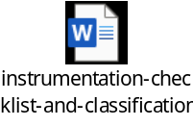
Reviewed, updated, and approved for posting the Instrumentation checklists that has been reconciled during our weekly calls since Spring meeting. It contains updated references based on all other RGP documents that were posted on the BLRBAC site this Spring. (Should not require 60 day posting) (Note: J!, J2, and J3 were consolidated in J.
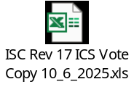
Does not contain updates for those items that were sent to the other RGP committees for guidance or clarification. On receipt of RPG replies, will update accordingly for posting and voting.
Lunch break
Afternoon sessions:
Continued discussions concerning future update to our documents.
- Many statements are based on older technology and methods that should be updated.
- Need a draft statement to allow for an “equivalency provision”.
- Equivalency provision would have to meet the following requirements:
- Approval of AHJ (Authority Having Jurisdiction)
- Documented Hazard Analysis performed.
- Documented MOC systems including life cycles guidance.
Discussed independent means of commanding a rapid drain valve to open. ESD, Profibus signal, etc.
Although Rotorq is heavily used in North America, many outside the US use AUMA actuators. They have a spring pack that can be released with a 24 vdc signal that will open / close a valve on loss of 480 VAC power. Some other suppliers have this feature also.
Based on previous ISC discussion in 2024 around the difference in refractometers and cookoffs due to deadload, CA Vossberg has prepared a document that we would like him to present to the SFBL committee in Spring of 2026.
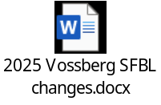
Great discussion around some other instrumentation, control methodology, how other SIL, SIS, based systems operate etc.
Motioned and seconded motion to close Fall 2025 ISC meeting.
John Browning

Gregory Burns from The Executive Committee, on the BLRBAC.net website there was an instrumentation guideline for review. This document was posted because when that guideline was previously approved the posted version omitted a couple sections. Since the document was approved and the EC has decided to post the procedure and replace the document missing the section and did not feel a vote was necessary. The instrumentation subcommittee is in the process of making some substantial changes to their document and that will be posted for review at a later date.

7.5 MATERIAL & WELDING – Laura Nicol

MATERIALS & WELDING Subcommittee Meeting REPORT

The Materials and Welding (M&W) Subcommittee met in Open Session on Monday morning, October 6, 2025.

The meeting was opened at 8:00 am with a review of the BLRBAC Anti-Trust Statement.

Attendance
Five (5) members and two (2) voting alternates out of eleven (11) attended. There were twenty-four (24) guests.
- Jesse Worsham has resigned from his position as vice-chair
- This will be Mark LeBel’s last meeting as Andritz alternate member
  - Paul Ceravolo (sp?) will become the alternate member
- Chris Skorton has been added as Midstate/SMS alternate member

Thank you to Jesse and Mark for their years of service, guidance and expertise. You will be missed.

Discussions
- Opened meeting with a Review of the BLRBAC Anti-Trust Statement.
- Introduction of attendees
- Reviewed minutes from last meeting and approved.
- Presentation on Hardness Requirements for Rolled Tubes – Laura Nicol of B&W
  - Base Material requirements/heat treatments vary by ASME Specification
  - Mills need to add specific hardness requests to purchase orders
    - Chemical composition dictates hardness
    - Cannot typically heat treat your way below MTR hardness values
  - Michael Lykins of Corrosion Probe Inc.: Annealing after swagging will not markedly reduce the MTR reported hardness
    - Quality of rolling depends on hardness variation of tubes being rolled
    - Recommended 100% hardness testing of material to be rolled
  - DO NOT go below ASME minimum tensile requirements
    - 60 ksi for SA-178 Grade C, and SA-210 A-1 = 69 HRBW
    - 47 ksi for SA-178 Grade A
  - Michael Lykins of Corrosion Probe Inc.: Do not use tape/adhesive on tube ends. Plastic caps okay but adhesive is problematic for tube rolling.
    - Properly clean tubes before inserting into drum/header
  - Bobby Johnston of Johnston Construction LLC: Make sure rolling equipment is cleaned multiple times during a shift
    - Do not use a rolling motor to re-roll weeping tubes – use a wrench to tighten (don’t over roll/break the existing seat)
  - Fabian Henriques of Smurfit Westrock: Does not recommend using rebound type hardness testers (Equotip Rebound). Recommends indent style of hardness tester (Ames Hardness tester or Microdur portable hardness tester)
- Reviewed additional agenda items:
  - Deciding factors on when to make tube weld repair – item was covered by adding the new sentence in Section 3.3.
    - 20251006 Action Item: Waiting for updated guidelines to be published before making additional changes. In April 2026, review Laura Nicol’s modifications to Section 4.3.
  - Neutral axis fatigue cracking in bends
    - Discussion from Mark LeBel of Andritz: Stress Assisted Corrosion (SAC) can occur in bend if there is enough residual stress and the water chemistry is bad enough. Background: a package boiler at a paper milled suffered a failure at a bend.
    - 20251006 Action Item: Determine if this information should be added, and if so, where? Review April 2025 ESP report on RB 4 in Lewiston.
- Discussion on cracking at a composite floor to carbon steel membrane bar welds.
  - Maxime Simard (FM) has a customer dealing with this issue
  - Mark LeBel (Andritz): this was a known issue in the 1990’s. Oak Ridge National Laboratories did extensive work on 304L.
    - 20251006 Action Item: Locate old ORNL reports. Requested Mark LeBel to locate this information.
- Discussion on training information and resources
  - 20251006 Action Item: Mike Rushing has been requested to develop a presentation for Spring 2026.
    - Discussed training sessions put on by ASME Code
- Discussion on inspection of main steam piping operating in creep
  - Michael Lykins of Corrosion Probe Inc.: no guidance for inspecting main steam piping (boiler external piping) that operates in creep.
  - Discussed that carbon steel creep can occur in 700 – 800 F
  - Operating in creep does not mean there is an issue with piping
  - It depends on temperature/pressure excursions, how many times and the length that the material was exposed to elevated temperatures
  - Companies do finite element analysis to help determine remaining life of components
  - Larson-Miller Parameters are utilized to calculate the remaining life
  - 20251006 Action Item: Determine if inspection guidance should be included in the Materials and Welding document.

Meeting adjourned at 10:14 am,

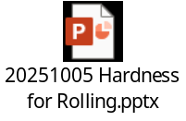

Voting on document
Gregory Burns Chairman of the Executive Committee, can I get a motion to accept the document as posted? We have a motion. Second? All in favor of accepting the document as posted. Anybody opposed? Thank You! The Material and Welding Guidelines have been approved and will be added to the BLRBAC.net website.

7.6 PERSONNEL SAFETY – Steve Morrison

BLRBAC Personnel Safety Subcommittee Meeting Minutes - 10/6/25

Morning Session – Open attendance
- Called to order at 8am
- Read and displayed the anti-trust statement
- Introductions of attendees
- Covered the agenda for the open morning session
  - Training Challenges
  - Brun treatments
- Began discussion on Training
  - Displayed BLRBAC Personnel Safety Guidelines section that addresses Training
  - Most attendees were unaware that the Personnel Safety Guidelines has a Training section contained within
  - Chairman began the discussion by explaining the difference between a paper industry that is experiencing very slight turnover with the current situation of high turnover and how the legacy Training systems were not robust enough to handle the increased training requirements
  - Discussed current strains on the Training departments and how companies are adapting to the new normal
  - Discussed options to aid in this overloaded system
    - Simulators
    - Drills
    - 3rd Party training
    - Leader Standard Work system
    - Spot checking trainees for absorption of training elements
  - Discussed refresher training options
    - A visitor shared how his department conducts a week long (4 days), (10) hours each day, off-shift training
    - This is repeated (4) times to cover all crews
    - Most companies present are conducting annual refresher training that consists of (1) day, (8) hours long training, repeated (4) times to cover all crews
    - Discussed using BLRBAC incidents as part of the training
Break 9:20am – 9:40am
Open Personnel Safety Continued 9:40am – 11:30am
- Continued discussion on Training
- Focused the conversation to entry-level engineer and entry-level supervisor training
- Most companies present have a rudimentary, technical focused training program for new entry-level positions
- A visitor shared how the entry-level personnel are rotated through the operation to gain some experience in all areas of Power and Recovery. (6) month long rotation.
- Discussed some current 3rd party training programs that are being used by companies:
  - TAPPI
  - AF&PA Recovery Boiler Operator Training
  - Auburn University - Alabama Center for Paper and Bioresource Engineering program
  - Boiler OEM training programs
- Discussed non-conventional training opportunities
  - National Boiler Board – Inservice Boiler Inspector training and certification
  - State/national boiler training certification programs (Example: National Association of Stationary Engineers)
  - Boiler training not specific to Recovery Boilers
- Discussed burn treatments currently in use by companies
  - Visitor from outside US, shared use of Diphoterine and how valuable it is on treating chemical burns
    - Not used at all in US mills
    - Carried on person by each employee
    - Neutralizes both acid and base
    - Hypertonic Solution: The solution is hypertonic, meaning it draws water out of the tissue, creating a reverse flow that helps pull the chemical away from the tissue cells.
  - US companies typically rely on emergency eye-wash stations and showers to treat chemical burns
  - For thermal burns, only chemical treatment mentioned (beside water) was Silver Sulfadiazine
- Adjourned the meeting at 11:30am
Afternoon Session:
- Called to order at 1pm
- Took role and had (5) members of the (12) present
- Not enough to have a quorum so the meeting was not started and the members were released

7.7 PUBLICITY & NEWS – Nick Quigley

No update.

7.8 SAFE FIRING OF BLACK LIQUOR – Vernon Blackard

BLRBAC SFBL FALL MEETING DRAFT MINUTES –

October 2025

Monday October 6th - 8:30 am – 4 pm
8:30 am --Noon Safe Firing of Black Liquor Subcommittee – (CLOSED)
1 pm to 4 pm Safe Firing of Black Liquor Subcommittee - (OPEN)

Proposed Agenda:
- Open the meetings. Both Closed and Open.

- Reviewed BLRBAC Anti Trust statement. Both closed and open meeting.

- Introduce members and guests. 23 members in closed and 62 members/ guests in open.

- Review and approve the Spring 2025 minutes. APPROVED

- Review any open items brought up to the subcommittee before the Fall 2025 Meeting.

- Guy Labonte of FM has two items to consider – Class 1 igniter checks and 30 percent air below liquor guns. See his email.
- Lengthy discussion about how a class 1 ignitor works, and what if manual valves are throttled, or closed completely? Code/policy reads that there must be a burner in. Just having an ignitor in does not satisfy this code.
- Peter Donahue and Guy will work together to help determine the best course forward on this topic.

- Len Erickson of PSA had question about checking for cracking on BW boilers with nose hanger tubes at the nose arch. Presentation and discussion was done. Most are replacing any tubes in this area if indications are found by PT or MT testing for cracking.

- Rudy Haraga of Fornax has RB incident to share. Interesting video also shared in question session on Tuesday afternoon.

- Continue new revisions after our Fall 2023 document was approved and posted.

- Review Fall 2025 Draft: NO ITEMS TO BE VOTED ON AFTER REVIEW.

Ch 3.5 LTL Logic…consider closing feedwater valve on ANY high FP or low DL event. LEN AND RUDY WILL WORK ON CLEANUPS

Ch 9.15 Spout leaks. Consider changing spout if cooling water off with immediate attention. Close off water to spout and plug immediately after any loss of cooling water flow. GOOD FOR NEXT REVISION AFTER MARK UP..

Ch 10.1 DT Plugged spouts – Black out conditions. If you cannot get your primary ports open with immediate attention; then do orderly shutdown, cool bed, and wash out the furnace and clear ports. DROP OPERATOR ACTION SHOULD BE SOP

Ch 10.2 DT design- Item 4 have two density devices , Item 5 have two level devices. SARAH TO CHECK BEST PRACTICE FOR DENSITY CONTROL.

Ch 10.3 DT Operation – item 5 on loss of DT primary agitator.

Immediate attention needed if you are running on back up agitation with loss of a primary agitator. HENRY RYAN GBP WORK ON BEST PRACTICE STEAM AGITATION
Suggestion to call it emergency agitation, rather than back-up agitation.

Appendix B Large tube leak logic check list.

Add second check list for example. RUDY WORK ON WITH LTL LOGIC REWORK.

Items brought up since Spring 2025 meeting:

- Continue discussions from Spring 2025 meeting (Refer to minutes). CONTINUE DISCUSSION FOR HIGH SOLIDS FIRING WITH SARAH INPUT. Some consider external heating of liquor pipes to prevent plugging on trips. Continue discussion next meeting.

Black liquor divert changes:
Specifically for high solids firing.
What if 1 of the 2 valves doesn’t reach its closed limit?
Right now we shut off a valve and pump.
Pressurized tanks to accept the high solids liquor form the lines to keep them from plugging. 80-83% solids increases the problem.

- DT incidents to be reviewed:

None received for this meeting.

- AFPA DT VENT STUDY – UPDATE ON STATUS

U OF TORONTO WORKING ON FOR APPROVED STUDY.

Three type of DT venting design requirements. Normal at full liquor firing rate, smelt rush at normal firing rate, DT explosion venting when percussions occur.

5’6” for shatter jet space
43” of freeboard from surface to bottom of overflow line.

- DT FUNCTIONAL TESTING – UPDATE ON STATUS.

One mill uses air to cool the shaft of the DT agitators rather than water. JAY DILWORTH WILL PRESENT NEXT MEETING.
All should make sure they can isolate all water to the DT from a safe distance.

Homework:

GETTING OEMS TO DESIGN OVERFLOW FOR MMLBDS BL/DAY BASIS WITH PROCEDURES.

WHAT DO OEMS RECOMMEND FOR VAPOR SPACE ABOVE BOTTOM OF DT OVERFLOW? 43”

WHAT DO OEMS RECOMMEND FOR SMELT SHATTERING SPACE ABOVE BOTTOM OF DT OVERFLOW?

Does anyone not use the Swedish standard for DT explosion venting and where do you put your vents.

- Tim Hicks did several good presentations heat input needed for stable firing of black liquor Spring 25 meeting. Any volunteers to draft language in our document to capture his work? TIM WILL HELP ON THIS ONE.

- Open item discussion from members.
- Any new items will be discussed:

- Other functional tests on DT. Check water sources off on crystallization event.

Shut off agitators and all water sources.
Hood wash water isolation
Peter says there doesn’t seem to be anything in out document diagrams to address isolating waste streams during a purge. In the liquor, not the combustion air. PETE AND GUY WILL LOOK OVER

Jason Lewis will provide procedure to set DT Agitator amp alarms. JASON NOT AT FALL 2025 MEETING.

Vernon will share some more examples of good LTL logic …tube leak check sheets. WILL INCLUDE IN MINUTES ANOTHER EXAMPLE

- Open discussion from guests
- Guest questions?

TIM OPINIONS

EXPLOSION TECH FOR CLEANING BOILERS…SFBL NEEDS?
MFT SAME AS SOOTBLOWER, GAS STORAGE ISSUES, WAY TO CHECK PULSE ENERGY TO PEAK IK PEAK PRESSURE OR TUBE FAILURES.

CRYSTALLIZATION DENSITY LIMIT IS VAGUE IN OUR DOCUMENT. NEED TO UPDATE WITH SOME MORE DETAILS. CH 10.2 ITEM 10. AFPA STUDY CAN BE UPDATED.

- Explosion videos…Will share any submitted. Have IP Power point of RB history of explosions (share visual only. No copies or files shared). Stephen Cox of IP shared on open meeting in the afternoon. Will include API video in minutes.

- Close meetings as needed (closed and open).

- Vernon announced this is his last meeting as chair of SFBL. Executive committee approved Sarah Henke taking over as chair position of SFBL. Wes Hill will be Vice Chair. Spring 2026 membership will reflect these changes.

7.9 WASTE STREAMS - Paul Seefeld

Monday 10-06-2025

The subcommittee met at 9am. Attendance sheet was circulated to count members and guests. The BLRBAC Antitrust statement was read, and the previous meeting minutes were reviewed and approved.
The majority of the meeting was focused on reviewing section 6.4, Soap firing as a waste stream. The subcommittee members and guests had several recommended redlines to the document for further discussion. This focused on language revisions regarding emphasizing proper mixing, ratios of soap: liquor firing to reduce process variability, and potential risks for soap accumulation in process tanks if systems operate partially recirculated. Additional comments were also added about impacts to furnace conditions and black liquor feed system due to variations in quality of soap. There was also a recommendation to prepare a simple process flow diagram, highlighting critical instrumentation necessary for adherence to recommended interlocks and permissives as well as other normal operational practices.
Question from visitors:
-How do you handle line purging of Soap Systems?
Guests and Members recommended designing systems with adequate steam outs at the end and beginning of the system, as well as middle points as needed, to allow for steaming out when the system is intended to be down for an extended period. The team also discussed designing systems to recirculate soap through most of the system to keep it flowing when not actively burning in the recovery boiler black liquor systems or design systems with auto purges as needed when the asset is down. The team discussed that permanent hot water flushes are discouraged but not prohibited upstream of the double block automatic shut off valves that could be used as well; weak or heavy liquor also was discussed as suitable alternatives to hot condensates.
-When we are cleaning the line out of methanol during maintenance, are there good practices referenced in the waste streams document or from users of the systems?
Team discussed using water to flush and to design system to allow for back flushing to storage tanks, ensuring you are aware of where it is flushed to and neutralizing chemicals. Team members do not recommend using steam for this service due to volatility of the fluid (Methanol). This is not spelled out in our waste streams document other than recognizing the need for adequate flush points on the system for maintenance purposes.
The meeting adjourned at 11:45am.

7.10 WATER TREATMENT – Dave Tjaarda

BLRBAC Fall 2025 Water Treatment Subcommittee meeting minutes

Fred Call – called the meeting to order at 08:30.
Fred reviewed the BLRBAC Antitrust Policy and passed the roster list around the room. See the roster at end of document for committee member attendance.
Morning agenda today includes:
Ø BLRBAC Anti-Trust Statement
Ø Update Subcommittee Membership Information
Ø Approve Spring 2025 Meeting Minutes
Ø Final review of the Sampling and Testing Documentation
Ø Production of Clarification/Filtration and Make-up water sections (time permitting)
· Continue building basic outline structure
· Discussion on extent of the above topics

Previous Meeting Minutes Approval
- Fred handed out printed copies of the Spring 2025 minutes. Review and Approve Spring 2025 Minutes.
- Fred circulated the meeting attendance roster
- Dave Tjaarda moved to approve the minutes, and Dylan Price seconded the motion, which was approved.
- Fred reviewed the list of Subcommittee members for an update from operating companies.

Review of Sampling and Testing Protocols (Section 6.1)

Tom reviewed the status of the document having been presented to the executive committee and posted to the website for review. No public comments were received.

Executive Committee was concerned with the usage of “shall” and “should” in the ESOP section. They felt there was some inconsistency in their usage referring to the requirement of an ESOP in separate sections of the document. Could lead to confusion on the requirement of mills having an ESOP.

The Executive Committee was also concerned that the document was a bit too detailed and lengthy making it “difficult to audit to”. Suggested summary tables for quick reference to requirements and suggestions.

Tom replied to both concerns detailing the reasons for the different uses of “should” and “shall” and pointing out that there is a summary table with a single line for each recommendation (should) and requirement (shall). The table has a summary of each item with a section header for reference, the type of guideline, whether it’s a “shall” or “should” guideline, and a comment for clarification. The table is set up so that it could be used as a template for an auditor to use and track compliance.

The suggestion was made to move the table to the front of the document so it is more apparent to any readers that it exists rather than being stuck in the back of the document.

The other option would be to include the list in the table of contents as an appendix.

There was discussion around how to highlight the summary table to a reader, what it should be called and where it should be in the document.

Tom mentioned that the instrumentation and classification guide was the template for this summary table, which is an appendix to that guideline.

Fred moved to add the Appendix (summary table) to the table of contents to ensure readers know it exists. Ricky Baxter seconded the motion, and it carried as moved.

Fred mentioned that another concern of the executive committee is that there is not enough representation on this subcommittee from recovery boiler owners and that the committee is actively recruiting new members from the operating companies.

Tom mentioned that the “Testing and Sampling” document is posted and should not have been on the agenda for review, “Clarification and Filtration” is the document that should have been on the agenda.

Fred had the “Clarification Filtration” document printed and distributed it for review by the meeting attendees.

The title had been agreed to be changed in the last meeting to “Deionization Systems” and the change was made during this meeting.

The system overview and Basic System Flow Path statements were modified for brevity and clarity.

Under Basic System Component Design, a section was added for Softeners

The header “Cation/Anion Exchange” was changed to “Demineralizers and the definition was changed to be more concise.

The definitions for reverse osmosis, heat exchangers and treated water storage were made more concise.

Electrodeionization (EDI) was added as a system.

Added sub-headings to separate out different water treatment equipment in 2.1.2, Key Chemical Control Variables and discussed, modified and added to the existing list of variables.

Section 2.1.3, Key Maintenance Practices & Protocols was reviewed and edited.

There was discussion around how often resin should be sampled and analyzed, settling on after any process excursions, but not to exceed a time limit of 2 years between samples.

The language around inspection of deionizing vessels and liners was discussed to ensure both the vessel is inspected with NDE and the liner is inspected visually and with spark testing. Initially put a limit of 10 years between spark tests on the liner, but highlighted it to return to it with more SME input.

Began working on section 2.1.4, SOPs

Discussed which SOPs would be required for treated water testing outside normal control boundaries. This included a discussion around whether this should include inlet water (pretreatment) or not. The items for inlet water were highlighted with a note that they should be noted in a separate section as this section is specifically for treated water.

There was another discussion around the difference between SOPs and ESOPs settling on an SOP being a description of how you operate normally and an ESOP being a reaction to being out of normal operating conditions.

Dave Tjaarda made a motion to adjourn the meeting at 3:26 and it was seconded by Jeff Armstrong, it was approved as moved.

Voting on document
Gregory Burns Chairman of the Executive Committee, can I get a motion to accept the document as posted? We have a motion. Second? All in favor of accepting the document as posted. Anybody opposed? Thank You! The Water Treatment Guidelines have been approved and will be added to the BLRBAC.net website.

Non BLRBAC organizations:

8.0 AMERICAN FOREST & PAPER ASOCIATION RECOVERY BOILER REPORT: See Appendix III – Slide Presentation) – Wayne Grilliot
The American Forest & Paper Association (AF&PA) Recovery Boiler Program was established in 1974 to help identify the root cause of recovery boiler critical incidents and explosions. The AF&PA Recovery Boiler Program assists companies in improving the safety, integrity, and reliability of recovery boiler operations. Recovery Boiler Program membership is open to all companies that operate recovery boilers. Program activities are funded by member company dues.

The Recovery Boiler Program is under the direction of a Steering Committee which includes Stephen Cox (International Paper), Jeff Wagoner (International Paper), Greg Burns (Domtar) and Wes Hill (Georgia-Pacific). The Steering Committee sets Program priorities based on Member Company Input, BLRBAC Incidents, and Industry Needs.

The Recovery Boiler Program provides a forum for companies to develop information to help evaluate Safe Operating Procedures, Organization and Training, Maintenance Programs, Specifications and Construction, and Research & Development Programs. Documents developed by the Program include Reference Manuals, Audit Guidelines, Best Practices, Training Aids, Checklists, Textbooks, and Studies. The Program sponsors R&D projects for Safety Improvements and Process Improvements. This helps drive improvements in Safety, Operations, Maintenance, and Recovery Boiler Integrity.

Available documents on the AF&PA Recovery Boiler Website include Publications, Studies, Training Aids, Standards, and General Program Information.

AF&PA Recovery Boiler Program Website:
http://www.afandpa.org/our-industry/recovery-boiler-program

9.0 TAPPI ENERGY, RECOVERY, RECAUST (ERR) Committee REPORT

– ERR Committee Daniel Franco

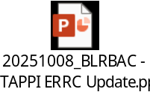

10.0 WESTERN CANADA BLRBAC REPORT – Angelo Porchetta

Western Canada BLRBAC – Spring 2025 Meeting Summary
Date: April 15–16, 2025
Location: Richmond, British Columbia
Meeting Room: Fraser Room

1. Opening & Business
- New Members Introduced: Representatives from Armstrong (Hinton), Caribou Pulp (Garret Powell, Brandon Sirsas), Valmet (Kimo, Gerry), Lundberg-Jansen (Jim Straka), GE Vernova (Jesse Hodgins), Andritz (Sam Milner), HSPP (Randy Muralt).
- Treasurer’s Report (Shawn Fenner):
  - Each session costs
  - Discussion about allowing retirees to attend free of charge.
- Old Business: None.
- Correspondence: None reported.
- Future Dates: Tentative Fall 2025 meeting – Nov 18, 2025.
- Motion to accept minutes: Passed (Dino motioned, Shawn seconded).

2. Incident Reviews
Multiple mills shared incident investigations and learnings:
- Mercer Celgar: Economizer leaks; fatigue at tube-to-casing welds.
- Northwood: Economizer leak traced to old weld defect.
- Skookumchuck: Multiple econo leaks in 2017 modules; lesson learned to increase NDT during fabrication.
- Harmac: Superheater tube stress from poor fit-ups; future SH replacement in 2027.
- Hinton: Cold-side attachment weld leak (March 2025).
- Crofton, Canfor, Celgar: Leaks tied to layup conditions, dry-out procedures, and corrosion.
- General Topic: Dry-out procedures after water wash – best practices discussed; FM Global and Domtar policies referenced.

3. Committee & External Reports
- PAPTAC: No report.
- Eastern BLRBAC: Smaller attendance, discussed collaboration with Western division.
- Atlanta BLRBAC:
  - 20 incidents (3 ESP, 6 critical).
  - Most leaks in economizers.
  - Leak detection mainly via walkdowns.
  - ESP response times: 19 min–2 hrs 57 min.
  - Overall trend: incidents decreasing.
- Steering Committee: Will meet to review financials and develop a two-year plan.

4. Manufacturers’ Updates
Andritz:
- Multiple SH and furnace wall projects in US mills.
- Adding engineers in North America.
- Shock pulse generator technology in use; first North American installation at Sappi.
Valmet:
- New PPE (Vulcan suits, Gore hood).
- ND deposit inspection methods.
- Smelt robot performing well in Spring Grove, PA.
- Ongoing projects: Harmac upgrades, new lime kilns, DT audits.
Jansen / Lundberg:
- Global projects in biomass, recovery, and WTE boilers.
- Focus on combustion tuning, reliability, and NCG integration.
- Partnership with Lundberg for environmental systems and crystallizers.
GE Vernova:
- Structural reorganization (split from GE); continues parts, engineering studies, and APM software.

5. New Business
- Proposal to invite retirees to attend meetings free of charge (to be reviewed by Steering Committee).
- River Rock hotel booking issues – need for improved booking coordination.
- Membership system updates: Exploring automation for invoicing and online registration.
- Meeting Format: Suggest mills present short “plant profiles” each session.
- Steering Committee Task: Develop a 2-year strategic plan with goals and feedback collection.

6. Mill Reports (Highlights)
Crofton: Reliability improving; CNCG incineration issues; fibre and bark press challenges.
Skookumchuck: Strong safety record and production.
Domtar (Howe Sound): Organizational changes; improved safety systems; outage work included valve replacements and BMS upgrades.
Hinton: Ownership change (Monty); capital upgrades; planning boiler capacity increase.
Caribou: Now fully West Fraser; major safety and maintenance upgrades; kiln and ESP rebuilds.
Kamloops: 5-year LTI-free; focus on combustible dust compliance and NCG safety.
Northwood: Transition to single-line operation; economizer corrosion issues; WorkSafe BC compliance actions.
Harmac: Record reliability and profit; major RB6 rebuild and tank replacements.
Howe Sound: Corrosion repairs on water wall, power failure events, seismic effects, and upcoming major shutdown work.

7. Roundtable & Closing
- Shared successes, near misses, and best practices.
- Discussion on online payments, training alignment with Atlanta BLRBAC, and future leadership succession.
- Meeting adjourned after general discussion.

11.0 ACTIVITIES OUTSIDE NORTH AMERICA REPORTS:

There were no reports from organizations outside of North America.

12.0 OPERATING PROBLEMS SESSION REPORT – David Tjaarda

Operating Problems Session Report Out
The session began at 1:00 PM on 10/7/27, and was facilitated by David Tjaarda of Smurfit Westrock the Vice chair of the Executive Committee.

There were 19 questions submitted in writing and 1 question form the floor. Additionally, video clips of an incident related to smelt spout violence was shared and questions fielded. We were able to talk through all the questions.

Questions topics were related to:
- Dissolving tank density & temperature measurement
- Time based vs. condition based chemical cleaning
- Water washing technique
- Paper machine condensate return
- Sulfidity
- Remote firing of burners
- Tripping of secondary air fan on ESP
- ID thinning of riser tubes
- Leak detection systems & displays
- Large leak logic
- Chemical cleaning evaporators OTR
- SAC
- Application of NBIC 4.4.8.7

CLOSING COMMENTS:

CHAIRMAN: Gregory Burns

That concludes our Main Committee Meeting this morning. Thank you all for your attendance and your time away from home and work. Our next meeting will be April 6th, 7th And 8th 2026 and it will be here at the Hilton Hotel. The Executive Committee strongly encourages you to register and stay at the Hilton. Be on the lookout for that registration email in late February. Please spread the word to increase participation in these meetings. We really need more participation from the mills.
With that I'll now entertain a motion to close the Main Committee meeting. Second? The Main committee Meeting is now closed. We will have our Technical Presentation starting in about 15 minutes.
Thank you all and have a Safe trip home!...

APPENDIX I

Incident Reports

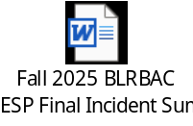

APPENDIX II

ESP PRESENTATION

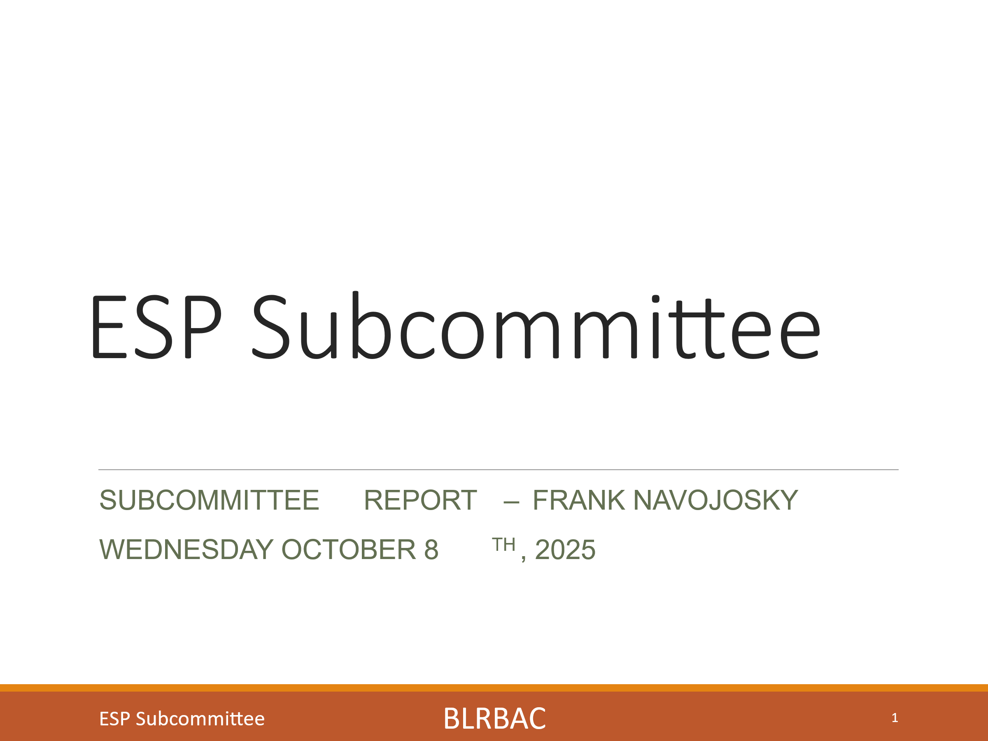
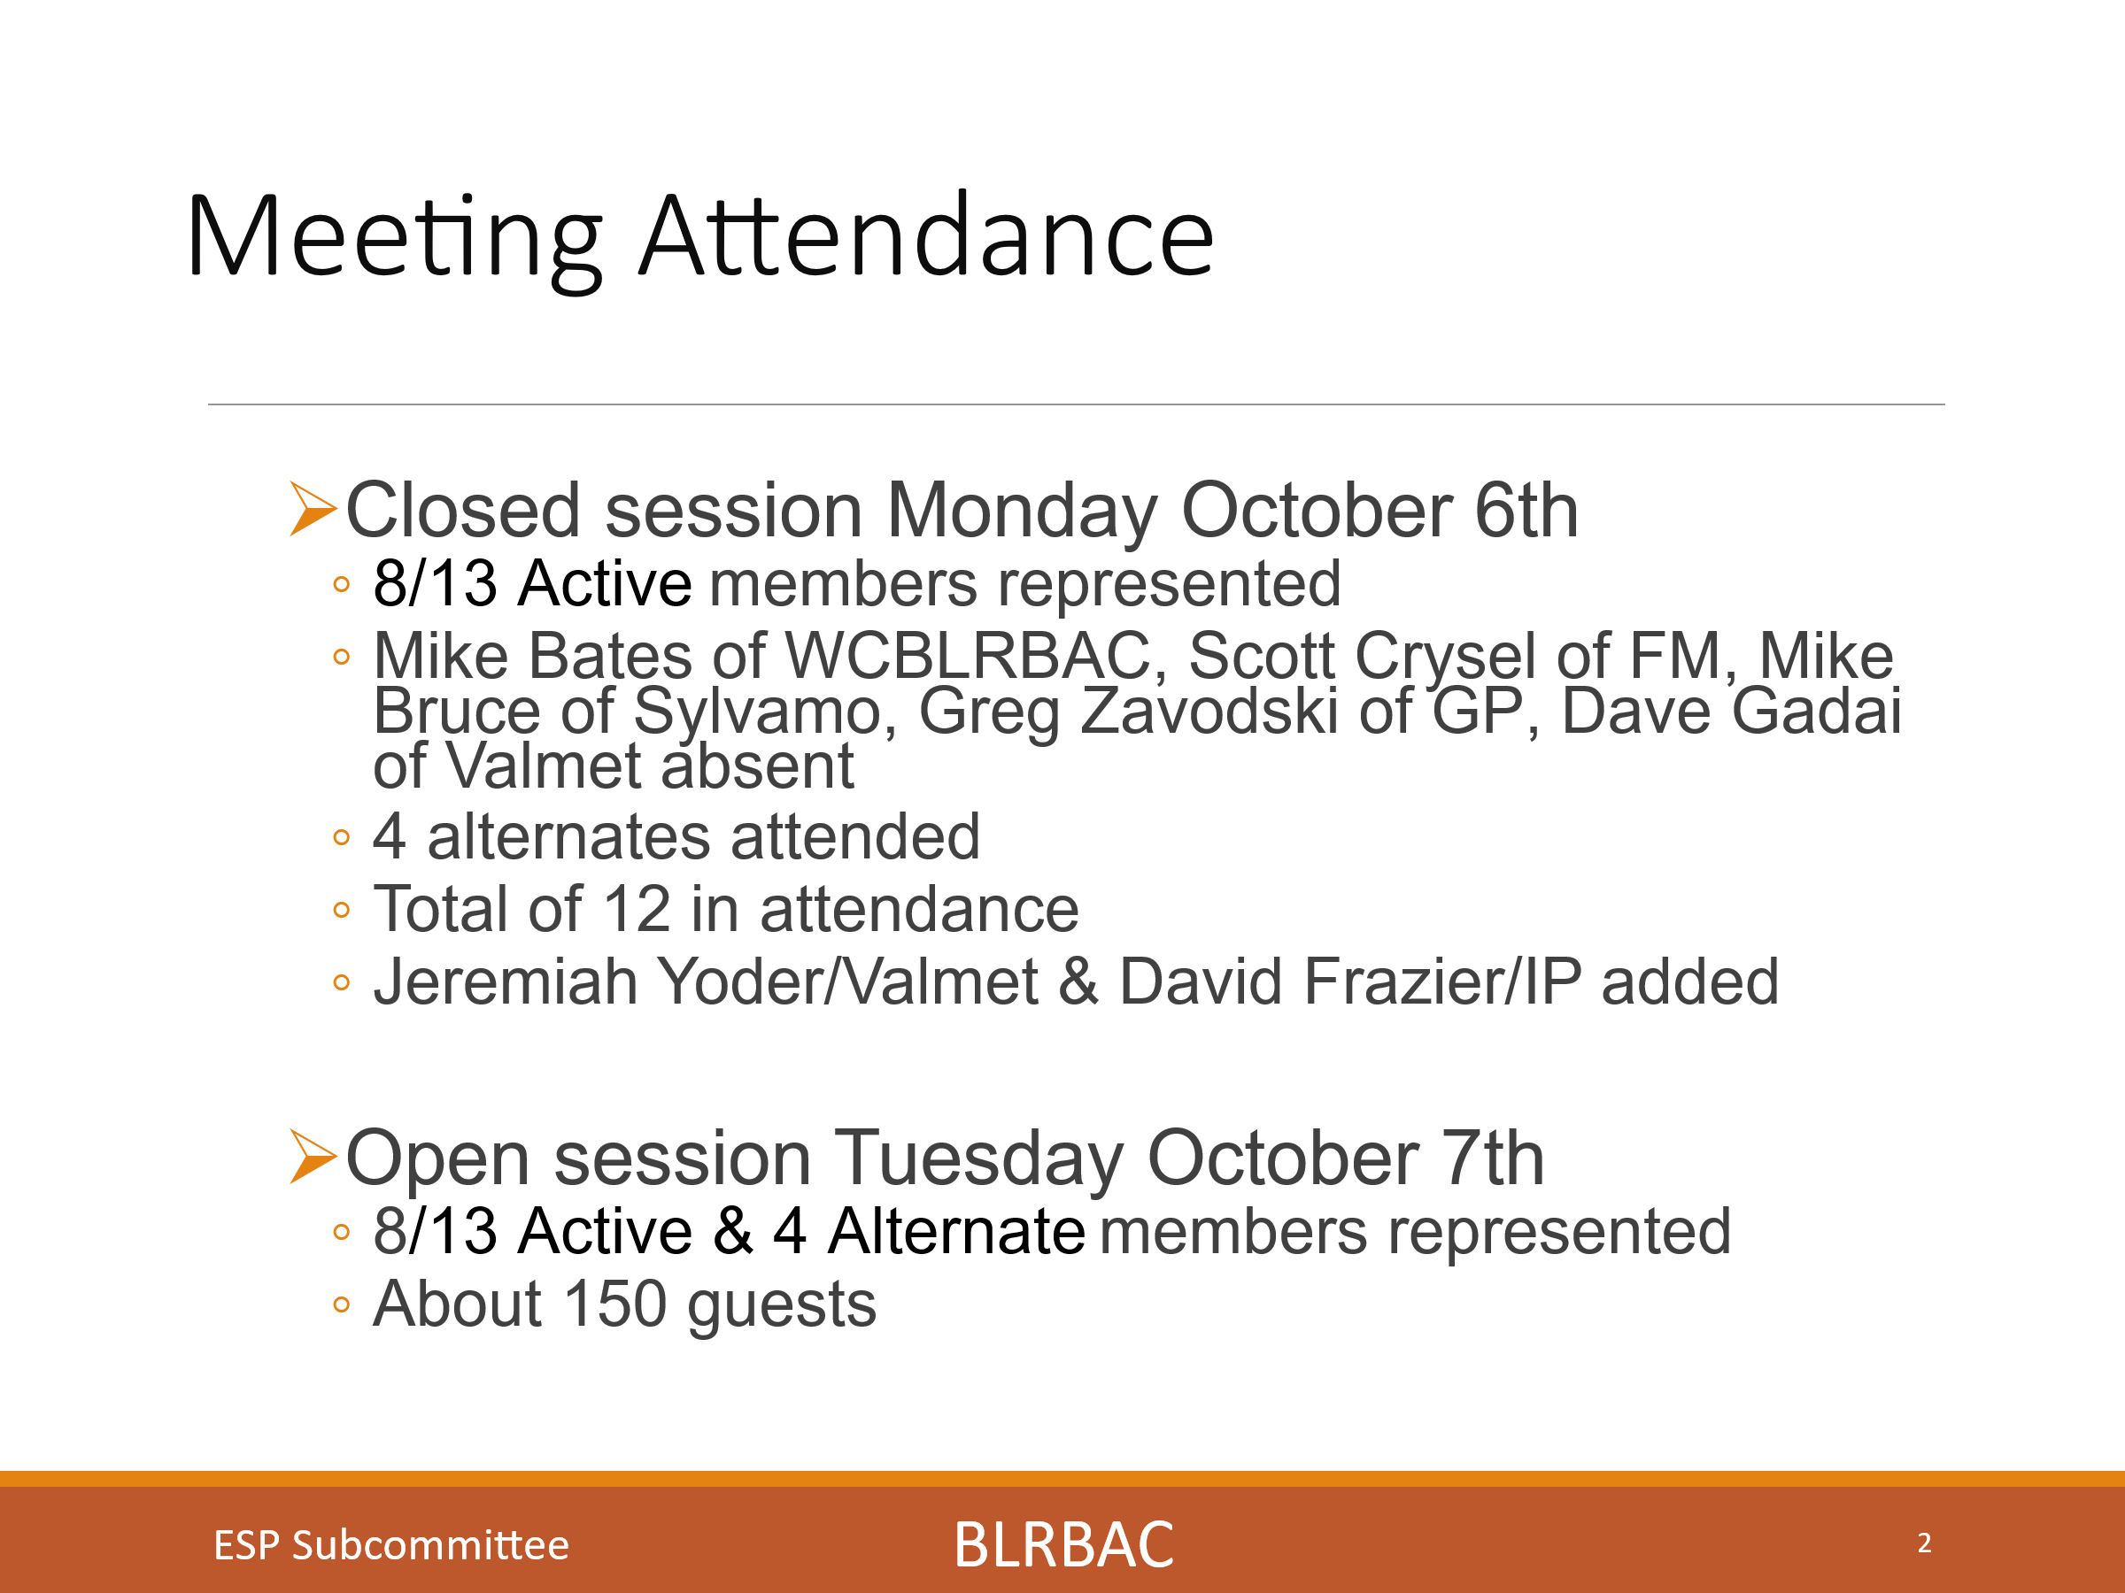
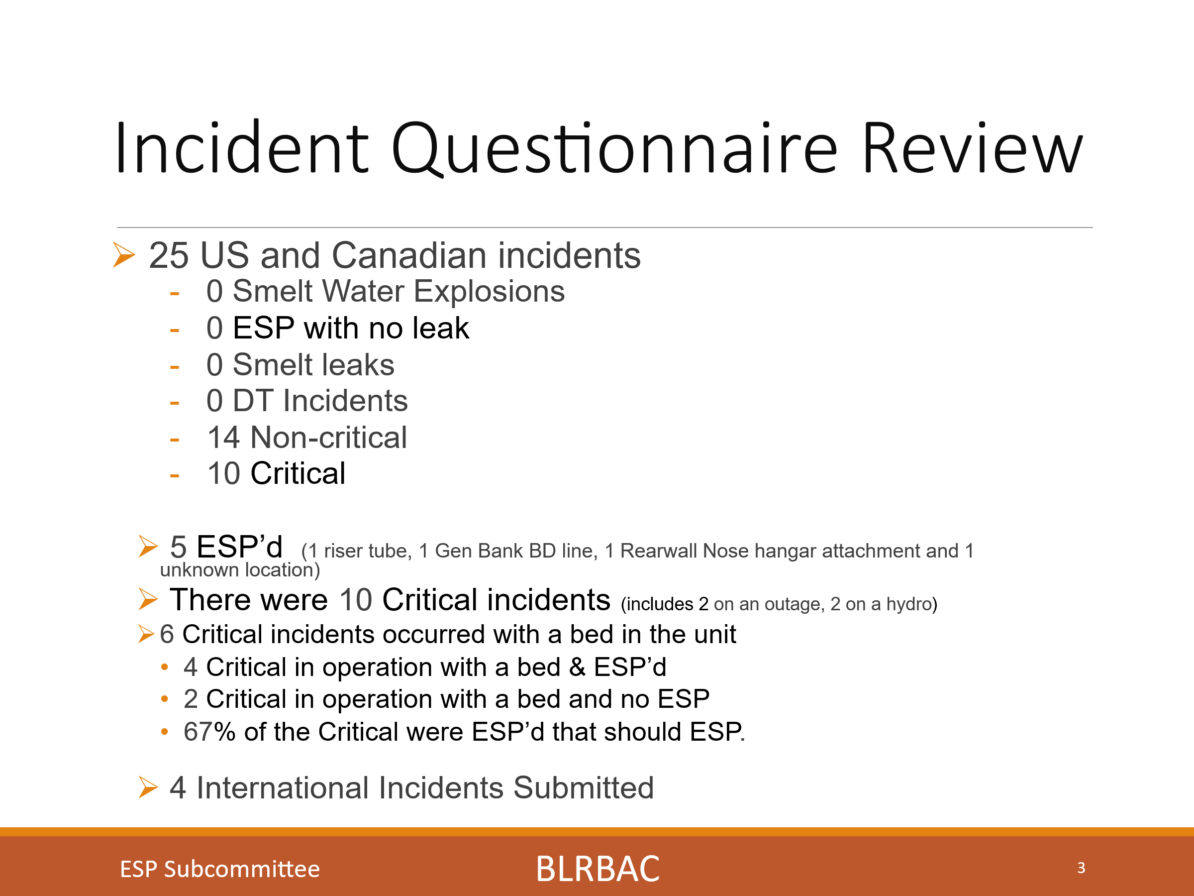
29 Total incidents reported and reviewed (25 US and Canada and 4 International)

There were 0 Smelt Water Explosions, 0 ESP’s with no leak, 0 Smelt leaks, 0 DT incidents.

14 were Non-critical and 10 incidents were Critical.

5 incidents were ESP’d. 1 Riser tube, 1 Generating bank Blowdown line internal to the hopper, 1 Rear wall nose hangar attachment, and I due to unknown location near the spouts.

Of the 10 critical incidents (8, 12 – 17, 21 - 23), Two were found on a hydro and 2 were found during an outage inspection.

Six were critical incidents which occurred in operation with a bed in the boiler.
One was a Riser in the penthouse, one was a blowdown line internal to the generating bank hopper, one was a generating bank cold side downcomer tube, one was in the nose to sidewall area, one was at a SB opening, and one was in the right wall at a previous metal sprayed area.

Four of the six critical incidents in operation were ESP’d which amounted to 67% of the incidents that should have ESP’d, were actually ESP’d.
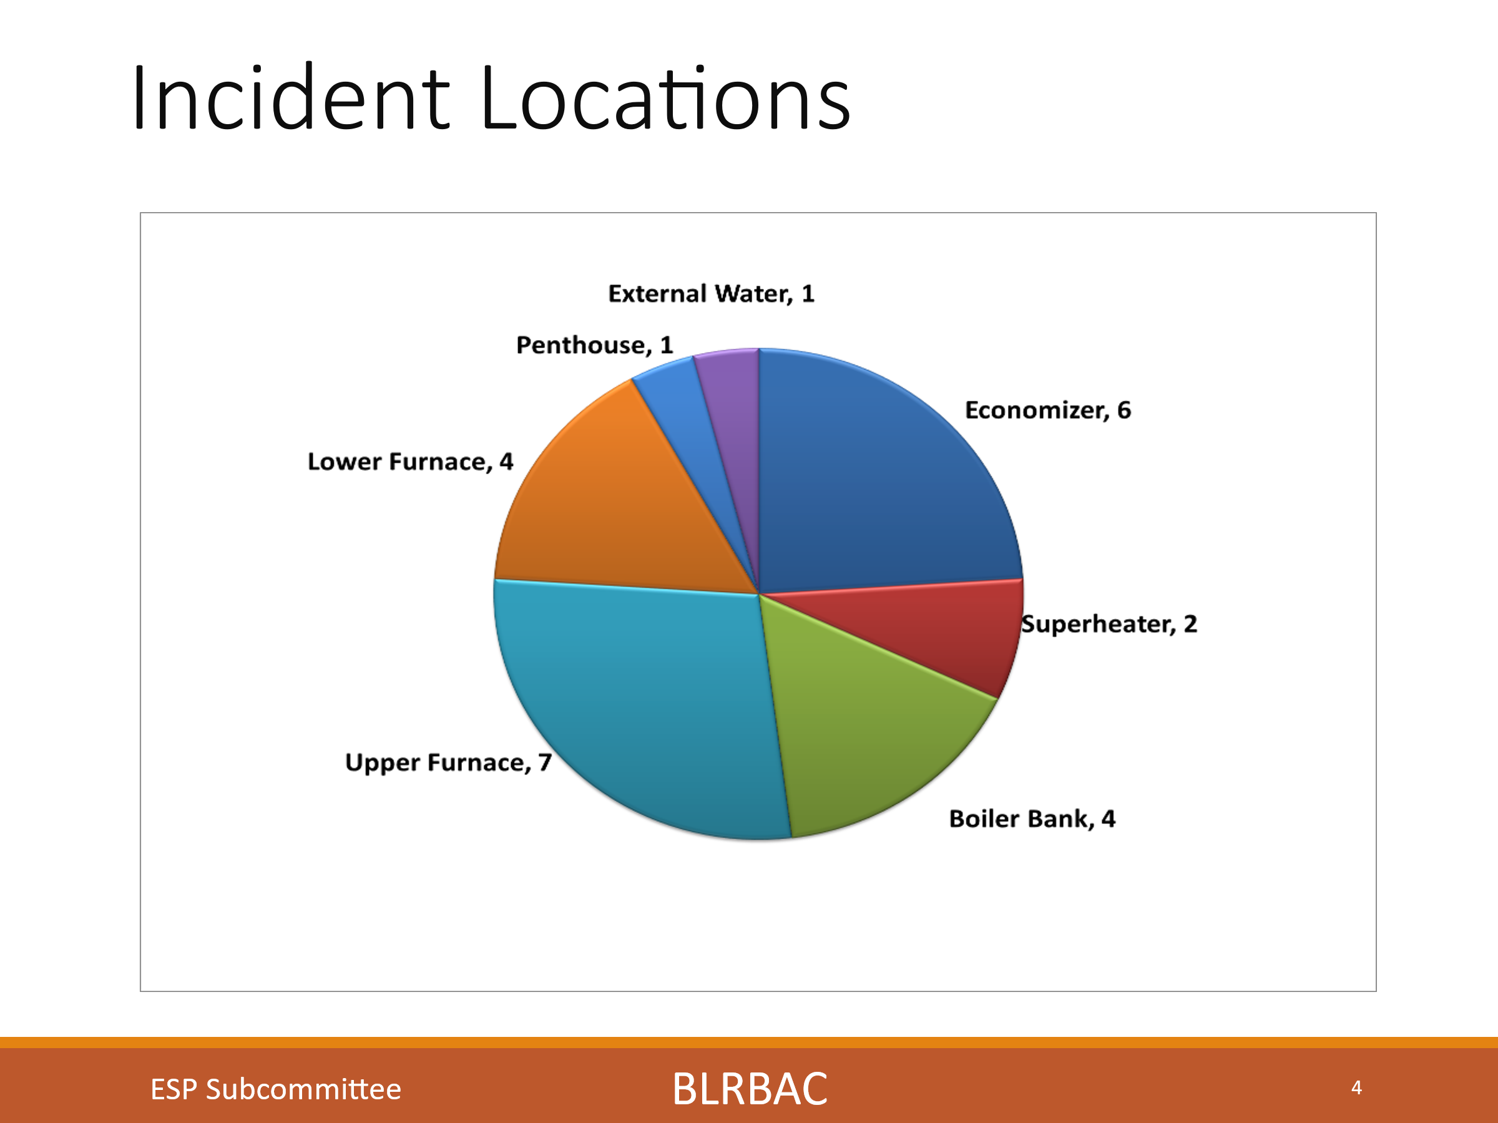
There were 6 economizer leaks, 2 super heater leaks, 4 Boiler bank leaks, 7 upper furnace leaks, 4 lower furnace leaks. 1 riser tube in the penthouse and 1 external water leak. Superheater and economizer leaks have typically been a larger portion of this chart and we are now seeing a larger portion of upper and lower furnace leaks as we did in the Spring.
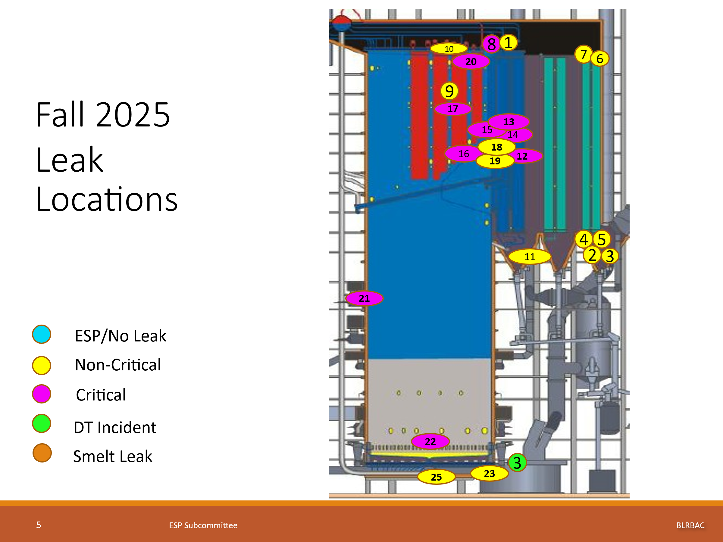
This slide is a side view of a recovery boiler showing approximate location and provides another view of the leak location. Some people like this type of view. It is not fully representative, as it does not also have a front view. Additionally, we now have added the section behind the nose for the generating section showing the location of a typical one drum boiler and two drum boiler leaks will also be shown in this location. The numbers in the circles are the incident numbers.

NOTE: Incident 12 was a BD line in a 2 drum generating section hopper. It is shown in the generating section up near the nose, making it a critical leak, even though it was in the generating section hopper (Hard to represent the risk of water going over the nose on this single drum drawing)

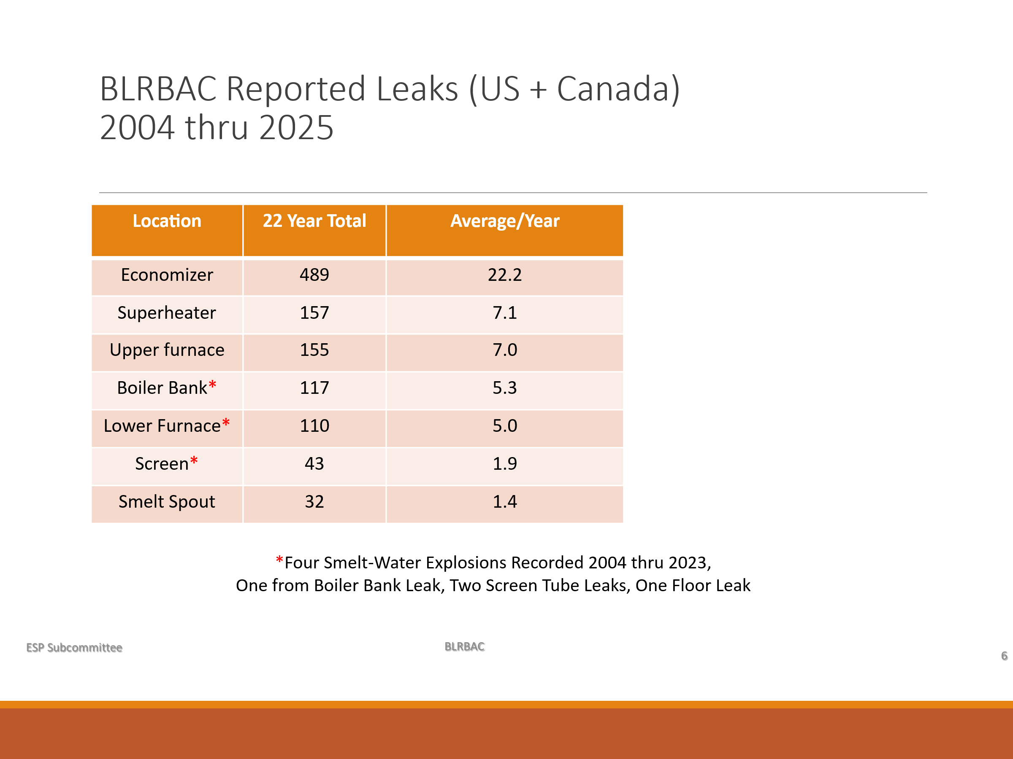
This chart is a total over the years from 2004 to present showing the total number of leaks per section and the average in each section. This is a 22-year total. We had 489 Economizer leaks (22.2 average), 157 Superheater leaks (7.1 average), 155 Upper furnace leaks (7.0 average), 117 Boiler bank leaks (5.3 average), 110 Lower furnace leaks (5.0 average), 43 Screen leaks (1.9 average) and 32 Smelt spout leaks (1.4 average). It is good to see that leaks in the more critical areas of the boiler are lower in frequency on the chart. The order has historically seemed to remain the same although SH and upper furnace are getting closer.

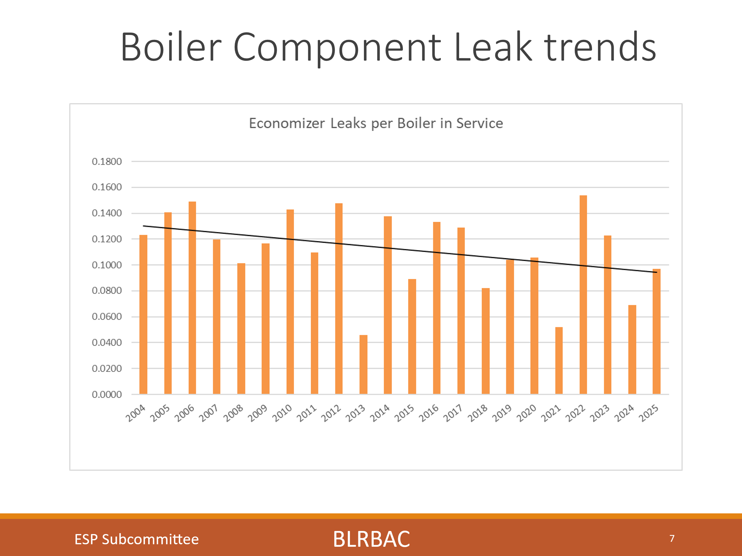
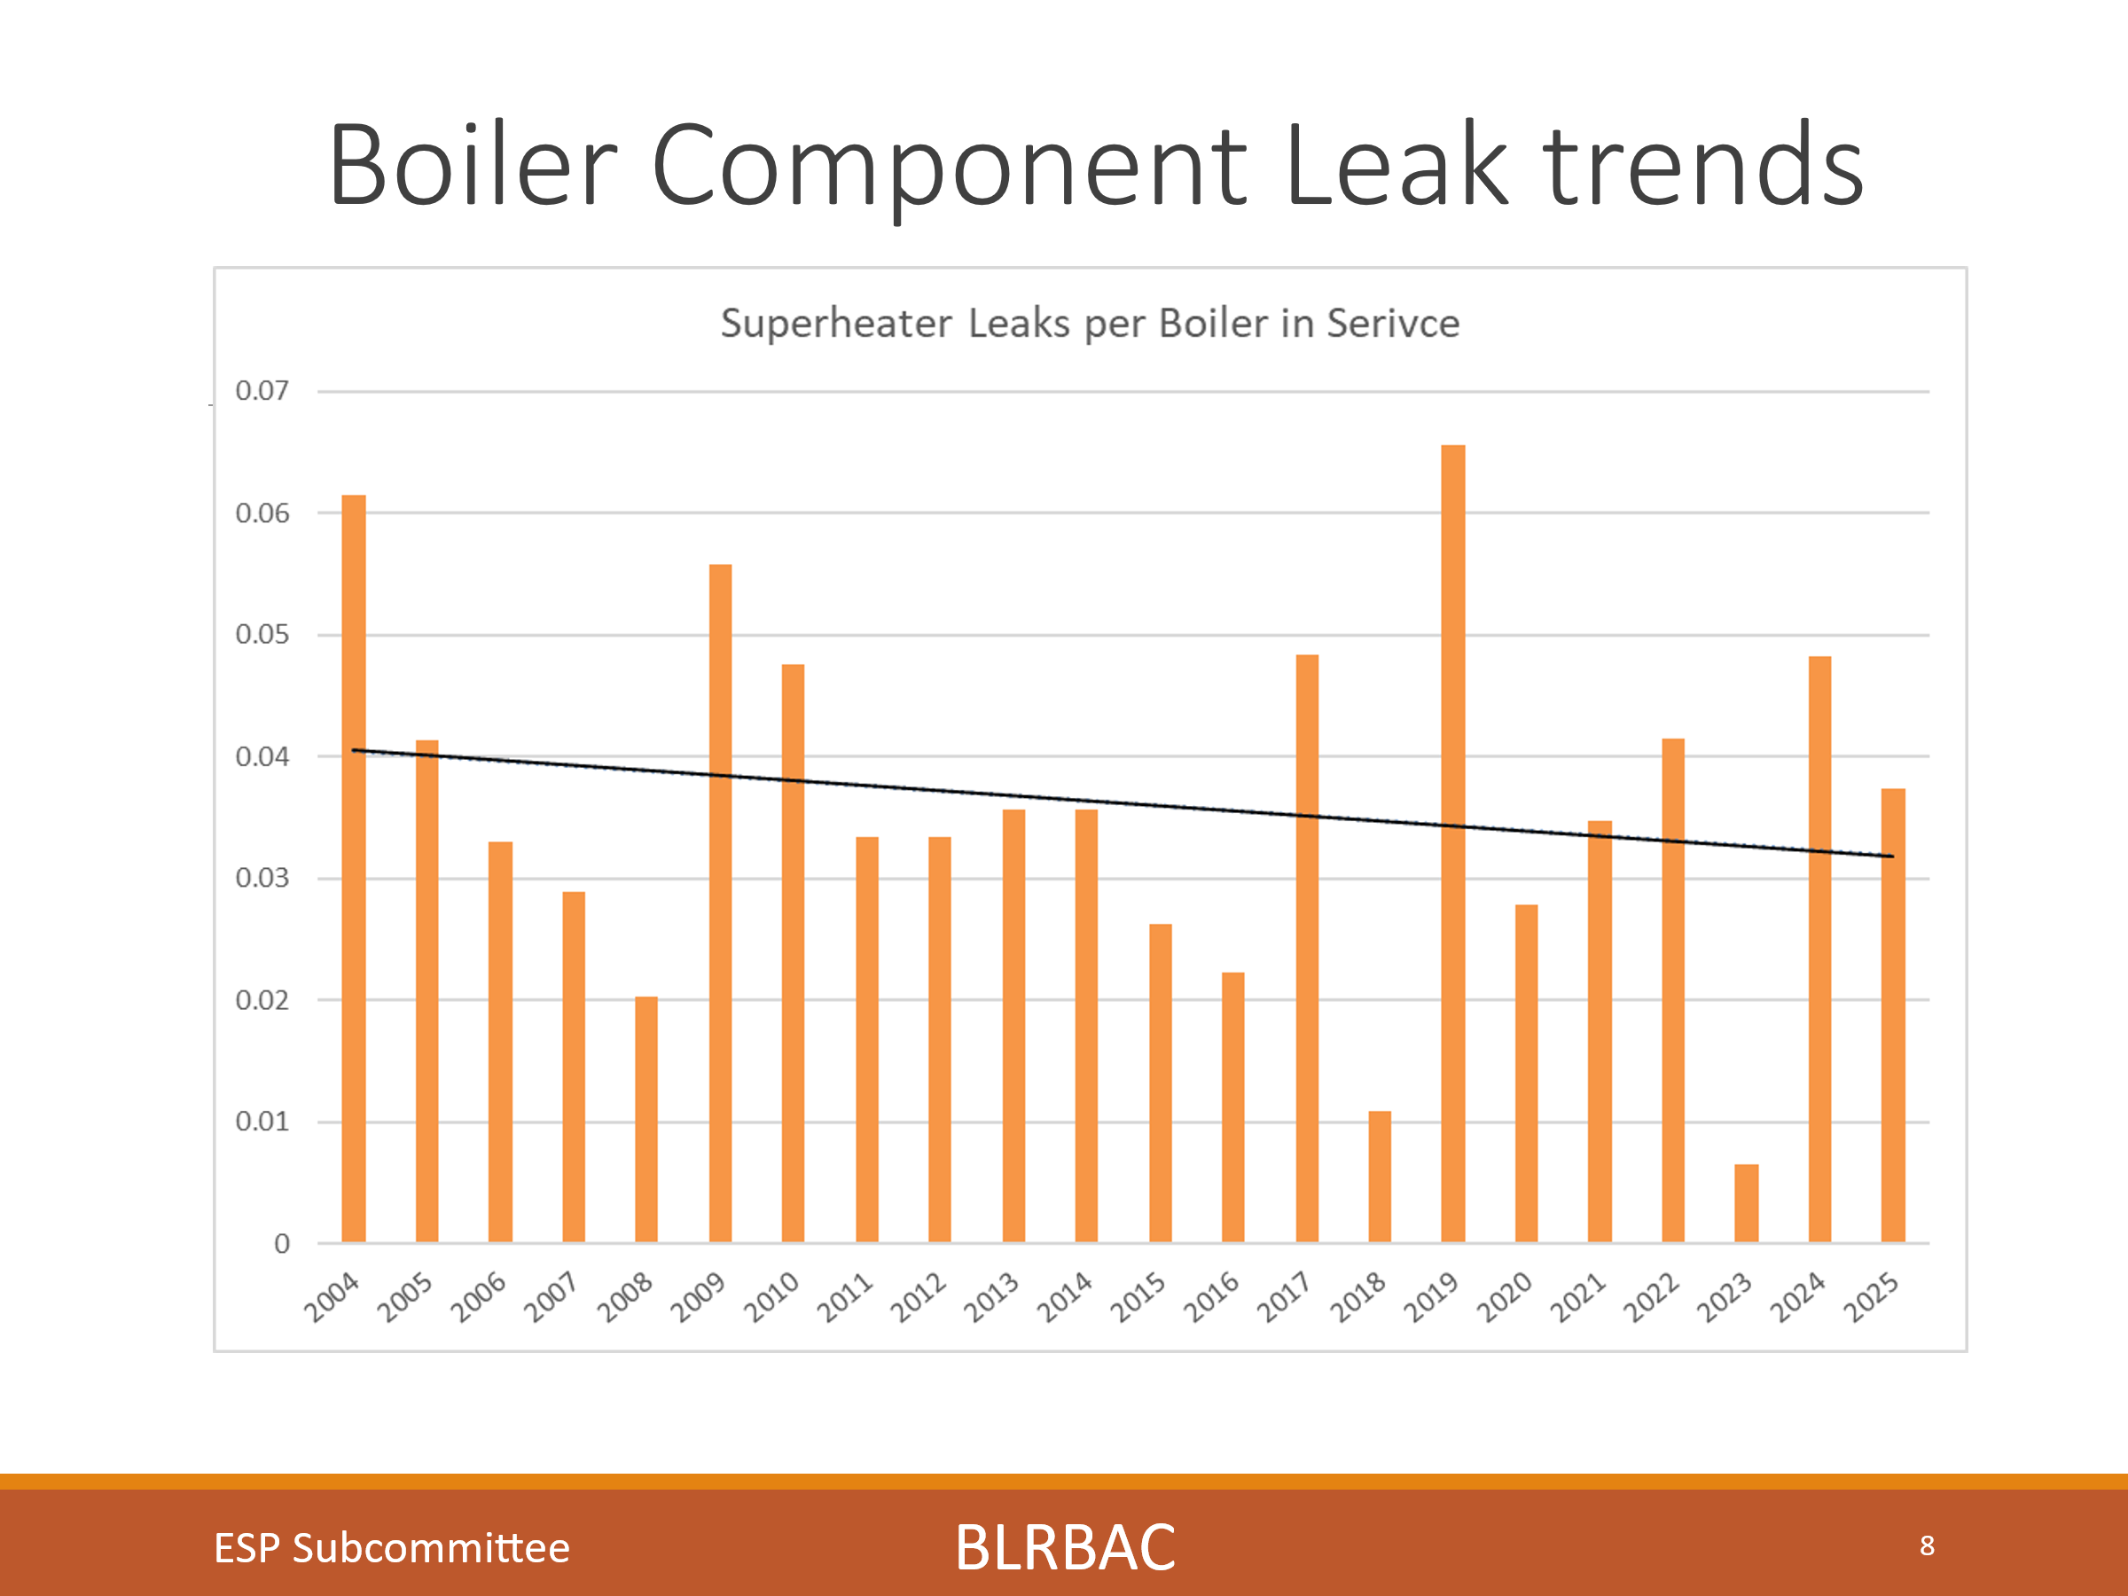

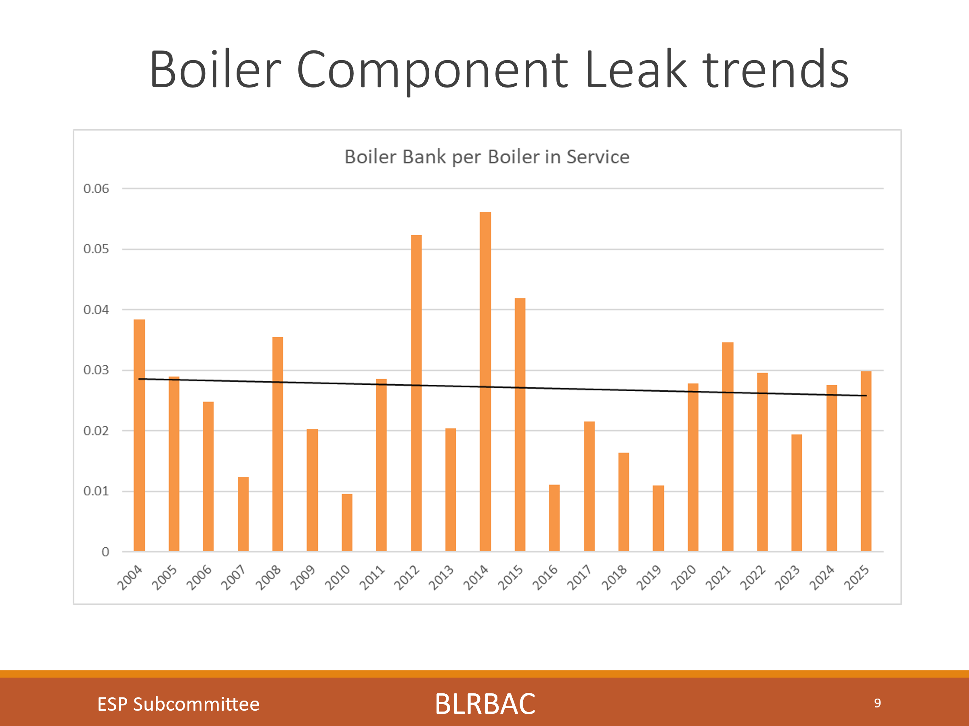
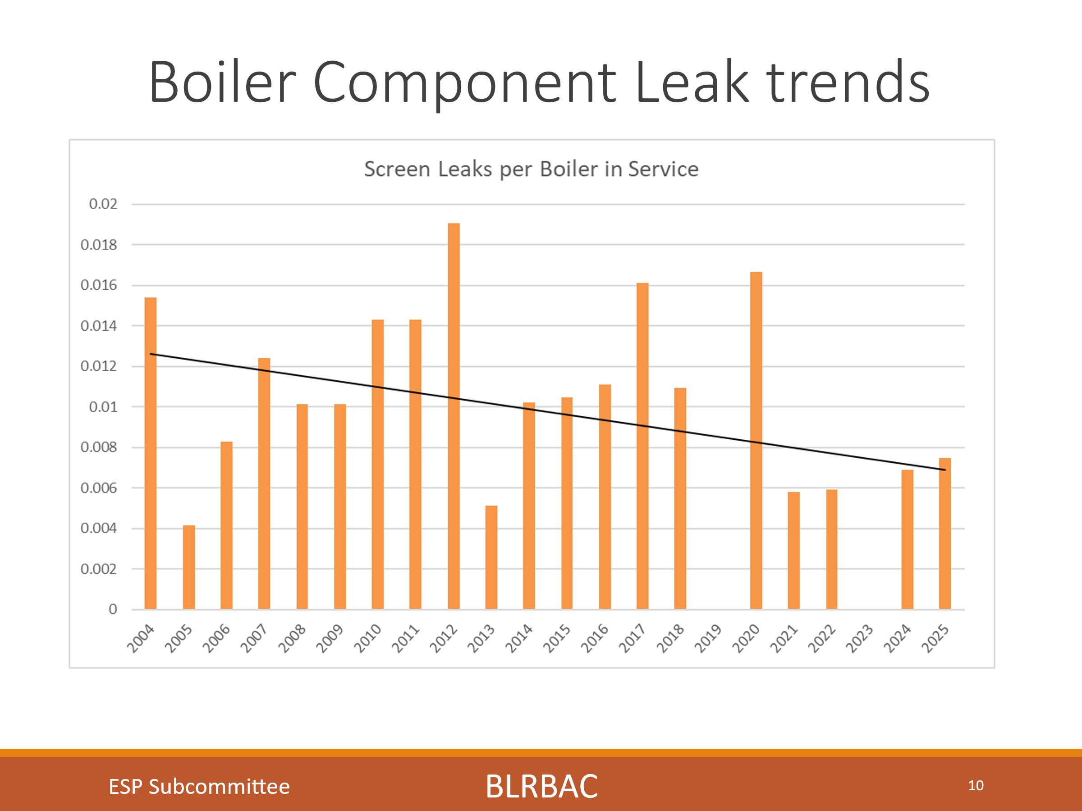
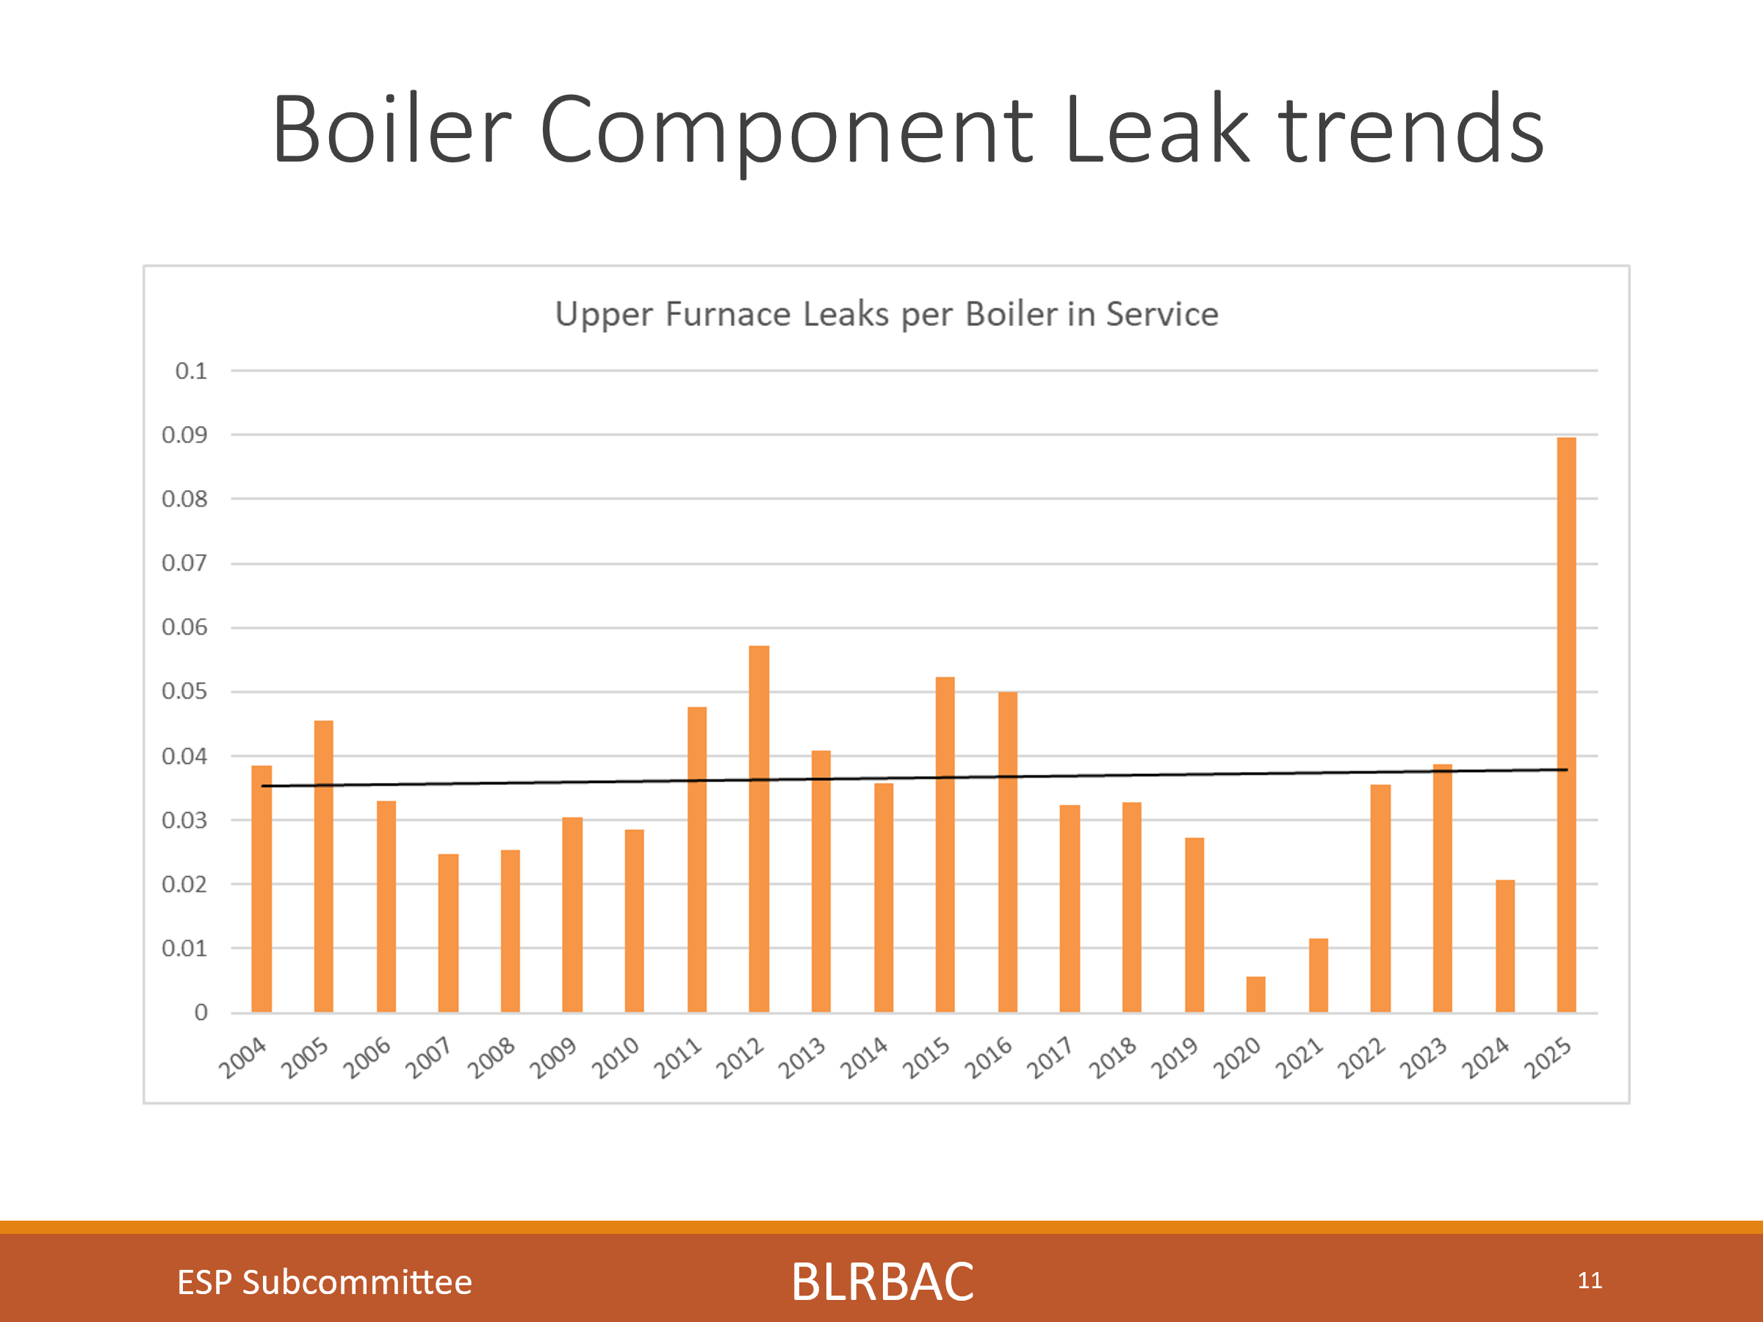

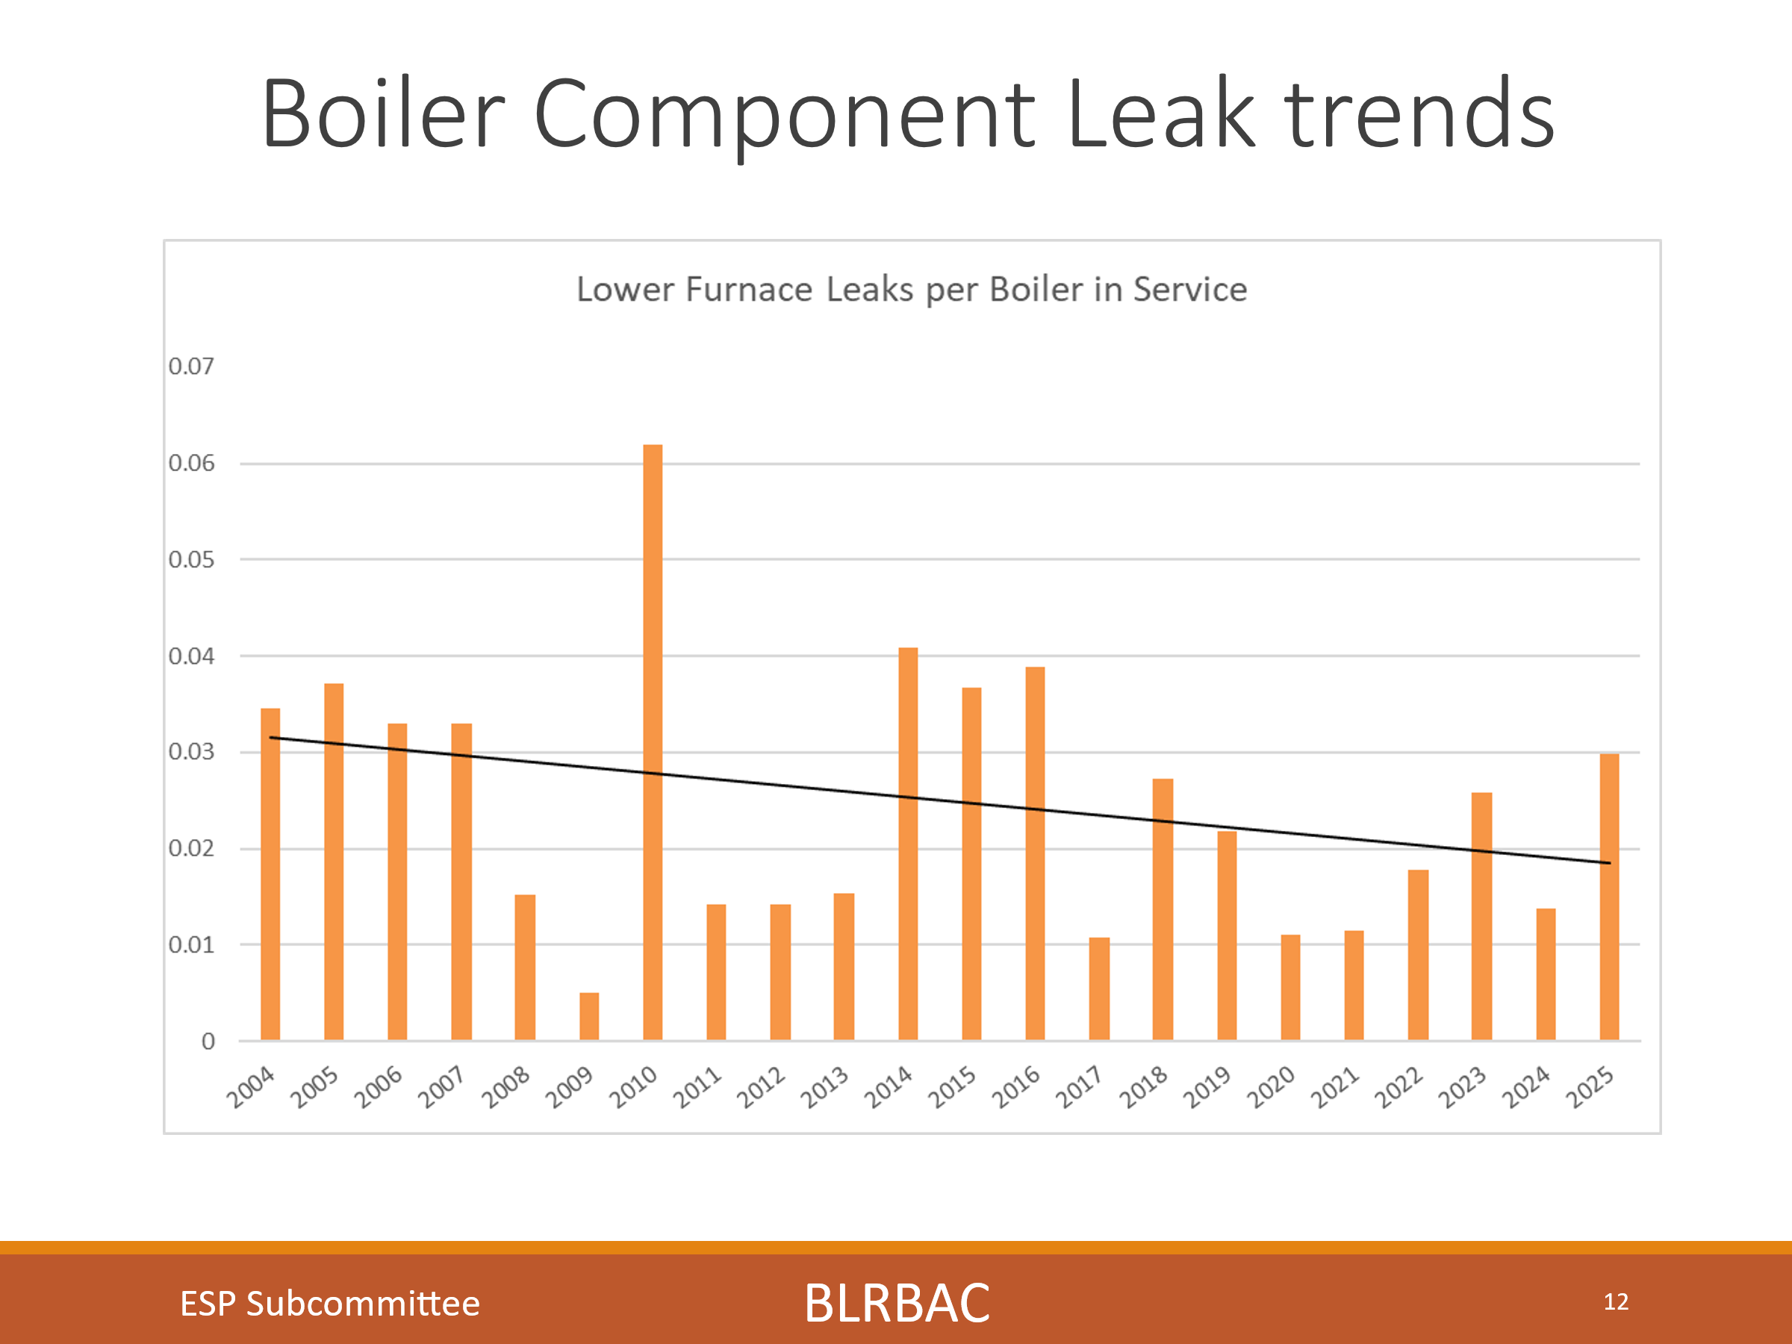

These charts show the trend in number of leaks since 2004 for each section of the boiler (Economizer, Superheater, Boiler Bank, Screen, Upper furnace and lower furnace). We track these trends looking to see if we have made a difference in the number of leaks in each section based on improved OEM design, repair practices, procedures, etc. I think it is safe to say that although we are always focusing on eliminating leaks, we have not designed, maintained and operated any sections trouble free. There can be multiple reasons for this such as age and the number of thermal cycles, SAC, etc.
Yet you will see later that we have now seen less explosions when critical leaks occur, so BLRBAC policies, systems and training have had a significant impact.
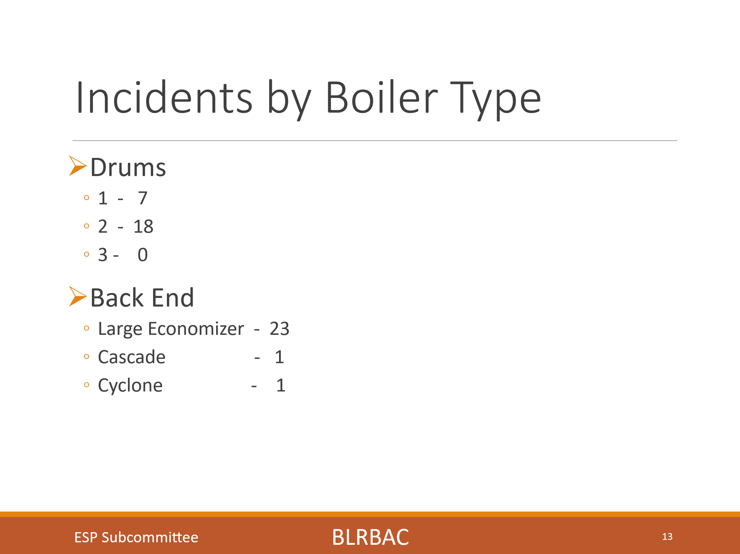
This slide shows incidents by boiler type. We have had 7 incidents reported in a one drum boiler, 18 incidents in a two drum boiler and 0 incidents in a three drum boiler. We show 23 incidents in large economizer boilers and 1 in a cascade boiler and 1 in a cyclone boiler. The larger number in large economizer boilers is likely due to a larger number of these type boilers now being in service.
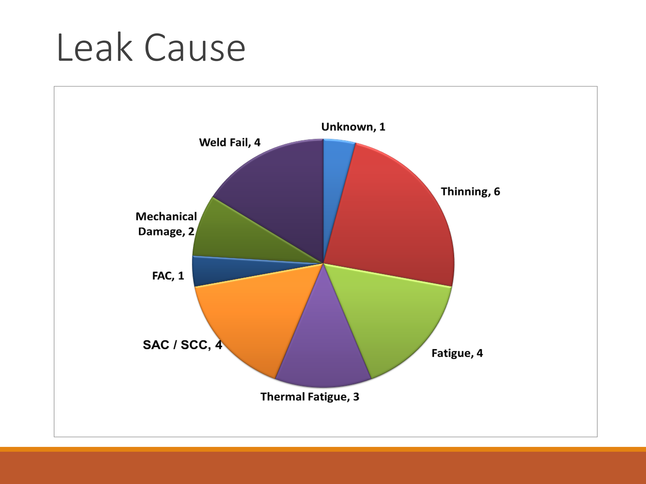
Regarding chart shows root cause of leaks, we had 1 unknown, 6 thinning failures, 4 fatigue failures, 3 Thermal Fatigue, 4 SAC/SCC failures, 1 FAC, 2 mechanical damage, and 4 weld failures. We historically see SAC/SCC failures which is a mechanism to watch for with an aging fleet with a large number of thermal cycles. Yet we are seeing failures due to Fatigue and thinning creep up.
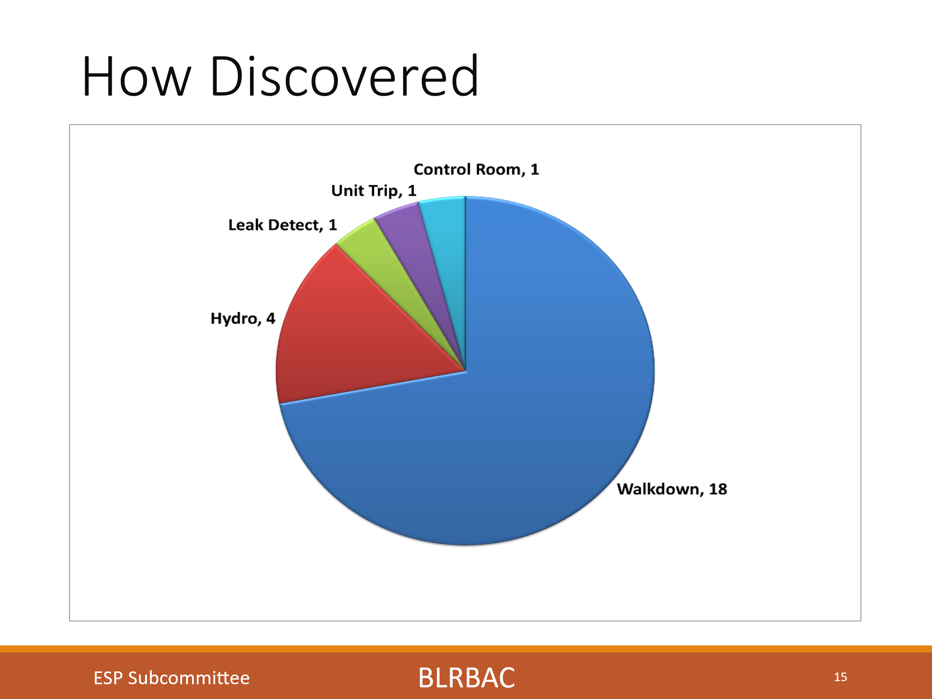
This chart shows how the leaks were detected, and again it shows a high percentage found by the operators on walkdowns. These are typically in the 75% -90% range each session. We had 18 found on walkdowns, 4 on hydro’s, 1 with leak detection, 1 on a unit trip and 1 from control room indications.
We had 4 leaks reported found on a hydro this session and it begs the question if these were leaking in service and if our leak detection systems are sensitive enough.
This also stresses the extreme importance of training operators and the value of walkdowns for early detection.
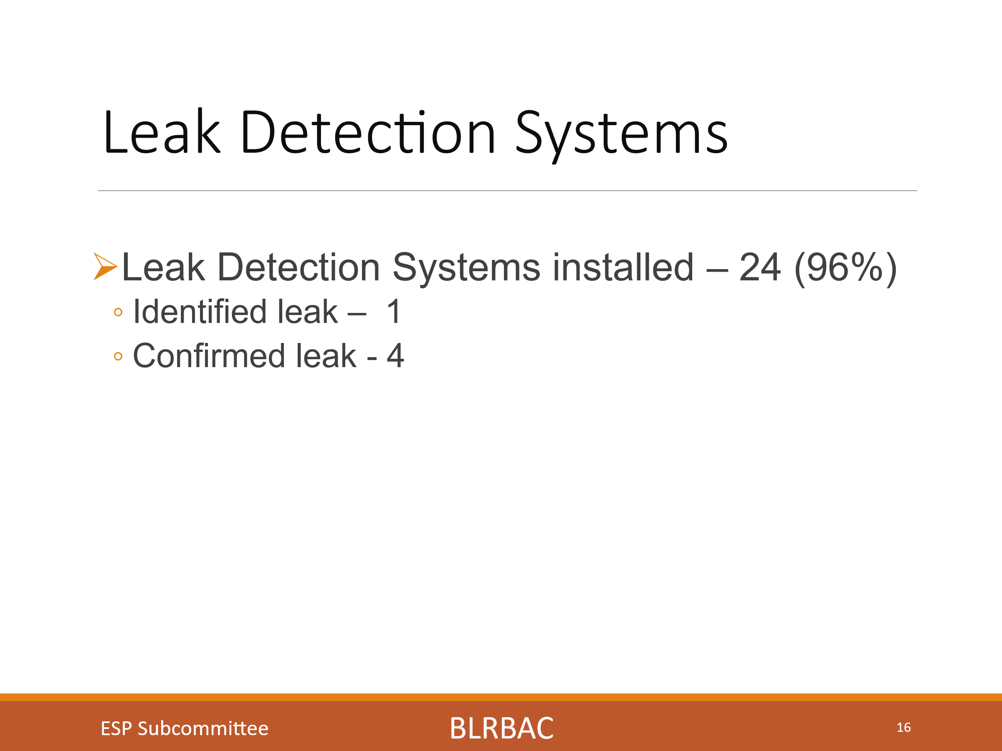
We had 24 incidents reported with leak detection systems installed on the units (96% of the units). One of the leak detection systems initially identified the leaks. Four leaks could be seen trending upward when going back and looking at the data trends but had not yet alarmed. As always, leak detection system sensitivity can play a part in the system’s ability to initially detect a leak or not. Do not desensitize your system to avoid nuisance alarms to the point that they will not detect an actual leak.

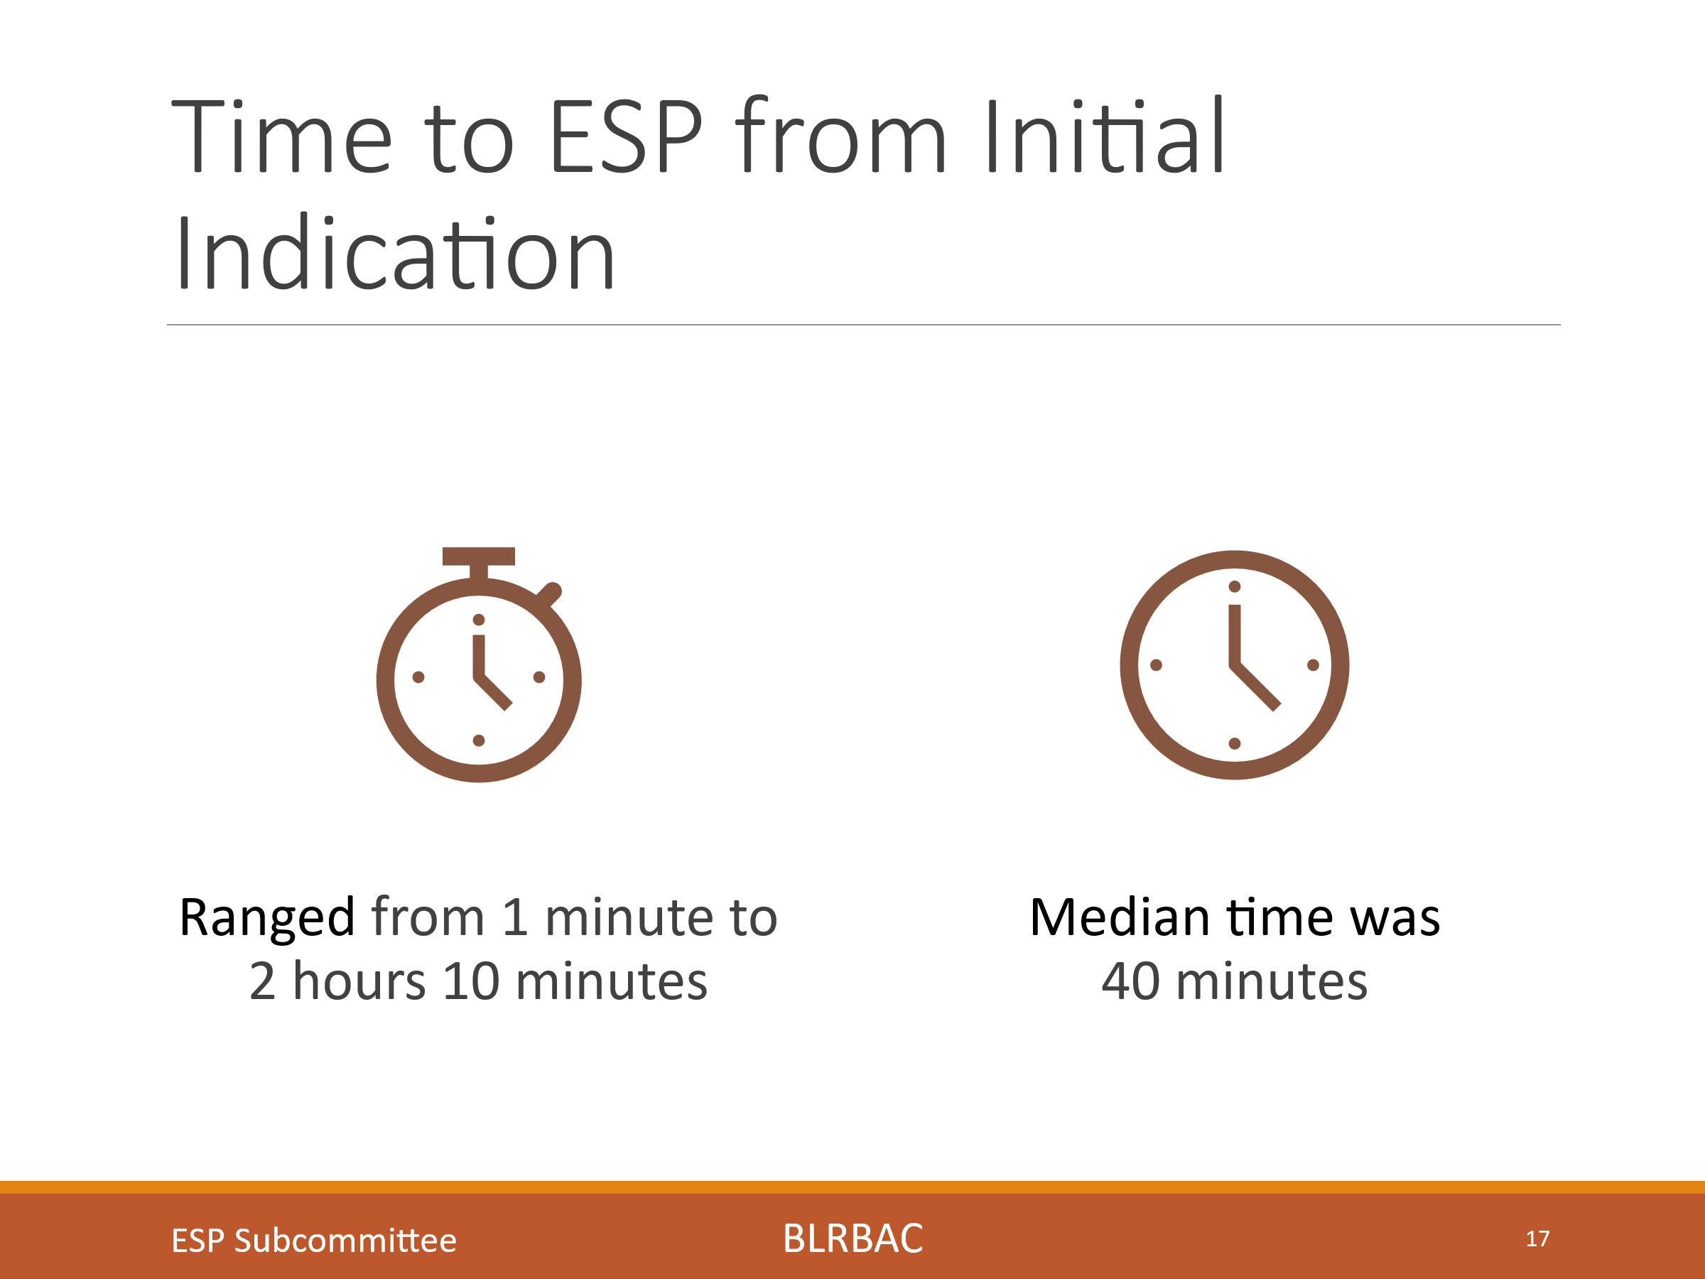
This chart indicates the time from first discovery of a leak, to the time the unit was ESP’d. The time ranged from 1 minute to 2 hours and 10 minutes. The average time was 40 minutes. As we know, evaluating a leak is a stressful and critical time. The time to act to ESP the unit on an actual leak is critical, and training and education can only help improve these times.
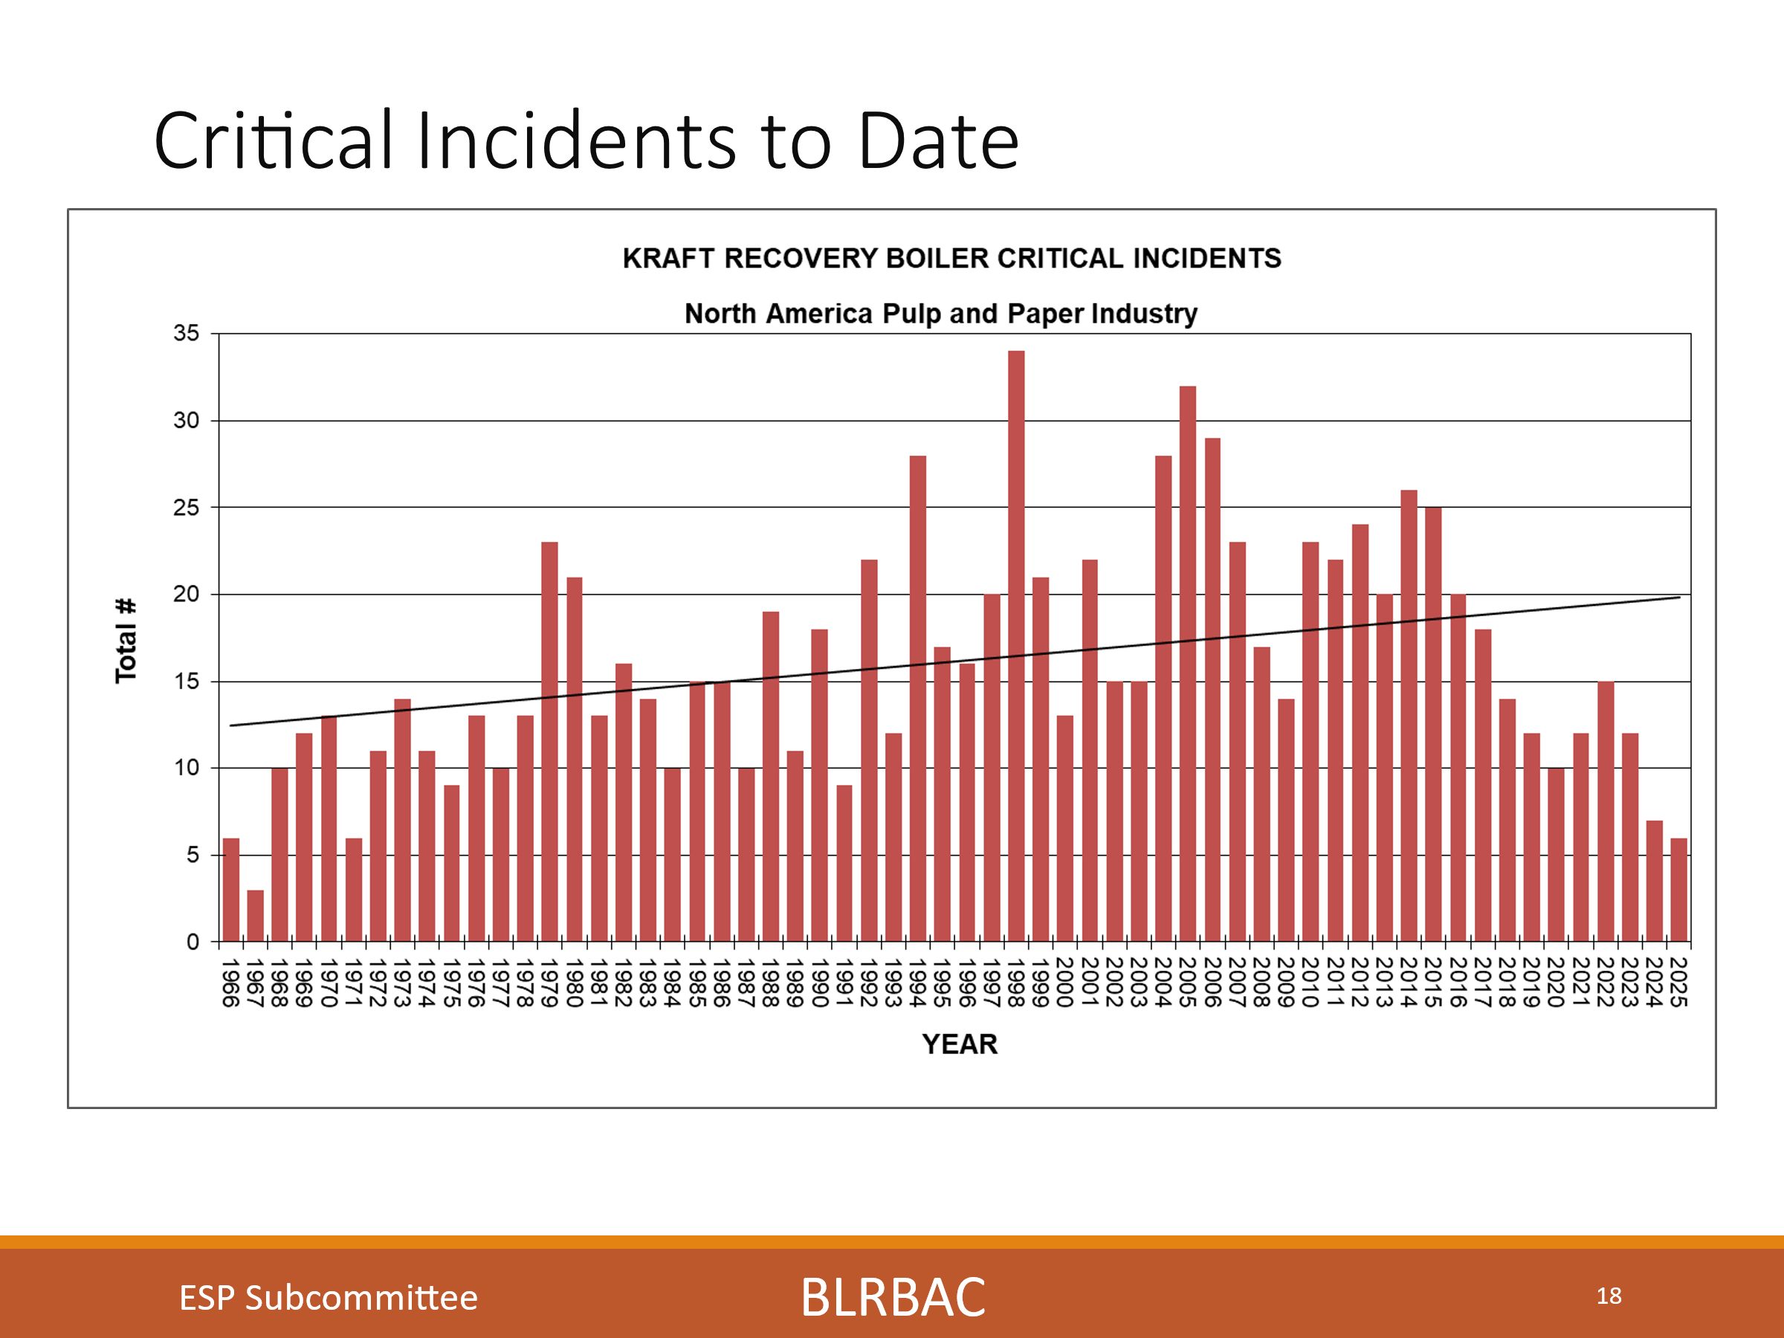
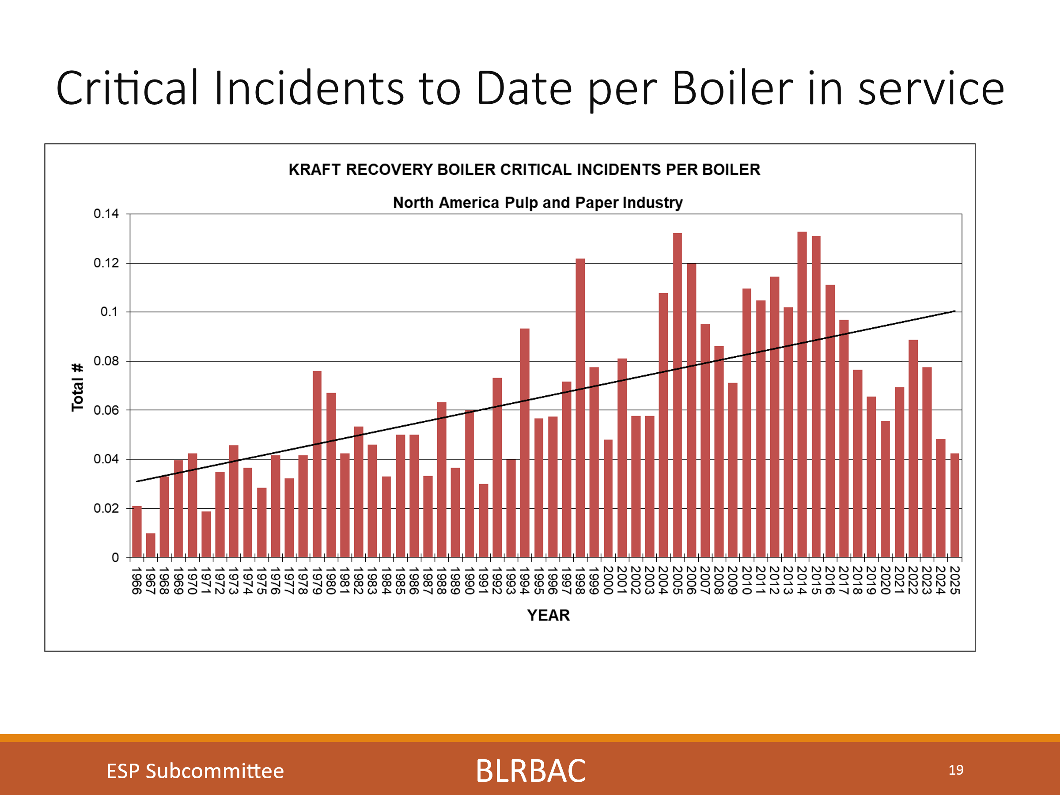
The two charts show Critical incidents to date. The first chart is the way we used to track it, just the straight number of critical incidents per year. I have adjusted it to show a trend in Critical incidents per boiler. You can now see that it shows much larger rise in the number of critical leaks per boiler now that the number of boilers have been taken into account.
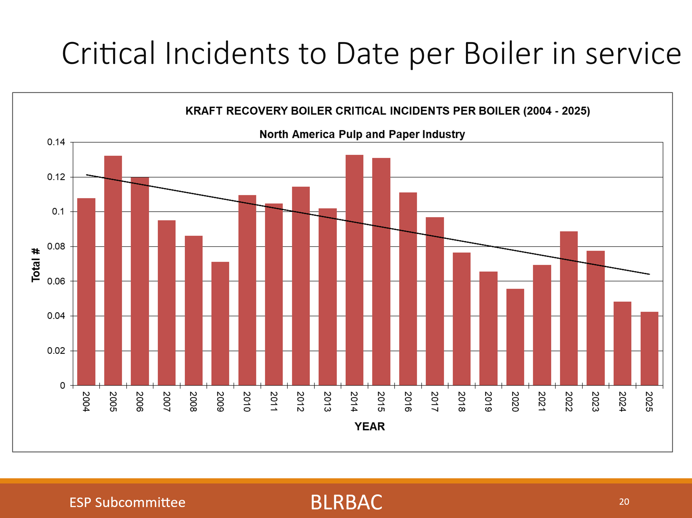
Yet looking at it solely for the last 20 years (Similar to the basis for the earlier charts), we do see an improved decreasing trend that we need to stay on.
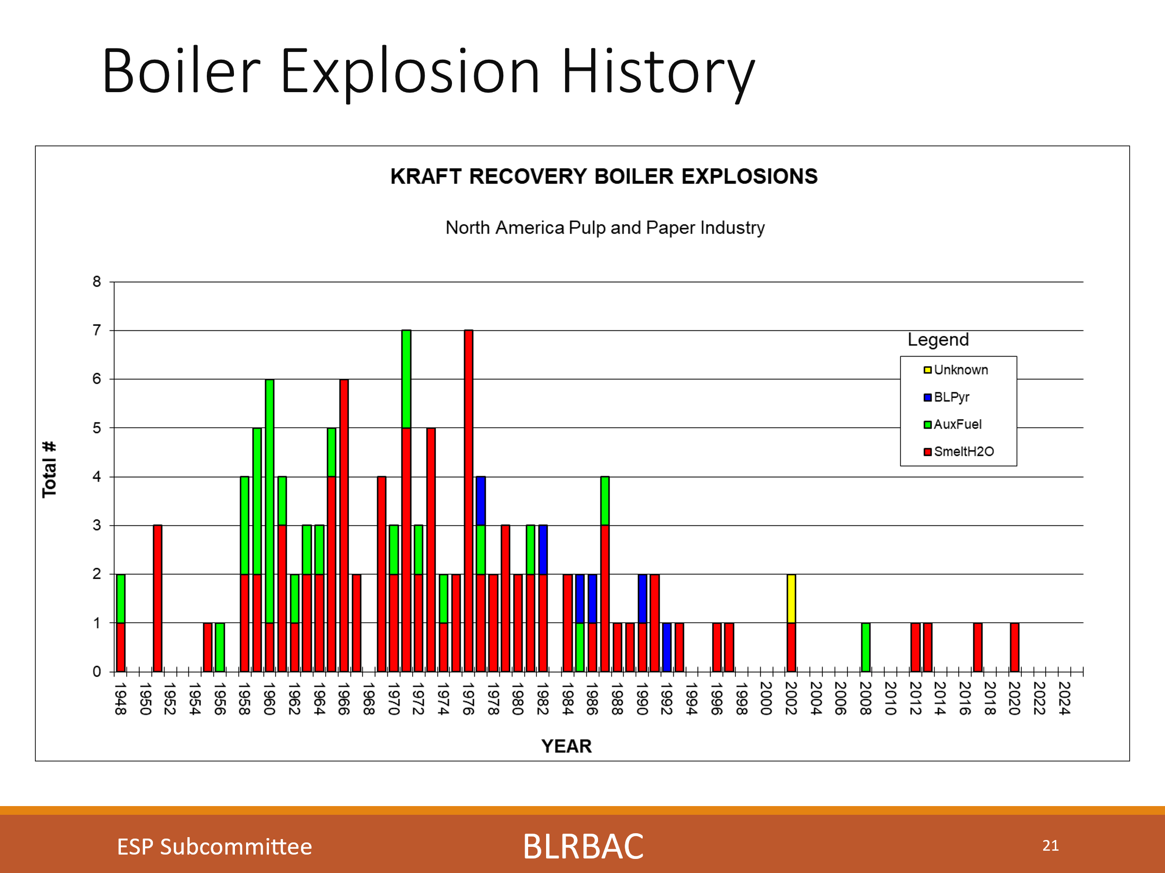
The chart shows Boiler explosion history. So why if the number of critical incidents per boiler increased since 1966, did we see less explosions?

I would guess that we have instituted better systems, equipment and guidelines to recognize, handle and prevent these incidents from having disastrous consequences.
We have instituted walkdowns for early detection as a prime example, which as you have seen, typically find 75 - 90% of leaks. Finding leaks early and reacting to them properly is just one example of the things we as an industry, working through BLRBAC, to proactively prevent bad situations from becoming worse.

This is a testament to everyone who has participated in the BLRBAC organization over the years and has been (And continues to be) a part of the constant learning through incident review, subcommittee guideline development and operating diligence that it has taken to affect these results. It is also a testament to the operations people who do these walkdowns and discover leaks early and who have implemented the systems and procedures to handle them.
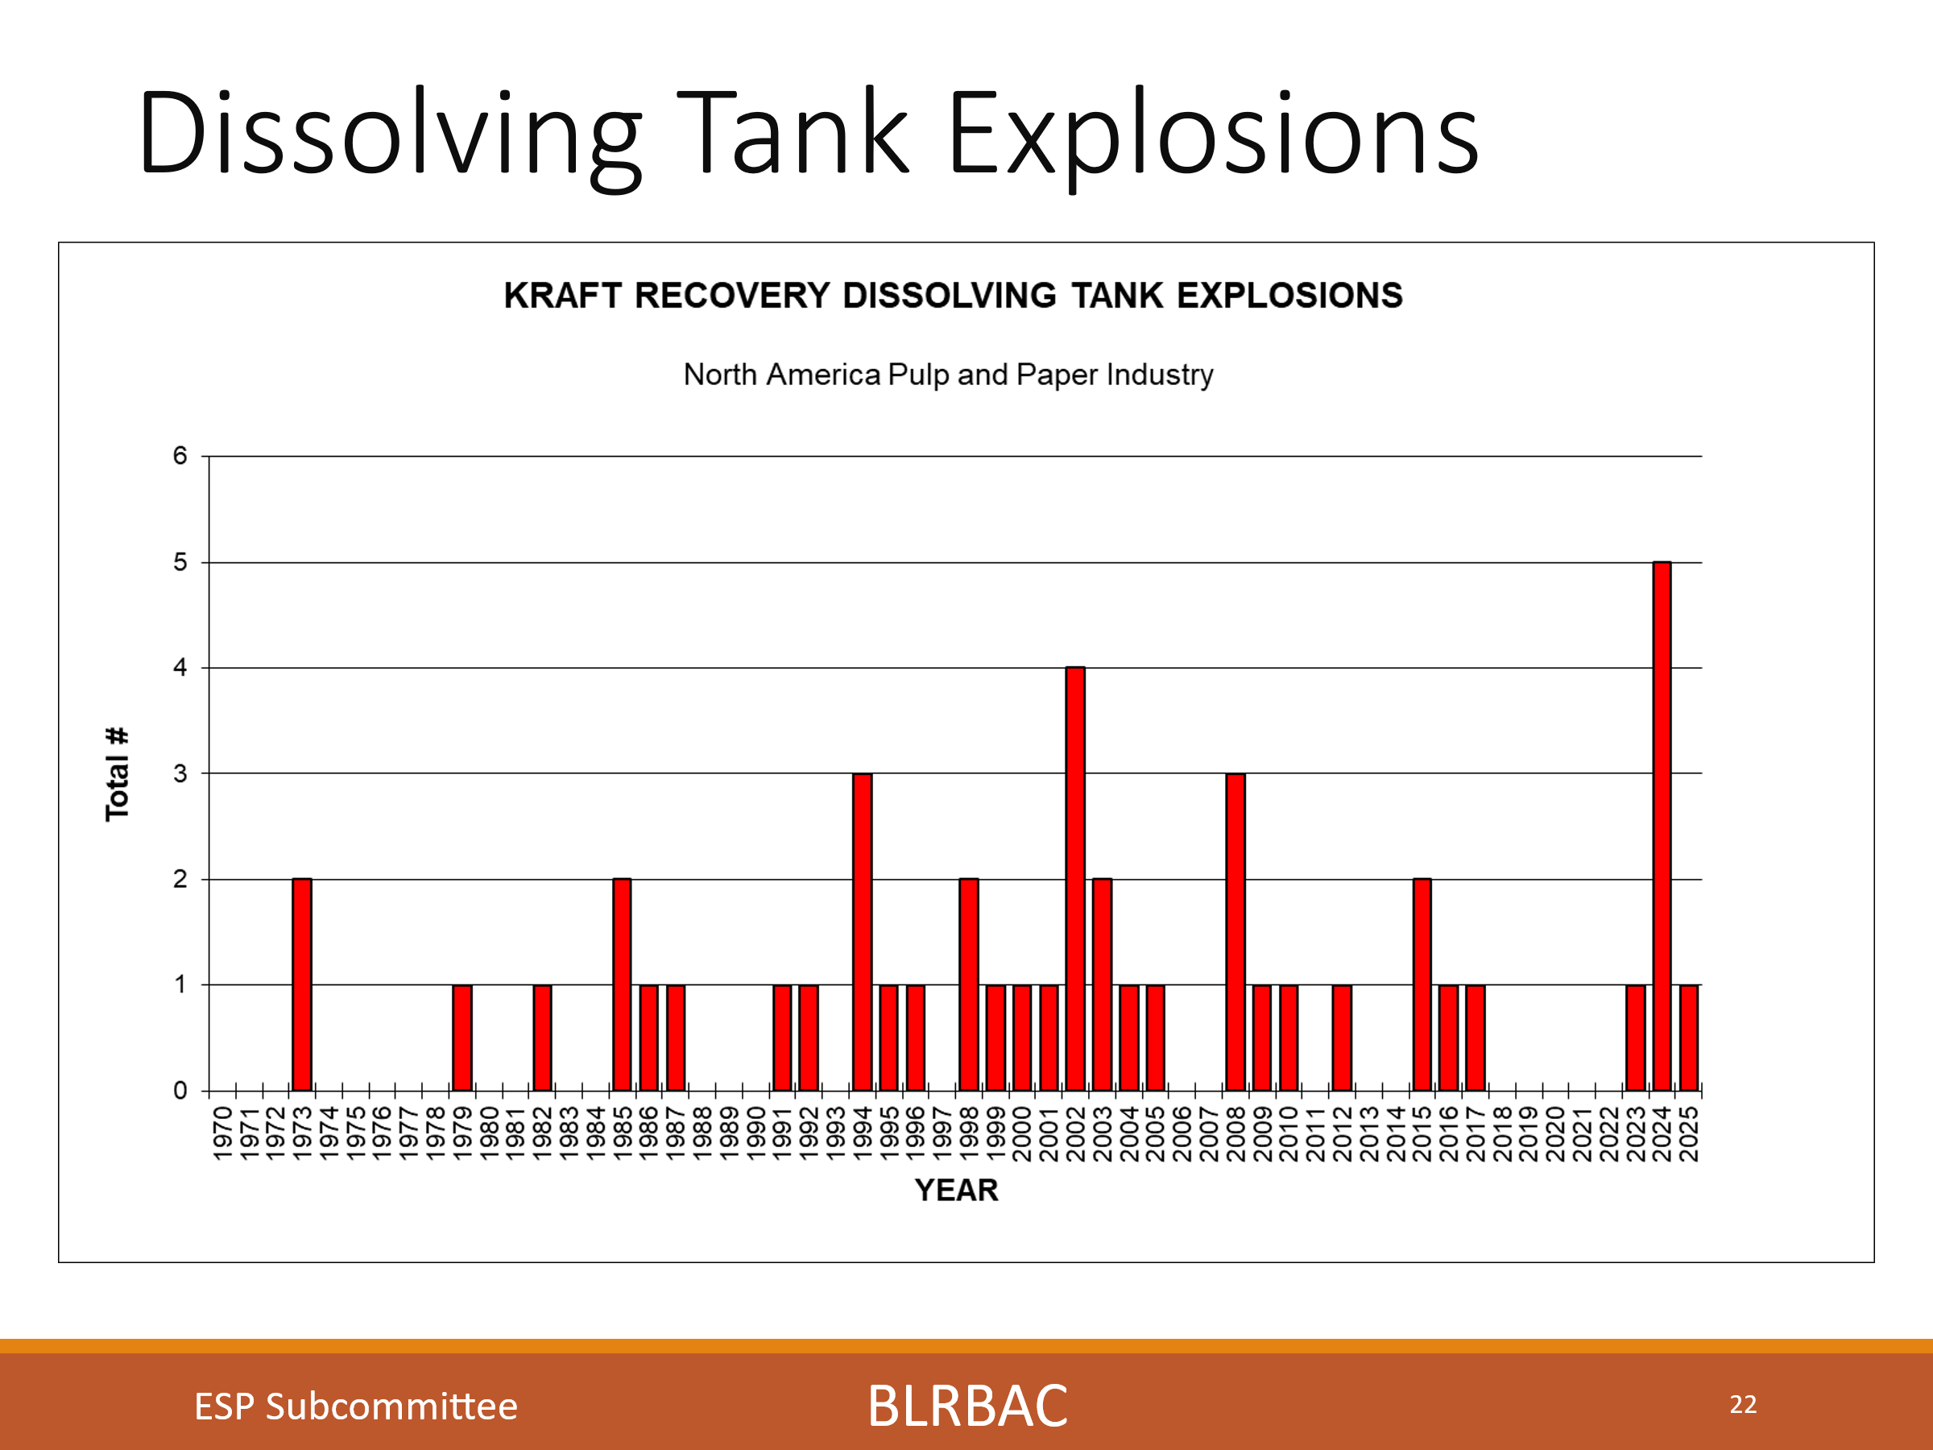
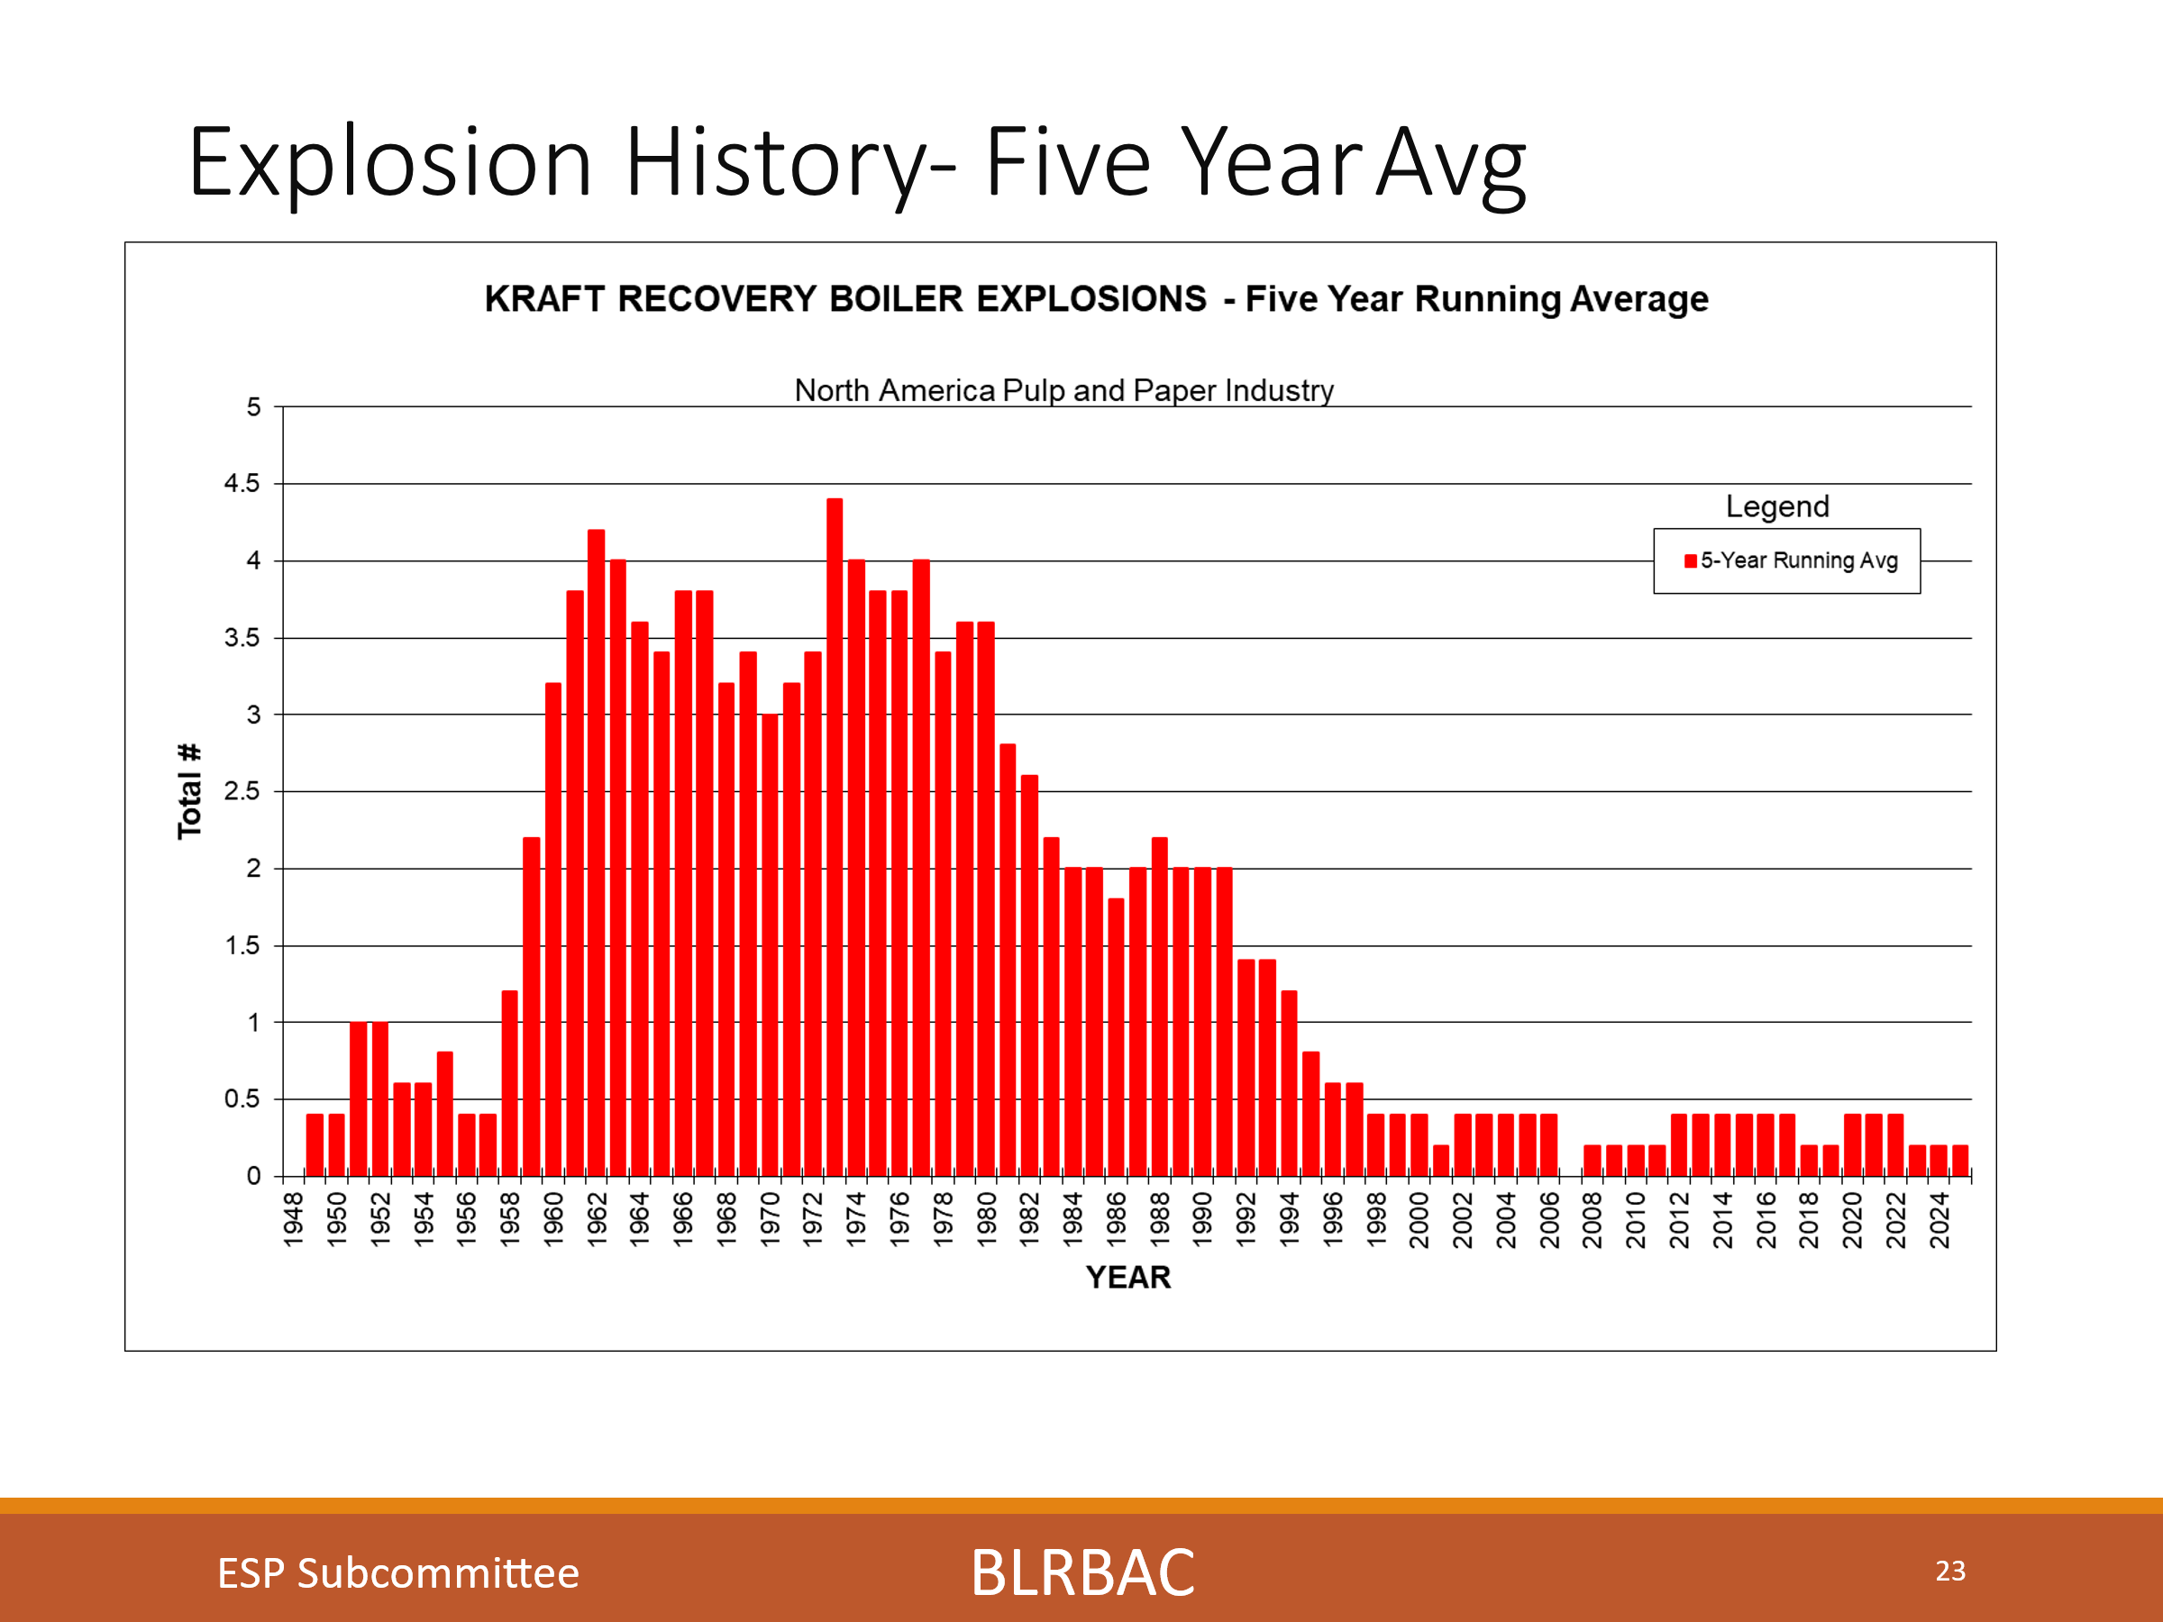

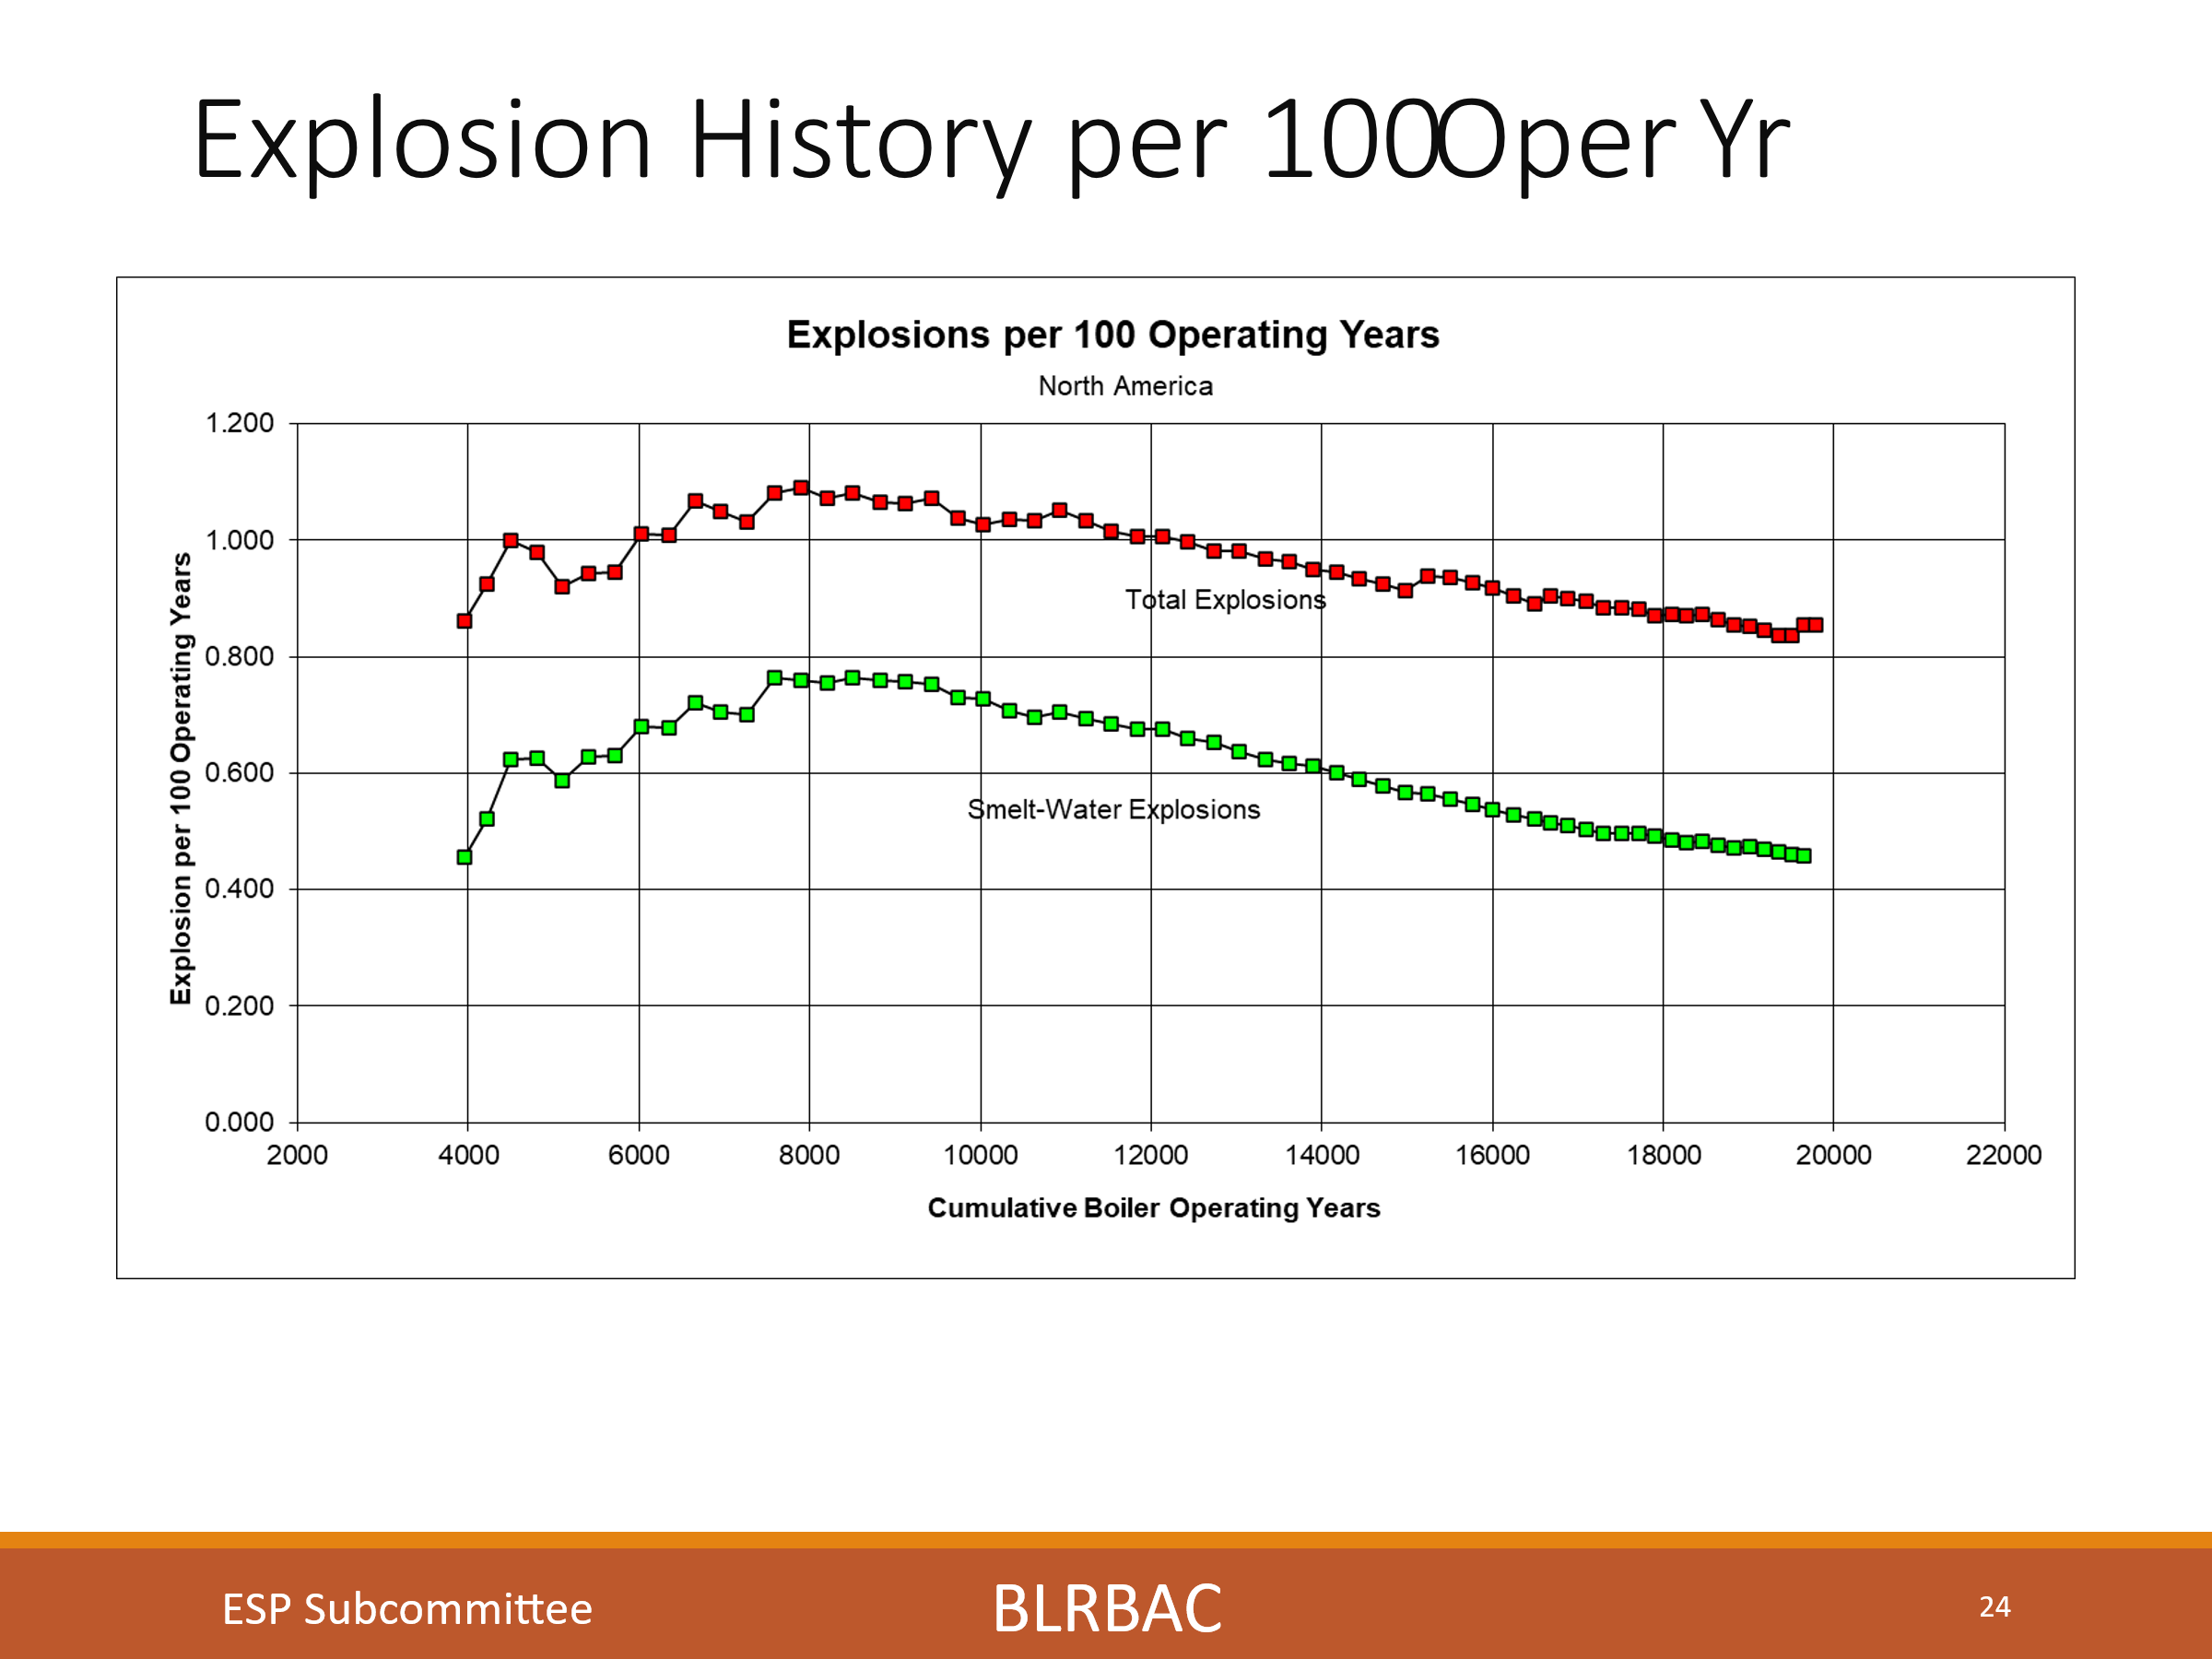
These charts show Dissolving tank explosions, Explosion history 5-year average and Explosions History per 100 operating years. We look at these charts to identify long term trends and improvements made. You see an uptick in the chart for explosions per 100 operating years. This last chart is a combined Recovery Boiler and Dissolving Tank chart and we had seen a rise in Dissolving tank incidents, although none were reported this session. Hopefully the work done by this organization and others has served to educate operating personnel on the methods to prevent incidents.

We know still that not all Dissolving tank incidents are being reported. We continue to encourage reporting dissolving tank near misses/plugged spouts/hood damage as incidents, so we can understand the issues leading to these incidents and be more preventative. We would like to encourage everyone to report these.
With this effort of reporting incidents, not just explosions, I feel we can have the same result as we have had with RB Explosion prevention through education, systems and guideline development. Hopefully this is the beginning of a good trend.
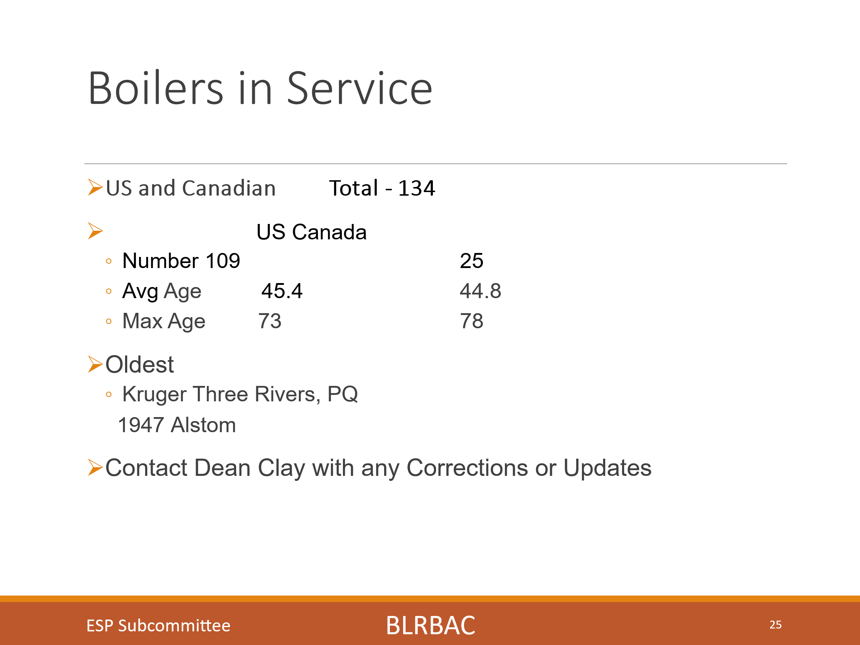
This chart shows the number and age of units in North America. We have 109 units in the US and 25 in Canada for a total of 134. The average age in the US is 45.4 years and in Canada is 44.8 years. The maximum age in the US is 73 years and in Canada is 78 years. The oldest unit in operation is the Kruger Three rivers, PQ unit and it is a 1947 Ahlstrom Boiler. Please send Dean any updates.

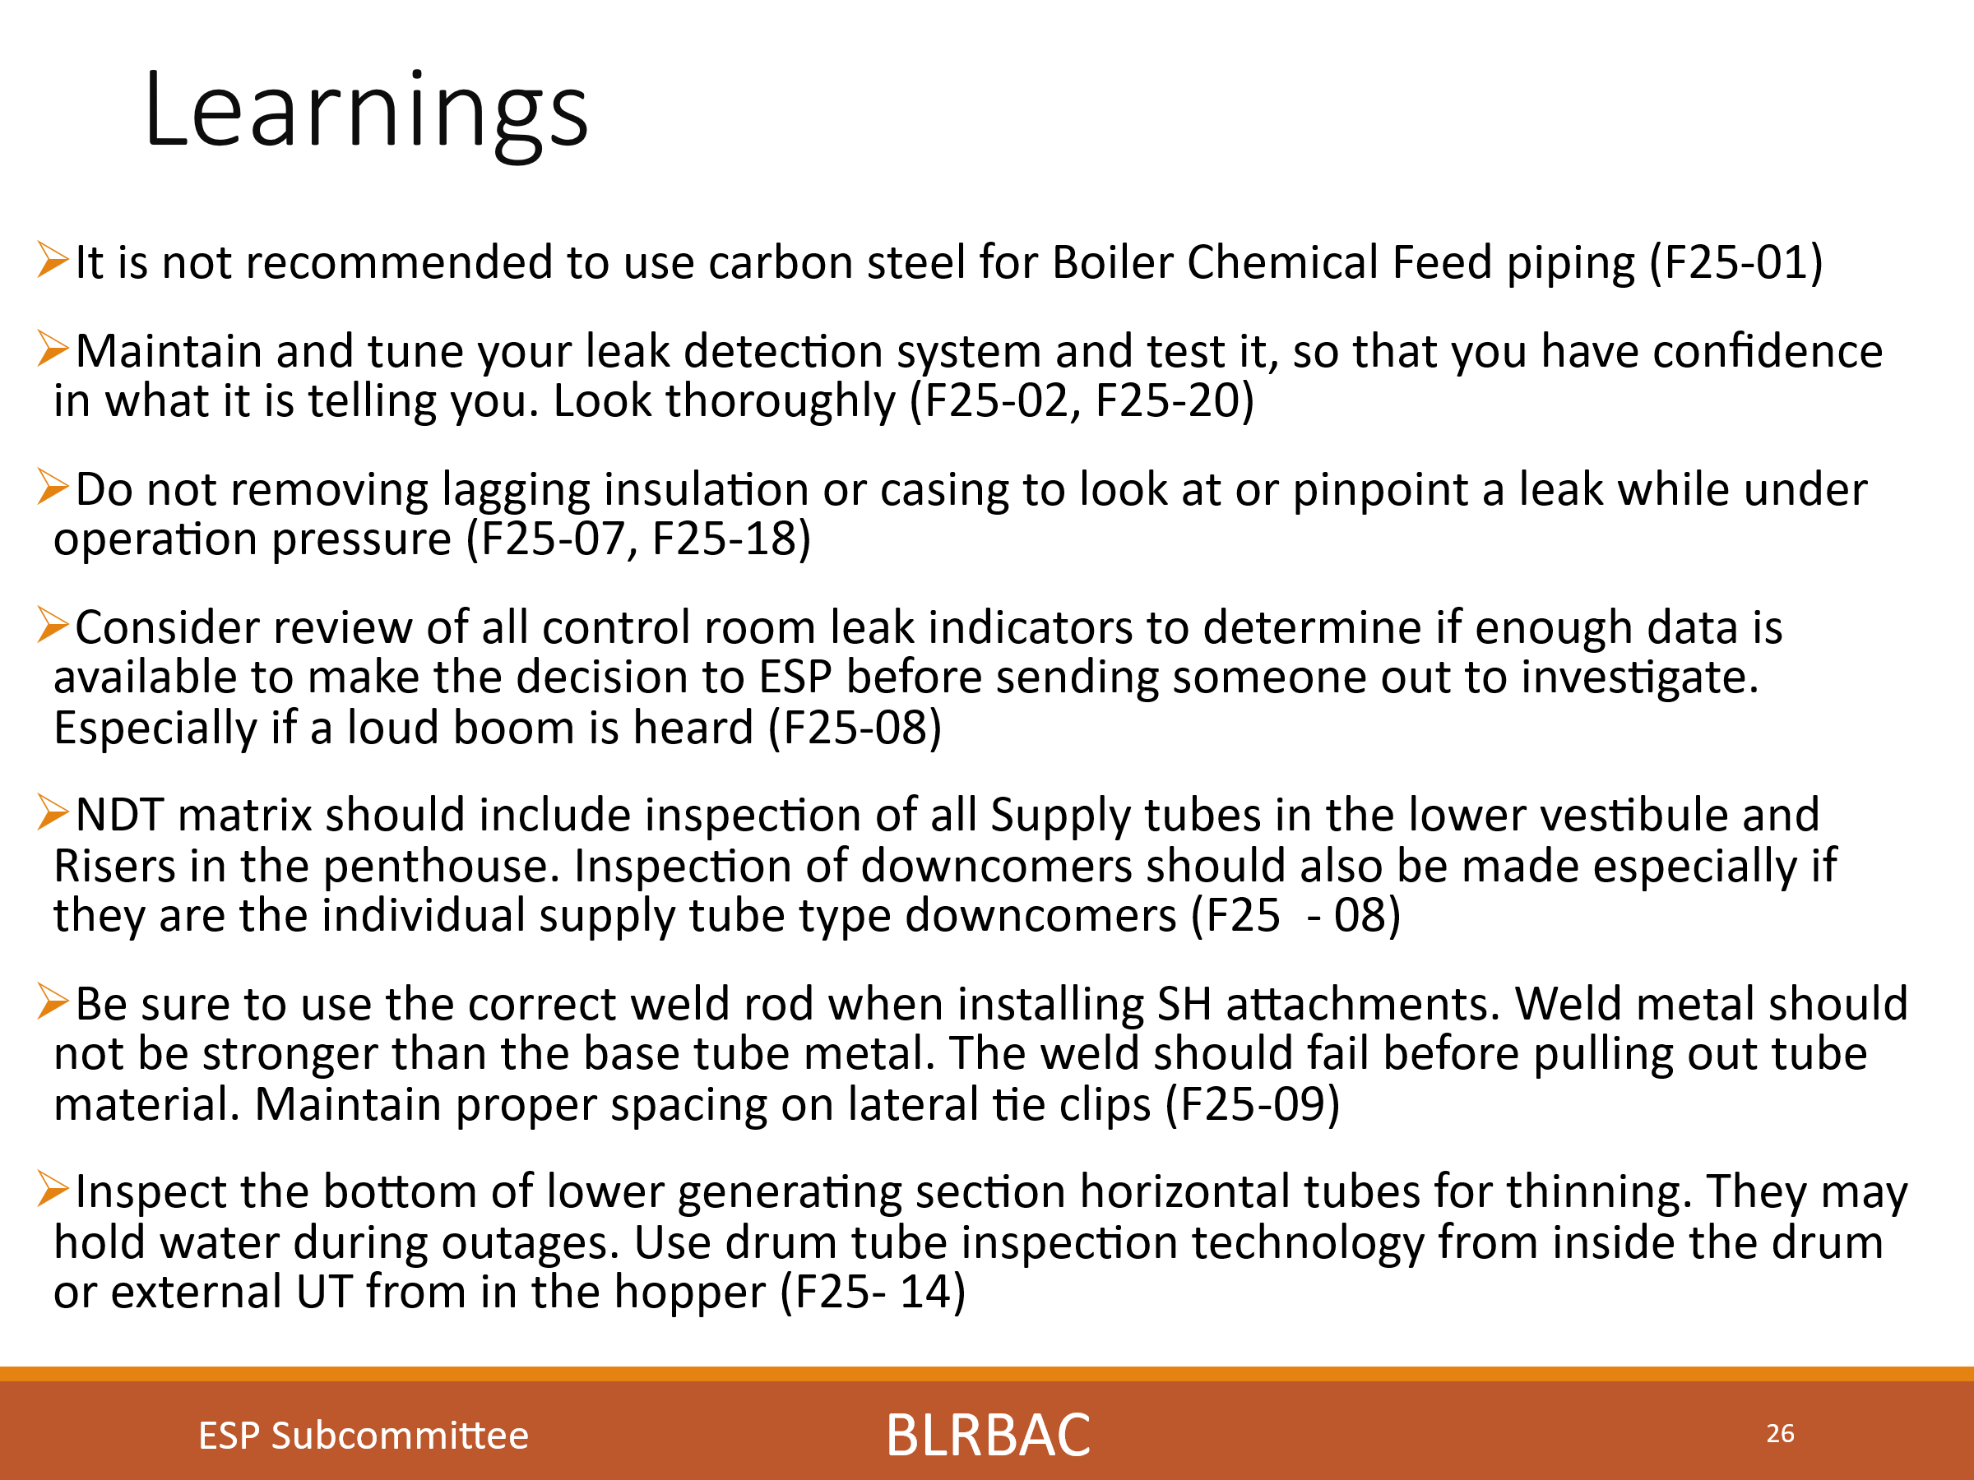

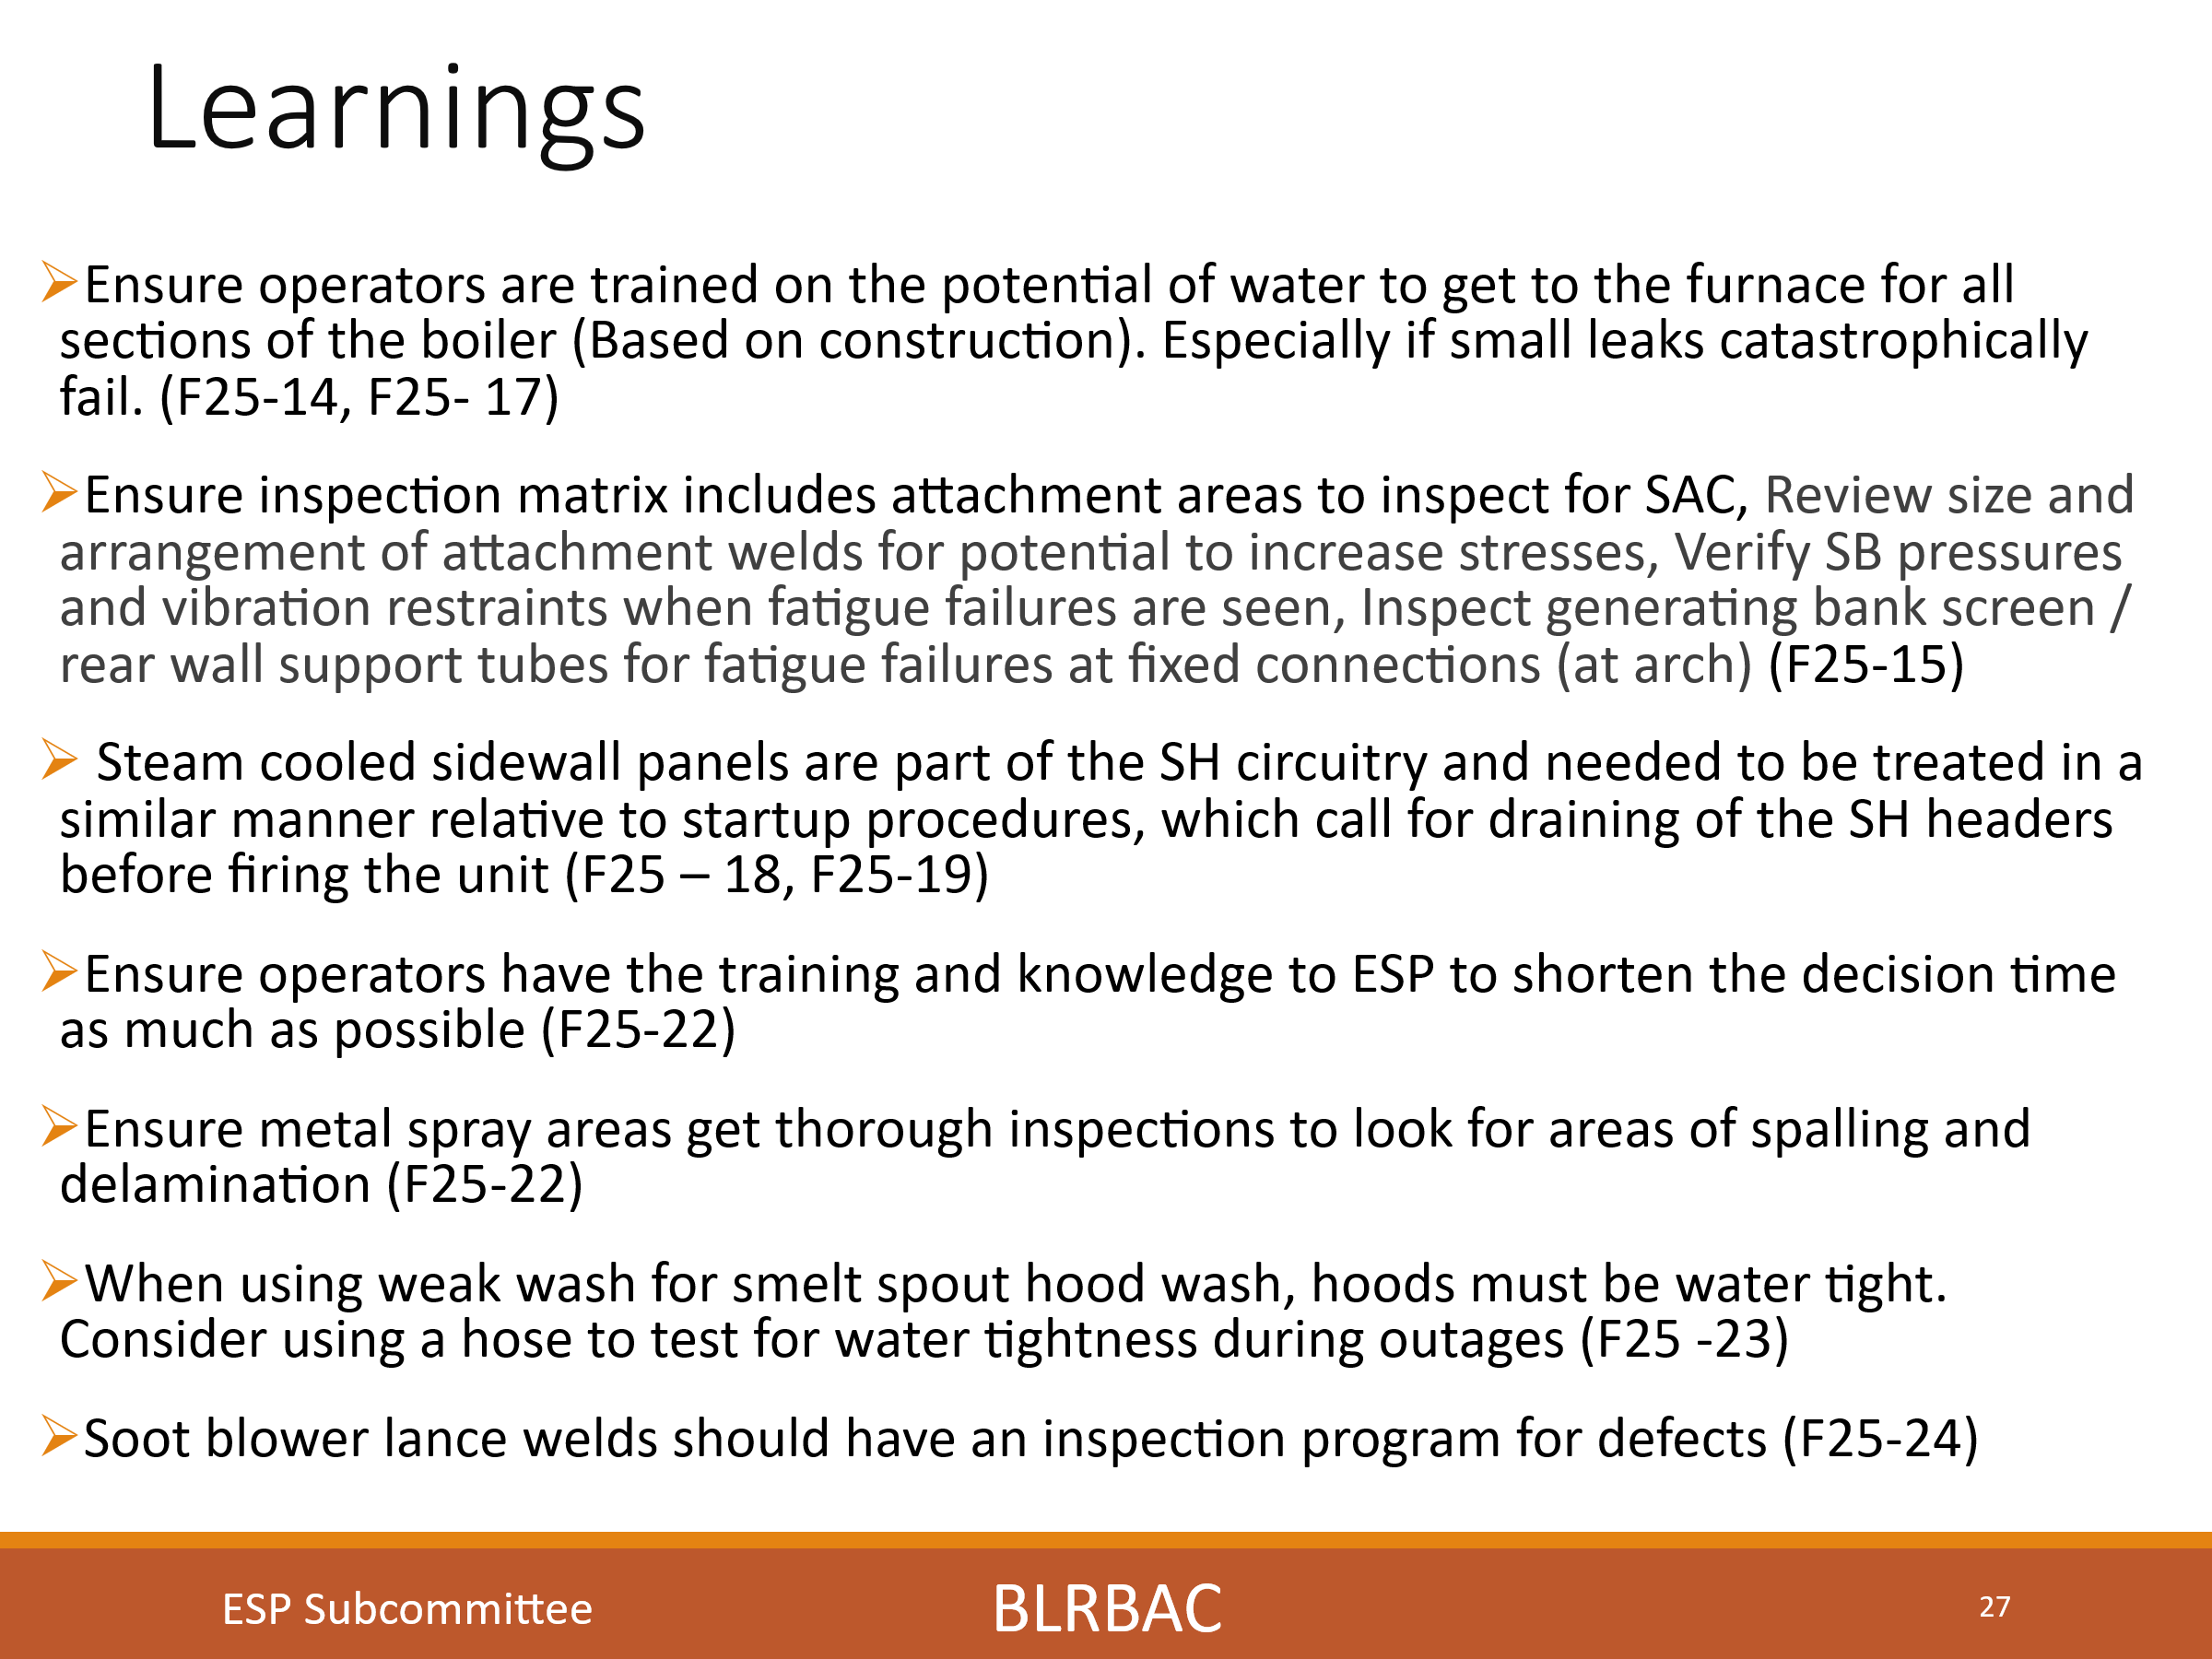

These slides are the captured learnings from the incidents reported this session. I will go through each of these. The numbers at the end of each learning are the incident number from this session. i.e., Spring, 2025 session, incident number 01 (S25-01)
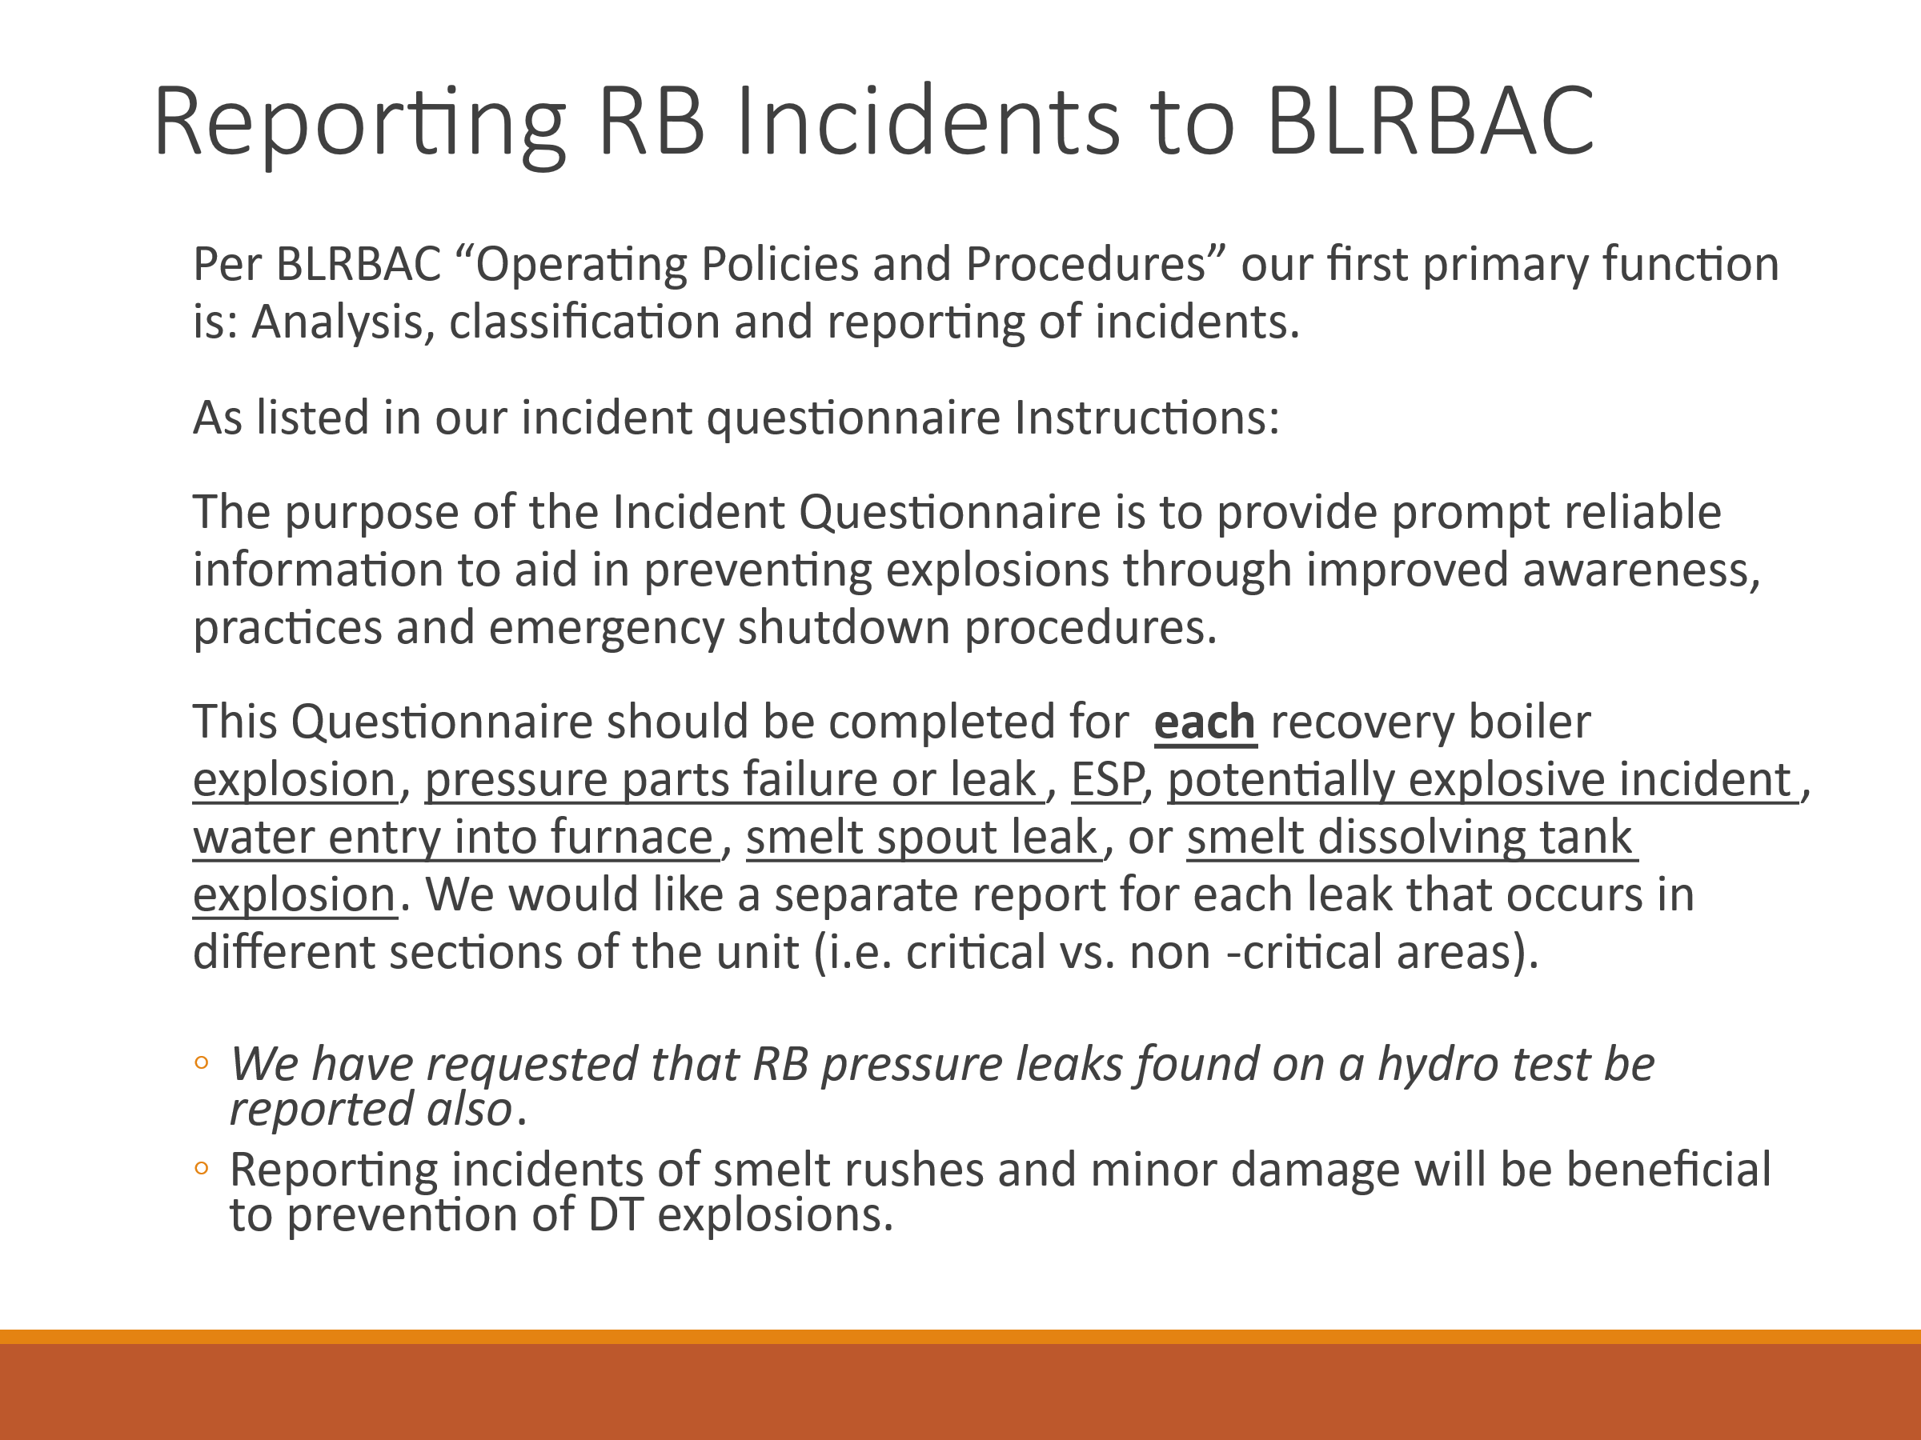
This slide discusses how to report incidents to BLRBAC and that we want incidents reported found on hydro. Even if found on hydro, we will classify these as critical if they are in a critical area even though the unit is not running. Sometimes they may have been leaking when the unit was on the way down. We are again also requesting that dissolving tank near misses also are reported so that we can learn from and address issues proactively. Please try to submit a separate incident when leaks occur in different sections of the boiler as they may be classified as Critical or Non-Critical differently.
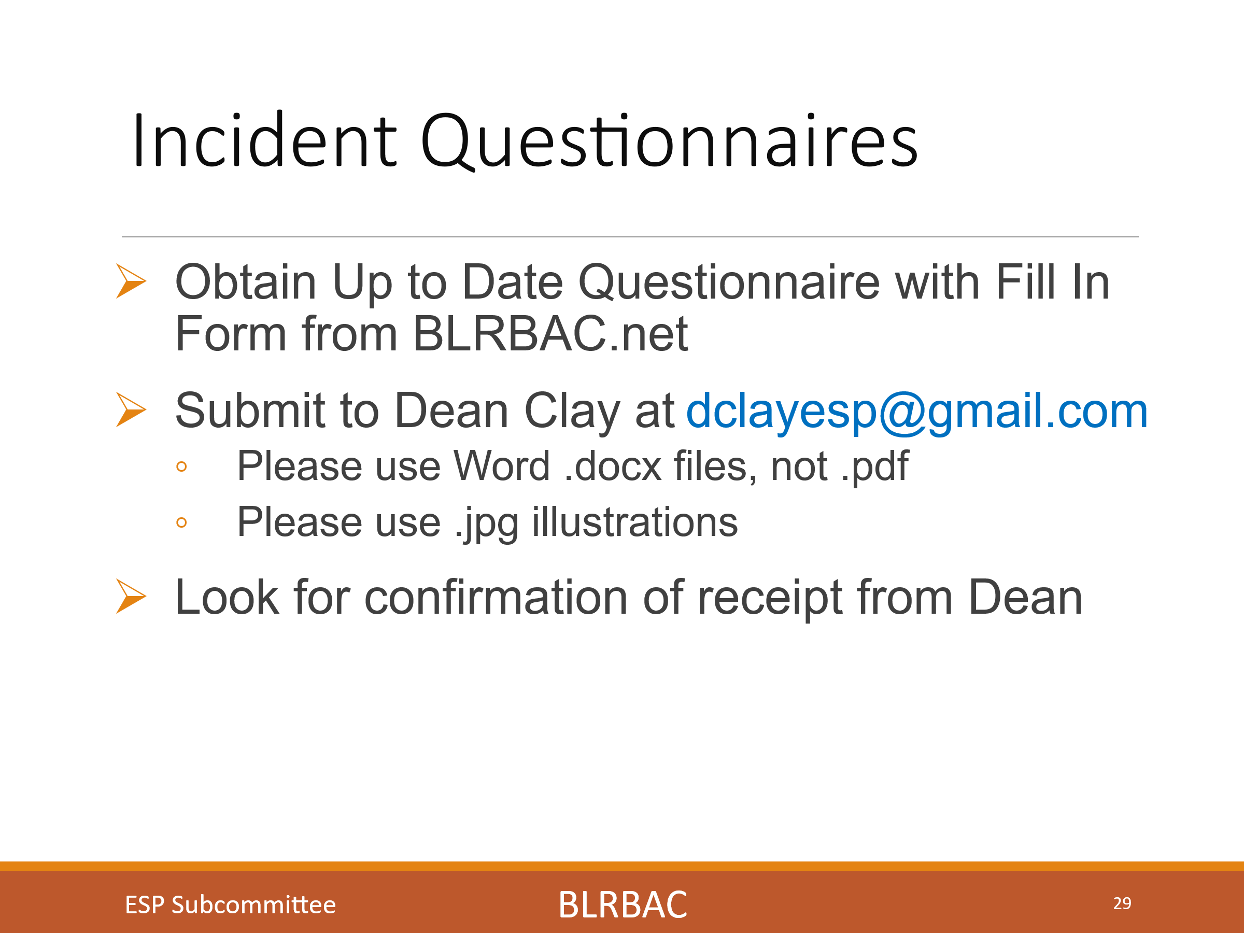
This slide shows the information related to where to find the incident questionnaire and to look for confirmation from Dean Clay that it was received.
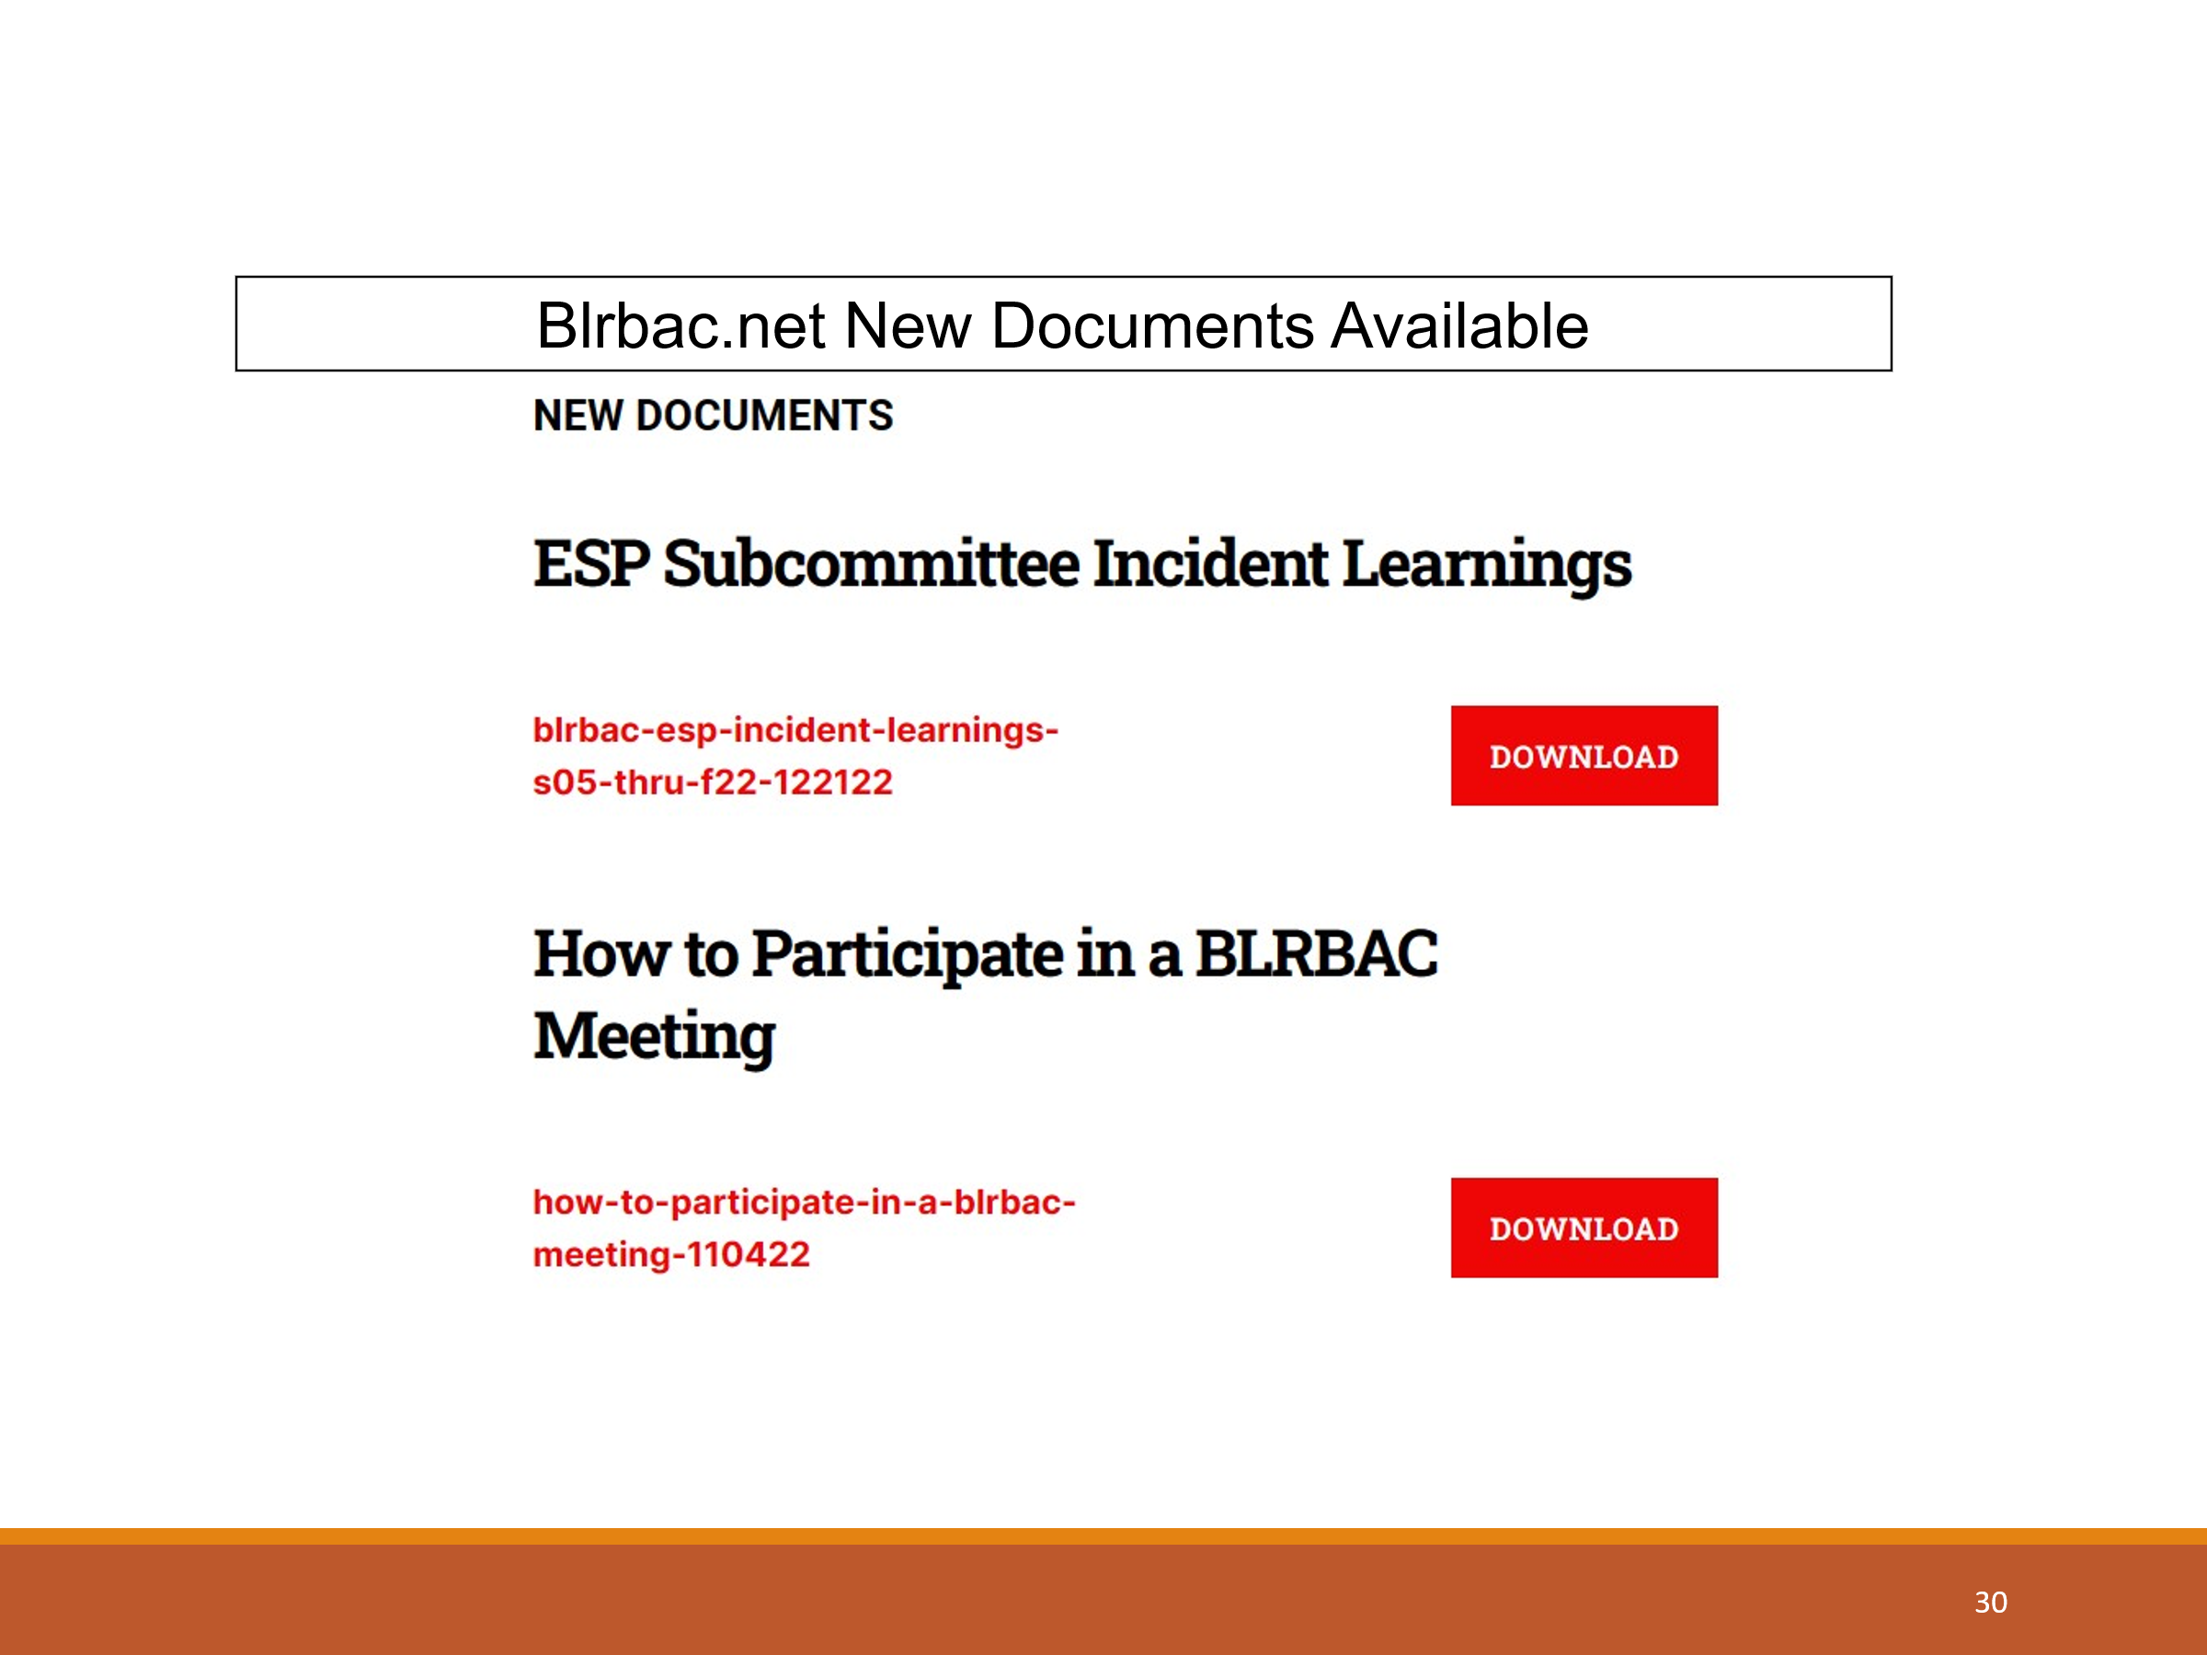
This slide shows where to find the Collection of incident learnings from Spring 2005 to Fall 2022 compiled by Dean Clay and soon to be updated by Mike Bruce and myself. The document describes how it is organized and the collective learnings over the years. I recommend this as a learning tool for management and operators for the prevention of future incidents.

The second item on the slide shows where to find the posted document of “How to get the most out of attending a BLRBAC meeting”. I highly encourage reading it and providing it to anyone in your mills planning on attending BLRBAC.

Downloadable presentation:
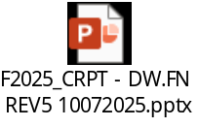

APPENDIX III

AF&PA Report

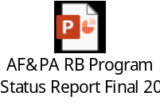

mmittee Vi

APPENDIX IV

Presentations

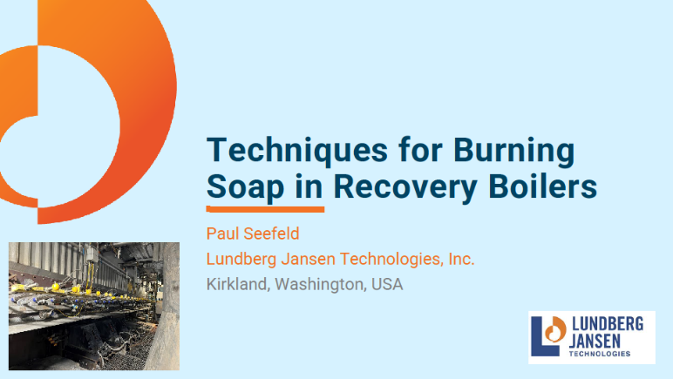

K Lundberg Jansen - Paul Seefeld -Techniques for Burning Soap in Recovery Boilers

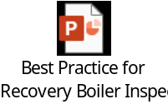

Corrosion Probe Inc. - Michael Lykins & Len Erickson – Update of Tappi Tip 0416-26 - Best Practice for RB Inspection Update



Andritz - Jordan Spicer & Sam Miller – Camera Technology Advancements Andritz - Jordan Spicer & Sam Miller – Camera Technology Advancements

